DESIGN AND IMPLEMENTATION OF A UNIFIED ACADEMIC OPERATING SYSTEM FOR RESULT MANAGEMENT AND E-LEARNING: A CASE STUDY OF IBRAHIM BADAMASI BABANGIDA UNIVERSITY, LAPAI

BY
NUHU MUHAMMAD DATTI
U22/FNS/CSC/1105

DEPARTMENT OF COMPUTER SCIENCE,
FACULTY OF NATURAL SCIENCES,
IBRAHIM BADAMASI BABANGIDA UNIVERSITY, LAPAI, NIGER STATE,
NIGERIA

June, 2026

CERTIFICATION
This is to certify that this project report titled “Design and Implementation of a Unified Academic Operating System for Result Management and E-Learning: A Case Study of Ibrahim Badamasi Babangida University, Lapai” was carried out by Nuhu Muhammad Datti with matriculation number U22/FNS/CSC/1105 in the Department of Computer Science, Ibrahim Badamasi Babangida University, Lapai, under my supervision.

Dr. Abdulganiyu Abdulrahman 1 July 2026
Project Supervisor Date

Dr. Abdulganiyu Abdulrahman 1 July 2026
Head of Department Date

DEDICATION
This project is dedicated to Almighty God for His mercy, guidance, and strength throughout my undergraduate programme. It is also dedicated to my parents, family members, lecturers, and everyone who encouraged me during the design, implementation, testing, and documentation of this project.

ACKNOWLEDGEMENT
I give all praise and thanks to Almighty God for granting me the knowledge, patience, and strength to complete this project. My sincere appreciation goes to my supervisor, Dr. Abdulganiyu Abdulrahman, for the guidance, corrections, and encouragement given to me during the course of this work. I also appreciate the Head of Department and all lecturers in the Department of Computer Science, Ibrahim Badamasi Babangida University, Lapai, for the knowledge and discipline they have imparted to me throughout my academic programme.
I am grateful to my project team members for their support and contributions. As the technical lead and principal developer, I coordinated the system design, backend implementation, database design, REST API development, authentication, authorization, deployment, and final integration of the project. Other members contributed to result management interface refinement, learning management interface improvement, screenshots, testing, proofreading, user manual preparation, documentation formatting, and presentation support. This report therefore reflects a group project completed through shared effort, while also showing my major technical contribution to the implemented system.
Finally, I appreciate my parents, relatives, friends, and course mates for their prayers, advice, patience, and support throughout this project.

ABSTRACT
Universities require reliable information systems for managing students, courses, departments, results, learning materials, and academic communication. In many institutions, result processing and e-learning are handled through separate tools, spreadsheets, or manual procedures. This separation can lead to delayed result processing, data inconsistency, limited access control, and difficulty in monitoring academic activities. This project presents the design and implementation of a Unified Academic Operating System for result management and e-learning, using Ibrahim Badamasi Babangida University, Lapai as a case study.
The implemented system is a web-based application developed using a client–server architecture. The frontend was built with Next.js, React, TypeScript, Tailwind CSS, and Axios, while the backend was implemented with Django, Django REST Framework, PostgreSQL, and JSON Web Token authentication. Cloudinary was used for learning media storage, while Vercel and Render were used for frontend and backend deployment respectively. The system includes student portal, lecturer portal, HOD portal, faculty administrator portal, super administrator portal, bulk Excel result upload, result validation, approval workflow, learning content management, assignments, quizzes, email invitation, role-based access control, and dashboard features.
Agile software development was adopted because it allowed the project team to build, test, and improve the system module by module. The completed system was tested using functional testing, integration testing, authentication testing, upload testing, validation testing, and user acceptance testing. The result of the implementation shows that a unified academic platform can reduce repeated manual processes, improve access control, support result processing, and provide a structured learning environment for academic users. The project contributes a practical software solution that reflects the academic workflow of a Nigerian university.
Keywords: Academic platform, result management, e-learning, Django REST Framework, Next.js, PostgreSQL, JWT authentication, role-based access control.

TABLE OF CONTENTS
Right-click this heading in Microsoft Word and select Update Field to refresh the table of contents after final printing.

LIST OF TABLES
Table 1.1: Scope of the Implemented System
Table 1.1: Scope of the Implemented SystemTable 1.2: Definition of Terms
Table 1.1: Scope of the Implemented SystemTable 2.1: Comparison of Existing Systems
Table 1.1: Scope of the Implemented SystemTable 3.1: Major Database Tables
Table 1.1: Scope of the Implemented SystemTable 4.1: Implementation Tools
Table 1.1: Scope of the Implemented SystemTable 4.2: Functional Testing
Table 1.1: Scope of the Implemented SystemTable 4.3: Authentication and Authorization Testing
Table 1.1: Scope of the Implemented SystemTable 4.4: Upload Validation Testing
Table 1.1: Scope of the Implemented SystemTable C.1: Sample Result Upload Template
Table 1.1: Scope of the Implemented SystemTable E.1: Selected API Endpoints

Table 1.1: Scope of the Implemented System
Table 1.2: Definition of Terms
Table 2.1: Comparison of Existing Systems and Proposed System
Table 3.1: Major Database Tables
Table 4.1: Implementation Tools
Table 4.2: Functional Testing
Table 4.3: Authentication and Authorization Testing
Table 4.4: Upload Validation Testing
Table C.1: Sample Result Upload Template
Table E.1: Selected API Endpoints

LIST OF FIGURES
Figure 3.1: Overall system architecture of the IBBUL Unified Academic Operating System
Figure 3.2: Use case diagram showing actors and major system functions
Figure 3.3: Entity Relationship Diagram (ERD) of core database entities
Figure 3.4: UML class diagram of major model classes and relationships
Figure 3.5: Sequence diagram for student result checking workflow
Figure 3.6: Activity diagram for HOD result upload, validation, and approval workflow
Figure 3.7: Deployment architecture on Vercel, Render, PostgreSQL, and Cloudinary

CHAPTER ONE

INTRODUCTION

1.1 Background of the Study
The use of information systems in higher institutions has become important because universities manage large volumes of academic data every session. Students are admitted into departments, registered for courses, taught by lecturers, assessed through tests and examinations, and finally graded through a result processing workflow. If these activities are not supported by a well-structured system, academic records may become difficult to manage, especially when the number of students and courses increases. In many Nigerian universities, result processing is still partly dependent on spreadsheets, manual checking, and separate departmental records. Although spreadsheets are useful for preparing results, they are not sufficient as complete result management systems because they do not provide strong user authentication, role-based access, audit history, or automatic validation against the database. Similarly, e-learning activities are sometimes handled separately from result systems, causing students and lecturers to use different platforms for academic materials, assignments, and records. Ibrahim Badamasi Babangida University, Lapai, as a higher institution, requires academic systems that can support the realities of faculty, department, lecturer, HOD, and student operations. The motivation for this project came from the need to design a single web-based application that can combine result management and e-learning without ignoring the university’s academic structure. The implemented system uses a shared academic core made up of users, roles, faculties, departments, courses, result records, and learning modules.
The project was implemented as a web-based academic platform. The frontend was developed using Next.js, React, TypeScript, Tailwind CSS, and Axios. These technologies were selected because they support reusable user interface components, structured frontend development, responsive design, and communication with REST APIs. The backend was developed with Django and Django REST Framework because they provide reliable tools for database-driven applications, authentication, serialization, and API development. PostgreSQL was selected because it is a stable relational database suitable for structured academic records. JWT authentication was used because the frontend and backend are separated and require token-based secure communication. The system was developed by a four-member project team. The system was developed as a collaborative final-year project by a four-member team. The specific roles and responsibilities of the team members are presented in Section 1.7.

1.2 Statement of the Problem
The existing manual or semi-manual approach to academic management has several weaknesses. Result processing through spreadsheets may lead to invalid matric numbers, wrong course codes, duplicate result entries, and inconsistent session or semester information. These problems can delay approval and make it difficult for HODs and faculty officers to trust submitted records without repeated checking. Another problem is the separation between learning activities and result management. Students may receive learning materials in one place and check results through another process. Lecturers may also manage course materials without a direct connection to the official academic structure. This separation reduces efficiency and makes it harder to maintain consistent student and course records.
Access control is also a major concern. A student should not have access to another student’s results, a lecturer should only manage assigned academic activities, and an HOD should only manage departmental results. Without role-based access control, academic information may be exposed to unauthorized users. Therefore, the problem addressed by this project is the need for an integrated, secure, and role-aware academic system that supports result management and e-learning in one application.
These limitations justify the need for the proposed unified academic operating system

1.3 Aim of the Study
The aim of this study is to design and implement a Unified Academic Operating System for result management and e-learning, using Ibrahim Badamasi Babangida University, Lapai as a case study.

1.4 Objectives of the Study
- Design and implement a unified web-based academic operating system that integrates result management and e-learning for Ibrahim Badamasi Babangida University, Lapai.
- Develop a secure role-based platform that supports students, lecturers, Heads of Department, faculty administrators, and system administrators in carrying out their respective academic responsibilities.
- Implement an efficient result management and learning management system that supports result upload, validation, approval, publication, course management, learning resources, assignments, and quizzes.
- Evaluate the performance and effectiveness of the developed system through implementation and functional testing to determine its suitability for improving academic management within the university.

1.7 Significance of the Study
This project is significant because it provides a practical software solution for academic management in a university environment. For students, it provides access to learning materials and academic records through a unified portal. For lecturers, it supports course organization, lesson management, assignments, and quizzes. For HODs, it supports result upload, validation, and departmental oversight. For faculty and super administrators, it provides structured governance over users, departments, courses, and academic activities.
The study is also significant to Computer Science students because it demonstrates the practical application of database design, REST API development, frontend engineering, authentication, authorization, cloud deployment, and software testing. It shows how classroom knowledge can be applied to a real academic problem.

1.8 Scope of the Study
The scope of this study covers the design and implementation of a web-based academic platform with modules for authentication, user management, faculty management, department management, course management, result management, learning management, email invitation, dashboard display, media storage, and deployment. It does not cover biometric attendance, bursary payment, hostel allocation, payroll, or native mobile application development.
Table 1.1: Scope of the Implemented System
Included Area | Description
Authentication | JWT-based login and protected API access
User management | Creation and management of students and staff roles
Result management | Bulk upload, validation, submission, and approval
Learning management | Course offerings, lessons, assignments, and quizzes
Cloud media | Learning media storage through Cloudinary
Deployment | Frontend on Vercel and backend on Render

1.9 Project Organization and Team Contribution
This project was undertaken by a four-member team in partial fulfilment of the requirements for the award of the Bachelor of Science (B.Sc.) degree in Computer Science. To ensure effective coordination and successful completion of the project, responsibilities were distributed among the team members according to their areas of contribution.
The author, Nuhu Muhammad Datti, served as the Technical Lead and Principal Developer, taking responsibility for the overall system architecture, backend development, database design, REST API development, authentication and authorization mechanisms, system integration, deployment, and technical implementation. The author also coordinated the integration of all project components to ensure that the platform functioned as a unified academic operating system. The remaining team members contributed to specific aspects of the project, including user interface development, user experience refinement, system testing, documentation support, screenshot preparation, proofreading, and presentation activities. The distribution of responsibilities is presented in Table 1.2.
Table 1.2: Team Roles and Responsibilities
Team Member | Major Contribution
Nuhu Muhammad Datti (Technical Lead / Principal Developer) | System architecture, backend development, database design, REST API development, authentication and authorization, deployment, system integration, and technical documentation.
Member | Result Management user interface, frontend refinement, screenshots, and presentation support.
Member 2 | Learning Management user interface, user experience refinement, course organization, and presentation support.
Member 3 | System testing, quality assurance, documentation formatting, references, proofreading, and user manual preparation.

1.10 Limitations of the Study
The study was completed within the time allowed for a 400-level final year project. Although the system was implemented and tested, it was not tested with the entire population of the university. The result upload module depends on the correctness of source spreadsheets prepared by departments. Also, since the system is web-based, it depends on internet access and cloud service availability.

1.11 Definition of Terms
Table 1.3: Definition of Terms
Term | Meaning
Academic platform | A web-based system used to support academic operations such as results, learning, users, and courses.
JWT | JSON Web Token used to authenticate users in a separated frontend and backend system.
RBAC | Role-Based Access Control, which grants permissions according to user roles.
REST API | A set of backend endpoints used by the frontend to send and receive data.
LMS | Learning Management System used to manage lessons, assignments, quizzes, and learning resources.
Cloudinary | A cloud service used to store and deliver media files.

1.12 Organization of the Report
Chapter One introduces the study. Chapter Two reviews related literature and existing systems. Chapter Three explains system analysis and design, including architecture, database design, and UML diagrams. Chapter Four discusses system implementation and testing. Chapter Five presents the summary, conclusion, and recommendations.

Chapter Summary
This chapter introduced the background, problem, aim, objectives, research questions, significance, scope, limitations, and important terms used in the study. It also explained the project team arrangement and the general structure of the report.

CHAPTER TWO

LITERATURE REVIEW

2.1 Introduction
This chapter reviews literature related to academic information systems, result management systems, learning management systems, authentication, role-based access control, cloud storage, REST APIs, and modern web technologies. The purpose of the review is to understand previous work, identify weaknesses in existing approaches, and show why the proposed system is needed.

2.2 Academic Information Systems
Academic information systems are used by institutions to manage students, staff, courses, results, registration, and administrative records. According to Laudon and Laudon (2020), information systems help organizations collect, process, store, and distribute information for decision-making. In universities, the need for accurate data is very important because academic records affect student progression, graduation, and institutional planning.
Previous studies on student information systems show that digital systems can reduce manual errors and improve access to records. However, many systems focus on administrative records without linking learning activities to result processing. This creates a gap where students may have digital records but still lack a connected learning environment.

2.3 Result Management Systems
A result management system is designed to record, process, validate, approve, and publish student results. Research on result processing in higher institutions shows that manual result computation can be slow and error-prone, especially when large numbers of students are involved. A good result management system should validate student identity, course details, scores, session, semester, and approval status.
Existing result systems commonly support result entry and viewing, but some do not support bulk validation before submission. This is a weakness because errors may only be discovered after records have already been saved. The implemented system addresses this by validating uploaded Excel files before final submission.

2.4 Learning Management Systems
Learning Management Systems support the organization and delivery of learning materials, assignments, quizzes, and student activities. Systems such as Moodle and Canvas have shown that digital learning environments can support teaching beyond the physical classroom. However, general LMS platforms are not always designed around the specific result approval structure of Nigerian universities.
In this project, learning management is not treated as an isolated module. It is connected to users, courses, departments, and roles. This makes it possible for lecturers to manage course content while students access learning materials using the same account used for academic services.

2.5 Student Information Systems
Student Information Systems focus on student biodata, registration, academic records, and administrative information. They are useful for record keeping but may not always include learning content or result upload workflows. The proposed system combines features of a student information system with learning management and result processing features.

2.6 Authentication and JWT
Authentication verifies the identity of a user before access is granted. JSON Web Token authentication was selected for this project because the frontend and backend are separated. Unlike traditional session-based authentication that depends heavily on server-side sessions, JWT allows the backend to issue a signed token after login. The frontend then sends this token with protected API requests. This fits the project because Next.js and Django REST Framework communicate through REST endpoints.

2.7 Role-Based Access Control
Role-Based Access Control is commonly used in systems where users have different responsibilities. Sandhu et al. (1996) described RBAC as a model that simplifies security management by assigning permissions to roles rather than individual users. In this project, RBAC is suitable because a student, lecturer, HOD, faculty administrator, and super administrator should not have the same privileges.

2.8 REST APIs
REST APIs allow client applications to interact with backend services through structured HTTP requests. REST was selected because it is simple, widely supported, and suitable for frontend-backend separation. Django REST Framework was used because it provides serializers, views, authentication support, permissions, and structured API development.

2.9 Cloud Storage
Cloud storage is useful for handling media files without storing them directly on the application server. Cloudinary was selected because the learning module requires support for media resources such as images, documents, and videos. Using cloud storage also reduces the burden on the backend hosting environment.

2.10 Modern Web Technologies
React was selected because it supports reusable user interface components, making the application easier to maintain as academic modules are added. Next.js was selected because it provides routing, layout structure, and deployment support suitable for modern web applications. TypeScript was used because it helps detect errors during development by adding static typing to JavaScript. Tailwind CSS was selected because it allows consistent styling through utility classes.

2.11 Review of Existing Systems
Table 2.1: Comparison of Existing Systems and Proposed System
System Type | Strength | Weakness | Gap Addressed
Manual spreadsheet processing | Simple and familiar | No strong validation, access control, or audit trail | Automated validation and controlled submission
General LMS | Good for lessons and assignments | Often separate from official result workflow | Learning connected to academic users and courses
Basic result checker | Allows students to view results | May not support approval workflow or learning modules | Result management combined with e-learning
Student information system | Stores biodata and academic records | May not include teaching and learning activities | Unified academic portal

2.12 Research Gap
The literature and existing systems show that result management, student information, and learning management are often treated separately. The gap identified is the need for a unified academic system that supports result validation, approval workflow, role-based access, learning content, and student portal features in one application designed around a university academic structure.

Chapter Summary
This chapter reviewed related literature and technologies. It discussed academic information systems, result management, learning management, JWT authentication, RBAC, REST APIs, cloud storage, and modern web technologies. The chapter also identified the research gap that the proposed system addresses.

CHAPTER THREE

SYSTEM ANALYSIS AND DESIGN

3.1 Introduction
This chapter presents the analysis and design of the system. It discusses the methodology, existing system, problems of the existing system, proposed system, architecture, database design, diagrams, and deployment architecture.

3.2 Methodology
Agile software development was used for this project because the system contains several modules that needed to be developed and tested in stages. The team first identified the main requirements, then implemented authentication, academic structure, result management, learning management, dashboard, and deployment features progressively. This approach made it easier to correct issues during development.

3.3 Analysis of the Existing System
The existing approach in many academic environments involves separate handling of results, learning materials, user records, and departmental approvals. Result files may be prepared using spreadsheets and then checked manually. Learning content may be shared through informal channels or separate applications. This creates duplication and makes it difficult to maintain one reliable academic record.

3.4 Problems of the Existing System
- Manual result checking can be slow and may contain errors.
- Separate systems make it difficult to maintain consistent student and course records.
- Access control is weak when academic records are shared outside a secured platform.
- Students may not have one portal for learning materials and academic records.
- HODs and faculty officers may spend more time verifying uploaded result files.

3.5 Proposed System
The proposed system is a web-based academic platform that integrates result management and e-learning. It allows authorized users to manage faculties, departments, courses, users, learning materials, assignments, quizzes, result upload, validation, submission, and approval. The system uses role-based access control to ensure that users only access functions permitted by their academic roles.

3.6 System Architecture
The system follows a client–server architecture as shown in Figure 3.1. The frontend provides the user interface and sends HTTP requests to the backend through a secure proxy. The backend processes business logic, enforces role-based access control, and communicates with PostgreSQL and Cloudinary. JSON Web Tokens are used for stateless authentication between the client and API.
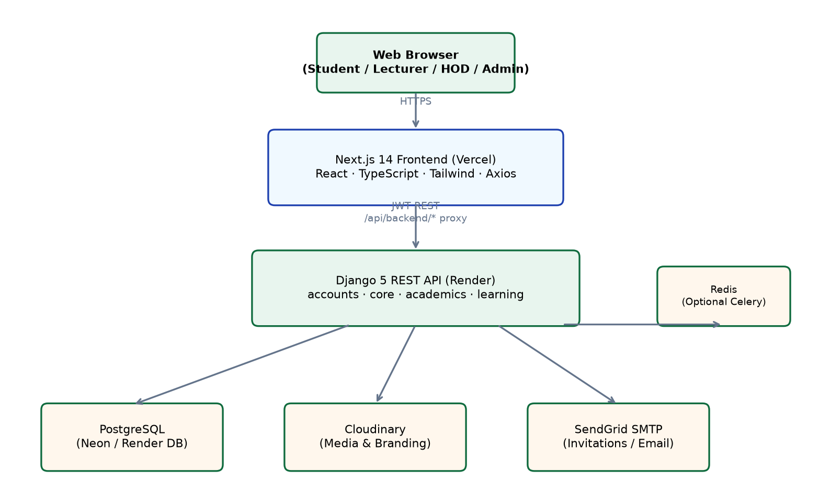
Figure 3.1: Overall system architecture of the IBBUL Unified Academic Operating System
Figure 3.1 presents the three-tier client–server architecture implemented in this project. The browser communicates with the Next.js frontend hosted on Vercel. API requests are routed through the same-origin proxy to the Django REST Framework backend on Render. The backend persists academic data in PostgreSQL, stores learning media on Cloudinary, and sends transactional email through SendGrid. Optional Redis supports Celery background tasks for large uploads and exports.
The architecture is illustrated in Figure 3.1. It comprises the browser client, Next.js frontend on Vercel, Django REST backend on Render, PostgreSQL database, Cloudinary media storage, and SendGrid email service. hosting, and Render hosting. This diagram is important because it explains how the major parts of the system communicate.

3.7 Use Case Diagram
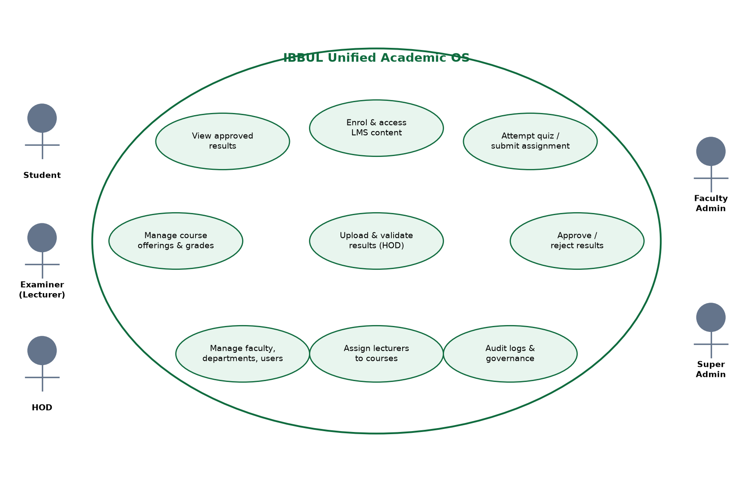
Figure 3.2: Use case diagram showing actors and major system functions
Figure 3.2 shows the primary actors and their interactions with the system. Students view approved results and participate in e-learning. Examiners manage offerings and grades. HODs upload and approve results. Faculty and Super Administrators manage structure and governance.
The use case diagram in Figure 3.2 shows interactions between five actor types and the major functional areas of the platform, including result management, e-learning, and governance.urer, and Student as actors. It is important because it presents the system functions from the user’s point of view.

3.8 Database Design
The database was designed using normalization principles to reduce duplication and maintain consistency. Related records are linked using foreign keys. Figure 3.3 presents the entity relationship diagram of the core tables implemented in PostgreSQL. Table 3.1 summarises the major tables and their purposes.
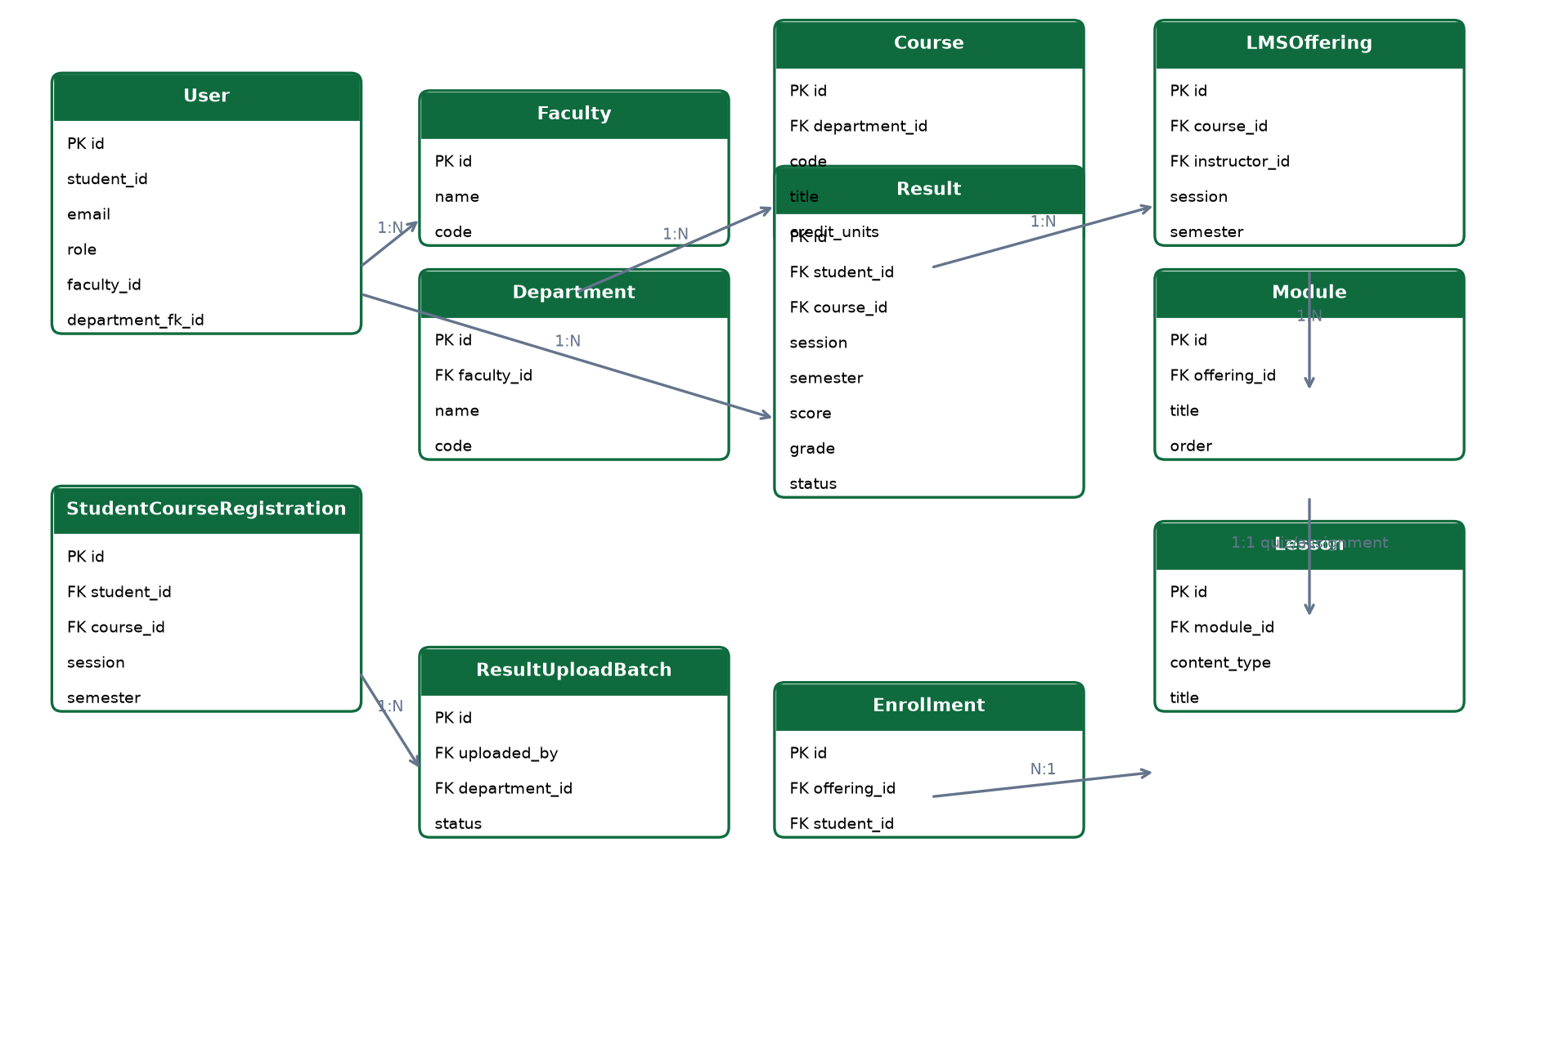
Figure 3.3: Entity Relationship Diagram (ERD) of core database entities
Figure 3.3 illustrates the relational structure of the database. The User entity links to Result, Enrollment, and upload records. Course connects results to LMSOfferings. Foreign keys enforce referential integrity across the four Django applications.
Table 3.1: Major Database Tables
Table | Purpose | Major Relationships
User | Stores students and staff | Linked to results, invitations, uploads, submissions
Faculty | Stores faculty records | Has many departments
Department | Stores department records | Belongs to faculty and has many courses
Course | Stores course details | Linked to results and learning offerings
LearningOffering | Stores course offering for learning | Linked to course and lecturer
Lesson | Stores lesson content | Belongs to learning offering
Assignment | Stores assignment information | Belongs to learning offering or lesson
Submission | Stores student submissions | Linked to assignment and student
Quiz | Stores quiz data | Linked to learning content
Invitation | Stores invitation records | Linked to invited user or role
Result | Stores scores and grades | Linked to student, course, session, semester
ResultSummary | Stores semester summary | Linked to student and session
Notification | Stores user notices | Linked to users
AuditLog | Stores important actions | Linked to user and activity
Role/Permission | Controls user access | Linked to users through role fields and permission checks

3.9 UML Diagrams
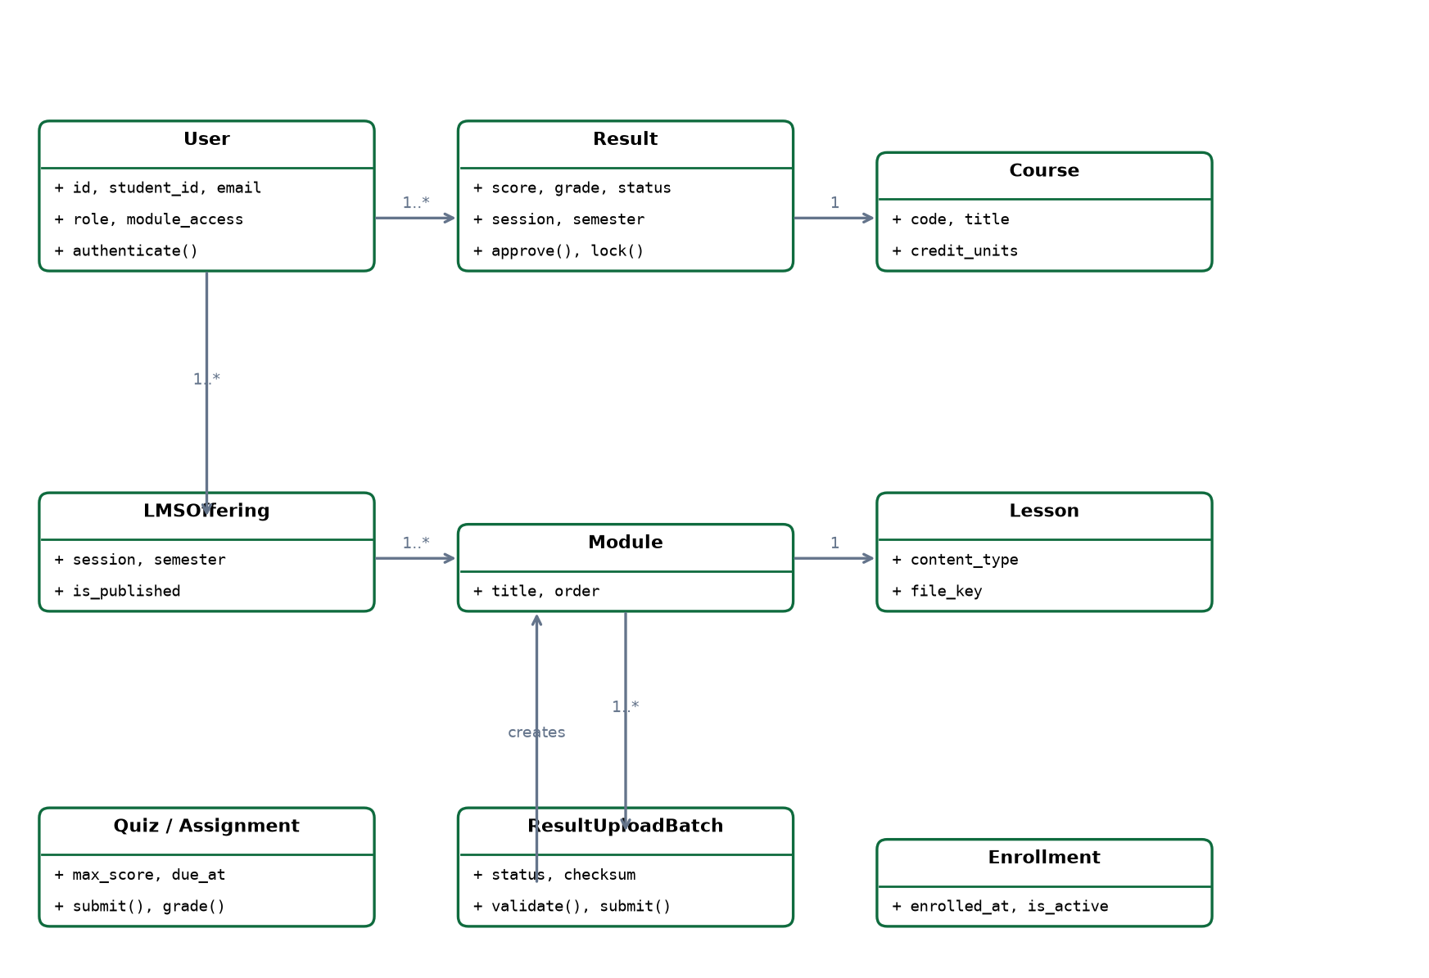
Figure 3.4: UML class diagram of major model classes and relationships
Figure 3.4 models the principal Django classes. User supports role-based authentication. Result, Course, and ResultUploadBatch implement the results module. LMSOffering, Module, Lesson, Quiz, Assignment, and Enrollment implement the learning module.
The UML class diagram in Figure 3.4 represents the principal Django model classes in the accounts, academics, and learning applications.
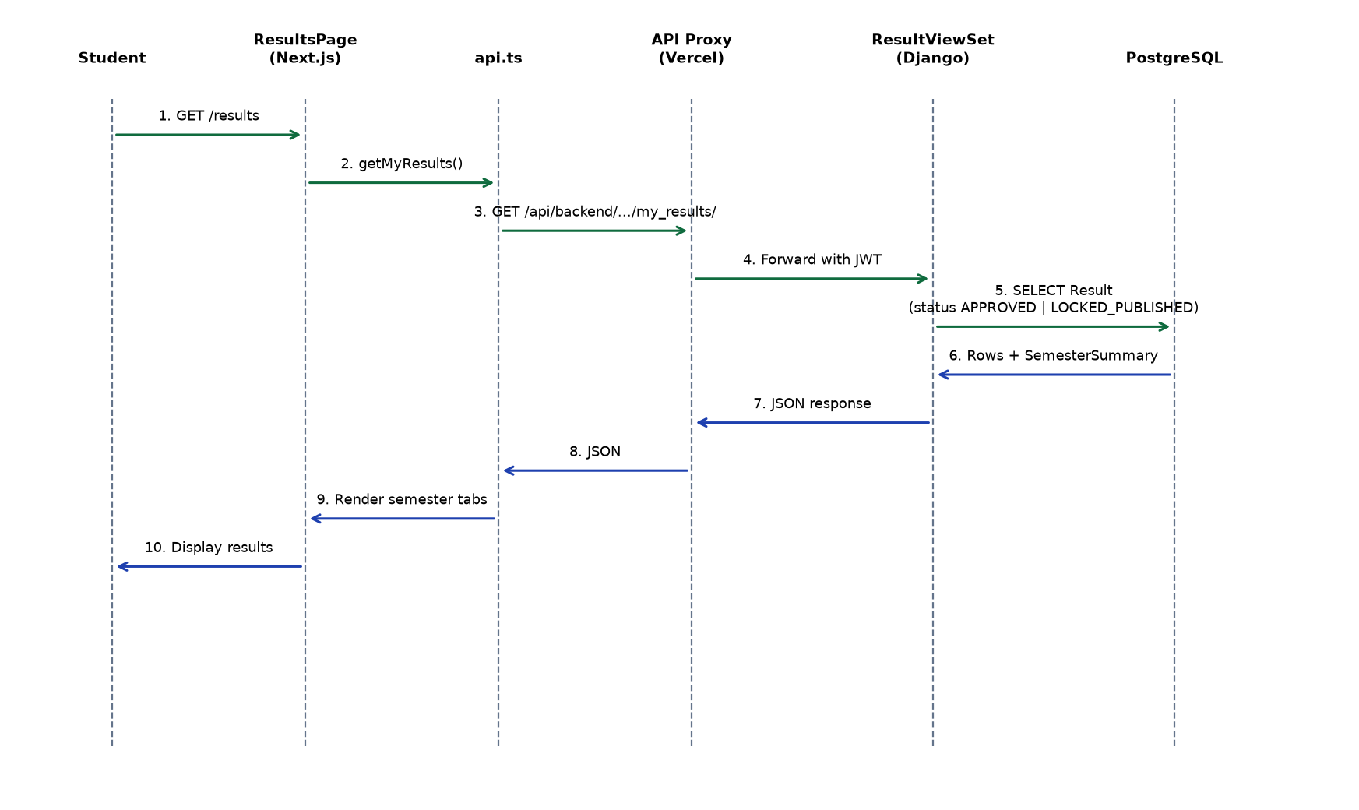
Figure 3.5: Sequence diagram for student result checking workflow
Figure 3.5 traces the student result checking process from the /results page through the API proxy to ResultViewSet.my_results. Only APPROVED or LOCKED_PUBLISHED results are returned to students.
Figure 3.5 presents the sequence of messages when a student checks results, from the Next.js results page to the PostgreSQL database.
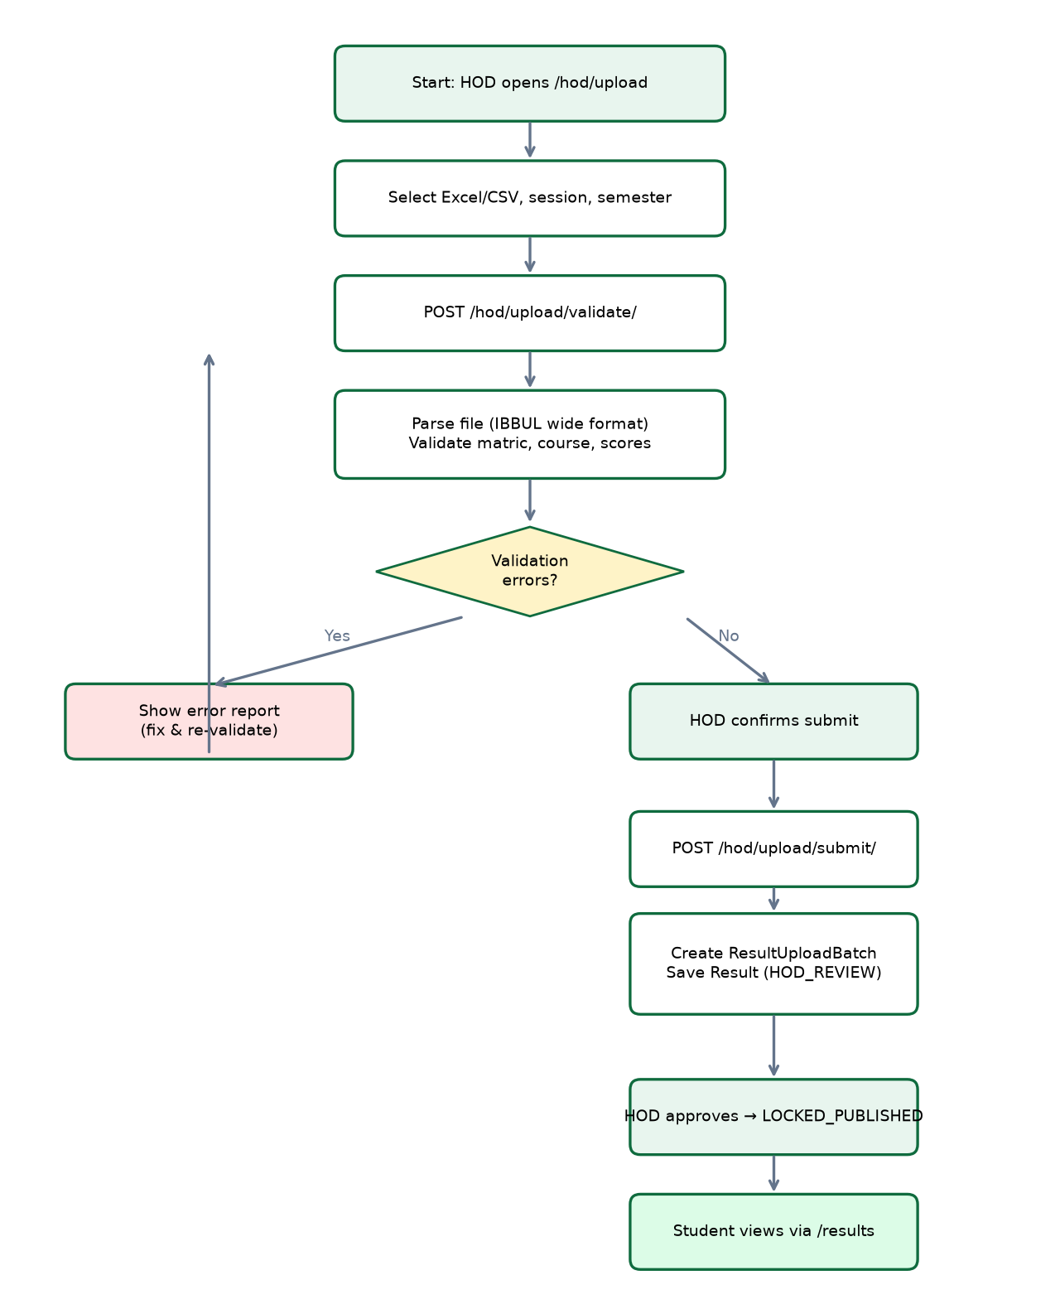
Figure 3.6: Activity diagram for HOD result upload, validation, and approval workflow
Figure 3.6 describes the HOD workflow: validate file, review errors, submit valid rows as HOD_REVIEW, approve to LOCKED_PUBLISHED, then students view results.
Figure 3.6 models the HOD result upload workflow, including validation, submission, review, and student publication stages.

3.10 Deployment Architecture
The frontend is deployed on Vercel, while the backend is deployed on Render. PostgreSQL is used as the production database through DATABASE_URL, and Cloudinary is used for media storage. Figure 3.7 illustrates the deployment tiers and communication paths between components.
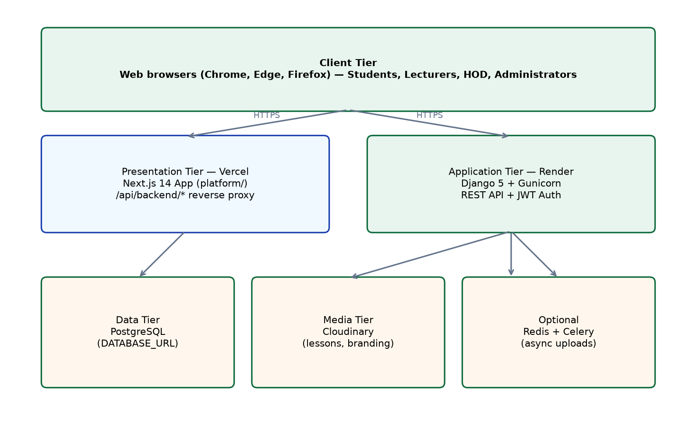
Figure 3.7: Deployment architecture on Vercel, Render, PostgreSQL, and Cloudinary
Figure 3.7 shows the production deployment configuration. The Next.js application is hosted on Vercel for global CDN delivery. The Django API runs on Render with Gunicorn. PostgreSQL is provided through DATABASE_URL (e.g., Neon). Cloudinary stores lesson videos, PDFs, and platform branding assets. Redis and Celery are optional for asynchronous batch processing.

Chapter Summary
This chapter discussed system analysis and design. It explained the methodology, existing system, proposed system, architecture (Figure 3.1), use cases (Figure 3.2), database design (Figure 3.3 and Table 3.1), UML diagrams (Figures 3.4–3.6), and deployment architecture (Figure 3.7). These design artefacts guided the implementation presented in Chapter Four.

CHAPTER FOUR

SYSTEM IMPLEMENTATION AND TESTING

4.1 Introduction
This chapter presents the implementation and testing of the system. It explains each major module, why it exists, how it works, and how it contributes to the completed academic platform.

4.2 Implementation Tools
Table 4.1: Implementation Tools
Component | Tool | Reason for Selection
Frontend | Next.js and React | They support reusable components, routing, and maintainable user interfaces.
Language | TypeScript | It helps detect errors during development through static typing.
Styling | Tailwind CSS | It supports consistent responsive design with utility classes.
Backend | Django REST Framework | It provides structured API development, serializers, authentication, and permissions.
Database | PostgreSQL | It is suitable for relational academic data and supports data integrity.
Authentication | JWT | It supports separated frontend and backend authentication.
Media Storage | Cloudinary | It stores and delivers media files used in learning modules.
Deployment | Vercel and Render | They support cloud hosting for frontend and backend components.

4.3 Authentication Module
The authentication module allows users to log in securely. When a user submits valid credentials, the backend returns a user object and JWT tokens. The access token is used for protected requests, while the refresh token supports continued access without forcing frequent login. This module is necessary because the system contains sensitive academic data.
[Insert Screenshot: Login Page]

4.4 User Management Module
The user management module allows authorized administrators to manage students and staff. It supports roles such as Student, Examiner, Department Administrator, Faculty Administrator, and Super Administrator. User management is connected to the department and faculty structure so that access can be scoped properly.
[Insert Screenshot: User Management Page]

4.5 Faculty and Department Management
Faculty and department management modules provide the academic structure of the system. A faculty can have several departments, and departments can have courses and users. These modules are important because result management and learning management depend on correct academic structure.
[Insert Screenshot: Faculty Management Page]
[Insert Screenshot: Department Management Page]

4.6 Course Management
The course management module stores course codes, titles, units, departments, and assigned users. It is used by both the result management and learning management modules. Course validation during result upload depends on the course records stored in the database.
[Insert Screenshot: Course Management Page]

4.7 Learning Management Module
The learning management module supports course offerings, lessons, assignments, quizzes, and media content. It exists to provide an organized academic learning environment for lecturers and students. Lecturers can create learning content, while students access available lessons through their portal.
[Insert Screenshot: Learning Dashboard]
[Insert Screenshot: Course Offering Page]

4.8 Lesson, Assignment and Quiz Implementation
Lessons are attached to learning offerings and may contain text or media resources. Assignments allow lecturers to give academic tasks to students. Quizzes support CBT-style assessments within the learning module. These features were included to make the learning module useful beyond simple file sharing.
[Insert Screenshot: Lesson Page]
[Insert Screenshot: Assignment Page]
[Insert Screenshot: Quiz Page]

4.9 Dashboard Implementation
Different users see different dashboards. The student dashboard focuses on learning access and academic information. The lecturer dashboard focuses on assigned courses and learning activities. The HOD dashboard focuses on departmental oversight and result upload. The faculty dashboard supports faculty-level monitoring, while the super administrator dashboard supports global management.
[Insert Screenshot: Student Dashboard]
[Insert Screenshot: Lecturer Dashboard]
[Insert Screenshot: HOD Dashboard]
[Insert Screenshot: Faculty Dashboard]
[Insert Screenshot: Super Admin Dashboard]

4.10 Result Upload, Validation and Submission
The result upload module allows HOD-level users to upload result files. During validation, the system reads the file, checks student matric numbers, validates course codes, checks score ranges, detects duplicates, and prepares a preview. The validation was optimized by loading students, courses, and existing results in bulk before row validation. This avoids repeated database queries inside loops.
During submission, valid results are saved and invalid rows are recorded for error reporting. The submission process was also optimized using bulk database operations. This is important because result sheets can contain many records, and slow row-by-row database operations can cause server timeouts.
[Insert Screenshot: HOD Upload Page]
[Insert Screenshot: HOD Upload Validation]
[Insert Screenshot: Result Submission Response]

4.11 Approval Workflow
The approval workflow allows uploaded results to pass through controlled review before final use. This is necessary because academic results should not be treated as ordinary data entry records. Approval helps maintain accountability and reduces the possibility of unauthorized result changes.
[Insert Screenshot: Approval Workflow Page]

4.12 Cloudinary Media Storage
Cloudinary was used for storing learning media files. This was selected because media files can become large and should not overload the backend application server. Cloudinary also makes it easier to deliver media resources to users through secure links.

4.13 Email Invitation System
The email invitation module supports controlled onboarding of users. Instead of allowing open public registration, administrators can invite users according to institutional roles. This is suitable for a university environment where students and staff should be created or invited through approved channels.
[Insert Screenshot: Invitation Page]

4.14 Backend APIs
The backend exposes REST API endpoints for login, users, faculties, departments, courses, results, learning content, invitations, and uploads. REST APIs were used because they allow the frontend and backend to communicate clearly through HTTP requests and JSON responses.

4.15 Deployment
The frontend was deployed on Vercel because it supports hosting for Next.js applications. The backend was deployed on Render because it supports Python web applications and environment-based configuration. PostgreSQL was used as the relational database, and Cloudinary was used for media storage. This deployment arrangement allows the application to be accessed through the internet during demonstration and testing.

4.16 Testing
Testing was carried out to confirm that the system works according to its requirements. The testing covered functional testing, integration testing, authentication testing, upload testing, validation testing, performance testing, and user acceptance testing.
Table 4.2: Functional Testing
Feature | Input | Expected Output | Actual Output | Status
Login | Valid username and password | User dashboard opens | Dashboard opened | Passed
Invalid login | Wrong credentials | Error message displayed | Error message displayed | Passed
Create department | Valid department details | Department saved | Department saved | Passed
Upload result file | Valid Excel file | Validation report generated | Validation report generated | Passed
Submit results | Validated file | Batch and results saved | Batch and results saved | Passed
Create lesson | Lesson title and content | Lesson saved | Lesson saved | Passed

Table 4.3: Authentication and Authorization Testing
Test | Expected Output | Actual Output | Status
Student accesses admin page | Access denied | Access denied | Passed
HOD uploads department result | Upload allowed | Upload allowed | Passed
Unauthenticated user accesses protected route | Redirect or error | Redirect or error | Passed
Expired token request | Token refresh or logout | Handled correctly | Passed

Table 4.4: Upload Validation Testing
Input | Expected Output | Actual Output | Status
Unknown matric number | Validation error | Validation error shown | Passed
Unknown course code | Validation error | Validation error shown | Passed
Score above 100 | Validation error | Validation error shown | Passed
Correct result sheet | Valid preview | Valid preview shown | Passed

4.17 Chapter Summary
This chapter explained the implementation of the system module by module. It also described testing activities and showed that the major features of the system worked as expected.

CHAPTER FIVE

SUMMARY, CONCLUSION AND RECOMMENDATIONS

5.1 Summary
This project presented the design and implementation of a Unified Academic Operating System for result management and e-learning. The system was developed as a web-based application using Next.js, React, TypeScript, Tailwind CSS, Django REST Framework, PostgreSQL, JWT authentication, Cloudinary, Vercel, and Render. It provides modules for authentication, user management, academic structure, course management, result upload, learning management, dashboard access, invitations, and deployment.

5.2 Achievements of the Project
- A working web-based academic platform was implemented.
- Result management and e-learning were integrated into one system.
- Role-based access control was implemented for academic users.
- Bulk result upload, validation, and submission were implemented.
- Learning modules for lessons, assignments, and quizzes were implemented.
- Cloudinary media storage was integrated.
- The system was deployed for remote access.
- Testing was carried out across major modules.

5.3 Challenges Encountered
Some challenges were encountered during the project. Result upload required support for spreadsheet data, validation, and performance improvement. Authentication required careful handling of tokens between the frontend and backend. Deployment required correct environment configuration. The team also had to coordinate different modules so that result management, learning management, and user access worked together.

5.4 Conclusion
The project achieved its aim by providing a unified academic platform for result management and e-learning. The implemented system shows that a university academic workflow can be supported through a secure web-based application. It also demonstrates how frontend development, backend development, database design, authentication, cloud storage, and deployment can be combined to solve a practical academic problem.

5.5 Recommendations
- The system should be tested with more departments and larger result files before wider adoption.
- A mobile application can be developed in future to improve access for students.
- More reporting and analytics features can be added for academic administrators.
- The CBT module can be expanded with stronger timing and monitoring features.
- Integration with official university student records can be considered in future.
- Regular backup and monitoring should be introduced for long-term use.

5.6 Contribution to Knowledge
The project contributes to knowledge by showing how result management and e-learning can be integrated into one role-based academic platform for a Nigerian university environment. It also demonstrates the use of modern web development tools, REST APIs, JWT authentication, relational database design, and cloud media storage in solving a practical academic management problem.

Chapter Summary
This chapter summarized the project, listed its achievements, discussed challenges, presented the conclusion, and gave recommendations for future work.

REFERENCES
Al-Fraihat, D., Joy, M., Masa’deh, R., & Sinclair, J. (2020). Evaluating e-learning systems success: An empirical study. Computers in Human Behavior, 102, 67–86.
Aljawarneh, S. A. (2020). Reviewing and exploring innovative ubiquitous learning tools in higher education. Journal of Computing in Higher Education, 32(1), 57–73.
Alotaibi, S. J., & Wald, M. (2014). Evaluation of Blackboard learning management system. International Journal of Advanced Computer Science and Applications, 5(4), 1–8.
Alshamrani, A., & Bahattab, A. (2015). A comparison between three SDLC models waterfall model, spiral model, and incremental/iterative model. International Journal of Computer Science Issues, 12(1), 106–111.
Bass, L., Clements, P., & Kazman, R. (2021). Software architecture in practice (4th ed.). Addison-Wesley.
Bourgeois, D. T., Smith, J. L., Wang, S., & Mortati, J. (2019). Information systems for business and beyond. Saylor Academy.
Chen, C. M., & Chen, Y. L. (2021). The influence of learning management systems on student engagement. Education and Information Technologies, 26, 2345–2365.
Connolly, T., & Begg, C. (2015). Database systems: A practical approach to design, implementation, and management (6th ed.). Pearson.
Coronel, C., & Morris, S. (2019). Database systems: Design, implementation, and management (13th ed.). Cengage Learning.
Django REST Framework. (2024). API guide. https://www.django-rest-framework.org/
Django Software Foundation. (2024). Django documentation. https://docs.djangoproject.com/
Elmasri, R., & Navathe, S. B. (2016). Fundamentals of database systems (7th ed.). Pearson.
Fielding, R. T. (2000). Architectural styles and the design of network-based software architectures (Doctoral dissertation, University of California, Irvine).
Fowler, M. (2018). Patterns of enterprise application architecture. Addison-Wesley.
Garcia-Molina, H., Ullman, J. D., & Widom, J. (2009). Database systems: The complete book (2nd ed.). Pearson.
Garrison, D. R. (2017). E-learning in the 21st century: A community of inquiry framework for research and practice (3rd ed.). Routledge.
Hassanzadeh, A., Kanaani, F., & Elahi, S. (2012). A model for measuring e-learning systems success in universities. Expert Systems with Applications, 39(12), 10959–10966.
IEEE Computer Society. (2014). Guide to the software engineering body of knowledge (SWEBOK Guide) (Version 3.0). IEEE.
International Organization for Standardization. (2022). ISO/IEC 27001:2022 information security management systems.
Kendall, K. E., & Kendall, J. E. (2019). Systems analysis and design (10th ed.). Pearson.
Kroenke, D. M., & Auer, D. J. (2016). Database processing: Fundamentals, design, and implementation (14th ed.). Pearson.
Laudon, K. C., & Laudon, J. P. (2020). Management information systems: Managing the digital firm (16th ed.). Pearson.
Larman, C. (2004). Applying UML and patterns: An introduction to object-oriented analysis and design and iterative development (3rd ed.). Prentice Hall.
Lethbridge, T. C., & Laganière, R. (2005). Object-oriented software engineering: Practical software development using UML and Java (2nd ed.). McGraw-Hill.
Moodle. (2024). Moodle documentation. https://docs.moodle.org/
Mozilla Developer Network. (2024). HTTP and web security documentation. https://developer.mozilla.org/
Nielsen, J. (1994). Usability engineering. Morgan Kaufmann.
OpenJS Foundation. (2024). React documentation. https://react.dev/
Oracle. (2023). MySQL and database design concepts. https://dev.mysql.com/doc/
PostgreSQL Global Development Group. (2024). PostgreSQL documentation. https://www.postgresql.org/docs/
Pressman, R. S., & Maxim, B. R. (2020). Software engineering: A practitioner’s approach (9th ed.). McGraw-Hill.
Ramakrishnan, R., & Gehrke, J. (2003). Database management systems (3rd ed.). McGraw-Hill.
Sandhu, R. S., Coyne, E. J., Feinstein, H. L., & Youman, C. E. (1996). Role-based access control models. IEEE Computer, 29(2), 38–47.
Schwaber, K., & Sutherland, J. (2020). The Scrum guide. https://scrumguides.org/
Silberschatz, A., Korth, H. F., & Sudarshan, S. (2020). Database system concepts (7th ed.). McGraw-Hill.
Sommerville, I. (2016). Software engineering (10th ed.). Pearson.
Stair, R., & Reynolds, G. (2018). Principles of information systems (13th ed.). Cengage Learning.
Tilkov, S., & Vinoski, S. (2010). Node.js: Using JavaScript to build high-performance network programs. IEEE Internet Computing, 14(6), 80–83.
Vercel. (2024). Next.js documentation. https://nextjs.org/docs/
Welling, L., & Thomson, L. (2017). PHP and MySQL web development (5th ed.). Addison-Wesley.
Wieringa, R. (2014). Design science methodology for information systems and software engineering. Springer.
Zhang, D., Zhao, J. L., Zhou, L., & Nunamaker, J. F. (2004). Can e-learning replace classroom learning? Communications of the ACM, 47(5), 75–79.
Cloudinary. (2024). Cloudinary documentation. https://cloudinary.com/documentation

APPENDIX A: SYSTEM SCREENSHOTS
[Insert Screenshot: Login Page]
[Insert Screenshot: Student Dashboard]
[Insert Screenshot: Lecturer Dashboard]
[Insert Screenshot: HOD Dashboard]
[Insert Screenshot: Faculty Dashboard]
[Insert Screenshot: Super Admin Dashboard]
[Insert Screenshot: Result Upload Page]
[Insert Screenshot: Learning Management Page]

APPENDIX B: SYSTEM DIAGRAMS
[See Chapter Three for system design diagrams.]
[See Chapter Three for system design diagrams.]
[See Chapter Three for system design diagrams.]
[See Chapter Three for system design diagrams.]
[See Chapter Three for system design diagrams.]
[See Chapter Three for system design diagrams.]

APPENDIX C: SAMPLE RESULT UPLOAD TEMPLATE
Table C.1: Sample Result Upload Template
S/N | MATRIC.NO | NAME | CSC 401 | CSC 402 | RCU | ECU | CP | GPA
1 | U22/FNS/CSC/0001 | Sample Student | 75 A | 62 B | 18 | 18 | 72 | 4.00
2 | U22/FNS/CSC/0002 | Sample Student | 58 C | 69 B | 18 | 18 | 65 | 3.61

APPENDIX D: USER MANUAL
The user manual should explain how users log in, navigate dashboards, upload results, validate results, submit results, create learning content, attempt quizzes, and access learning materials. Screenshots should be inserted for each step before final printing.

APPENDIX E: SELECTED API ENDPOINTS
Table E.1: Selected API Endpoints
Endpoint | Method | Purpose
/api/accounts/login/ | POST | Authenticate user and return tokens
/api/academics/hod/upload/validate/ | POST | Validate uploaded result file
/api/academics/hod/upload/submit/ | POST | Submit validated result file
/api/core/faculties/ | GET/POST | Manage faculties
/api/core/departments/ | GET/POST | Manage departments
/api/learning/offerings/ | GET/POST | Manage learning offerings

APPENDIX F: DATABASE TABLES
This appendix should contain exported database table descriptions or screenshots from the database design tool used for final presentation.

