|  |  |
| --- | --- |
|  | **FPT ACADEMY INTERNATIONAL**  **FPT – APTECH COMPUTER EDUCATION** |

**Centre Name: ACE-HCMC-2-FPT.**

**Address: 590 Cach Mang Thang 8, District 3, Ho Chi Minh City, Viet Nam.**

**SRC Travel Agencies**

|  |  |  |
| --- | --- | --- |
| **Supervisor:** | MR. HOANG DUC QUANG | |
| **Semester:** | 3 | |
| **Batch No:** | T1.1807.M0 | |
| **Group No:** | 4 | |
| **Order:** | **Full name** | **Roll No.** |
| 1. | NGUYEN HUU PHUC | Student1114449 |
| 2. | HA HOANG BAO NGUYEN | Student1121927 |
| 3. | NGUYEN BACH TUNG | Student1122724 |
| 4. | TRAN DUC TRUONG GIANG | Student1114461 |

October 2019

**Table of Contents:**

This is to certify that

Ms. Ha Hoang Bao Nguyen

Mr. Nguyen Huu Phuc

Mr. Nguyen Bach Tung

Mr. Tran Duc Truong Giang



have successfully designed and

developed 

Submitted by:

Date of Issue: ________

Authorized Signature: ___________



**REVIEW I 4**

**Acknowledgment 5**

**Problem Definition 6**

1. Introduction 6
2. Project Requirement 6
3. Project Designing 6
4. Functional Logic 7

**Task sheet review 1 8**

REVIEW I

**Acknowledgment**

We would like to acknowledge all those who have given support and help us make the project a success.

We wish to express our deep gratitude to all teachers who have been devoting their lives to teach us how to stand-alone and walk ahead.

We are grateful to our families who take care and encourage us even though we are successful or failed, also to our friends who are always care of us. They never leave us alone and always look forward to us when we are on any road of the life.

We are much thankful to the entire staff and chairpersons at the Head Office of Aptech Worldwide, Aptech – Vietnam, and FPT – Aptech Center who have been organizing and looking after our studying course.

There are no words to show our appreciation for teachers of FPT Aptech Centre who have been organizing and looking after us during our studying course to finish this project. Our special thanks Mr ??? who works day by day to teach and guide us, e-Project Team at the Head Office who instruct and help us.

Finally, we would like to offer many thanks to all our schoolfellows for their valuable suggestions.

We would like to thank sincerely!

**Problem Definition**

# Introduction

SRC Travel Agencies is a domestic privatized transportation company that runs the

vehicles all over the country. They have several branches at different locations of the

country, so that they can provide the transportation facilities between the places. They

want an online application to be developed, where the details of the bookings done and

the customer will be updated from time to time and one can track the details of the

available seats immediately.

# Customer Requirement Specification

SRC Travel Agencies ’s online service application provides details of the bookings done and the customer will be updated from time to time and one can track the details of the available seats immediately online for their customer. For their employees or administrator, the application will help to maintain the information like bus details, employees details, customer details, ticket details, counter details, etc,...

1. Functional Requirement Specification
   1. Administrator

* Login with username and password
* Manage employee details
  + Add new employee
  + Update employee
  + Change status of employee
  + Search
* Manage bus details
  + Add new bus
  + Update
  + Search
* Manage booking details
  + Add new booking
  + Update booking
  + Change status booking
  + Search
* Calculate the charges depend on bus type, customer’s age, distance
* Manage customer details
  + Add new customer
  + Update customer
  + Search
* Manage route details
  + Add route
  + Update route
* Manage block time details
  + Add block time
  + Update block time
* Manage group block time details
  + Add group block time
  + Update group block time
  1. Employee
* Login with username and password
* Change password
* Edit their information
* Search option by date time, starting place, destination place
* Manage booking details
  + Add new booking
  + Update booking
  + Change status booking
  + Search
* Print ticket
  1. Customer
* Login with username and password
* Change password
* Edit their information
* Track details of available seats from time to time
* Register customer account
* Search option by date time, starting place, destination place
* Make a booking

**Hardware / Software Requirements**

1. Server Requirement

* Hardware

|  |  |
| --- | --- |
| **Component** | **Requirement** |
| **CPU** | Processor type:  Pentium IV-compatible processor or faster  Processor speed:  Recommended: 2.0 GHz or faster |
| **OS** | Microsoft Windows Server 2012 with IIS |
| **Memory (RAM)** | RAM:  Minimum: 512 MB  Recommended: 2 GB or more |
| **Hard Drive** | Free space:  Minimum: 200 MB  Recommended: 50 GB or more  Maximum: Operating system maximum |

* Software

|  |  |
| --- | --- |
| **Component** | **Requirement** |
| **Microsoft .NET Framework** | Version 4.6 or higher |
| **RDBMS** | Microsoft SQL Server 2017 |

1. Client Requirement

* Hardware

|  |  |
| --- | --- |
| **Component** | **Requirement** |
| **CPU** | Processor type:  Pentium III-compatible processor or faster  Processor speed:  Recommended: 1.0 GHz or faster |
| **OS** | All OS (Window, Linux, Android, Mac OS …) |
| **Memory (RAM)** | RAM:  Minimum: 512 MB  Recommended: 1 GB or more  Maximum: Operating system maximum |
| **Hard Drive** | Free space:  Minimum: 10 MB |

* Software

|  |  |
| --- | --- |
| **Component** | **Requirement** |
| **Web Browser** | Chrome, Opera (up to date) |

# Task Sheet Review I

|  |  |  |  |  |  |
| --- | --- | --- | --- | --- | --- |
| Project Ref. No: 4 | Project Title:  Railway Reservation Manage System | Date of Preparation of Activity Plan | | | |
| No. | Task | Actual Start Date | Actual Days | Team Member Names | Status |
| 01 | Acknowledgment | Oct 26, 2019 | 2 | All Members | Completed |
| 02 | Problem Definition | All Members | Completed |
| 03 | Customer Requirement | All Members | Completed |
| 05 | Hardware/Software | All Members | Completed |
| 06 | Task sheet | All Members | Completed |

|  |  |  |
| --- | --- | --- |
|  | Prepare By: Group 4 | Approved By: Faculty |
| Date: Oct 21, 2019 | Team Leader  Nguyen Huu Phuc | Mr. Hoang Duc Quang |

REVIEW II

# Architecture & Design of the Project

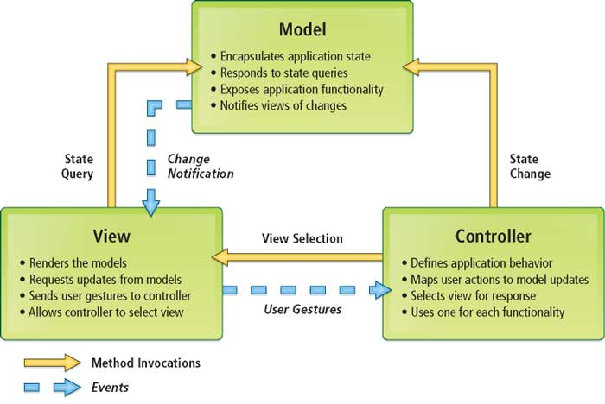

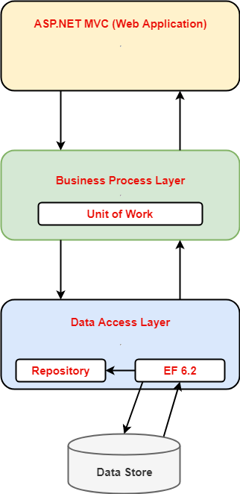

Architecture of the Project

1. Presentation Tier:

Is the tier in which the users interact with application. Presentation Tier contents Model, View, Controller used to receive a request and response to User.

Technology: ASP.NET MVC5, Razor, HTML, CSS, JavaScript, Ajax, JQUERY, Twitter Bootstrap

1. Business Logic Tier:

Is mainly working as the bridge between Data Tier and Presentation Tier. All the Data passes through the Business Tier before passing to the Presentation Tier.

Technology: ASP.NET

1. Data Access Tier:

Is basically the server which stores all the application’s data .Data tier contents Database Tables, Database Views and other means of storing Application Data .

Technology: SQL Server, LINQ

# Algorithms - Data Flowchart

Symbol generates:

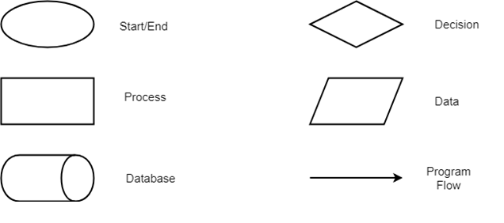

1. Booking function

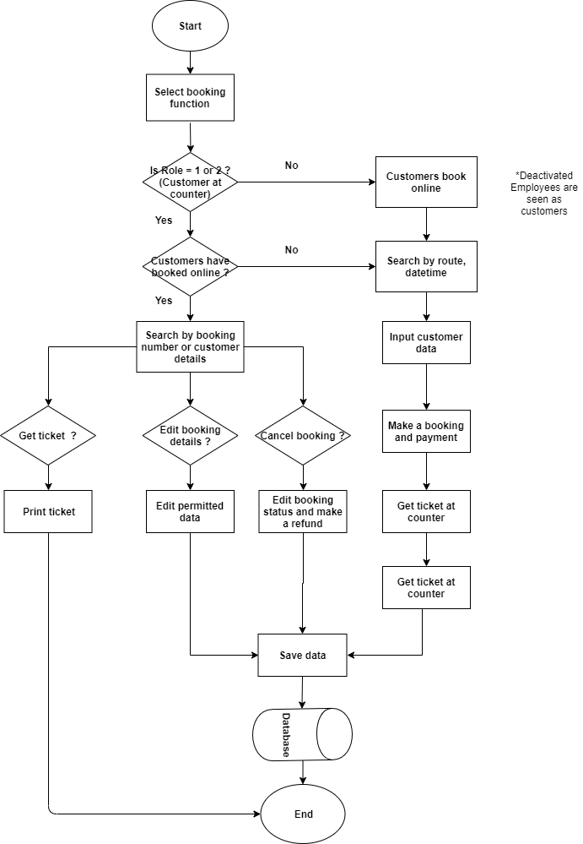

1. Insert employee function (Admin only)

## P:\Downloads\Flowchart (1) (1).png

1. Update employee function (Admin, employee only)

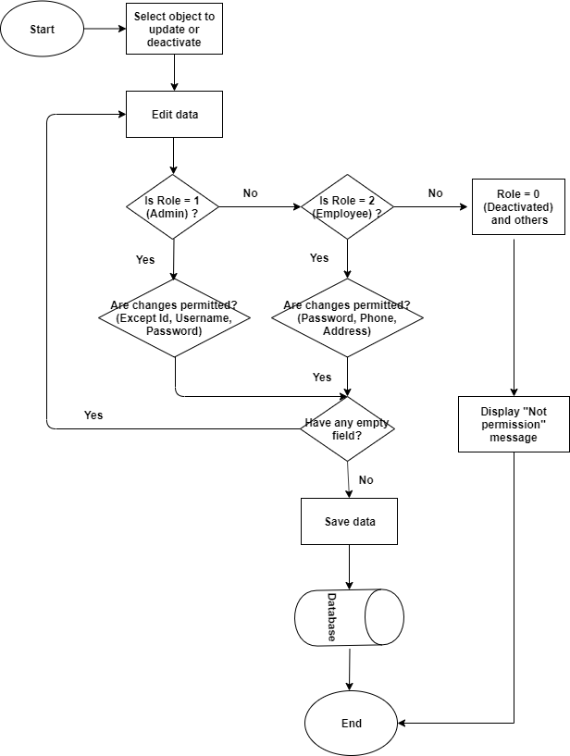

1. Insert account, customer details function

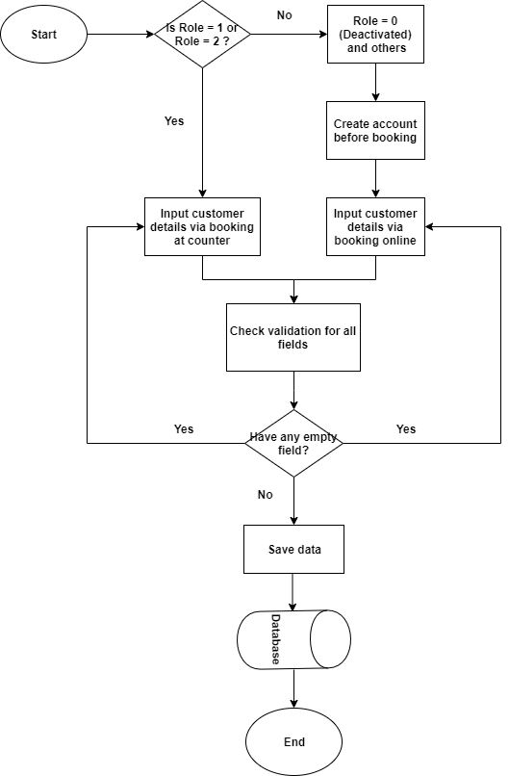

1. Update account, customer details function

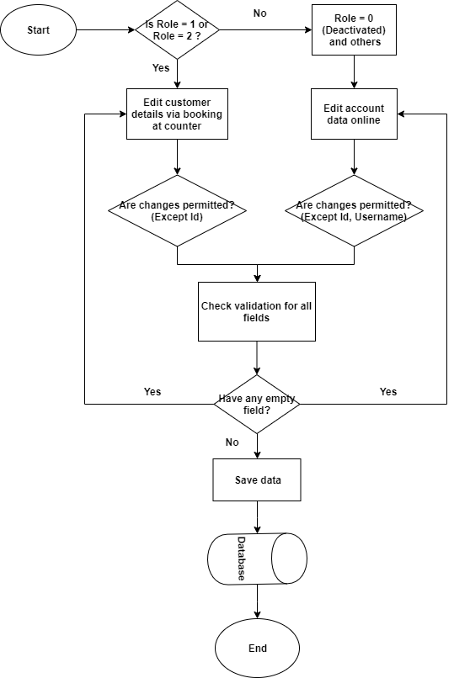

1. Auto generated route, route details function

## p:\Desktop\Flowchart (2).png p:\Desktop\Flowchart (2)1.png

1. Update route function

## P:\Downloads\Flowchart (2) (1).png

# Data Flow Diagram

**Define:** Data Flows Diagram (DFD) describes the information flow in the system. The next step of system analysis is to consider in detail the information necessary for the implementation for functions discussed above and the one necessary for the improvement of the functions. Modelling tool frequently used for this purpose is DFD. DFD will support 4 main activities:

* **Analysis**: DFD is used to determine requirement of users.
* **Design:** DFD is used to map out plan and illustrate solution to analysis and users while designing a new system.
* **Communication:** One of the strength of DFD is its simplicity and ease to understand to analysts and users.
* **Document:** DFD is used to provide special description of requirement and system design. DFD provide an overview of key functional components of the system but it does not provide any detail on these components. We have to use other tools like database dictionary, process specification to get an idea of which information will be exchanged and how.

**The main components of Context Diagram:**

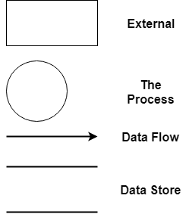

The external factors: External factors can be a person, a group of persons or an organization that are sources of information for the systems and are where system products are transferred to.

The process: Shows the common function of system

The data flow: Describe the movement of information from one part of the system to another.

The data store: The Data Store is used to model a collection of data packets at rest. A store is represented graphically by two parallel lines. The name of a Data Store that identifies the store is the plural of the name of the packets that are carried by flows into and out of the Data Store.

1. Data flow diagram

ADMIN

Client

Employees

1. Employee management

ADMIN

Manage Employees

1. Bus management

ADMIN

Bus Detail

1. Booking management

ADMIN

Booking Detail

1. Customer management

ADMIN

Customer

# Use Case Diagram

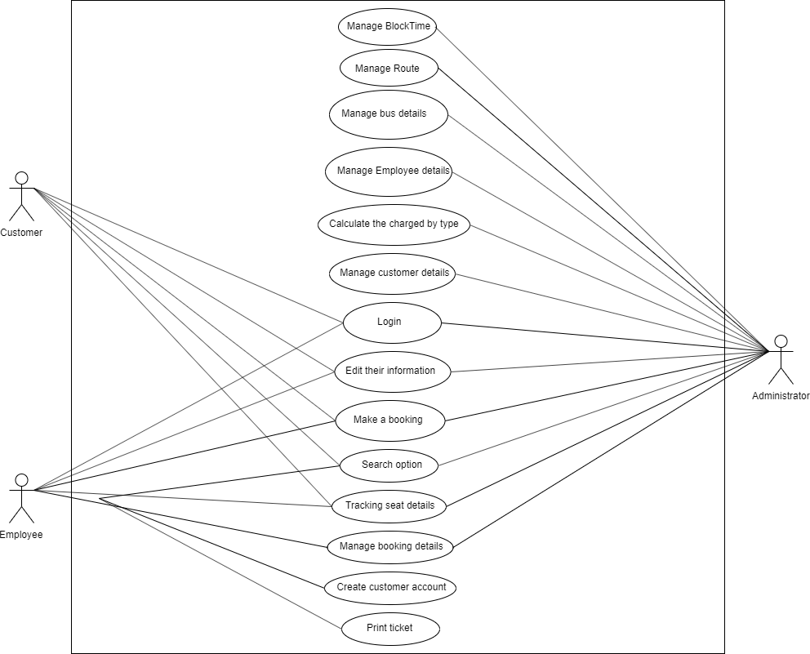

1. Administrator use case

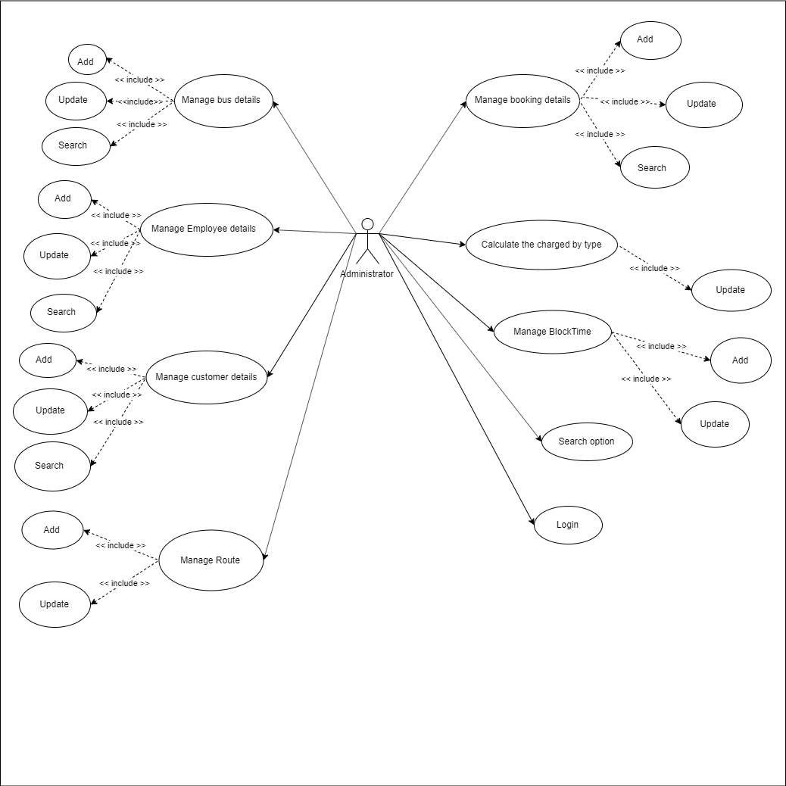

1. Staff use case

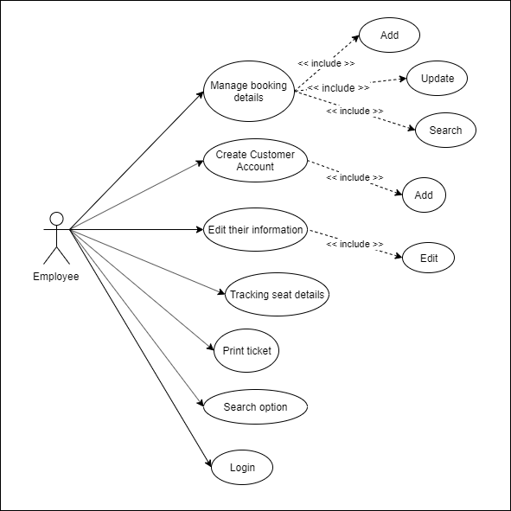

1. Customer use case

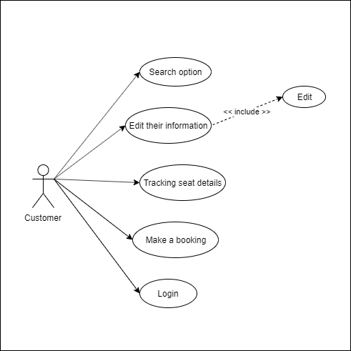

# Entity–Relationship Design

1. Entity–Relationship Diagram

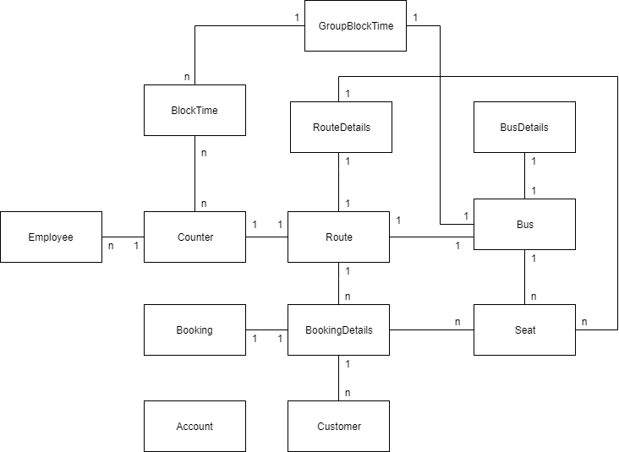

1. Entities and Properties
   1. **Employee Entity & Properties**

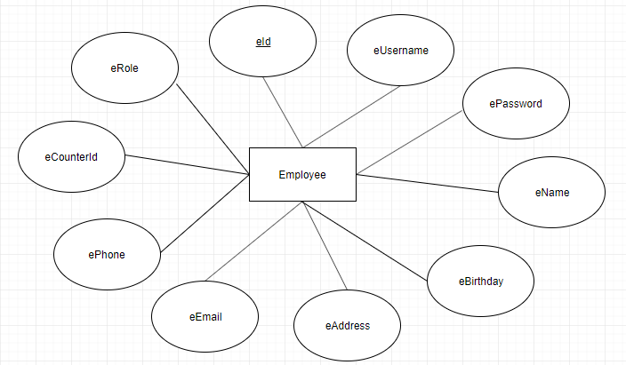

* 1. **Booking Entity & Properties**

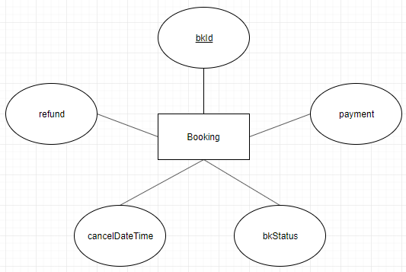

* 1. **BookingDetails Entity & Properties**

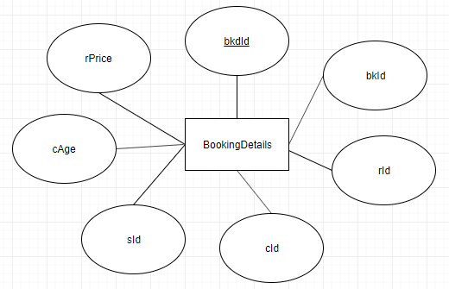

* 1. **Route Entity & Properties**

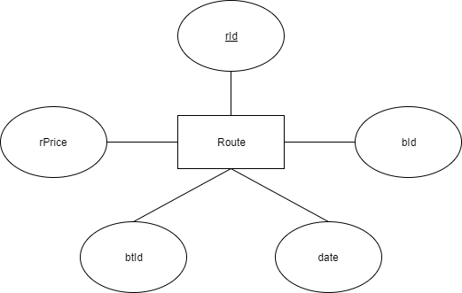

* 1. **RouteDetails Entity & Properties**

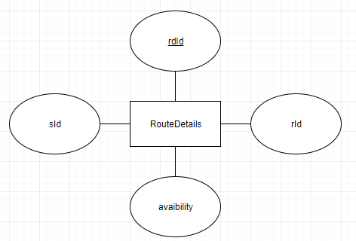

* 1. **BlockTime Entity & Properties**

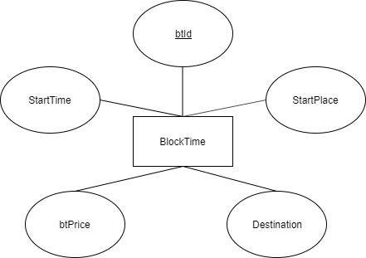

* 1. **GroupBlockTime Entity & Properties**

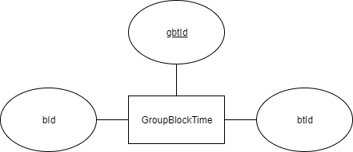

* 1. **Account Entity & Properties**

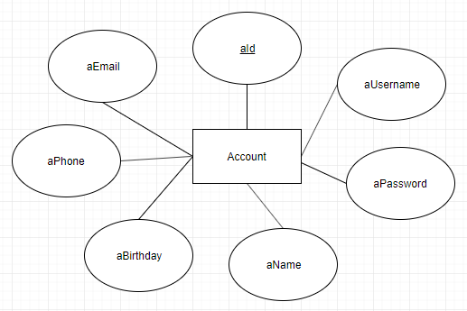

* 1. **Bus Entity & Properties**

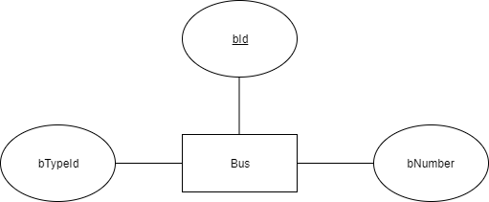

* 1. **BusDetails Entity & Properties**

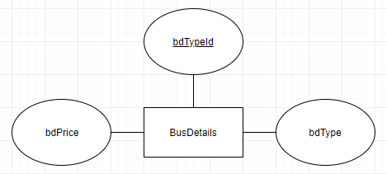

* 1. **Seat Entity & Properties**

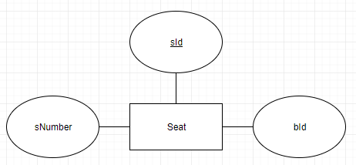

* 1. **Counter Entity & Properties**

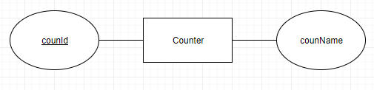

* 1. **Customer Entity & Properties**

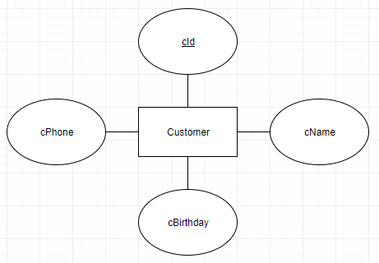

# Task sheet review 2

|  |  |  |  |  |  |
| --- | --- | --- | --- | --- | --- |
| Project Ref. No: 4 | Project Title:  Railway Reservation Manage System | Date of Preparation of Activity Plan | | | |
| No. | Task | Actual Start Date | Actual Days | Team Member Name | Status |
| 01 | Architecture & Design of the Project | Oct 31, 2019 | 6 | All Members | Completed |
| 02 | Algorithms - Data Flowchart | Ha Hoang Bao Nguyen,  Nguyen Huu Phuc | Completed |
| 03 | Data Flow Diagram | Tran Duc Truong Giang | Completed |
| 04 | Use Case Diagram | Nguyen Bach Tung | Completed |
| 05 | ERD | Nguyen Huu Phuc,  Ha Hoang Bao Nguyen | Completed |

|  |  |  |
| --- | --- | --- |
|  | Prepare By: Group 4 | Approved By: Faculty |
| Date: Oct 31, 2019 | Team Leader  Nguyen Huu Phuc | Mr. Hoang Duc Quang |

REVIEW III

# Database Design

1. Database Design Diagram

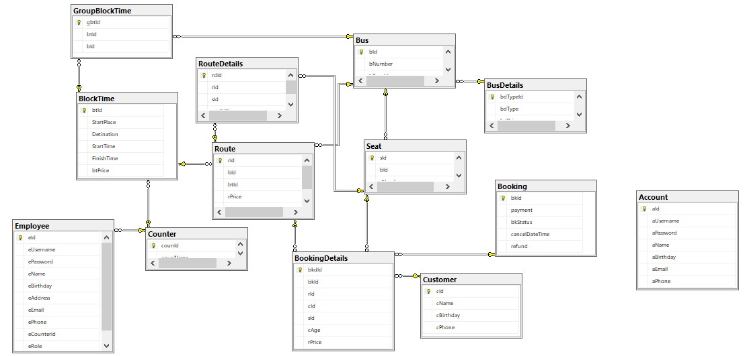

1. Database Structure

2.1 Table Account

|  |  |  |  |  |  |  |
| --- | --- | --- | --- | --- | --- | --- |
| Field Name | Data Type | Null | Default | Key | Field-Ref | Description |
| aId | int | No |  | PK |  |  |
| aUsername | nvarchar(30) | No |  |  |  |  |
| aPassword | nvarchar(30) | No |  |  |  |  |
| aName | nvarchar(30) | No |  |  |  |  |
| aBirthday | date | No |  |  |  |  |
| aEmail | nvarchar(30) | No |  |  |  |  |
| aPhone | nvarchar(10) | No |  |  |  |  |

2.2 Table BlockTime

|  |  |  |  |  |  |  |
| --- | --- | --- | --- | --- | --- | --- |
| Field Name | Data Type | Null | Default | Key | Field-Ref | Description |
| btId | int | No |  | PK |  |  |
| StartPlace | int | No |  |  |  |  |
| Detination | int | No |  |  |  |  |
| StartTime | time(7) | No |  |  |  |  |
| btPrice | float | No |  |  |  |  |

2.3 Table GroupBlockTime

|  |  |  |  |  |  |  |
| --- | --- | --- | --- | --- | --- | --- |
| Field Name | Data Type | Null | Default | Key | Field-Ref | Description |
| gbtId | int | No |  | PK |  |  |
| btId | int | No |  |  |  |  |
| bId | int | No |  |  |  |  |

2.4 Table Booking

|  |  |  |  |  |  |  |
| --- | --- | --- | --- | --- | --- | --- |
| Field Name | Data Type | Null | Default | Key | Field-Ref | Description |
| bkId | int | No |  | PK |  |  |
| payment | float | No |  |  |  |  |
| bkStatus | tinyint | No |  |  |  |  |
| cancelDateTime | datetime | Yes |  |  |  |  |
| refund | float | Yes |  |  |  |  |

2.5 Table BookingDetails

|  |  |  |  |  |  |  |
| --- | --- | --- | --- | --- | --- | --- |
| Field Name | Data Type | Null | Default | Key | Field-Ref | Description |
| bkdId | int | No |  | PK |  |  |
| bkId | int | No |  |  |  |  |
| rId | int | No |  |  |  |  |
| cId | int | No |  |  |  |  |
| sId | int | No |  |  |  |  |
| cAge | tinyint | No |  |  |  |  |
| rPrice | float | No |  |  |  |  |

2.6 Table Bus

|  |  |  |  |  |  |  |
| --- | --- | --- | --- | --- | --- | --- |
| Field Name | Data Type | Null | Default | Key | Field-Ref | Description |
| bId | int | No |  | PK |  |  |
| bNumber | nvarchar(10) | No |  |  |  |  |
| bTypeId | int | No |  |  |  |  |

2.7 Table BusDetails

|  |  |  |  |  |  |  |
| --- | --- | --- | --- | --- | --- | --- |
| Field Name | Data Type | Null | Default | Key | Field-Ref | Description |
| bdTypeId | int | No |  | PK |  |  |
| bdType | nvarchar(30) | No |  |  |  |  |
| bdPrice | float | No |  |  |  |  |

2.8 Table Counter

|  |  |  |  |  |  |  |
| --- | --- | --- | --- | --- | --- | --- |
| Field Name | Data Type | Null | Default | Key | Field-Ref | Description |
| counId | int | No |  | PK |  |  |
| counName | nvarchar(30) | No |  |  |  |  |

2.9 Table Customer

|  |  |  |  |  |  |  |
| --- | --- | --- | --- | --- | --- | --- |
| Field Name | Data Type | Null | Default | Key | Field-Ref | Description |
| cId | int | No |  | PK |  |  |
| cName | nvarchar(30) | No |  |  |  |  |
| cBirthday | date | No |  |  |  |  |
| cPhone | nvarchar(10) | No |  |  |  |  |

2.10 Table Seat

|  |  |  |  |  |  |  |
| --- | --- | --- | --- | --- | --- | --- |
| Field Name | Data Type | Null | Default | Key | Field-Ref | Description |
| sId | int | No |  | PK |  |  |
| bId | int | No |  |  |  |  |
| sNumber | nvarchar(50) |  |  |  |  |  |

2.11 Table Employee

|  |  |  |  |  |  |  |
| --- | --- | --- | --- | --- | --- | --- |
| Field Name | Data Type | Null | Default | Key | Field-Ref | Description |
| eId | nvarchar(30) | No |  | PK |  |  |
| eUsername | nvarchar(30) | No |  |  |  |  |
| ePassword | nvarchar(30) | No |  |  |  |  |
| eName | nvarchar(30) | No |  |  |  |  |
| eBirthday | datetime | No |  |  |  |  |
| eAddress | nvarchar(80) | No |  |  |  |  |
| eEmail | nvarchar(30) | No |  |  |  |  |
| ePhone | nvarchar(10) | No |  |  |  |  |
| eCounterId | int | No |  |  |  |  |
| eRole | tinyint | No |  |  |  |  |

2.12 Table Route

|  |  |  |  |  |  |  |
| --- | --- | --- | --- | --- | --- | --- |
| Field Name | Data Type | Null | Default | Key | Field-Ref | Description |
| rId | int | No |  | PK |  |  |
| bId | int | No |  |  |  |  |
| btId | int | No |  |  |  |  |
| rPrice | float | No |  |  |  |  |
| date | date | No |  |  |  |  |

2.13 Table RouteDetails

|  |  |  |  |  |  |  |
| --- | --- | --- | --- | --- | --- | --- |
| Field Name | Data Type | Null | Default | Key | Field-Ref | Description |
| rdId | int | No |  | PK |  |  |
| rId | int | No |  |  |  |  |
| sId | int | No |  |  |  |  |
| avaibility | tinyint | No |  |  |  |  |

1. GUI Design
2. Client site
3. Manager site

**Task Sheet Review III**

|  |  |  |  |  |  |
| --- | --- | --- | --- | --- | --- |
| Project Ref. No: 4 | Project Title:  Railway Reservation Manage System | Date of Preparation of Activity Plan | | | |
| No. | Task | Actual Start Date | Actual Days | Team Member Names | Status |
| 01 | Database Design, GUI Design (BlockTime, GroupBlockTime, Route) | Nov-13,2018 | 2 | Nguyen Huu Phuc | Completed |
| 02 | GUI Design Client site | Nguyen Bach Tung | Completed |
| 03 | GUI Design (Booking, Bus, Seat) | Tran Duc Truong Giang | Completed |
| 04 | GUI Design (Customer, Account, Employee) | Ha Hoang Bao Nguyen | Completed |

|  |  |  |
| --- | --- | --- |
|  | Prepare By: Group 4 | Approved By: Faculty |
| Date: Nov-13,2018 | Team Leader  Nguyen Huu Phuc | Mr. Hoang Duc Quang |