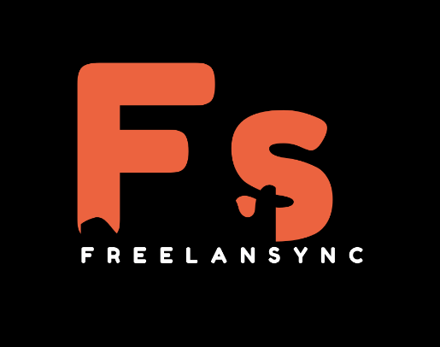 **FreelanSync**

Being a freelancer is a tough job. Especially in today's world -- where the competition is as high as ever. Looking for a client is a tough work; with some people ending up not finding any. There are various issues that needs to be addressed between a freelancer and a client such as, no guarantee of payment from the client side, lack of trust from both the sides etc. According to a survey conducted by Freelancer’s Union in 2019, 1 in every 5 freelancers had had experienced such a situation, where they were ghosted by their client after doing the job. The study also found that freelancers lose an average of $1000 annually, which roughly converts to 83,000 INR! In today's world, there is always a factor of trust between the client and the freelancer. Time crunch too, is yet another factor. These days no one wants to go through the hassle to find someone who is willing to work at an affordable cost.

So, we unveil upon you, **‘FreelanSync’** a platform where freelancers and the clients get rid of all their grievances and work in an environment where you are your own boss. Our aim is to resolve all the issues which the freelancers as well as the clients face— faced in the past. We want to give everyone an extraordinary opportunity and a platform to work, thrive and make people consider freelancing not as a side job, but as an actual full-time job. A platform where freelancers can create and earn without the headache of searching for clients. The clients too, can be reassured about the quality of freelancers they are hiring; knowing they are hiring the best from us. Our platform will have state of the art facilities to make connection seamless, end to end encrypted, hassle-free experience and ensure that no one is exploited in the process.

**Founding Members:**

1. Biprangshu Das (Chief Executive Officer)
2. Chayan Sarkar (Chief Technology Officer)
3. Payal Paul Choudhury (Chief Finance Officer)
4. Rituparna Deka (Public Relations Head)