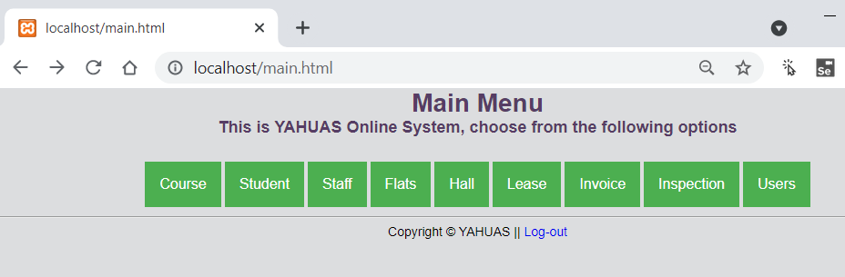

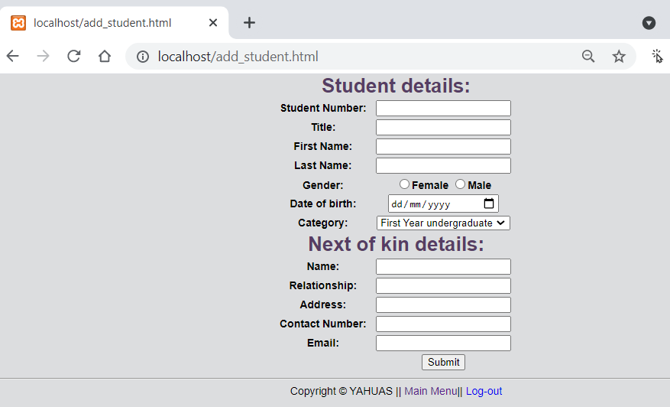

Check javascript

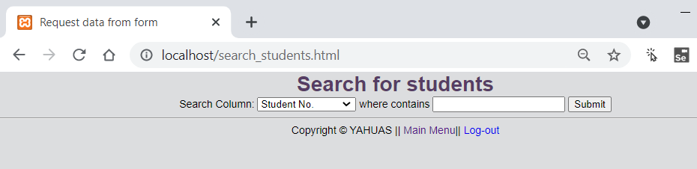

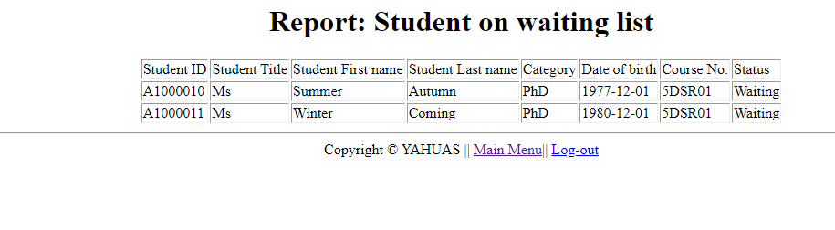

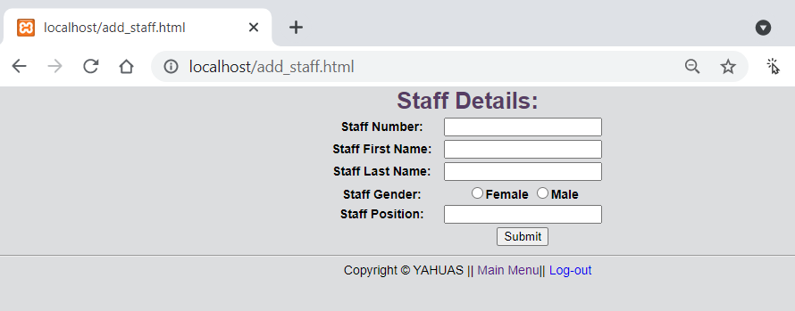

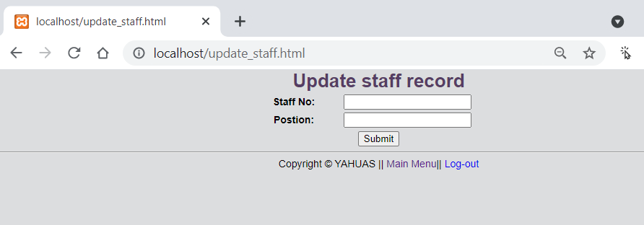

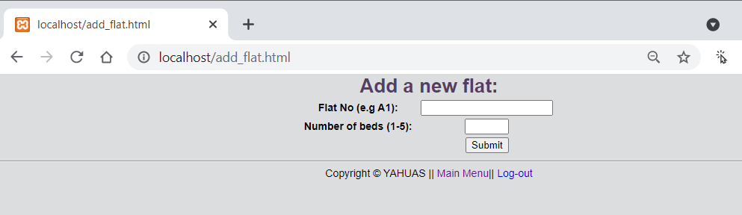

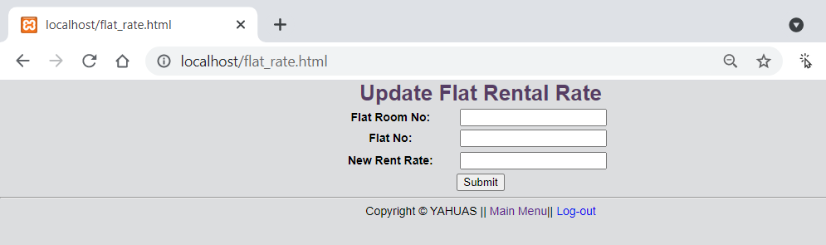

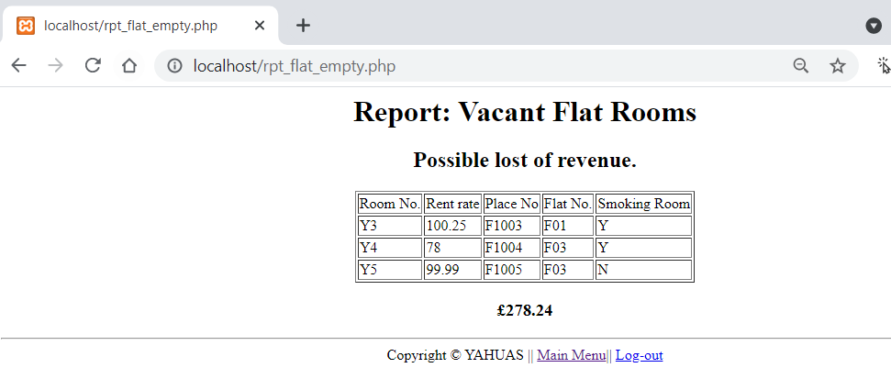

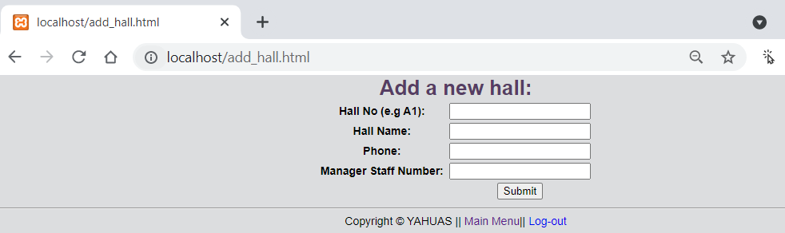

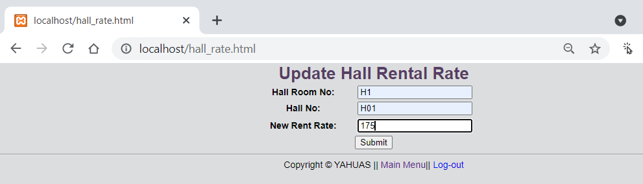

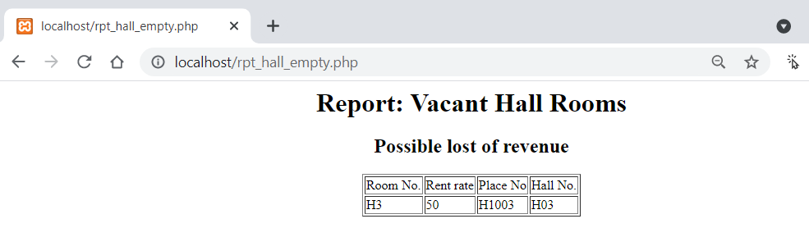

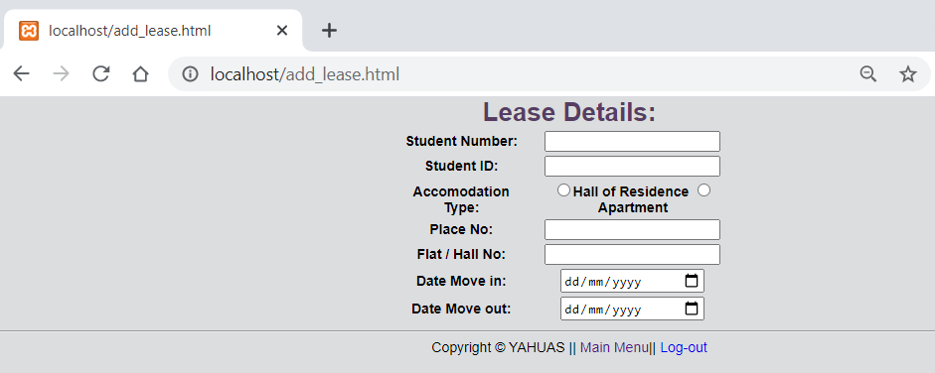

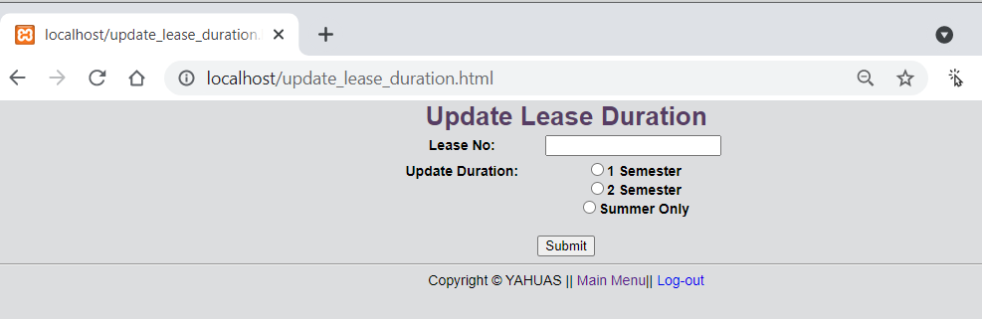

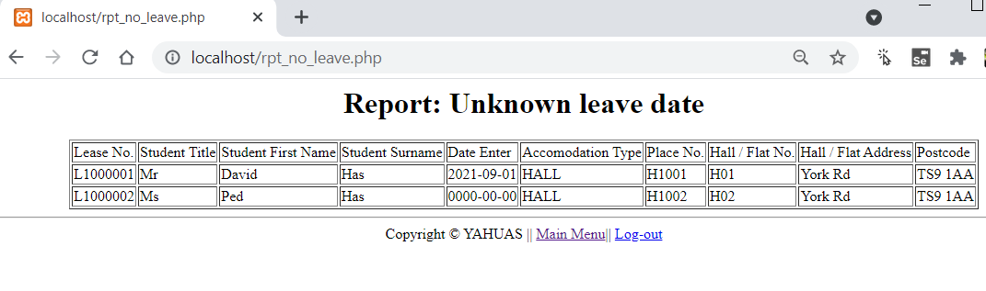

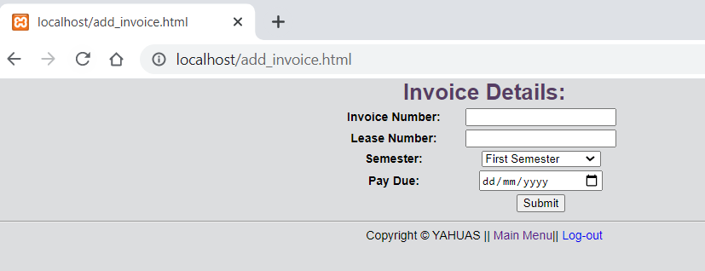

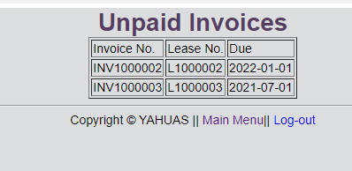

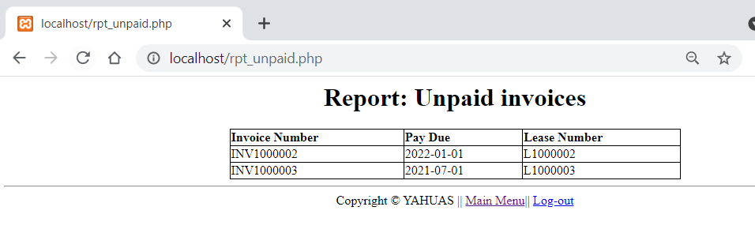

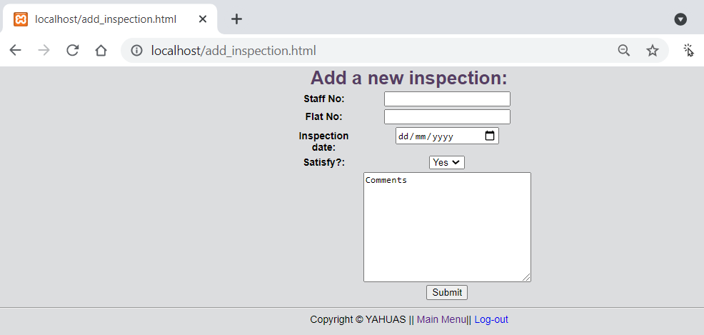

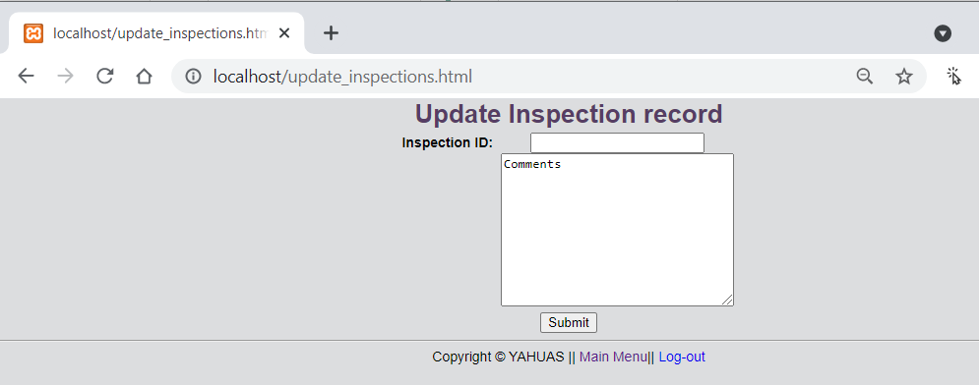

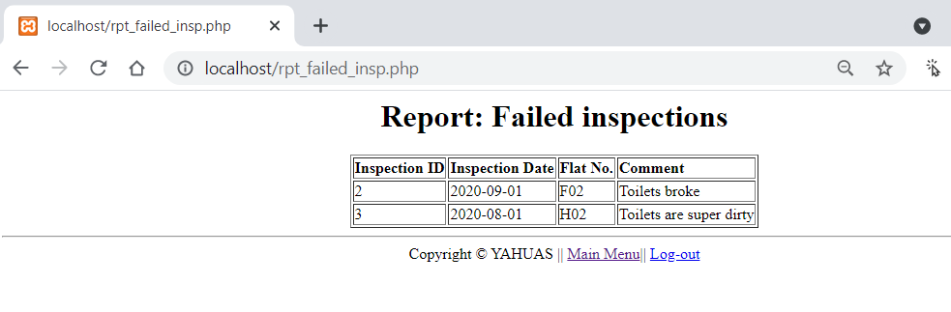

SQL

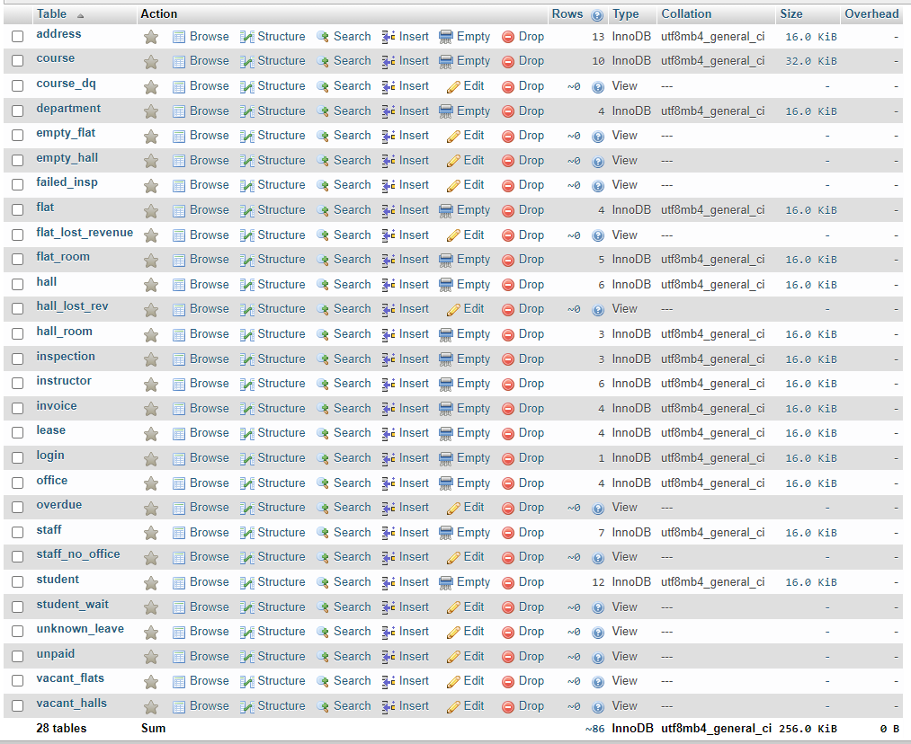

[INSERT](http://localhost/phpmyadmin/url.php?url=https://dev.mysql.com/doc/refman/8.0/en/insert.html) INTO `address` (`address_id`, `addr1`, `postcode`, `updated_by`, `updated`) [VALUES](http://localhost/phpmyadmin/url.php?url=https://dev.mysql.com/doc/refman/8.0/en/miscellaneous-functions.html#function_values) (NULL, 'Newcastle Rd', 'TS9 1AA', 'admin', '2021-07-26')

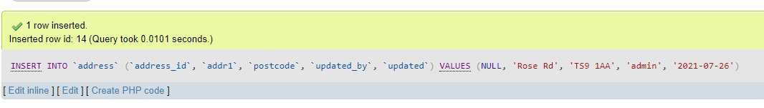

[INSERT](http://localhost/phpmyadmin/url.php?url=https://dev.mysql.com/doc/refman/8.0/en/insert.html) INTO `course` (`course_no`, `course_title`, `room_no`, `instructor_id`) [VALUES](http://localhost/phpmyadmin/url.php?url=https://dev.mysql.com/doc/refman/8.0/en/miscellaneous-functions.html#function_values) ('9DSR02', 'Advanced Programming II', 'XX0', NULL)

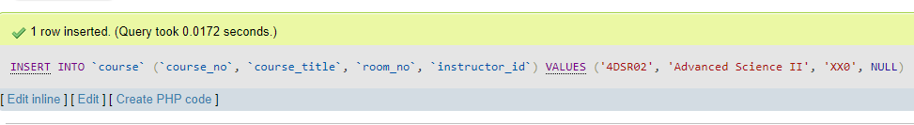

[INSERT](http://localhost/phpmyadmin/url.php?url=https://dev.mysql.com/doc/refman/8.0/en/insert.html) INTO `department` (`dept_id`, `department`, `office_id`, `updated`, `updated_by`) [VALUES](http://localhost/phpmyadmin/url.php?url=https://dev.mysql.com/doc/refman/8.0/en/miscellaneous-functions.html#function_values) (NULL, 'Science', '2', CURRENT_DATE, 'admin')

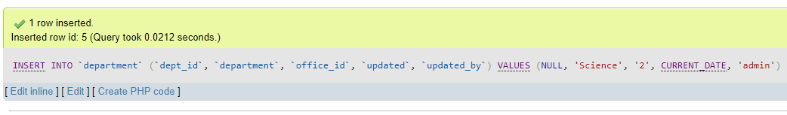

[INSERT](http://localhost/phpmyadmin/url.php?url=https://dev.mysql.com/doc/refman/8.0/en/insert.html) INTO `flat` (`flat_no`, `address_id`, `postcode`, `num_of_bed`) [VALUES](http://localhost/phpmyadmin/url.php?url=https://dev.mysql.com/doc/refman/8.0/en/miscellaneous-functions.html#function_values) ('F05', '13', 'LA4 7AA', '4')

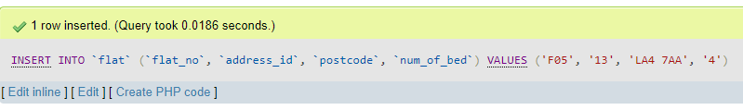

[INSERT](http://localhost/phpmyadmin/url.php?url=https://dev.mysql.com/doc/refman/8.0/en/insert.html) INTO `flat_room` (`room_no`, `month_rent_rate`, `place_no`, `smoking_room_yn`, `flat_no`) [VALUES](http://localhost/phpmyadmin/url.php?url=https://dev.mysql.com/doc/refman/8.0/en/miscellaneous-functions.html#function_values) ('A1', '99.99', 'F1005', 'N', 'F01')

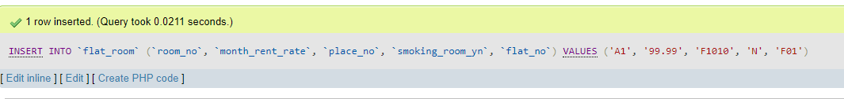

[INSERT](http://localhost/phpmyadmin/url.php?url=https://dev.mysql.com/doc/refman/8.0/en/insert.html) INTO `hall` (`hall_name`, `address_id`, `telno`, `postcode`, `hall_no`, `manager_no`) [VALUES](http://localhost/phpmyadmin/url.php?url=https://dev.mysql.com/doc/refman/8.0/en/miscellaneous-functions.html#function_values) ('Northallerton Hall', '12', '', 'TS11 7AA', 'H05', 'AA12')

[INSERT](http://localhost/phpmyadmin/url.php?url=https://dev.mysql.com/doc/refman/8.0/en/insert.html) INTO `hall_room` (`room_no`, `monthly_rent_rate`, `place_no`, `hall_no`, `smoking_room_yn`) [VALUES](http://localhost/phpmyadmin/url.php?url=https://dev.mysql.com/doc/refman/8.0/en/miscellaneous-functions.html#function_values) ('H3', '50', 'H1003', 'H03', 'N')

[INSERT](http://localhost/phpmyadmin/url.php?url=https://dev.mysql.com/doc/refman/8.0/en/insert.html) INTO `inspection` (`inspect_date`, `satisfy_yn`, `comment`, `inspection_id`, `staff_no`, `flat_no`) [VALUES](http://localhost/phpmyadmin/url.php?url=https://dev.mysql.com/doc/refman/8.0/en/miscellaneous-functions.html#function_values) ('2020-08-01', 'N', 'Toilets are super dirty', NULL, 'AA12', 'H02')

[INSERT](http://localhost/phpmyadmin/url.php?url=https://dev.mysql.com/doc/refman/8.0/en/insert.html) INTO `instructor` (`instructor_id`, `instructor_fname`, `instructor_sname`, `dept_id`, `updated`, `updated_by`) [VALUES](http://localhost/phpmyadmin/url.php?url=https://dev.mysql.com/doc/refman/8.0/en/miscellaneous-functions.html#function_values) (NULL, 'Jane', 'Smith', '4', '2020-10-01', 'admin')

[INSERT](http://localhost/phpmyadmin/url.php?url=https://dev.mysql.com/doc/refman/8.0/en/insert.html) INTO `invoice` (`invoice_no`, `pay_due`, `paid_date`, `payment_method`, `lease_no`) [VALUES](http://localhost/phpmyadmin/url.php?url=https://dev.mysql.com/doc/refman/8.0/en/miscellaneous-functions.html#function_values) ('INV1000004', '2021-06-01', '2021-07-26', '', 'L1000004')

[INSERT](http://localhost/phpmyadmin/url.php?url=https://dev.mysql.com/doc/refman/8.0/en/insert.html) INTO `lease` (`duration`, `student_id`, `accom_type`, `date_enter`, `date_leave`, `lease_no`, `place_no`) [VALUES](http://localhost/phpmyadmin/url.php?url=https://dev.mysql.com/doc/refman/8.0/en/miscellaneous-functions.html#function_values) ('S', 'A1000004', 'FLAT', '2021-04-01', '2021-10-31', 'L1000004', 'F1002')

[INSERT](http://localhost/phpmyadmin/url.php?url=https://dev.mysql.com/doc/refman/8.0/en/insert.html) INTO `login` (`username`, `password`, `email`) [VALUES](http://localhost/phpmyadmin/url.php?url=https://dev.mysql.com/doc/refman/8.0/en/miscellaneous-functions.html#function_values) ('Thomas', 'thomas', 'thomas@bat.com')

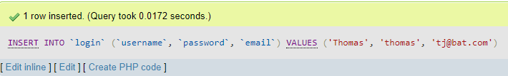

[INSERT](http://localhost/phpmyadmin/url.php?url=https://dev.mysql.com/doc/refman/8.0/en/insert.html) INTO `office` (`office_id`, `office_title`, `address`, `postcode`, `telno`) [VALUES](http://localhost/phpmyadmin/url.php?url=https://dev.mysql.com/doc/refman/8.0/en/miscellaneous-functions.html#function_values) ('4', 'Humber Campus', 'Humber road', 'HU1 1AA', '01789 99999')

[INSERT](http://localhost/phpmyadmin/url.php?url=https://dev.mysql.com/doc/refman/8.0/en/insert.html) INTO `staff` (`staff_fname`, `staff_sname`, `staff_gender`, `title`, `staff_no`, `office_id`) [VALUES](http://localhost/phpmyadmin/url.php?url=https://dev.mysql.com/doc/refman/8.0/en/miscellaneous-functions.html#function_values) ('Dr No', 'Pink', 'F', 'Admin', 'AA17', NULL)

[INSERT](http://localhost/phpmyadmin/url.php?url=https://dev.mysql.com/doc/refman/8.0/en/insert.html) INTO `student` (`student_id`, `stu_title`, `stu_fname`, `stu_sname`, `category`, `dob`, `next_of_kin_name`, `next_of_kin_rel`, `next_of_kin_addr`, `next_of_kin_telno`, `next_of_kin_email`, `course_no`, `address_id`, `updated`, `updated_by`, `status`, `stu_gender`) [VALUES](http://localhost/phpmyadmin/url.php?url=https://dev.mysql.com/doc/refman/8.0/en/miscellaneous-functions.html#function_values) ('A1000012', 'Mr', 'Andrew', 'Smith', 'first-year undergraduate', NULL, 'Bernie Smith', 'Spouse', 'Bernie Smith', '07888888', 'spouse@nat.com', NULL, NULL, '2021-07-26', 'admin', 'Placed', '')

**Updates**

[UPDATE](http://localhost/phpmyadmin/url.php?url=https://dev.mysql.com/doc/refman/8.0/en/update.html) `address` [SET](http://localhost/phpmyadmin/url.php?url=https://dev.mysql.com/doc/refman/8.0/en/set.html) `addr1` = 'Newcastle Rd.' WHERE `address`.`address_id` = 13

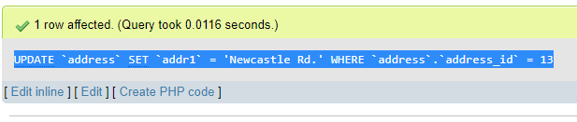

[UPDATE](http://localhost/phpmyadmin/url.php?url=https://dev.mysql.com/doc/refman/8.0/en/update.html) `hall_room` [SET](http://localhost/phpmyadmin/url.php?url=https://dev.mysql.com/doc/refman/8.0/en/set.html) `monthly_rent_rate` = '95' WHERE `hall_room`.`place_no` = 'H1003'

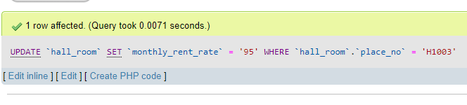

[UPDATE](http://localhost/phpmyadmin/url.php?url=https://dev.mysql.com/doc/refman/8.0/en/update.html) `inspection` [SET](http://localhost/phpmyadmin/url.php?url=https://dev.mysql.com/doc/refman/8.0/en/set.html) `comment` = 'Toilets are very dirty' WHERE `inspection`.`inspection_id` = 3

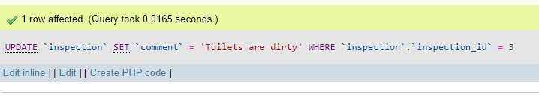

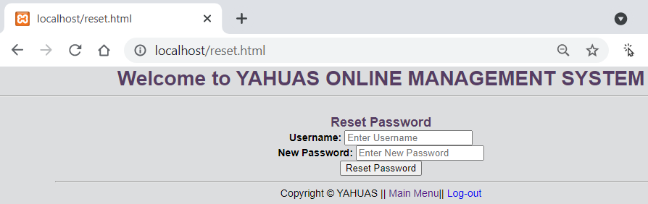

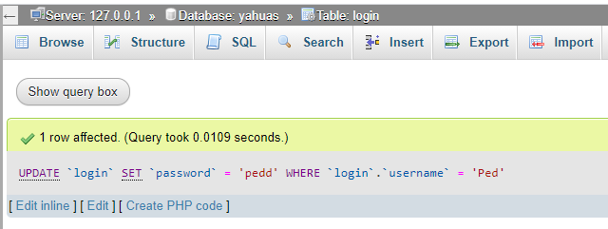



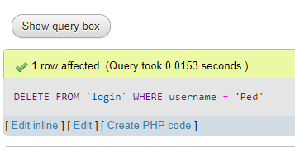

[INSERT](http://localhost/phpmyadmin/url.php?url=https://dev.mysql.com/doc/refman/8.0/en/insert.html) INTO `course` (`course_no`, `course_title`, `room_no`, `instructor_id`) [VALUES](http://localhost/phpmyadmin/url.php?url=https://dev.mysql.com/doc/refman/8.0/en/miscellaneous-functions.html#function_values) ('7DSR02', 'Advanced Programming VI', 'XZ0', '6')

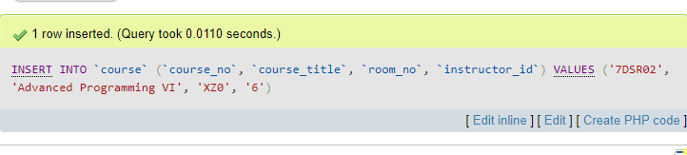

Schema

TO-DO – document about audit record for audit record

Student table

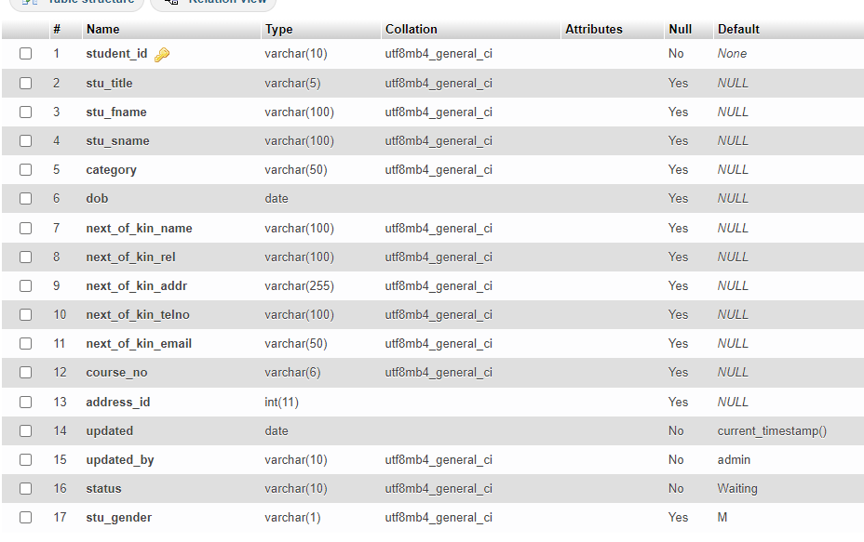

Address

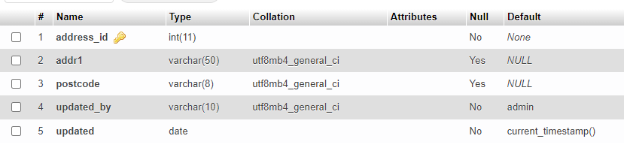

Course

