ADS 2 Assignment 1
“Convolutional Autoencoder for Noise Reduction with Keras”
Lee Ling Jun, PSB academy

INTRODUCTION

Background and Objective
This report focuses on the development and evaluation of a convolutional autoencoder using TensorFlow and Keras to perform image denoising on the CIFAR-10 dataset. The primary objective of this work is to design a deep learning pipeline that maps noisy images to their clean counterparts, demonstrating both theoretical understanding and practical implementation of GPU-accelerated learning workflows.

Data Processing and Pipeline

Dataset and Preprocessing
The dataset used for this project is CIFAR-10, a widely used benchmark in computer vision consisting of 60,000 32x32 color images across 10 classes. For the purposes of denoising, only the image data is used—class labels are ignored. The dataset is split into 50,000 training images and 10,000 validation images. All images are converted to floating-point format and normalized to the [0, 1] range to ensure compatibility with the neural network’s learning requirements. This normalization step is crucial for stable and efficient training, as it allows the network to process pixel values on a consistent scale.

Noise Injection Strategy
To simulate a realistic denoising task, Gaussian noise is added to both the training and validation datasets. A noise factor of 0.05 is applied by adding normally distributed random values to the original image pixel values, followed by clipping to ensure that the noisy images remain within the valid [0, 1] pixel range.

Use of GPU for Acceleration
Training deep neural networks is computationally intensive, particularly with image data. This project leverages TensorFlow’s GPU acceleration capabilities to significantly reduce training time and improve model responsiveness. TensorFlow automatically utilizes available GPU hardware via CUDA and cuDNN, enabling the convolutional operations in the autoencoder to be performed in parallel. The ability to scale processing across GPU hardware not only speeds up model convergence but also makes experimentation with larger models and datasets feasible within reasonable time constraints.

Model Architecture and Design

Encoder Architecture
The encoder of the convolutional autoencoder is designed to progressively reduce the spatial dimensions of the input image while increasing the depth of feature maps. It consists of three convolutional layers. The first layer applies 32 filters with a 3×3 kernel and uses ReLU activation, followed by batch normalization to stabilize training. The second convolutional layer also uses 32 filters and applies a stride of 2 to downsample the input to 16×16. A third convolutional layer with 32 filters further processes the features. This configuration allows the encoder to learn abstract representations of the noisy input while retaining essential spatial and structural information.

Decoder Architecture
The decoder mirrors the encoder structure but performs upsampling instead of downsampling. It begins with a convolutional layer with 32 filters followed by batch normalization and a ReLU activation. This is followed by an upsampling layer that restores the spatial dimensions back to 32×32. A second convolutional layer with 32 filters continues the reconstruction, and the final layer outputs a 32×32×3 image using a sigmoid activation to ensure the pixel values remain in the [0, 1] range. The decoder’s role is to reconstruct a clean image from the latent representation learned by the encoder.

Design Rationale and TensorFlow Use
The architecture design strikes a balance between model complexity and performance, using relatively shallow layers to keep training efficient while still capturing meaningful features. Convolutional layers are chosen over dense layers due to their spatial locality and parameter efficiency, which is especially beneficial in image-based tasks. TensorFlow and Keras were used due to their built-in support for GPU acceleration, ease of model construction through the functional API, and integration with powerful debugging and visualization tools such as Tensor Board.

Training Procedure

Compilation and Loss Function
The autoencoder is compiled using the Adam optimizer, which adapts the learning rate dynamically and performs well across a wide range of tasks. The loss function used is binary crossentropy, which is appropriate for comparing pixel-wise differences in normalized images. This loss penalizes large discrepancies between predicted and true pixel values, guiding the model to produce accurate reconstructions. Accuracy is also tracked as a metric, providing insight into the proportion of correctly predicted pixels.

Callbacks and Checkpointing Strategy
To ensure the best model is preserved during training, a ModelCheckpoint callback is used. This callback monitors the validation accuracy and saves the model weights only when an improvement is detected. This prevents overfitting and avoids saving suboptimal models. The checkpoint file uses the .weights.h5 format, which complies with Keras’ requirements for saving weight-only models.

Training Settings and Performance Trends
The model is trained for 15 epochs with a batch size of 128. The training is shuffled at each epoch to ensure better generalization. During training, a steady decrease in loss and increase in accuracy are observed on both training and validation sets, indicating that the model is learning effectively. No significant signs of overfitting are present, suggesting that the chosen architecture and noise factor are well-balanced for the task.

Evaluation and Results

Quantitative Performance (Loss and Accuracy)
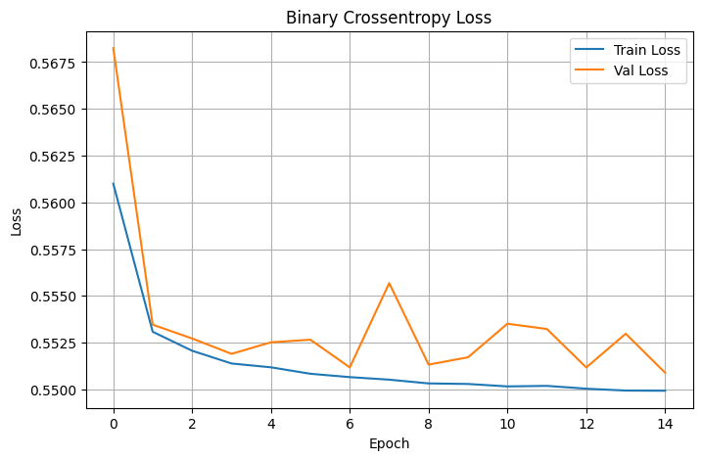Fig. 1 Training and Validation Loss
The training and validation curves illustrates the model’s performance over the course of 15 epochs. The binary cross entropy loss plot shows a consistent decline for both training and validation sets, indicating stable learning. Although the validation loss fluctuates slightly, it stays close to the training loss, suggesting that the model is generalizing well without significant overfitting.
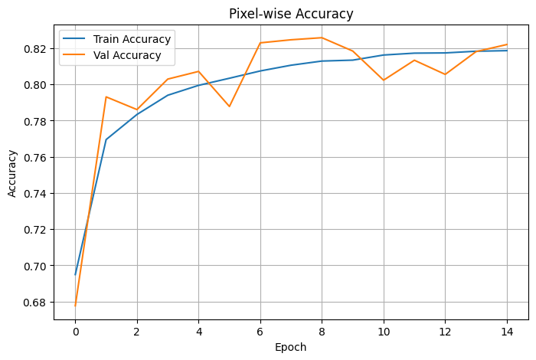Fig. 2 Training and validation accuracy plot
The pixel-wise accuracy plot also supports this observation. Both training and validation accuracies improve steadily and converge toward ~82%, with validation accuracy occasionally surpassing the training accuracy. This suggests that the model effectively learns to restore the structure of noisy images without excessive reliance on memorization. The accuracy stabilizes in later epochs, showing convergence of the learning process.

Qualitative Analysis (Image Reconstructions)
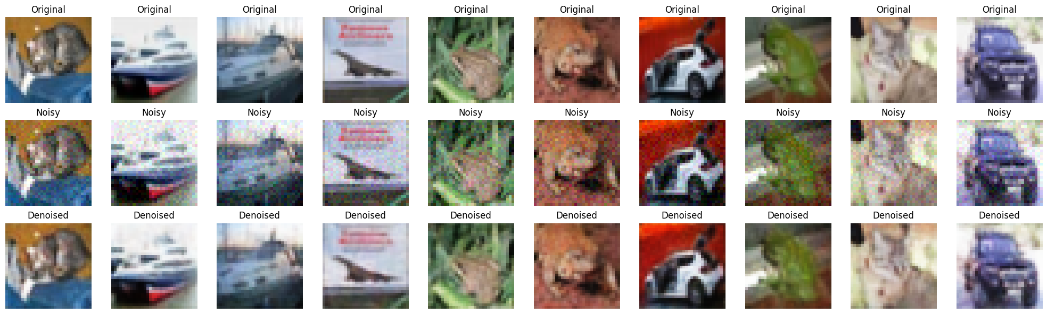
Fig. 3 Original vs Noise vs Denoise images
The reconstruction examples further confirm the model’s effectiveness. The images show three stages — original, noisy, and denoised. The noisy images clearly demonstrate distortion due to Gaussian noise, with visible grain and loss of detail. However, the denoised outputs successfully restore the underlying content and reduce noise without over-smoothing the details. Textures, object shapes, and even edges are reasonably preserved. For instance, the contours of the cars and animals remain visible, and background clutter is significantly suppressed.

Examples and Visual Results
The visualizations (fig.3) cover a diverse selection of images from different classes. This helps illustrate that the autoencoder is robust across different types of content. While some fine-grained textures are lost, the overall semantic structure is well-recovered. In some cases, the denoising introduces slight blurring, which is expected due to the averaging effect of convolutional reconstruction.

Critical Analysis and Discussion

Strengths of the Model
The convolutional autoencoder demonstrates strong performance in denoising tasks on the CIFAR-10 dataset. One strength lies in its ability to generalize well across various image classes, as evidenced by the consistent accuracy and low loss on both training and validation sets. The architecture effectively learns to extract and preserve essential visual features while filtering out noise, even from relatively small 32×32-pixel inputs. Additionally, the model benefits from GPU acceleration via TensorFlow, which allows for efficient training even with convolutional operations and batch normalization layers. The use of a relatively lightweight model ensures fast inference, making it suitable for real-time or embedded applications.

Weaknesses or Limitations
Despite its strengths, the model exhibits some limitations. The reconstructed (denoised) images, while visually cleaner, often appear slightly blurred compared to the originals. This is a common side effect of convolutional reconstruction, especially when using simple architectures with limited depth. Fine-grained textures and small details (such as facial features or text) are sometimes lost or oversmoothed. Furthermore, the model may struggle to differentiate between noise and subtle image patterns when both have similar frequency characteristics. Another limitation is that performance was evaluated only using pixel-wise accuracy and binary Cross entropy, which may not fully capture perceptual quality or structural similarity.

Suggestions for Improvement
Several enhancements could improve both performance and perceptual quality. Increasing the model depth or incorporating residual connections could help capture more complex features and preserve finer details. Using skip connections (as in U-Net architectures) could enable the decoder to access high-resolution spatial information from earlier encoder layers. Alternatively, replacing the loss function with a perceptual loss (e.g., based on SSIM or features extracted from a pretrained network like VGG) could help the model produce sharper, more realistic outputs. Finally, applying data augmentation or using progressive noise levels during training could further improve robustness and generalization across varying types of image degradation.

Conclusion

Summary of Findings
This project successfully implemented a convolutional autoencoder for image denoising using the CIFAR-10 dataset. The model was trained to map noisy images to clean counterparts, achieving stable and improving performance over 15 epochs. Evaluation through both quantitative metrics and qualitative image comparisons demonstrated that the network effectively learned to remove Gaussian noise while preserving key features of the original images. The binary crossentropy loss steadily decreased, and pixel-wise accuracy reached over 82% on both training and validation sets. Visual reconstructions confirmed that the model was capable of producing clear, denoised images across a wide variety of object categories.

Reflections on Deep Learning and TensorFlow Usage
The project highlights the effectiveness of deep learning, particularly convolutional architectures, in solving complex image processing tasks such as noise reduction. TensorFlow, paired with Keras, provided a powerful and flexible framework to construct and train the model, while offering seamless GPU acceleration that significantly reduced training time. The ease of model definition, checkpointing, and evaluation through TensorFlow’s APIs enabled a smooth and modular development process. This assignment reinforced not only the technical understanding of autoencoder architectures but also the practical skills needed to build, train, and optimize deep learning pipelines for real-world applications.

