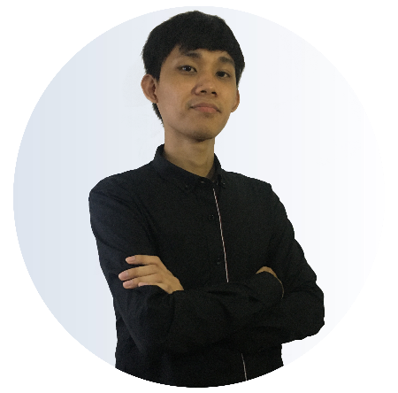
- Develop scalable application using MERN Stack.
- Develop a cross-platform mobile app using React Native Framework.
- Oversaw all major database practices with best systematic methods in MongoDB.
- Reviewing code structure and convention of other developers.
- Worked on passing data to client side using RESTful API
- Develop scalable application using MERN Stack.
- Develop a cross-platform mobile app using React Native Framework.
- Led and supervised the backend department and team project.
- Oversaw all major database practices with best systematic methods in MongoDB.
- Planning to resolve technical issues and other problems of the team.
- Responsible for maintaining good server performance.
- Responsible for reviewing code structure and convention.

CONTACTS
ADDRESS
Phase 1 Block 9 Lot 6 Wood Side Subdivision, Tanza, Cavite
PHONE
(+63) 965 534 3148
EMAIL
nujjohnhenryreyes@gmail.com
LINKEDIN
www.linkedin.com/in/nuj-reyes-4250391b3
NATIONAL CERTIFICATE II
IN COMPUTER SYSTEMS SERVICING
Christ the King College
January 2019
BACHELOR OF SCIENCE
IN INFORMATION TECHNOLOGY
Cavite State University – Imus Campus
Academic Scholar
October 2015 to June 2020
EDUCATION
March 2021 to Present
July 2020 to March 2021
June 2019 to August 2019
Z
Z
Z
- Monitor system performance.
- Tests every feature of the system and encode bugs and issues encountered in Google Spread Sheet.
- Creating wireframes using Power Point Presentation.
- Designing payslip for the clients.
- Creating flow chart for the future process.
MID SOFTWARE ENGINEER
JUNIOR SOFTWARE ENGINEER
QUALITY ASSURANCE INTERN

EXPERIENCE
NUJ JOHN HENRY V. REYES
Software Engineer
Jayson I. Lariza
IT Professor, Cavite State University – Imus Campus
(+63) 997 425 6919
Janyne T. Umali
Employee Relation HR Department, United Graphic Expression Corporation
(+63) 997 604 8958
Bryan Balaga
Mid Software Engineer, Xypher Solutions Inc.
(+63) 907 068 0221
REFERENCES
Bash / Shell
GIT
Bootstrap
HTML 5/ CSS3 / SASS
Ajax
JQuery
Javascript
Redux
React Native
React.js
MongoDB
Redis
PHP
Node.js
MySQL / MariaDB
Microsoft SQL Server
PROFILE
I'm an enthusiastic, responsible and hardworking mid-level software engineer. Being worked for different projects helped me to adopt to the changes quickly and made me a mature team worker. I enjoy coding, testing and integration. Areas of expertise include coding software products, problem solving and leading teams.
SKILLS

