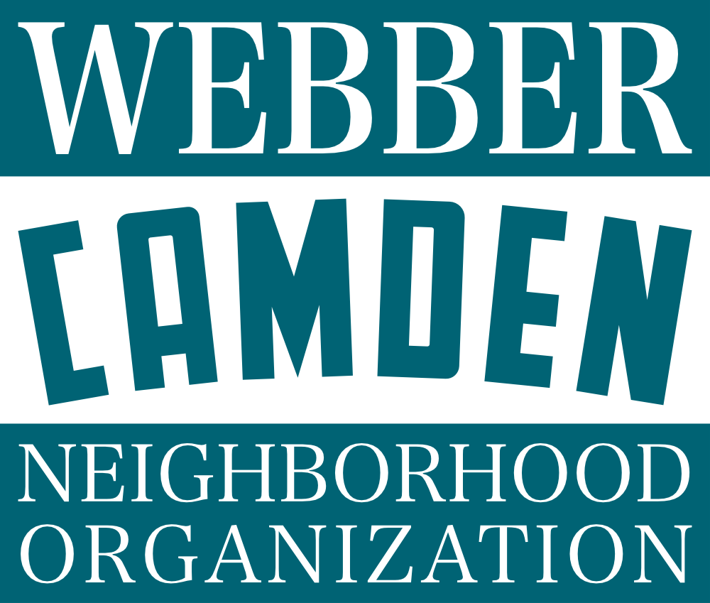

Webber-Camden Neighborhood Organization (WCNO) is a democratically operated, city recognized non-profit organization, which advocates for our residents and businesses. Voting membership in WCNO is open to any person of legal voting age, who either resides in, or owns property in, our neighborhood. Any businesses or organizations located in Webber-Camden can also designate a non-resident member to participate in the organization. A Board of Directors is elected by community members to manage the affairs of WCNO.

We hold monthly meetings with the Board of Directors, quarterly membership meetings, and tons of fun neighborhood events throughout the year. Members of the organization advocate for our community, make meaningful change, and support our neighborhood. **We strongly encourage neighbors to engage with the organization, learn what we’re working on, and provide feedback and support on how the organization can grow!** Join one of WCNO's committees to help shape change around the neighborhood. Each committee meets monthly in 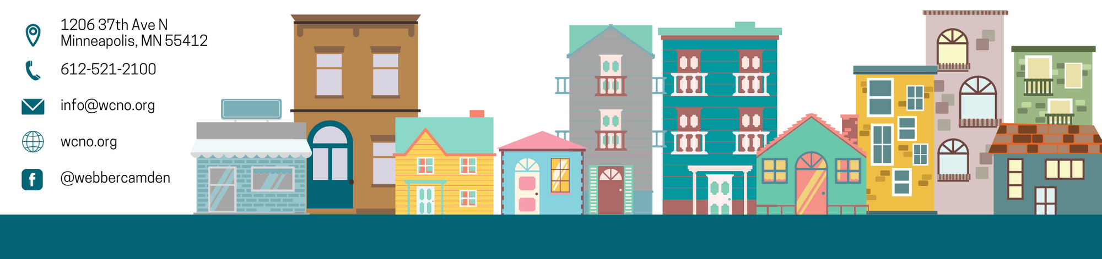the evenings.

|  |  |  |
| --- | --- | --- |
| **Committee Name** | **Day of the Month** | **Committee Point of Contact** |
| Youth and Family | Second Monday | Maria Ahlgren: maria.ahlgren@wcno.org |
| Finance | Second Wednesday | Sheree Breedlove: sheree.breedlove@wcno.org |
| Operations | Second Thursday | Krystin Eldridge: krystin.eldridge@wcno.org |
| Housing | Third Wednesday | Tiara Brown: tiara.brown@wcno.org |
| Safety | Third Thursday | Monica Colberg: monica.colberg@wcno.org |
| Communications | Fourth Thursday | Eric Hoffer: eric.hoffer@wcno.org |
| Business and Land Use | As needed | Kevin Aldwaik: kevin.aldwaik@wcno.org |