



Roles of Advocates

A YPM is a person who has had direct life

experience with

receiving services from a mental health system, alcohol and drug

services, child welfare, and/or juvenile justice system.

A Family Partner is a person who has had

direct life experience as a parent or caregiver of a child receiving, or having previously

received, services within the public systems mentioned above.

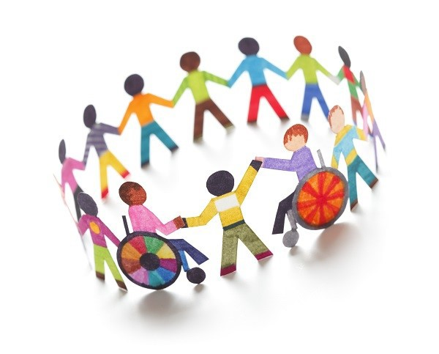

**HOW TO GET**

**LINKED TO ADVOCACY**

**Talk to your child’s therapist and ask to be linked up with a Family Partner**

**OR**

**A Youth Peer Mentor**

**(YPM) OR**

**BOTH!**



**ADVOCACY**



# OUTCOMES



As advocates, we also serve as

the voice and choice of the youth within the treatment

team and encourage the team to make choices that the youth agrees with.

Youth Peer Mentors are a great

outlet for youth who need a

little extra support. We provide one on one mentoring in the community, and offer a

relaxed, no-pressure space for kids to explore their interests and identities. Through our own lived experience we will

walk with the youth.

Youth Peer Mentor

* **Families and youth feel empowered to advocate for themselves in all areas of the children’s system of care.**
* **The family and youth voice and choice will be represented at all levels of policy, program development and service delivery.**
* **The family and youth will receive education and resources specific to the needs , treatment, and services in the children’s system .**
* **Identify creative outlets and exploration of interests and hobbies.**
* **Social skills and coping strategies for “real world” situations.**
* **Connection to community resources and development of natural supports.**

# Family Partner

## As Advocates, we teach, coach, and empower families to help

**themselves. We offer support at a variety of venues such a**

**school, home, in the community, and at our offices. Through our own lived experience we will walk with caregivers.**

**Family Advocates will help professionals recognize that**

**families are the child’s strongest advocates. The caregiver’s voice and perspective is a valued component of the treatment plan.**