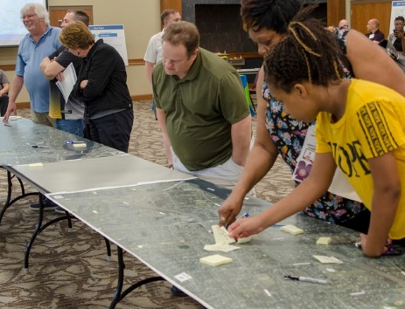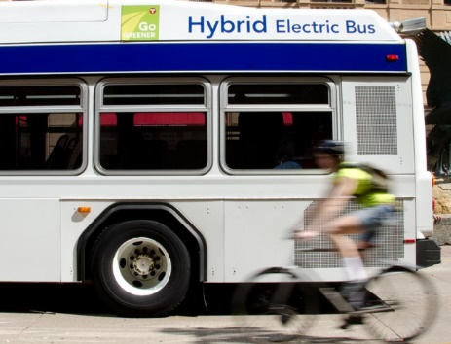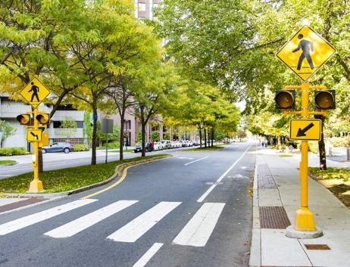

**HIGHWAY 252/I-94 ENVIRONMENTAL REVIEW**

EQUITY AND HEALTH ASSESSMENT

Transportation affects all of us, and all of us should have a say in how transportation decisions get made.

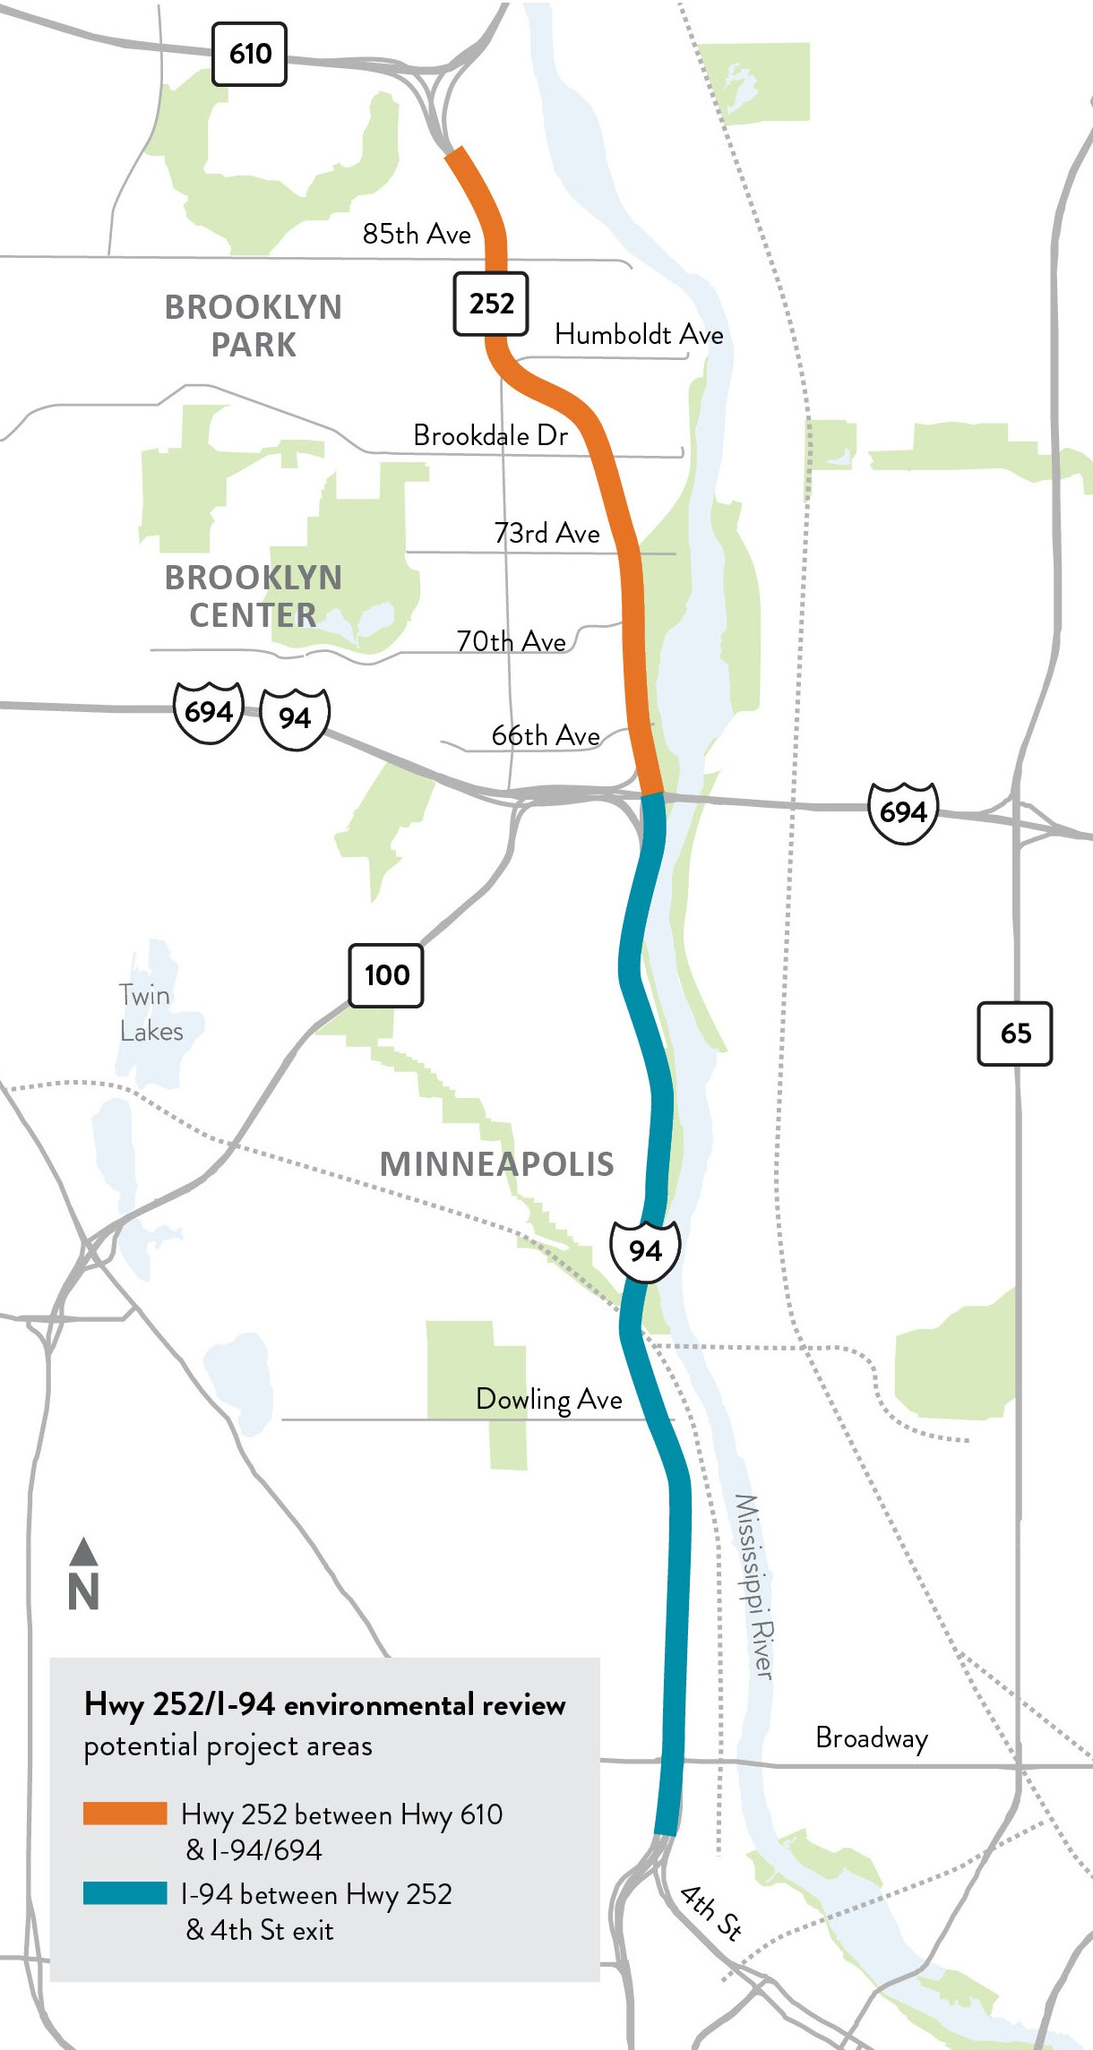MnDOT is looking for Brooklyn Park, Brooklyn Center, and Minneapolis residents to help us understand how

transportation impacts the health of people, the environment, and the economy. We want to know how these impacts affect historically underserved and overburdened communities,

and how MnDOT and its partners can deliver transportation improvements that affect positive change.

If you live, work, or own a business along the Highway

252/I-94 corridor and have a passion for equity, health, and transportation, we invite you to apply to be an Equity and Health Neighborhood Advisor (EHNA) for the ongoing Highway 252 and I-94 project. As a member of the EHNA committee, you will be asked to:

* Identify equity issues to be addressed in MnDOT decision- making.
* Describe the role of transportation in physical, social, and economic health.
* Guide MnDOT’s engagement of your community.
* Provide input to MnDOT on the Highway 252/I-94 project.

People selected to serve on the EHNA committee will be compensated for each EHNA meeting attended. MnDOT anticipates up to 10 EHNA meetings between mid-2021 and mid-2022. Meetings will be approximately 2 hours in length on weekday evenings.

Applications are available in English, Spanish, Hmong, and Somali on the Highway 252/I-94 project website at [www.dot.state.mn.us/metro/projects/hwy252study/eha.html](http://www.dot.state.mn.us/metro/projects/hwy252study/eha.html) For questions, or to request a paper application, please contact Dale Gade at 651-251-4045 or [dgade@srfconsulting.com.](mailto:dgade@srfconsulting.com)

Minnesota Department of Transportation.June 18, 2021 | [www.dot.state.mn.us/metro/projects/hwy252study/](http://www.dot.state.mn.us/metro/projects/hwy252study/)