### . Page 1

Peb tau tsim cov khoom muaj kev pom zoo thiab cov txheej txheem kev teeb tsa txhawm rau los xyuas seb qhov twg yog qhov yuav ua tiav cov txiaj ntsig ntawv thiab sib luag. Tom qab ntawv peb tau xaiv cov kev pom zoo siab tshaj plaws uas ua tau raws li cov Txheej Txheem Kev Pab Nyiaj Txiag Kev Hloov pauv Kev Nyab Xeeb rau Zej Zog:

|  |  |
| --- | --- |
| **Kev Xav Tau Thooj Nyiaj** | **Txoj Cia Ua Qhia** |
| Kev tsim cov tsev pheej yig | Nroog Fresno "Ntawm No Txhawm Rau Nyob" zej zog Kev ntseeg siab |
| Kev thiv thaiv ntawm cov tsev pheej yig | Kev Ruaj Ntseg Ntawm kevXauj, Kev Hloov Kev Pauv Siab, thiab Kev Tsim Tus Qauv "Muaj Nqi Pheej Yig" |
| Kev pov hwm thiab pab cuam ntawm tus xauj | Kev Ncaj Ncees ntawm Vaj Tse |

### 

Page 12

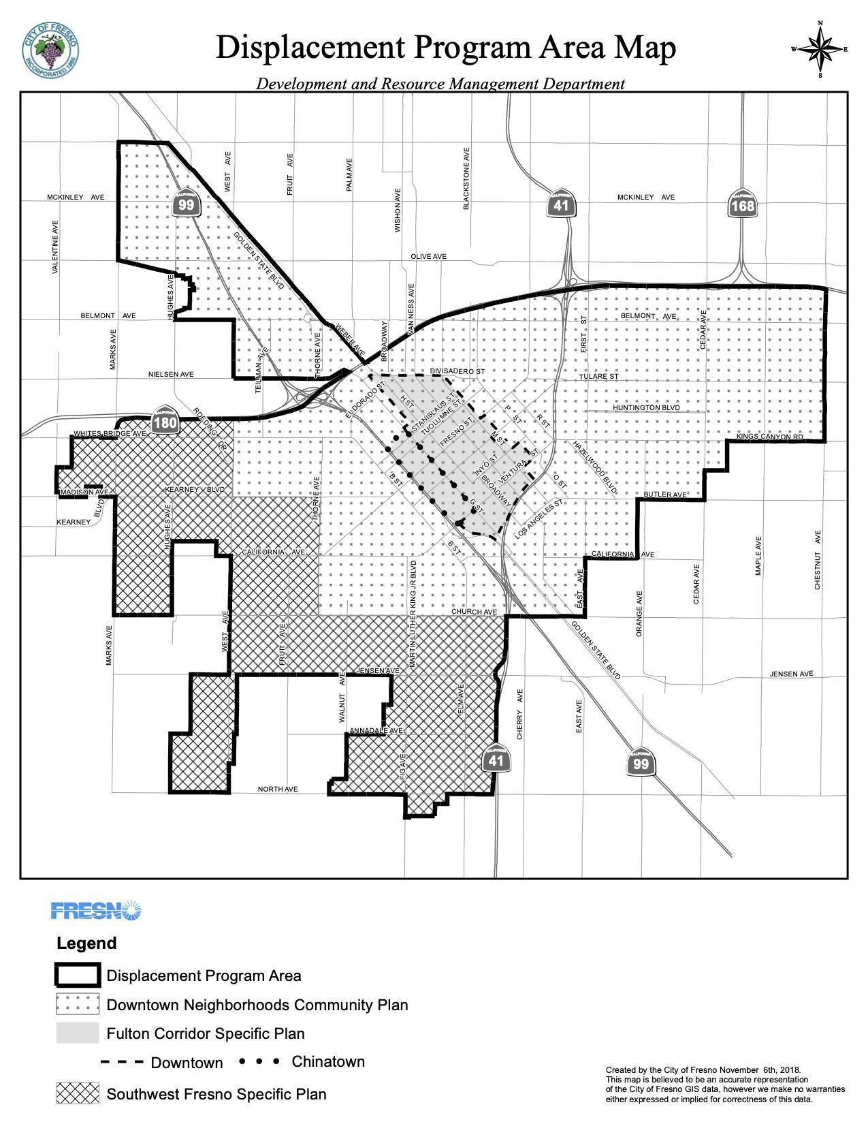

Page 13

Transform Fresno Plan Project, November 2020

# 

Page 14

.

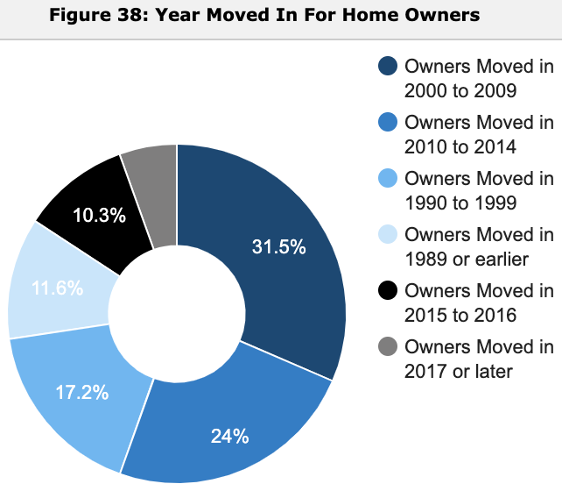

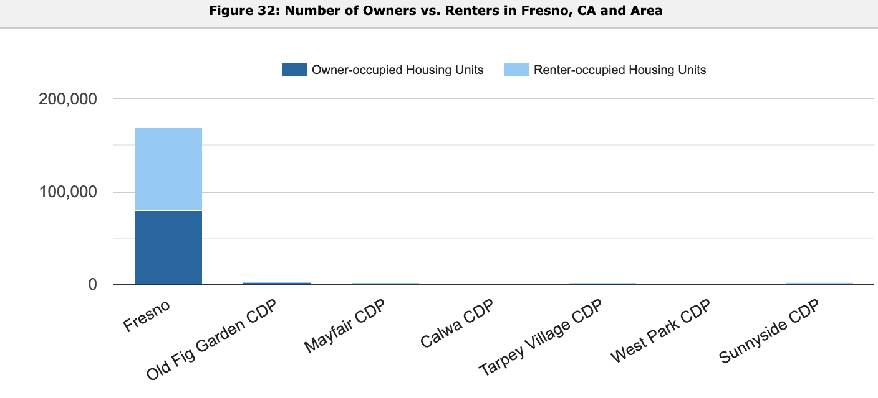

Page 23

How Familiar are you with Fresno’s Policies and Programs to keep residents housed?

