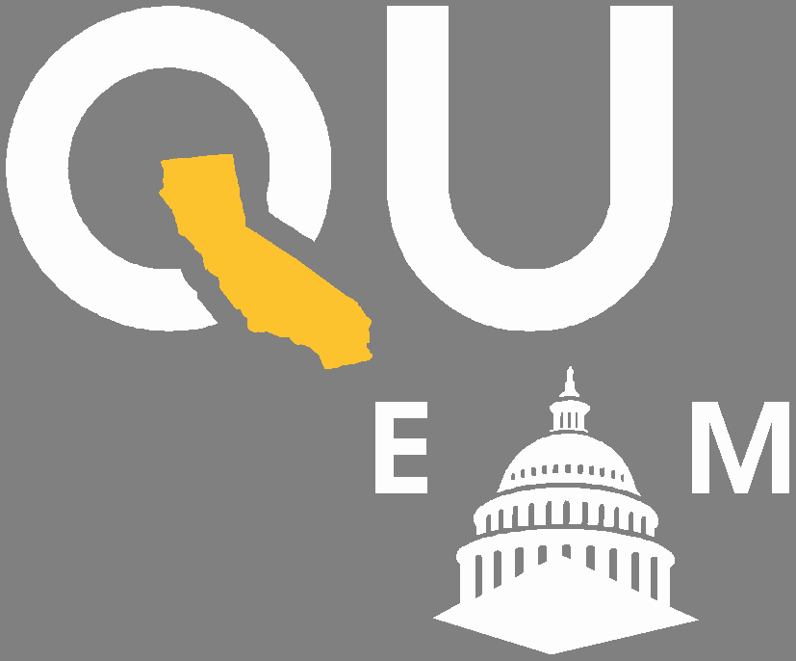

**# V A L L E Y R I S I N G**

**JOIN US AT THE STATE CAPITOL**

**with other Valley residents and leaders to stand in unity for immigrants, children, youth, women, families, LGBTQA**

**and vulnerable communites**

**FREE TRANSPORTATION ▪ FREE FOOD ▪ FREE ACTIVITIES FOR KIDS**

**WEDNESDAY**

**APRIL 26, 2023**

**9 AM – 3 PM**

**CALIFORNIA STATE CAPITOL ▪ SACRAMENTO**

[**Register now at:**](https://www.shfcenter.org/programs-and-initiatives/san-joaquin-valley-health-fund/equity-on-the-mall/)

[**EQUITYONTHEMALL ORG**](https://www.shfcenter.org/programs-and-initiatives/san-joaquin-valley-health-fund/equity-on-the-mall/)

[**Contact us at sjvhealthfund@shfcenter org**](mailto:sjvhealthfund@shfcenter.org)