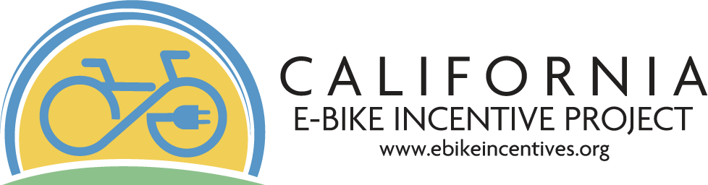



**Cov npav nqi tsheb tshwj xeeb (E-bike incentive vouchers) rau cov nyiaj tau los uas tsim nyog ntawm Californians**

Cov koom kas npav tsheb nqi tshwj xeeb ntawm California (California E-Bike Incentive Project provides vouchers point-of-male incentive vouchers) los pab cov neeg tau txais txiaj ntsig hauv California yuav tau lub tsheb kauj vab hluav taws xob tshiab (e-bike). Peb lub hom phiaj yog ua kom muaj kev nyab xeeb rau kev thauj mus los yooj yim thiab pheej yig rau txhua tus.

# Cov npav nqi tsheb tshwj xeeb yog dab tsi? (What is an e-bike incentive voucher?)

Cov npav nqi tsheb tshwj xeeb (e-bike incentive voucher) raug muab tsub rau cov neeg thov kev pom zoo los thov ua tus nqi luv nqi thaum kev yuav khoom e-bike. Txhawm rau txhiv daim ntawv txhawb nqa, koj yuav tsum xub ua tiav daim ntawv thov hauv online thiab tau txais tsab ntawv ceeb toom pom zoo. Cov nyiaj txhawb siab yog them rau cov khw muag khoom e-bike uas muab cov cov nqi luv.

Cov npav nqi tsheb tshwj xeeb muaj nqis npaum li cas? (How much are the e-bike incentive vouchers worth?)

$1,750 + $250 $2000

Cov nyiaj tau los

## tsim nyog txhawb (300% FPL)

Cov neeg thov ua ntej (225% FPL) los sis cov

neeg txom nyem / cov nyiaj tau los tsawg

## **cov zej zog**

Qhov siab tshaj plaws

tus nqi tshwj xeeb

# Kuv tuaj yeem tau txais cov npav nqi tsheb tshwj xeeb li cas? (How can I get an e-bike incentive voucher?)

Cov ntawv thov yuav raug lees txais los ntawm peb tus vev xaib online ntawm thawj zaug, thawj qhov. Cov ntawv thov yuav xav tau cov ntaub ntawv tseem ceeb ntawm tus neeg thov kev pab nrog rau cov ntaub ntawv nyob hauv thiab cov ntaub ntawv txheeb xyuas nyiaj tau los.

**Kuv yuav tsim nyog li cas? (How do I qualify?)**

# Hnub nyoog siab duas 18+

**Nyob hauv California**

**Xyuas koj tus kheej**

# tsev neeg

**cov nyiaj tau los tsim nyog\***

**Ua kom tiav koj**

**daim ntawv thov hauv online**

# Txais qhov

**kev pom zoo**

# ceeb toom

* Cov nyiaj tau los txhua xyoo hauv tsev neeg tsawg dua $45,180 rau ib tus neeg, $61,320 rau ib tsev neeg muaj 2, thiab $93,600 rau ib tsev neeg muaj 4. Ib tsev neeg txhais tau tias yog tus neeg thov, tus txij nkawm thiab/los sis tus khub hauv tsev, cov neeg nyob los sis tus saib xyuas. Yog xav paub ntxiv txog cov nyiaj tau los, saib peb tus vev xaib.

# Cov e-bikes twg uas tsim nyog? (Which e-bikes are eligible?)

**E-bike uas tsim nyog: Cov khoom siv thiab cov chaw tsim**

* Yuav tsum yog tshiab
* Yuav tsum yog chav kawm 1, 2 los sis 3
* Yuav tsum ua raws li UL-2849 thiab/los sis EN-15194
* Yuav tsum muaj chaw tsuj ua hauj lwm tau
* Yuav tsum muaj lub cev muaj zog tsawg dua los sis sib npaug li 750 Watts

**khoom uas xav tau:**

* + 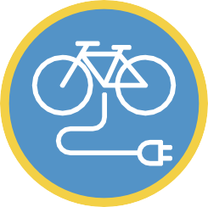Yuav tsum muaj lub teeb pem hauv ntej ua ke
  + Yuav tsum muaj lub teeb nram qab
  + Yuav tsum muaj tsawg kawg yog 1 xyoo lav ntawm cov khoom siv hluav taws xob
  + Yuav tsum tau ua kom tiav

### Yog xav paub ntxiv mus saib peb tus vev xaib:

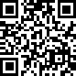

v 1.3