**ທ້າວ ນູຊົ່ວ ເຮີ ຫ້ອງ 3cw1**

**Soure File xml ໃນການ design**

<EditText  
 android:id="@+id/editText1"  
 android:layout_width="wrap_content"  
 android:layout_height="wrap_content"  
 android:layout_alignParentLeft="true"  
 android:layout_alignParentStart="true"  
 android:layout_alignParentTop="true"  
 android:layout_marginLeft="100dp"  
 android:layout_marginStart="100dp"  
 android:layout_marginTop="24dp"  
 android:ems="10"  
 android:hint="@string/name"  
 android:inputType="textPersonName"  
 android:selectAllOnFocus="true" />  
 <EditText  
 android:id="@+id/editText2"  
 android:layout_width="wrap_content"  
 android:layout_height="wrap_content"  
 android:layout_alignLeft="@+id/editText1"  
 android:layout_alignStart="@+id/editText1"  
 android:layout_below="@+id/editText1"  
 android:layout_marginTop="12dp"  
 android:ems="10"  
 android:hint="@string/e_mail"  
 android:inputType="textEmailAddress" />  
 <EditText  
 android:id="@+id/editText3"  
 android:layout_width="wrap_content"  
 android:layout_height="wrap_content"  
 android:layout_alignLeft="@+id/editText2"  
 android:layout_alignStart="@+id/editText2"  
 android:layout_below="@+id/editText2"  
 android:layout_marginTop="18dp"  
 android:ems="10"  
 android:hint="@string/contact_number"  
 android:inputType="phone" />  
 <EditText  
 android:id="@+id/editText4"  
 android:layout_width="wrap_content"  
 android:layout_height="wrap_content"  
 android:layout_alignLeft="@+id/editText3"  
 android:layout_alignStart="@+id/editText3"  
 android:layout_below="@+id/editText3"  
 android:layout_marginTop="19dp"  
 android:ems="10"  
 android:hint="@string/password_0_9"  
 android:inputType="numberPassword" />  
  
 <Button  
 android:id="@+id/button"  
 style="@android:style/Widget.Button"  
 android:layout_width="wrap_content"  
 android:layout_height="wrap_content"  
 android:layout_alignParentLeft="true"  
 android:layout_alignParentStart="true"  
 android:layout_marginLeft="160dp"  
 android:layout_marginStart="160dp"  
 android:layout_below="@+id/editText4"  
 android:layout_marginTop="62dp"  
 android:text="@string/submit"  
 android:textColor="@color/white"  
 android:textSize="16sp"  
 android:textStyle="normal|bold" />  
  
 <Button  
 android:id="@+id/buttonr"  
 style="@android:style/Widget.Button"  
 android:layout_width="wrap_content"  
 android:layout_height="wrap_content"  
 android:layout_alignParentLeft="true"  
 android:layout_alignParentStart="true"  
 android:layout_below="@+id/button"  
 android:layout_marginLeft="160dp"  
 android:layout_marginStart="160dp"  
 android:layout_marginTop="27dp"  
 android:text="@string/submitr"  
 android:textColor="@color/white"  
 android:textSize="16sp"  
 android:textStyle="normal|bold" />

**ຜົນ run ການ design**

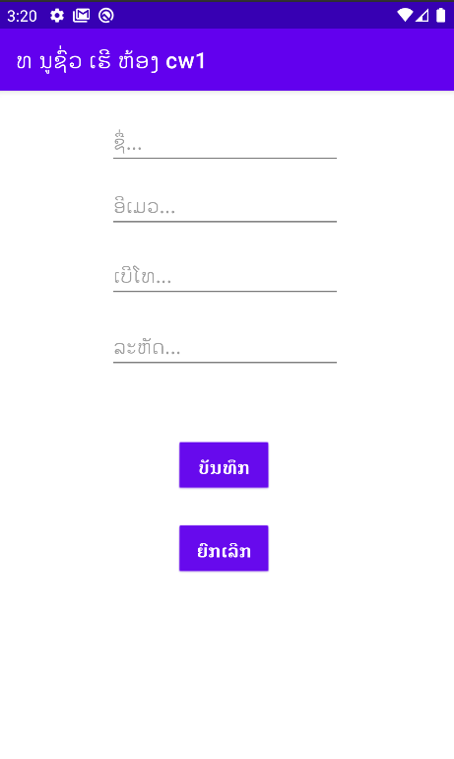

**Soure File Java (MainActivity)**

public class MainActivity extends AppCompatActivity {  
  
 Button submit, submitr;  
 EditText name, password, email, contact;  
  
 @Override  
 protected void onCreate(Bundle savedInstanceState) {  
 super.onCreate(savedInstanceState);  
 setContentView(R.layout.*activity_main*);  
  
 name = (EditText) findViewById(R.id.*editText1*);  
 email = (EditText) findViewById(R.id.*editText2*);  
 contact = (EditText) findViewById(R.id.*editText3*);  
 password = (EditText) findViewById(R.id.*editText4*);  
 submit = (Button) findViewById(R.id.*button*);  
 submitr = (Button) findViewById(R.id.*buttonr*);

submit.setOnClickListener(new View.OnClickListener() {  
 @Override  
 public void onClick(View v) {  
 if (name.getText().toString().isEmpty() || password.getText().toString().isEmpty() || email.getText().toString().isEmpty()  
 || contact.getText().toString().isEmpty()) {  
 Toast.*makeText*(getApplicationContext(), "ກະລຸນາປ້ອນຂໍ້ມູນ", Toast.*LENGTH_SHORT*).show();  
 } else {  
 Toast.*makeText*(getApplicationContext(), "ຊື່ - " + name.getText().toString()  
 + " \n" + "ອີເມວ - " + email.getText().toString()  
 + " \n" + "ເບີໂທ - " + contact.getText().toString()  
 + " \n " + "ລະຫັດ - " + password.getText().toString(), Toast.*LENGTH_SHORT*).show();  
 }  
 }  
 });  
  
 submitr.setOnClickListener(new View.OnClickListener() {  
 @Override  
 public void onClick(View v) {  
 name.setText("");  
 email.setText("");  
 contact.setText("");  
 password.setText("");  
 }  
 });  
  
 }  
}

**ຜົນ run ເມື່ອກົດປຸ່ມບັນທຶກ**

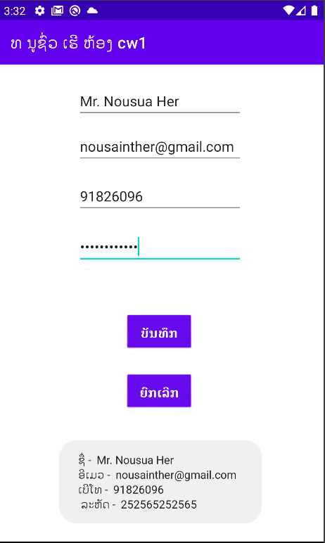

**ຜົນ run ເມື່ອກົດປຸ່ມຍົກເລີກ**

