KRISHNOVA LLP

Technology Division

AI-Powered Internship &
Project Management Platform
(AIPMS)

Phased Technical Specification &
Implementation Roadmap

Team Members:
- N.varshitha
- M.Akshitha
- R.Sankeerthana
- P.Gouthami
- P.Hemasri
- B.Vivekraj
- D.Dharani
- M.Pragnusha
- B.Varshitha
- J.Nandini
- N.Nanditha
- Nandini
- CH.Sravani
- P.Mamatha
- P.Vaishali
- CH.Asritha
- Shephali

INTRODUCTION

1.1 Introduction
The AI-Powered Internship & Project Management System (AIPMS) is a web-based application designed to simplify and automate the management of internships and projects within educational institutions and organizations. Traditional internship management often involves manual processes for assigning tasks, tracking attendance, monitoring project progress, and evaluating intern performance. These processes are time-consuming, prone to errors, and difficult to manage as the number of interns increases.
AIPMS integrates internship management, project management, attendance tracking, task assignment, performance monitoring, and AI-assisted reporting into a single platform. The system enables administrators, mentors, and interns to collaborate effectively while reducing manual work. AI-based features help generate daily summaries, monitor progress, identify delays, and support better decision-making.
The system is developed using Python-based technologies with a user-friendly web interface, making it scalable, secure, and easy to maintain.

1.2 Project Overview
The AI-Powered Internship & Project Management System (AIPMS) is designed to provide a centralized platform for managing internship activities from registration to project completion.
The system allows administrators to manage users, mentors to assign and monitor projects, and interns to submit daily work updates, mark attendance, and complete assigned tasks. It also provides dashboards and reports to monitor internship performance. AI modules analyze collected data to generate summaries and assist mentors in identifying delays, inactive interns, and overall project progress.
The project is planned in three phases:
- Phase 1 – Pilot: Develop the core modules such as authentication, project management, task assignment, attendance tracking, and AI-generated daily summaries.
- Phase 2 – Scale-Up: Introduce recruitment management, performance evaluation, AI mentor assistance, report generation, and chatbot support.
- Phase 3 – Enterprise Scale: Add certificate generation, learning management, predictive analytics, cloud deployment, mobile support, and enterprise-level dashboards.

1.3 Problem Statement
Many educational institutions and organizations manage internships using spreadsheets, emails, and multiple software applications. These disconnected systems make it difficult to track attendance, assign tasks, monitor project progress, and evaluate intern performance efficiently.
Mentors spend considerable time preparing reports and monitoring daily activities manually. Communication between interns and mentors is often scattered across different platforms, making collaboration less effective. Existing solutions generally focus on either project management or internship management rather than providing an integrated platform.
Therefore, there is a need for a unified system that combines internship management, project tracking, attendance, AI-assisted monitoring, and reporting in a single application.
1.4 Need for the Project
The growing number of interns and projects has increased the need for an efficient digital management system. Manual management methods consume time, require continuous monitoring, and increase the possibility of errors.
The proposed system addresses these challenges by automating routine tasks, improving communication, and providing real-time information through dashboards and reports. AI-based analysis helps mentors quickly understand project progress and identify potential issues before they become major problems.
The system also improves transparency, accountability, and productivity by ensuring that all internship activities are recorded and monitored through a single platform.

1.5 Objectives
The main objectives of the AI-Powered Internship & Project Management System are:
- To develop a centralized platform for internship and project management.
- To automate task assignment and project tracking.
- To maintain accurate attendance records.
- To enable interns to submit daily stand-up reports.
- To provide role-based access for administrators, mentors, and interns.
- To generate AI-based daily summaries and project insights.
- To monitor intern performance through dashboards and reports.
- To reduce manual paperwork and reporting effort.
- To improve communication among administrators, mentors, and interns.

1.6 Scope of the Project
The scope of AIPMS includes managing the complete internship lifecycle through a web-based application. The system supports user authentication, internship registration, project creation, task assignment, attendance tracking, daily stand-up reporting, AI-generated summaries, and performance monitoring. It also provides dashboards for administrators and mentors to monitor project status and intern activities.
The project is designed with future expansion in mind, allowing additional features such as recruitment management, certificate generation, learning modules, predictive analytics, mobile applications, and cloud deployment to be incorporated in later phases.

1.7 Existing System
Currently, many organizations use separate applications for internship management, project management, attendance tracking, and communication. Project management tools help assign tasks, while communication platforms support team discussions. Internship portals focus mainly on recruitment and internship opportunities.
Because these systems operate independently, users often switch between multiple platforms to complete daily activities. This results in fragmented information, duplicated work, and reduced efficiency.

1.8 Limitations of Existing System
The existing systems have several limitations:
- Internship and project management are handled using different applications.
- Manual attendance tracking increases administrative work.
- Daily progress reporting requires significant manual effort.
- Limited AI support for monitoring and decision-making.
- Performance evaluation is often subjective and time-consuming.
- Communication is spread across multiple platforms.
- Report generation requires manual data collection and preparation.
- Lack of centralized dashboards for monitoring overall internship activities.
- Difficult to scale efficiently as the number of interns increases.

1.9 Proposed System
The proposed AI-Powered Internship & Project Management System (AIPMS) provides a unified web-based platform that integrates internship management, project management, attendance tracking, task assignment, AI-assisted reporting, and performance monitoring.
Administrators can manage users, projects, and internships from a centralized dashboard. Mentors can assign tasks, monitor intern progress, review attendance, and receive AI-generated summaries. Interns can manage their assigned tasks, submit daily work updates, mark attendance, and communicate through the platform.
The system is developed using Python, HTML, CSS, JavaScript, Bootstrap, and a relational database such as SQLite or MySQL, providing a secure, user-friendly, and scalable solution.

1.10 Advantages of Proposed System
The proposed system offers several advantages:
- Centralized internship and project management.
- Reduced manual work through automation.
- Secure role-based user authentication.
- Efficient task assignment and tracking.
- Automated attendance management.
- AI-generated daily summaries and insights.
- Real-time dashboards for monitoring performance.
- Faster report generation.
- Improved collaboration between mentors and interns.
- Better decision-making through analytics.
- Easy scalability for future enhancements.
- User-friendly interface with simplified navigation.
- Improved productivity and transparency.
- Flexible architecture that supports future AI modules and enterprise-level expansion.
1.11 Business Value

- The AI-Powered Internship & Project Management System (AIPMS) delivers significant business value by improving operational efficiency, enhancing collaboration, and enabling intelligent decision-making. By integrating internship management, project tracking, attendance monitoring, and AI-powered analytics into a single platform, the system simplifies complex administrative processes and reduces the dependency on manual work.
- One of the major benefits of the proposed system is its ability to reduce manual administrative effort by approximately 70–80% through automation of routine activities such as attendance management, task assignment, report generation, and progress tracking. This allows administrators and mentors to focus more on mentoring and strategic planning rather than repetitive operational tasks.
- The system also enables faster project tracking through real-time dashboards, automated progress updates, and AI-generated summaries. Mentors and administrators can monitor project status, identify delays, and take corrective actions quickly, ensuring timely project completion.
- AIPMS significantly improves mentor productivity by automating performance monitoring, daily stand-up analysis, and report generation. AI-generated insights help mentors evaluate intern progress more efficiently, reducing the time spent on manual reviews and documentation.
- The platform contributes to better internship outcomes by providing personalized learning recommendations, continuous performance monitoring, and AI-assisted mentoring. These features help interns improve their technical skills, complete projects successfully, and achieve better learning experiences throughout the internship.
- The system supports data-driven decision-making by providing comprehensive dashboards, analytics, and predictive reports. Administrators can analyze internship performance, resource utilization, attendance trends, and project progress to make informed decisions based on real-time data.
- Finally, AIPMS is designed with enterprise scalability in mind. Its modular architecture supports multiple organizations, departments, mentors, and thousands of concurrent users. The platform can be easily expanded with advanced AI capabilities, cloud deployment, and enterprise integrations, making it suitable for both educational institutions and large organizations.

2.Literature Survey
2.1 Introduction
A literature survey is an important part of developing any software project. It involves studying existing research, technologies, and systems related to the proposed project. This helps in understanding how similar systems work, the features they provide, and the challenges they face. It also helps identify gaps that can be improved in the new system.
For the proposed AI-Powered Internship & Project Management System (AIPMS), the literature survey focuses on internship management systems, project management tools, and AI-based solutions. Existing systems provide features such as internship registration, task management, attendance tracking, project monitoring, and report generation. These systems help organizations manage their work more effectively, but many of them still rely on manual processes and do not offer intelligent decision-making capabilities.
With the rapid growth of Artificial Intelligence (AI), modern management systems are becoming smarter and more efficient. AI can automate routine tasks, generate progress reports, analyze performance, predict project delays, and provide useful recommendations. By studying these existing technologies, the proposed AIPMS aims to combine internship management, project tracking, and AI-powered automation into a single platform that improves productivity, reduces manual effort, and provides a better experience for both interns and mentors.

2.2 Existing Internship Management Systems
Internship Management Systems (IMS) are digital platforms that help universities and organizations manage internship activities. They simplify processes such as student registration, mentor assignment, attendance tracking, task submission, and progress monitoring. These systems help reduce paperwork and improve communication between students, mentors, and administrators. They also make it easier to maintain internship records and monitor student performance.
Most existing internship management systems provide features like attendance tracking, document uploads, project updates, and report generation. These features help manage internships in a more organized and efficient way.
However, many of these systems still rely on manual monitoring and lack AI-based features such as automated performance analysis, smart recommendations, and project risk prediction. This creates the need for an AI-powered internship management system that can improve efficiency and support better decision-making.

2.3 Existing Project Management Systems
Project Management Systems are software applications that help organizations plan, execute, monitor, and control projects efficiently. These tools enable teams to organize tasks, assign responsibilities, track deadlines, monitor project progress, and collaborate in real time. Popular platforms include Jira, Trello, Asana, ClickUp, Monday.com, and Microsoft Project.
Most project management tools support features such as Kanban boards, Gantt charts, sprint planning, milestone tracking, document sharing, notifications, and team communication. They improve productivity by providing a centralized platform where team members can update task status and managers can monitor project completion. Agile development teams particularly benefit from these platforms because they simplify sprint management and workflow visualization.
Although these systems are powerful for project coordination, they are designed for general business projects rather than internship management. They do not include intern-specific features such as attendance monitoring, mentor evaluations, recruitment workflows, internship certification, or AI-generated performance reports. Most systems also depend on users manually updating task progress, reducing the accuracy of project tracking. Therefore, integrating AI with project management can significantly improve automation and decision-making.

2.4 AI-Based Project Management
Artificial Intelligence (AI) is changing the way projects are managed by automating routine tasks and improving decision-making. AI-based project management systems use technologies such as Machine Learning (ML), Natural Language Processing (NLP), and Large Language Models (LLMs) to analyze project data and provide useful insights.
Modern AI-powered systems can generate project summaries, predict task delays, monitor team performance, recommend task assignments, and identify potential project risks. These features help managers save time, improve productivity, and make better decisions throughout the project lifecycle.
However, most existing AI project management tools are designed mainly for software development or business projects. They do not combine internship management, attendance tracking, mentor support, recruitment, and performance evaluation in one platform. The proposed AI-Powered Internship & Project Management System (AIPMS) addresses these limitations by integrating AI-driven automation with internship and project management into a single, centralized system.

2.5 Comparative Study
Feature | Internship Management Systems | Project Management Systems | Proposed AIPMS
Internship Tracking | Yes | No | Yes
Task Management | Limited | Yes | Yes
AI-Based Summary | No | Limited | Yes
Attendance Monitoring | Basic | No | Yes
Performance Analytics | Limited | Limited | Yes
AI Mentor Support | No | No | Yes
Recruitment Support | No | No | No

Comparative Study of Existing Systems
Several project management and internship management platforms are widely used in organizations. While these platforms offer strong project tracking and collaboration features, most lack integrated AI capabilities specifically designed for internship management, performance analysis, and intelligent decision support. The following comparison highlights the research gap that AIPMS aims to address.
System | Strengths | Limitations | How AIPMS Improves
Jira | Agile project management, sprint planning, issue tracking | Complex for internship management, limited built-in AI mentoring | Adds AI Mentor, Skill Gap Analysis, AI Risk Prediction, and intern performance tracking
Trello | Simple Kanban boards, task management, collaboration | No AI analytics, no attendance or internship management | Provides AI-powered task prioritization, attendance management, and learning recommendations
ClickUp | Project management, dashboards, document collaboration | Limited AI features for mentoring and recruitment | Integrates AI Mentor, Resume Analyzer, Interview Preparation, and predictive analytics
Monday.com | Workflow automation, reporting, customizable dashboards | Lacks AI-driven intern evaluation and project intelligence | Offers AI-based productivity scoring, project risk prediction, and personalized recommendations
Internshala | Internship postings, recruitment, candidate applications | Focuses only on recruitment and internship listings | Extends functionality with complete internship lifecycle management, AI mentoring, task management, and performance monitoring
Microsoft Project | Enterprise project planning, scheduling, resource management | High complexity, limited AI assistance, no internship-specific features | Combines project management with AI automation, internship management, analytics, and intelligent reporting

2.6 Research Gap
The literature survey shows that existing internship management systems mainly focus on administrative tasks such as student registration, attendance tracking, mentor assignment, and report submission. Similarly, project management tools are designed to manage tasks, schedules, deadlines, and team collaboration. While these systems are useful, they work independently and do not provide a complete solution for managing both internships and projects together.
Another major limitation is the lack of Artificial Intelligence (AI) features in most existing systems. They require manual monitoring to track intern progress, evaluate performance, identify project risks, and generate reports. They also do not provide AI-based recommendations, automated summaries, or intelligent support for mentors and administrators, which increases manual effort and reduces efficiency.
To address these limitations, the proposed AI-Powered Internship & Project Management System (AIPMS) aims to integrate internship management, project tracking, attendance monitoring, AI-powered reporting, mentor support, recruitment assistance, and performance analytics into a single platform. This integrated approach will reduce manual work, improve transparency, enhance productivity, and help organizations make faster and better decisions.

3. System Analysis
3.1 Feasibility Study
A feasibility study is an important step in software development that helps determine whether a proposed system can be successfully designed, implemented, and maintained. It evaluates different aspects of the project before development begins, ensuring that the system is practical, cost-effective, and capable of meeting user requirements. For the AI-Powered Internship & Project Management System (AIPMS), the feasibility study focuses on three major areas: technical feasibility, economic feasibility, and operational feasibility. These analyses help identify whether the project can be completed using available resources while delivering value to educational institutions, students, mentors, and industry partners.

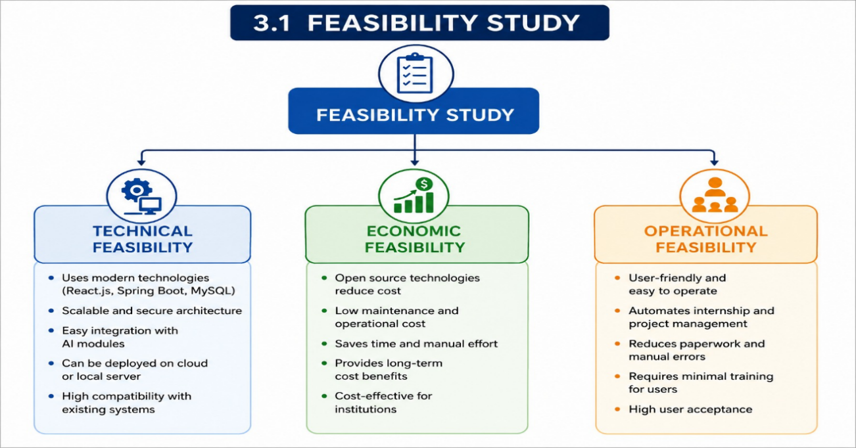

3.1.1 Technical Feasibility
Technical feasibility examines whether the required technologies, tools, and technical expertise are available to develop the proposed system. The AI-Powered Internship & Project Management System is technically feasible because it is built using modern and reliable technologies that are widely used in software development.The frontend of the application is developed using React.js, which provides a responsive and interactive user interface. The backend is implemented using Java Spring Boot, which offers a secure, scalable, and high-performance environment for handling business logic and API development. MySQL is used as the database to store and manage user information, internship details, project records, reports, and system logs efficiently.

The system can be deployed on both local servers and cloud platforms, making it flexible for different organizational requirements. Integration of AI modules for internship recommendations and project suggestions is also technically achievable using existing machine learning libraries and APIs. Since all the required technologies are well-established, open-source, and supported by large developer communities, the proposed system can be developed without significant technical challenges.
3.1.2 Economic Feasibility
Economic feasibility evaluates whether the benefits of the proposed system justify the overall development and maintenance costs. The AI-Powered Internship & Project Management System is economically feasible because it primarily uses open-source software and development frameworks, which eliminate expensive software licensing costs.The implementation of this system significantly reduces manual work involved in internship management, project allocation, report evaluation, and communication between stakeholders. Administrative staff spend less time handling paperwork, while students and mentors can complete most activities online. This reduction in manual effort leads to lower operational costs and improved productivity.
Although some investment is required for system development, hosting, maintenance, and training, these costs are relatively low compared to the long-term benefits. The automation provided by the system improves efficiency, reduces errors, and saves valuable time, making the project economically beneficial for educational institutions.
The proposed AI-Powered Internship & Project Management System (AIPMS) is economically feasible because it automates several time-consuming administrative activities, reducing operational costs and improving overall productivity. The system minimizes the need for manual processes such as attendance management, project monitoring, report generation, and performance evaluation, allowing mentors and administrators to utilize their time more effectively.
By leveraging Artificial Intelligence, cloud technologies, and automated workflows, the system is expected to reduce manual administrative work by approximately 70–80%, leading to significant savings in time and organizational resources. Automated project tracking, AI-generated reports, and intelligent recommendations further reduce the effort required for routine monitoring and decision-making.
The implementation of AIPMS also improves mentor productivity by enabling real-time monitoring of intern performance, automated stand-up analysis, and personalized learning recommendations. These capabilities reduce repetitive tasks while allowing mentors to focus on providing quality guidance and technical support.
The system enhances internship outcomes through continuous performance tracking, AI-assisted mentoring, and data-driven recommendations. This contributes to improved project completion rates, better skill development, and increased organizational efficiency.
Since the platform is designed using scalable open-source technologies such as React, FastAPI, PostgreSQL, Docker, and Kubernetes, software licensing costs are minimized while ensuring flexibility for future expansion. The cloud-ready architecture supports enterprise-scale deployment without requiring significant infrastructure changes, making the system suitable for educational institutions as well as large organizations.
Overall, the long-term benefits of reduced operational costs, improved productivity, faster project tracking, enhanced decision-making, and enterprise scalability outweigh the initial development and deployment costs, making the proposed system economically viable and sustainable.

3.1.3 Operational Feasibility
Operational feasibility determines whether the proposed system can be effectively used by its intended users and whether it supports existing organizational processes. The AI-Powered Internship & Project Management System is designed with a simple, intuitive, and user-friendly interface, making it easy for students, mentors, administrators, and industry partners to use with minimal training.
The platform automates several activities such as internship applications, project allocation, task management, report submission, feedback collection, and progress monitoring. This reduces paperwork, minimizes human errors, and speeds up the overall internship management process. The system also improves communication between all stakeholders through notifications and real-time updates. Since the platform supports daily operational activities while improving efficiency and user satisfaction, it is considered operationally feasible.
3.2 Functional Requirements
Functional requirements define the specific features and services that the system must provide to satisfy user needs. These requirements describe what the system should do and how users interact with it. The AI-Powered Internship & Project Management System provides a secure user registration and login mechanism, allowing users to create accounts and access the platform safely.

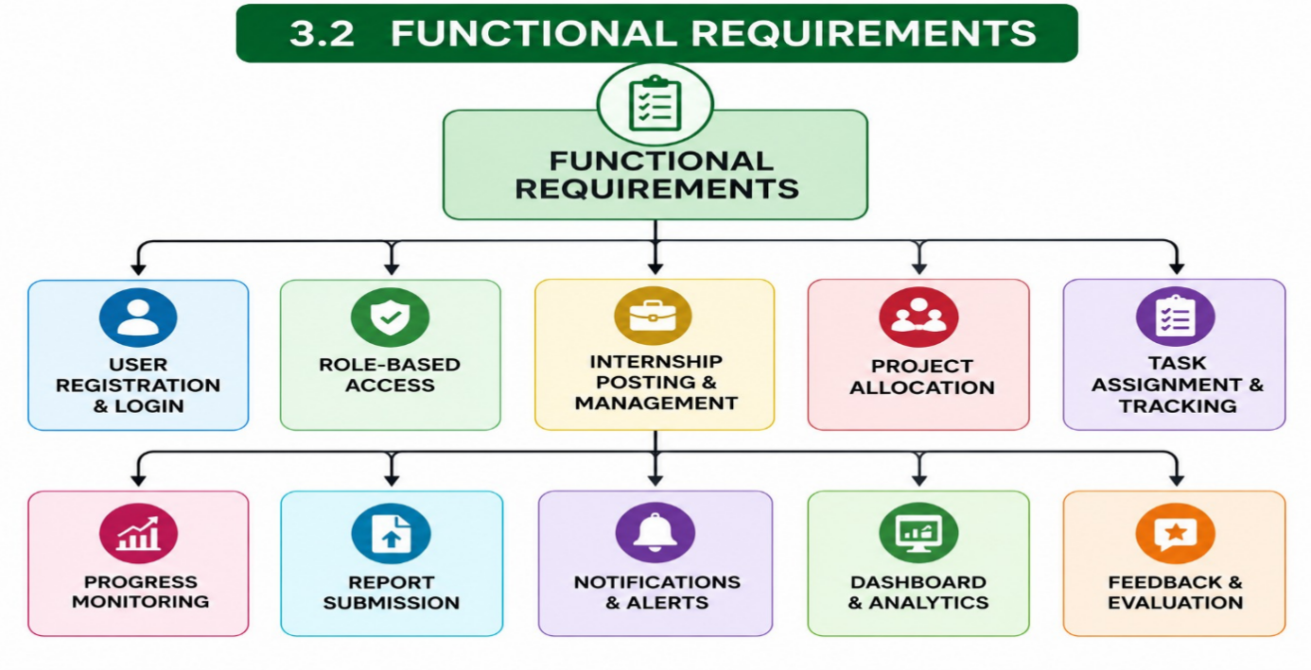
The system allows organizations to post internship opportunities, while students can browse, apply for, and track internship applications. Administrators and mentors can create projects, assign them to students, define project milestones, and monitor progress throughout the internship period. Students can upload reports, submit project documents, and receive feedback from mentors through the platform. AI-based recommendation features analyze student profiles, interests, and skills to suggest suitable internships and projects, helping students make informed career decisions.
The system also includes notification services that remind users about deadlines, meetings, report submissions, and important announcements. A comprehensive dashboard displays internship statistics, project progress, student performance, and analytical reports, enabling administrators to make better decisions. Overall, these functional requirements ensure efficient management of internships and projects from beginning to completion.
3.3 Non-Functional Requirements
Non-functional requirements describe the quality characteristics of the system rather than its specific functions. These requirements ensure that the application performs efficiently, securely, and reliably under different operating conditions.The system should provide high performance, allowing users to access information quickly without unnecessary delays. Even when many users access the platform simultaneously, response times should remain fast.
Security is one of the most important requirements. The platform must implement secure authentication, role-based authorization, password encryption, and protected communication channels to safeguard sensitive user information. Personal data, internship records, and project documents should remain confidential and protected from unauthorized access.Reliability ensures that the system functions consistently without frequent failures or downtime. The platform should maintain stable operation even during heavy usage.
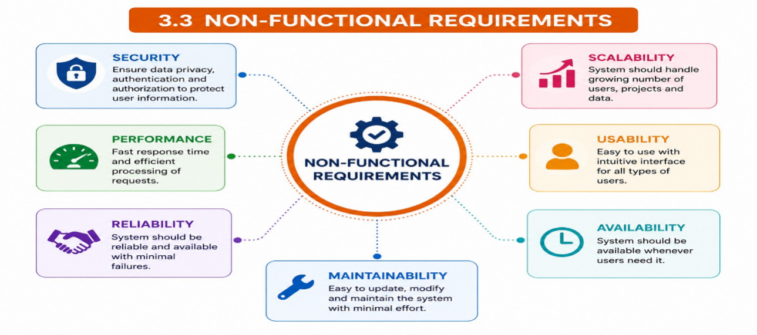
Scalability allows the application to support increasing numbers of users, internships, projects, and organizations without reducing system performance. As the institution grows, the software should continue operating efficiently. Usability focuses on providing a clean, attractive, and easy-to-use interface that enables users with different technical backgrounds to perform tasks comfortably. Availability ensures that the system remains accessible whenever users need it.
Maintainability allows developers to update, improve, and fix the system efficiently without affecting existing functionalities. Data integrity guarantees that stored information remains accurate, consistent, and protected throughout the system lifecycle.
3.4 Software Requirements
Software requirements specify the operating environment, programming languages, frameworks, databases, and development tools required to build and execute the proposed system.The application can run on Windows 10/11 or Linux operating systems. The user interface is developed using HTML5, CSS3, JavaScript, and React.js, providing a responsive and interactive web experience.
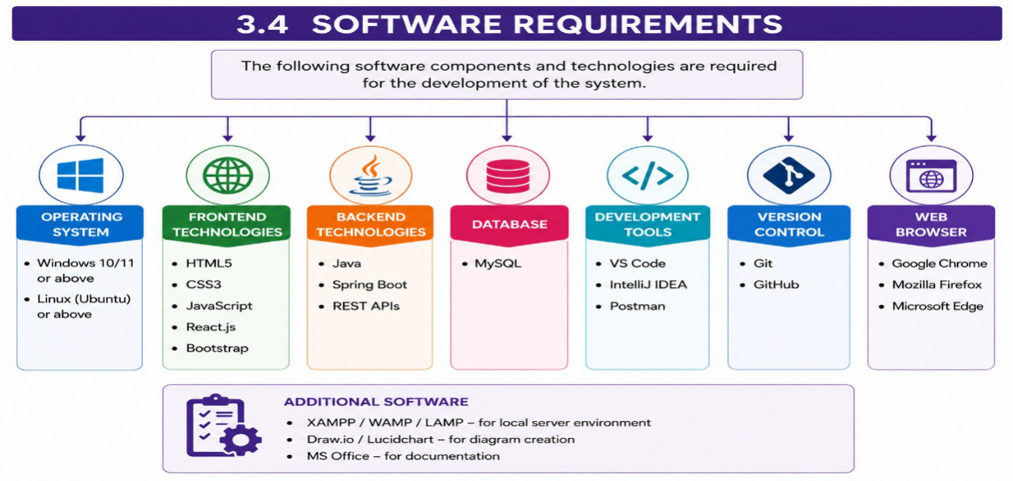

The backend is implemented using Java Spring Boot, which manages application logic, security, APIs, and database communication. MySQL serves as the database management system, storing user profiles, internship records, project details, reports, and other important information securely.
Development is carried out using Visual Studio Code or IntelliJ IDEA, both of which provide efficient coding, debugging, and project management features. Git and GitHub are used for version control, enabling collaborative development and tracking code changes. Postman assists in testing REST APIs during development, while modern web browsers such as Google Chrome and Microsoft Edge provide compatibility for accessing the application.Together, these software tools provide a stable, secure, and scalable environment for developing and maintaining the system.

3.5 Hardware Requirements
Hardware requirements define the minimum computing resources needed to develop, deploy, and operate the AI-Powered Internship & Project Management System efficiently. A computer equipped with an Intel Core i3 processor or higher provides sufficient processing power for software development and application execution. A minimum of 4 GB RAM is required, while 8 GB RAM is recommended for better performance when running development tools and databases simultaneously.
The system requires at least 100 GB of free storage space to accommodate source code, databases, software installations, and project files. A monitor with a resolution of 1366 × 768 pixels or higher ensures comfortable viewing of the application interface. Standard input devices such as a keyboard and mouse are necessary for interacting with the system. Since the platform supports cloud-based communication and real-time updates, a stable internet connection is essential for uninterrupted access and data synchronization.
These hardware specifications ensure that the application performs efficiently during both development and deployment while providing a smooth user interface.sign

4.System Design hapt

4.1 System Architecture
The AI-Powered Internship & Project Management System (AIPMS) employs a highly scalable, decoupled Three-Tier Architecture. This structural pattern separates the application into three logical layers: the Presentation Layer (Frontend), the Application/Logic Layer (Backend), and the Data Layer (Database). This ensures independent maintainability, modular updates, and optimized resource allocation.

Database Relational Entity Relationship Concept. Source:islander11 / Getty Images

4.4.1 Entity Relationship Definitions & Mappings
The system utilizes structural tables linked together through precise cardinality relationships:
Users to Roles (Many-to-One): Each user possesses a single specified security access clearance level (role), determining system routing permissions.
Projects to Teams (One-to-Many): A structured project hosts multiple registered users grouped into distinct work categories.
Interns to Daily Stand-ups (One-to-Many): Each intern submits exactly one text-based update diary entry per business day.
Tasks to Interns (Many-to-One): Tasks are owned by exactly one primary assignee inside the sprint backlog.
Stand-ups to AI Insights (One-to-One): Each text entry runs through the NLP
parsing queue to generate a single structured insight record (sentiment, status flags,and
classification labels).

4.4.2 SQL DDL (Database Schema Definitions)

-- Enable UUID extension for robust primary keys
CREATE EXTENSION IF NOT EXISTS "uuid-ossp";

-- 1. ROLES TABLE
CREATE TABLE roles (
role_id INT GENERATED ALWAYS AS IDENTITY PRIMARY KEY,
role_name VARCHAR(50) UNIQUE NOT NULL CHECK (role_name IN ('Admin', 'Mentor', 'Intern', 'Project_Manager'))
);

-- 2. USERS TABLE (Role-Based Access Control)
CREATE TABLE users (
user_id UUID DEFAULT uuid_generate_v4() PRIMARY KEY,
first_name VARCHAR(50) NOT NULL,
last_name VARCHAR(50) NOT NULL,
email VARCHAR(100) UNIQUE NOT NULL,
password_hash VARCHAR(255) NOT NULL,
role_id INT NOT NULL REFERENCES roles(role_id) ON DELETE RESTRICT,
created_at TIMESTAMP WITH TIME ZONE DEFAULT CURRENT_TIMESTAMP,
updated_at TIMESTAMP WITH TIME ZONE DEFAULT CURRENT_TIMESTAMP
);

-- 3. PROJECTS TABLE
CREATE TABLE projects (
project_id UUID DEFAULT uuid_generate_v4() PRIMARY KEY,
title VARCHAR(150) NOT NULL,
description TEXT,
start_date DATE NOT NULL,
end_date DATE,
status VARCHAR(30) DEFAULT 'Not Started' CHECK (status IN ('Not Started', 'In Progress', 'On Hold', 'Completed')),
created_by UUID REFERENCES users(user_id) ON DELETE SET NULL,
created_at TIMESTAMP WITH TIME ZONE DEFAULT CURRENT_TIMESTAMP
);

-- 4. PROJECT ASSIGNMENTS (Junction Table for Teams)
CREATE TABLE project_assignments (
assignment_id UUID DEFAULT uuid_generate_v4() PRIMARY KEY,
project_id UUID NOT NULL REFERENCES projects(project_id) ON DELETE CASCADE,
user_id UUID NOT NULL REFERENCES users(user_id) ON DELETE CASCADE,
assigned_at TIMESTAMP WITH TIME ZONE DEFAULT CURRENT_TIMESTAMP,
CONSTRAINT unique_project_user UNIQUE(project_id, user_id)
);

-- 5. TASKS TABLE (Sprint & Task Management)
CREATE TABLE tasks (
task_id UUID DEFAULT uuid_generate_v4() PRIMARY KEY,
project_id UUID NOT NULL REFERENCES projects(project_id) ON DELETE CASCADE,
title VARCHAR(150) NOT NULL,
description TEXT,
priority VARCHAR(15) DEFAULT 'Medium' CHECK (priority IN ('Low', 'Medium', 'High', 'Critical')),
status VARCHAR(20) DEFAULT 'Todo' CHECK (status IN ('Todo', 'In Progress', 'In Review', 'Done')),
assignee_id UUID REFERENCES users(user_id) ON DELETE SET NULL,
due_date DATE,
created_at TIMESTAMP WITH TIME ZONE DEFAULT CURRENT_TIMESTAMP,
updated_at TIMESTAMP WITH TIME ZONE DEFAULT CURRENT_TIMESTAMP
);

-- 6. ATTENDANCE TABLE (With IP/Geo-fencing support)
CREATE TABLE attendance (
attendance_id UUID DEFAULT uuid_generate_v4() PRIMARY KEY,
user_id UUID NOT NULL REFERENCES users(user_id) ON DELETE CASCADE,
work_date DATE NOT NULL DEFAULT CURRENT_DATE,
clock_in TIMESTAMP WITH TIME ZONE NOT NULL,
clock_out TIMESTAMP WITH TIME ZONE,
ip_address VARCHAR(45),
latitude NUMERIC(9, 6),
longitude NUMERIC(9, 6),
status VARCHAR(15) DEFAULT 'Present' CHECK (status IN ('Present', 'Absent', 'Late', 'Excused')),
CONSTRAINT unique_user_date UNIQUE(user_id, work_date)
);

-- 7. DAILY STAND-UPS TABLE
CREATE TABLE daily_standups (
standup_id UUID DEFAULT uuid_generate_v4() PRIMARY KEY,
user_id UUID NOT NULL REFERENCES users(user_id) ON DELETE CASCADE,
submission_date DATE NOT NULL DEFAULT CURRENT_DATE,
yesterday_tasks TEXT NOT NULL,
today_plan TEXT NOT NULL,
blockers TEXT,
submitted_at TIMESTAMP WITH TIME ZONE DEFAULT CURRENT_TIMESTAMP,
CONSTRAINT unique_user_standup UNIQUE(user_id, submission_date)
);

-- 8. AI SUMMARY / INSIGHTS TABLE (One-to-One mapping with Daily Standup)
CREATE TABLE ai_insights (
insight_id UUID DEFAULT uuid_generate_v4() PRIMARY KEY,
standup_id UUID UNIQUE NOT NULL REFERENCES daily_standups(standup_id) ON DELETE CASCADE,
sentiment_score NUMERIC(3, 2) CHECK (sentiment_score BETWEEN -1.00 AND 1.00), -- NLP Mood
blocker_detected BOOLEAN DEFAULT FALSE,
inferred_progress_percentage INT DEFAULT 0 CHECK (inferred_progress_percentage BETWEEN 0 AND 100),
ai_feedback TEXT,
processed_at TIMESTAMP WITH TIME ZONE DEFAULT CURRENT_TIMESTAMP
);

-- 9. CREATE INDEXES FOR OPTIMIZED RETRIEVAL PERFORMANCE
CREATE INDEX idx_users_email ON users(email);
CREATE INDEX idx_tasks_project ON tasks(project_id);
CREATE INDEX idx_tasks_assignee ON tasks(assignee_id);
CREATE INDEX idx_attendance_user_date ON attendance(user_id, work_date);
CREATE INDEX idx_standups_user_date ON daily_standups(user_id, submission_date);

10.Skills Table
Purpose: Stores technical and soft skills of interns and mentors.
Fields:
Skill_ID (Primary Key)
Skill_Name
Skill_Category
Skill_Level
Created_Date
Advantages:
Enables AI Skill Gap Analysis.
Supports skill-based project allocation.
Recommends personalized learning paths.
11. Teams Table
Purpose: Manages project teams.
Fields:
Team_ID
Team_Name
Team_Leader
Project_ID
Team_Description
Created_Date
Advantages:
Supports collaborative projects.
Tracks team performance.
Simplifies project management.
12. Notifications Table
Purpose: Stores all system notifications.
Fields:
Notification_ID
User_ID
Notification_Type
Message
Status
Created_Time
Advantages:
Sends task reminders.
Attendance alerts.
AI recommendations.
Project updates.
13. Chat Table
Purpose: Stores communication between interns and mentors.
Fields:
Chat_ID
Sender_ID
Receiver_ID
Message
Attachment
Timestamp
Advantages:
Enables real-time communication.
Stores conversation history.
Supports AI chatbot integration.
14. Certificates Table
Purpose: Stores internship completion certificates.
Fields:
Certificate_ID
User_ID
Internship_ID
Certificate_Number
Issue_Date
Verification_Code
Advantages:
Digital certificate generation.
Easy verification.
Secure certificate management.
15. AI Conversations Table
Purpose: Stores AI mentor conversations.
Fields:
Conversation_ID
User_ID
User_Query
AI_Response
AI_Model
Timestamp
Advantages:
Maintains AI chat history.
Improves AI recommendations.
Supports learning analytics.
16. Documents Table
Purpose: Stores uploaded project documents.
Fields:
Document_ID
User_ID
Project_ID
File_Name
File_Type
Upload_Date
Advantages:
Centralized document storage.
Easy document retrieval.
Secure file management.
17. Audit Logs Table
Purpose: Records important user activities.
Fields:
Log_ID
User_ID
Activity
IP_Address
Login_Time
Timestamp
Advantages:
Enhances security.
Tracks user actions.
Supports compliance and auditing.
18. Learning Modules Table
Purpose: Stores learning resources and courses.
Fields:
Module_ID
Module_Name
Category
Difficulty_Level
Duration
Resource_Link
Advantages:
Supports personalized learning.
Tracks learning progress.
AI-based course recommendations.
19. Interview Feedback Table
Purpose: Stores recruitment and interview feedback.
Fields:
Feedback_ID
Candidate_ID
Interviewer_ID
Technical_Score
Communication_Score
HR_Score
Overall_Rating
Remarks
Advantages:
Tracks interview performance.
Helps placement preparation.
Supports AI recruitment analysis.

4.7 Use Case Diagram
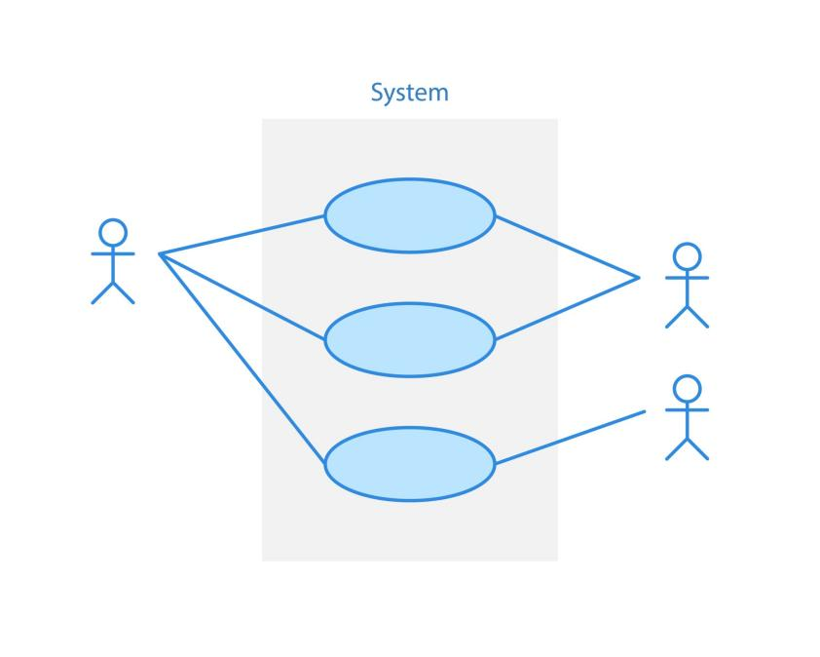
Intern (Primary Actor): Logged-in student managing tasks, submitting attendance, and logging daily updates.
Mentor / Project Manager (Primary Actor): Responsible for tracking progress, reviewing tasks, grading performance, and viewing aggregated summaries.
Administrator (Primary Actor): Manages users, roles, system parameters, databases, and global configuration.
AI Engine Microservice (Supporting System Actor): Processes daily logs to automate sentiment scoring, extraction of blockers, and task matching.
External Geolocation API (Supporting System Actor): Resolves IP address coordinates during the user clock-in To clarify division of responsibilities, operations are divided across four structural swimlanes:
Client Browser (Intern Interface): The React SPA where data input occurs.
Web Application Server (Express API Gateway): Coordinates routing, token authorization, validation, and write operations to the primary relational storage.
AI Microservice (FastAPI NLP Engine): Houses the text-mining logic, transformer model weights, and sentiment algorithms.
Data Store (PostgreSQL): Executes transactional commits, stores records, and serves index-optimized queries.

4.10.2 Step-by-Step Execution Sequence
The operational flow runs through the following stages:
[Start] (Intern Interface)
│
▼
1. Enter Daily Stand-up text fields (Tasks, Today's Plan, Blockers)
│
▼
2. Click "Submit" Button
│
▼
3. Forward HTTPS POST Request to Express Gateway (With JWT Bearer Token)
│
▼
4. [Decision: Is Token Valid?]
├── (No) ──> Return 401 Unauthorized Code ──> [Terminate / Redirect to Login]
└── (Yes) ──> Continue
│
▼
5. Persist raw text submission to PostgreSQL (Table: `daily_standups`)
│
├──────────────────────────────────────────┐
▼ (Primary Return Loop) ▼ (Asynchronous NLP Job Trigger)
6. Send 201 Success Response to Client UI 7. Forward payload to FastAPI Service via HTTP REST
│ │
▼ ▼
8. Update UI state: "Submitted Successfully" 8. Tokenize text inputs & execute Sentiment Classifier
│ │
▼ ▼
[End] 9. Parse text for explicit barrier/blocker phrases
│
▼
10. Write computed parameters to `ai_insights`
│
▼
11. [Decision: Is Blocker Detected OR Score < -0.5?]
├── (Yes) ──> Dispatch Alert notification to Mentor Dashboard
└── (No) ──> Complete process quietly
│
▼
[End]
2. Enhanced Microservices System Architecture
Overview
To support enterprise-scale deployment and AI-driven automation, the AI-Powered Internship & Project Management System (AIPMS) adopts a Microservices-Based System Architecture. Unlike a traditional monolithic architecture, this design divides the application into independent services, each responsible for a specific business function.
The architecture improves scalability, maintainability, security, and performance while enabling seamless integration of Artificial Intelligence (AI), cloud services, and external Large Language Models (LLMs). Communication between services is performed through secure REST APIs and asynchronous messaging.
Architecture Components
1. API Gateway
The API Gateway acts as the single entry point for all client requests. It routes incoming requests to the appropriate backend services while handling authentication, request validation, rate limiting, and load balancing.
Responsibilities
- Route API requests
- Request validation
- Load balancing
- Rate limiting
- API version management
- Logging and monitoring
Benefits
- Simplifies client communication
- Enhances security
- Improves scalability
- Centralizes API management

2. Authentication Service
The Authentication Service manages user identity and access control.
Features
- JWT Authentication
- OAuth2 Single Sign-On (SSO)
- Role-Based Access Control (RBAC)
- Password Encryption (BCrypt)
- Session Management
- Multi-Factor Authentication (Future)
Responsibilities
- User Login
- User Registration
- Token Generation
- Access Validation
- Permission Management
3. AI Service
The AI Service is the core intelligence layer of AIPMS. It integrates with Large Language Models to automate internship and project management activities.
Features
- AI Mentor
- Resume Analysis
- Skill Gap Analysis
- Interview Preparation
- Project Risk Prediction
- Task Prioritization
- Productivity Scoring
- Automatic Report Generation
- AI Chatbot
Responsibilities
- AI inference
- Prompt management
- Model integration
- AI workflow execution
4. Notification Service
The Notification Service delivers real-time notifications to users through multiple communication channels.
Features
- Email notifications
- In-app notifications
- SMS alerts (Future)
- Microsoft Teams notifications
- Slack notifications
- Push notifications (Mobile)
Responsibilities
- Deadline reminders
- Meeting alerts
- Attendance notifications
- Project updates
- AI-generated recommendations
5. File Storage Service
The File Storage Service securely stores and manages all uploaded files.
Supported Files
- Resume documents
- Project documents
- Certificates
- Images
- Reports
- Profile pictures
- Learning materials
Features
- Secure storage
- File versioning
- Cloud backup
- Access control
- Document sharing
6. Redis Cache
Redis improves application performance by storing frequently accessed data in memory.
Uses
- Session storage
- Frequently accessed data
- Authentication tokens
- API response caching
- Temporary AI results
Benefits
- Faster response time
- Reduced database load
- Improved scalability
7. Message Queue (Kafka / RabbitMQ)
The Message Queue enables asynchronous communication between microservices.
Responsibilities
- Background task execution
- Report generation
- Notification processing
- AI request handling
- Email scheduling
- Event processing

Benefits
- Decouples services
- Improves system reliability
- Handles high traffic efficiently
- Enables parallel processing
8. Monitoring Service
The Monitoring Service continuously monitors application health and performance.
Features
- System monitoring
- Performance monitoring
- Error logging
- Health checks
- Resource utilization
- API monitoring
- AI performance monitoring
Benefits
- Early issue detection
- Better system reliability
- Faster troubleshooting
- Improved uptime
9. Vector Database
The Vector Database stores embeddings generated by AI models for semantic search and Retrieval-Augmented Generation (RAG).
Features
- Document embeddings
- Semantic search
- AI knowledge retrieval
- Context-aware responses
- Similarity search
Benefits
- Faster information retrieval
- Better chatbot accuracy
- Enhanced AI recommendations
10. External LLM APIs
The platform integrates with external Large Language Models to provide intelligent automation.
Supported Models
- OpenAI GPT
- Google Gemini
Responsibilities
- Natural Language Processing
- Report generation
- Resume analysis
- Question answering
- AI mentoring
- Project recommendations
Benefits
- Human-like interaction
- Intelligent automation
- Continuous learning support
4.3 Module Design
4.3.1 Multi-Agent AI Module Design
The AI-Powered Internship & Project Management System (AIPMS) incorporates a Multi-Agent AI Architecture to automate internship management and improve decision-making. Unlike a traditional system with a single AI assistant, AIPMS consists of multiple specialized AI agents, where each agent performs a dedicated responsibility while collaborating with other agents through an AI orchestration framework.
This modular approach improves scalability, flexibility, and maintainability while enabling intelligent automation across different business functions.
1. AI Mentor Agent Module
Purpose
Provides personalized mentoring and continuous guidance to interns.
Functions
- Monitor daily stand-up reports
- Analyze intern performance
- Recommend learning resources
- Detect inactive interns
- Identify missed deadlines
- Provide AI-based mentoring
- Answer internship-related questions
Input
- Daily stand-up reports
- Attendance records
- Task completion status

Output

Personalized feedback

Learning recommendations

Performance alerts

2. AI Project Manager Agent Module
Purpose
Automates project planning, monitoring, and risk analysis.
Functions
- Intelligent task assignment
- Project scheduling
- Deadline prediction
- Risk prediction
- Resource allocation
- Workload balancing
Input
- Project details
- Team information
- Task status

Output
- Optimized project plans
- Risk reports
- Task recommendations

3. HR & Attendance Agent Module
Purpose
Automates attendance management and HR-related activities.
Functions
- Attendance tracking
- Leave management
- Working hour calculation
- Attendance analytics
- Employee verification
Input
- Login/Logout records
- Leave requests
Output
- Attendance reports
- Attendance percentage
- HR analytics
4. Recruitment Agent Module
Purpose
Automates recruitment and internship candidate selection.
Functions
- Resume analysis
- Skill extraction
- Candidate ranking
- Internship matching
- Interview recommendations
Input
- Resume
- Candidate profile
Output
- Candidate ranking
- Skill report
- Interview recommendation
5. Learning Agent Module
Purpose
Provides personalized learning recommendations.
Functions
- Skill Gap Analysis
- Learning Path Generation
- Course Recommendation
- Certification Recommendation
Input
- Performance reports
- Skill assessment
Output
- Learning roadmap
- Recommended courses
- Improvement suggestions
6. Report Generation Agent Module
Purpose
Automatically generates reports and dashboards.
Functions
- Daily reports
- Weekly reports
- Monthly reports
- Attendance reports
- Productivity reports
- Executive dashboards
Input
- Attendance
- Tasks
- AI analysis
Output
- PDF reports
- Excel reports
- Analytics dashboard
7. Code Review Agent Module
Purpose
Improves code quality using AI.
Functions
- Code review
- Bug detection
- Coding standard verification
- Best practice suggestions
- Documentation review
Input
- Source code
- GitHub repository
Output
- Code quality score
- Bug report
- Improvement suggestions
8. Admin Agent Module
Purpose
Manages overall platform administration.
Functions
- User management
- Role management
- AI monitoring
- System configuration
- Security monitoring
Input
- User data
- System logs
Output
- Dashboard
- Audit reports
- System analytics

4.3.2 AI Agent Communication
The Multi-Agent AI Architecture is coordinated using an AI orchestration framework that enables communication between specialized AI agents.
Framework | Purpose
LangGraph | Manages workflow execution and communication among AI agents using graph-based orchestration.
CrewAI | Enables collaborative task execution among multiple specialized AI agents.
Microsoft AutoGen | Supports autonomous conversations and coordinated task execution between AI agents.

User Request
│
▼
Supervisor Agent
│
▼
Task Planner Agent
│
▼
Project Manager Agent
│
▼
HR Agent
│
▼
Mentor Agent
│
▼
Reporting Agent
│
▼
Dashboard / User Response

Advantages of the Multi-Agent Module Design

Modular and scalable architecture.

Specialized AI agents for different functionalities.

Reduced manual workload

Improved project and internship management.

Faster response through parallel AI processing.

Better decision-making with AI-driven insights.

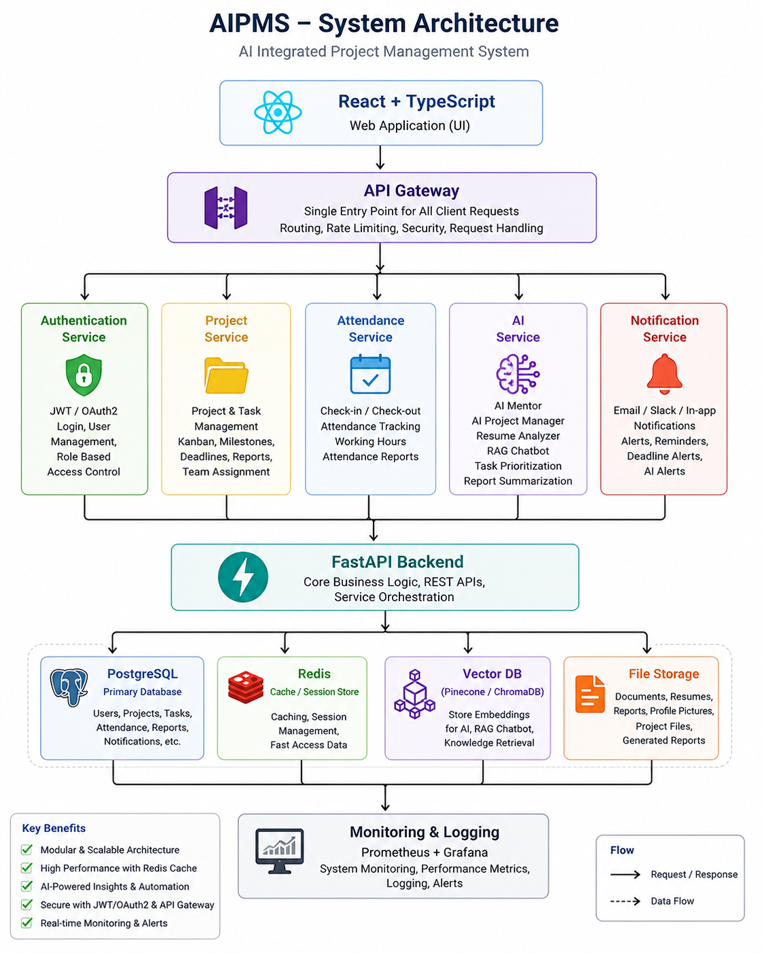

User Login Sequence Diagram
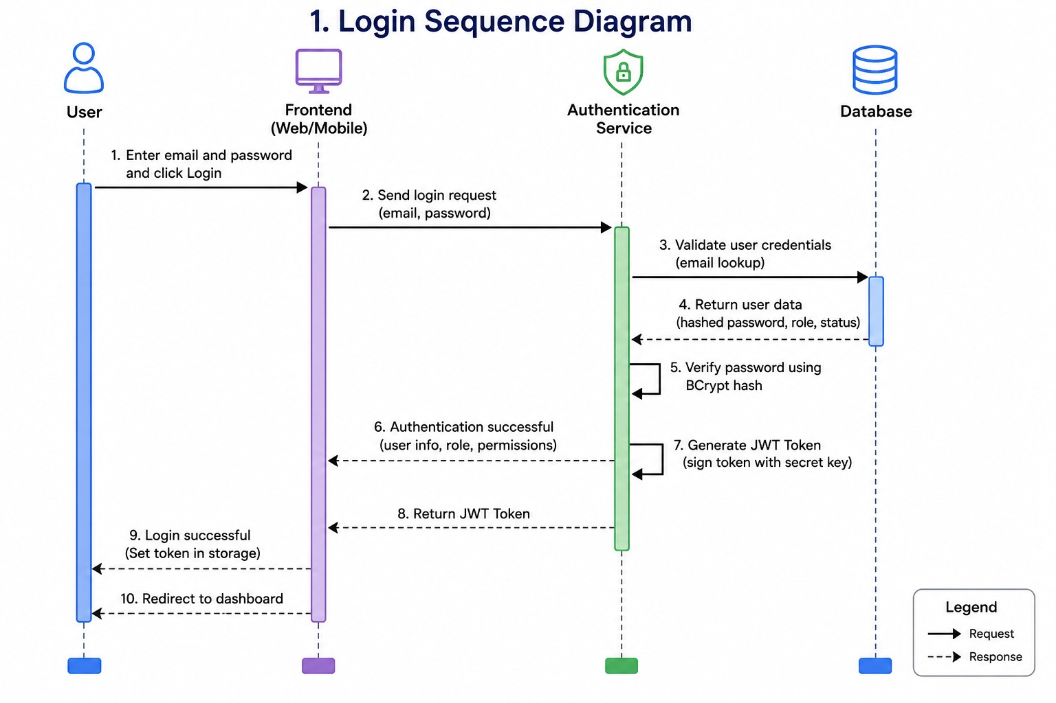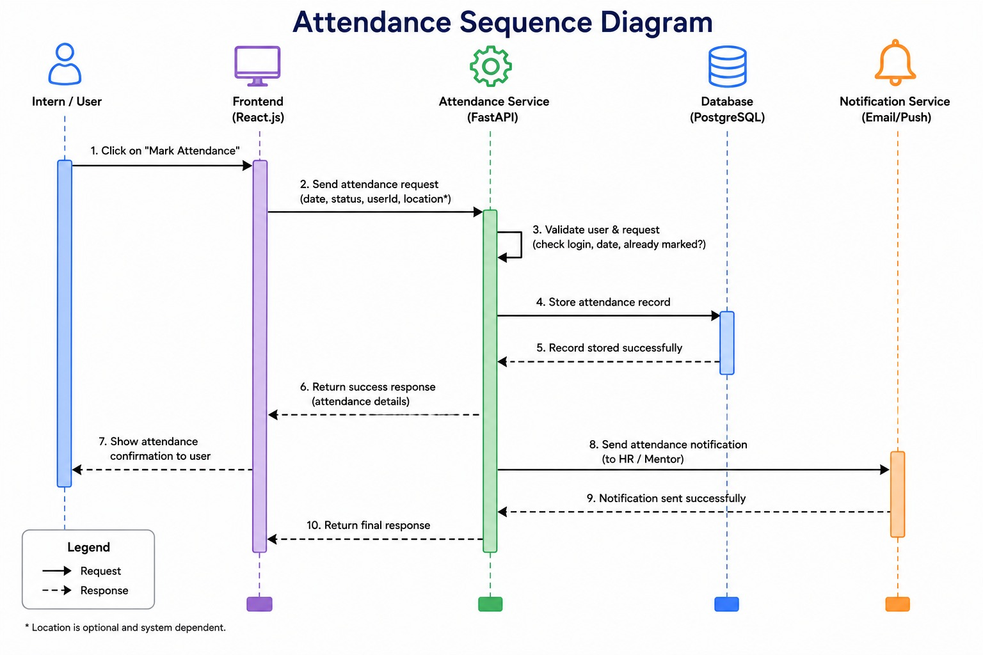Attendance Management Sequence Diagram

Daily Stand-up Submission Sequence Diagram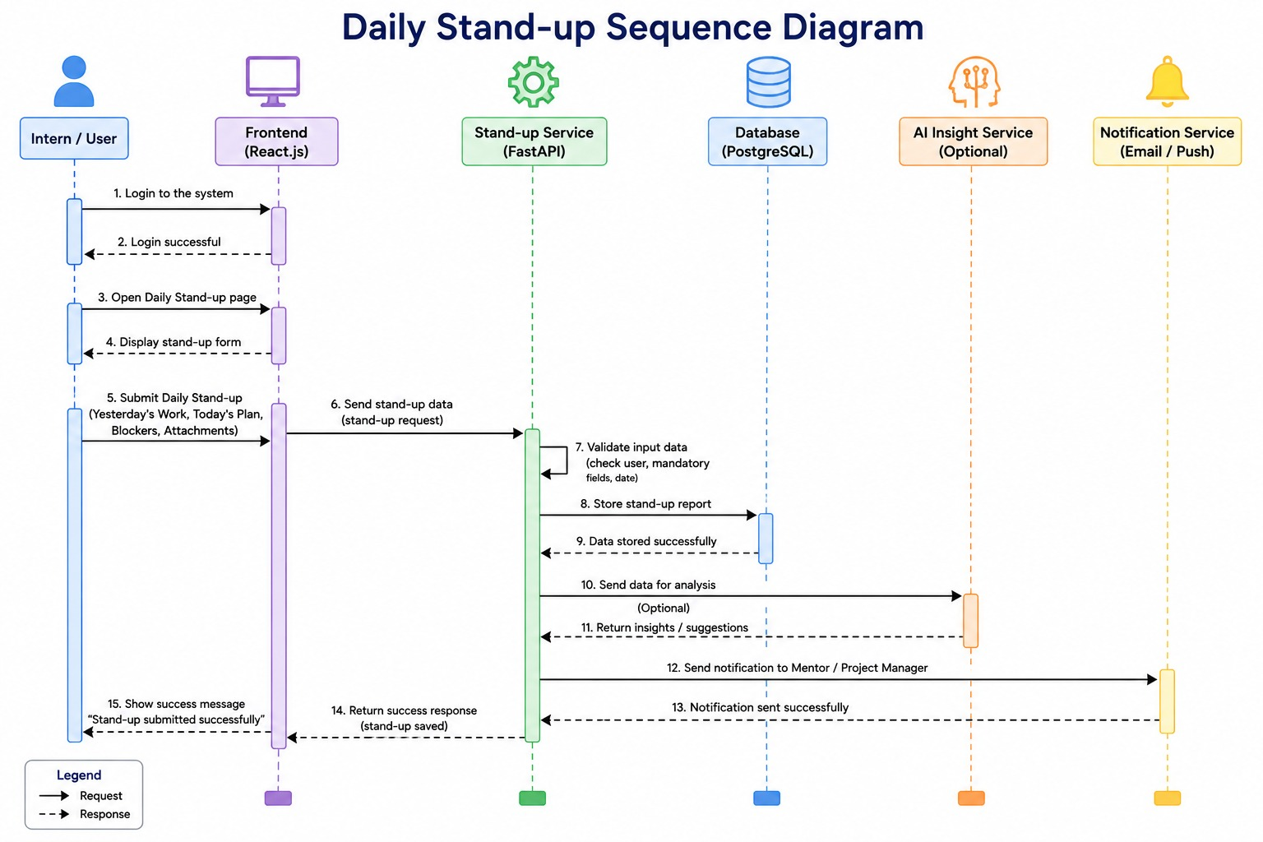

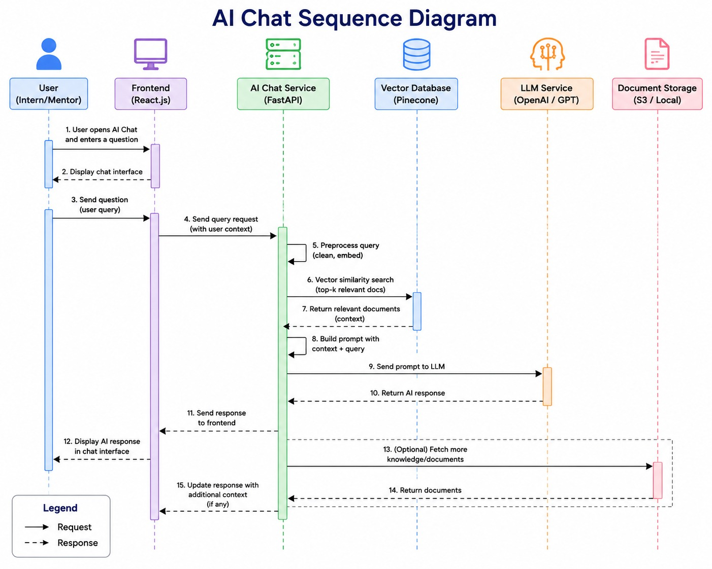

Resume Analysis Sequence Diagram
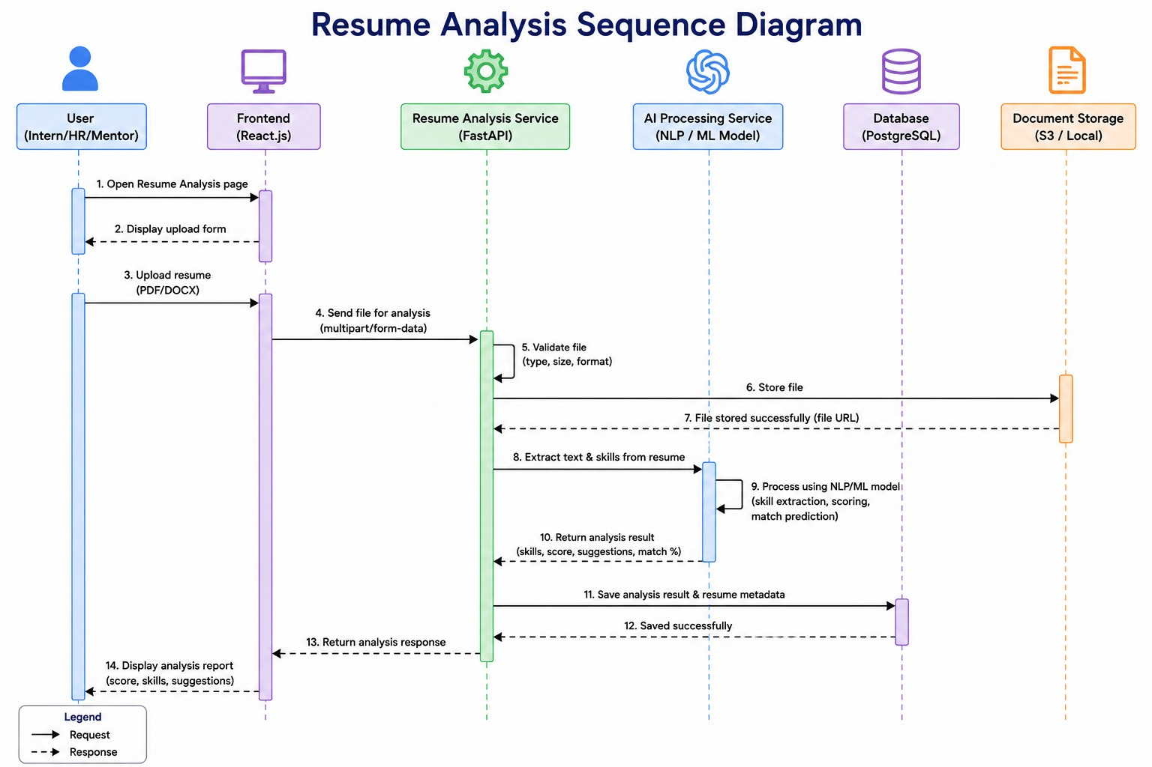
Report Analysis Sequence Diagram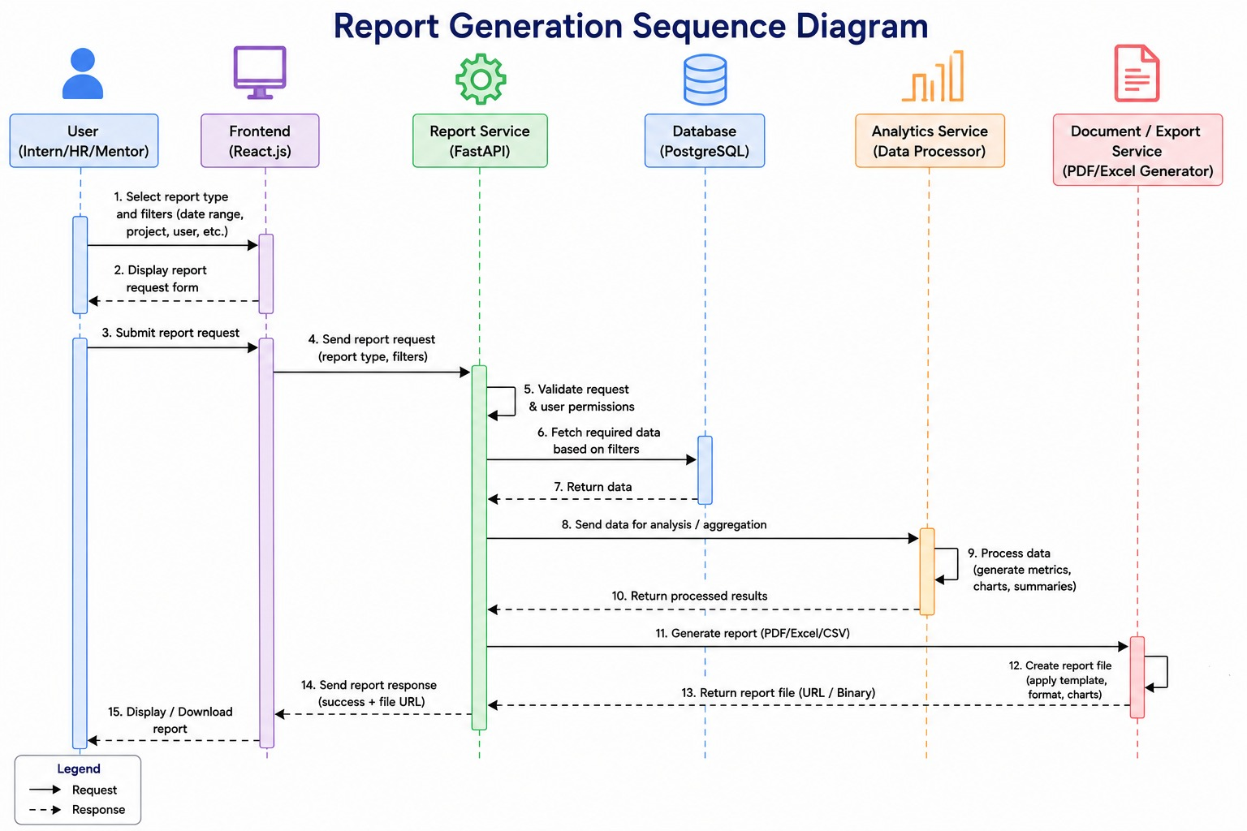

Implementation

5.1.1 Introduction

The AI-Powered Internship & Project Management System (AIPMS) is built using a modern, scalable, and cloud-native technology stack. To maintain architectural consistency and improve maintainability, a single technology stack is used throughout the application. The system follows a client-server architecture with React for the frontend, FastAPI for the backend, PostgreSQL for data management, Redis for caching, OpenAI/Gemini for AI capabilities, and Docker with Kubernetes for deployment.

5.1.2 Frontend Technology

The frontend is developed using React.js with TypeScript, providing a responsive, component-based user interface.

Technogies: React.js

TypeScript

Responsibilities

User authentication

> Dashboard

Project management

Attendance management

AI chatbot interface

Reports and analytics

Responsive user interface

Advantages

Fast rendering

Component reusability

Type safety

Easy maintenance

> Responsive design

5.1.3 Backend Technology

The backend is developed using FastAPI (Python), which provides high-performance REST APIs and seamless integration with AI services.

Responsibilities

REST API development

Authentication

Business logic

AI service integration

Database communication

Notification management

Advantages

High performance

Asynchronous request handling

Automatic API documentation

Easy AI integration

Scalability

5.1.4 Database

The system uses PostgreSQL as the primary relational database.

Stores

User information

Internship details

Attendance

Tasks

Projects

Performance records

Reports

AI-generated data

Advantages

ACID compliance

High reliability

Advanced indexing

Strong security

Excellent scalability

5.1.5 Cache Layer
Redis is used as an in-memory caching solution.
Responsibilities
- Session management
- Frequently accessed data
- API response caching
- Authentication tokens
- Temporary AI responses
Benefits
- Faster response time
- Reduced database load
- Improved system performance

5.1.6 Artificial Intelligence
The AI layer integrates OpenAI GPT or Google Gemini models to provide intelligent automation and decision support.
AI Features
- AI Mentor
- Resume Analysis
- Skill Gap Analysis
- Interview Preparation
- Project Risk Prediction
- Productivity Scoring
- Task Prioritization
- Learning Recommendations
- Automatic Report Generation
Benefits
- Intelligent automation
- Personalized recommendations
- Faster decision-making
- Enhanced user experience

5.1.7 Vector Database
- The system uses Pinecone or ChromaDB as the vector database.
- Responsibilities
- Store document embeddings
- Semantic search
- Retrieval-Augmented Generation (RAG)
- Organization knowledge retrieval
- Benefits
- Faster AI responses
- Organization-specific answers
- Improved search accuracy

5.1.8 Deployment Technologies
- The application is containerized using Docker and orchestrated using Kubernetes.
- Components
- Docker
- Kubernetes
- Nginx
- GitHub Actions
- Prometheus
- Grafana
- ELK Stack
- Benefits
- High availability
- Auto-scaling
- Easy deployment
- Continuous delivery
- Fault tolerance

5.1.9 Cloud Platform
- The platform supports deployment on major cloud providers.
- Supported Platforms
- Amazon Web Services (AWS)
Cloud Services
- Amazon EC2 / Amazon ECS
- Amazon RDS (PostgreSQL)
- Amazon ElastiCache (Redis)
- Amazon S3
- Amazon API Gateway
- Application Load Balancer (ALB)
- AWS Certificate Manager (ACM)
- Amazon CloudWatch
- AWS Identity and Access Management (IAM)
- Amazon Route 53

- Advantages
- Scalability
- High availability
- Disaster recovery
- Global accessibility
- Secure infrastructure
5.2 AI Module
The Artificial Intelligence (AI) Module is the most innovative component of the AI-Powered Internship & Project Management System. It transforms the application from a simple management platform into an intelligent assistant capable of providing personalized guidance, recommendations, automation, and predictive insights.The AI module minimizes manual work by understanding user queries, analyzing historical data, generating reports, recommending internships, and acting as a virtual mentor. It improves decision-making and enhances the learning experience for students.
AI Mentor, Resume Analyzer, Skill Gap Analysis, RAG Knowledge Assistant, AI Interview Preparation, Stand-up Summaries, Risk Prediction, Productivity Scoring, Task Prioritization, Learning Recommendations.
Natural Language Processing (NLP)
Natural Language Processing (NLP) is a branch of Artificial Intelligence that enables computers to understand, process, interpret, and generate human language. It allows users to communicate with the system using everyday language instead of technical commands.In AIPMS, NLP is used to develop an AI Mentor Chatbot that can answer student questions, explain project concepts, recommend learning resources, and provide internship guidance.
5.2.1 Introduction
Artificial Intelligence (AI) serves as the core component of the AI-Powered Internship & Project Management System (AIPMS). Rather than functioning as a simple chatbot, the AI module acts as an intelligent assistant that automates project management, internship monitoring, recruitment, learning support, and decision-making. By leveraging Large Language Models (LLMs) such as OpenAI GPT or Google Gemini along with Retrieval-Augmented Generation (RAG), the system provides personalized recommendations, predictive insights, and real-time assistance to interns, mentors, HR personnel, and administrators.
5.2.2 AI Mentor
The AI Mentor provides 24×7 personalized guidance to interns throughout their internship journey.
Responsibilities
- Answers technical and project-related questions.
- Explains programming concepts and technologies.
- Assists in debugging and resolving coding issues.
- Suggests learning resources and documentation.
- Provides career guidance and interview preparation tips.
- Monitors individual learning progress.
Benefits
- Continuous learning support
- Reduced mentor workload
- Faster problem resolution
- Improved intern engagement
5.2.3 Resume Analyzer
The Resume Analyzer automatically evaluates candidate resumes during recruitment.
Features
- Extracts technical skills and certifications.
- Identifies educational qualifications.
- Detects relevant work or internship experience.
- Matches candidate profiles with project requirements.
- Generates resume scores and rankings.
Benefits
- Faster recruitment process
- Improved candidate selection
- Reduced manual resume screening

5.2.4 Skill Gap Analysis
The Skill Gap Analysis module compares an intern's current competencies with the skills required for assigned projects.
Functions
- Identifies missing technical skills.
- Measures current proficiency levels.
- Suggests personalized learning paths.
- Tracks skill improvement over time.
- Generates progress reports.
Benefits
- Personalized development plans
- Better project assignments
- Continuous skill enhancement
5.2.5 RAG-Based Knowledge Assistant
The Retrieval-Augmented Generation (RAG) Knowledge Assistant provides accurate responses by combining Large Language Models with organizational knowledge stored in a Vector Database (Pinecone or ChromaDB).
Data Sources
- Company documentation
- Project documents
- Standard Operating Procedures (SOPs)
- Internship guidelines
- Technical manuals
- Frequently Asked Questions (FAQs)
Benefits
- Accurate organization-specific answers
- Reduced misinformation
- Faster access to project knowledge
5.2.6 AI Interview Preparation
The AI Interview Preparation module helps interns prepare for technical and HR interviews.
Features
- Technical interview questions
- HR interview simulations
- Coding practice sessions
- Mock interviews
- Communication feedback
- Performance evaluation
Benefits
- Improved interview confidence
- Better placement readiness
- Personalized preparation
5.2.7 Automatic Stand-up Summaries
The AI system automatically generates daily, weekly, and monthly stand-up summaries from intern updates.
Summary Includes
- Completed tasks
- Tasks in progress
- Pending work
- Blockers
- Overall team progress
- Project milestones
Benefits
- Eliminates manual reporting
- Saves mentor time
- Improves project visibility
5.2.8 Project Risk Prediction
The Project Risk Prediction module uses AI and historical project data to identify potential risks before they impact project delivery.
Predictable Risks
- Missed deadlines
- Resource shortages
- Delayed task completion
- Low productivity
- High absenteeism
- Project bottlenecks
Benefits
- Early risk identification
- Improved project planning
- Better resource allocation

5.2.9 Productivity Scoring
AI continuously evaluates intern performance using multiple performance indicators.
Evaluation Parameters
- Attendance percentage
- Task completion rate
- Code quality
- Learning progress
- Participation in stand-ups
- Collaboration and communication
Output
- Individual productivity score
- Team productivity score
- Weekly performance reports
- Improvement recommendations
Benefits
- Fair performance evaluation
- Data-driven decision making
- Increased accountability
5.2.10 AI-Based Task Prioritization
The AI engine intelligently prioritizes project tasks based on urgency, dependencies, deadlines, and available resources.
Priority Levels
- Critical
- High
- Medium
- Low
Factors Considered
- Project deadlines
- Task dependencies
- Team workload
- Risk level
- Resource availability
Benefits
- Efficient project scheduling
- Reduced delays
- Better workload distribution
AI Learning Recommendation module suggests relevant educational resources based on an intern's skills, project requirements, and learning progress.
Recommended Resources
- Online courses
- Documentation
- Coding challenges
- Technical articles
5.3 Personalized Learning Recommendations
- Practice projects
Benefits
- Continuous learning
- Faster skill development
- Improved project performance
AI Processing Pipeline
User Question / Request
│
▼
Generate Embeddings
│
▼
Vector Search
│
▼
Vector Database
(Pinecone / ChromaDB)
│
▼
Retrieve Relevant
Project Documents &
Knowledge Base
│
▼
Combine Context
with User Prompt
│
▼
OpenAI GPT / Gemini
│
▼
AI Response / Answer
5.3.1 AI Workflow
The AI workflow of the Internship Management System defines the sequence of operations performed by the application, beginning with user interaction and ending with the generation of personalised internship recommendations and career guidance. The workflow integrates authentication, data processing, artificial intelligence, machine learning, database management, and notification services to provide an intelligent, secure, and user-friendly experience. Each stage of the workflow contributes to accurate decision-making and continuous improvement of the system.
1.User Interaction
The workflow begins when a user accesses the Internship Management System through a web browser or mobile application. The platform supports multiple user roles, including students, mentors, administrators, and recruiters. Every user is presented with an intuitive dashboard where they can register, log in, upload resumes, search for internships, submit projects, communicate with mentors, and interact with the AI chatbot.
The interface validates user input before sending requests to the backend server, ensuring that incomplete or invalid information is rejected. The frontend communicates with backend APIs using secure HTTPS requests.
Activities
· User registration
· User login
· Resume upload
· Internship search
· Project submission
· Chatbot interaction
· Dashboard access
· Profile management

Input
· Login credentials
· Resume (PDF/DOCX)
· Academic details
· Skills
· Project descriptions
· Career-related questions
Processing
· Form validation
· File upload
· Request generation
· API communication
Output
· Authenticated session
· User dashboard
· Data forwarded to AI engine

5.3.2 Authentication and Authorization
Authentication verifies the identity of every user before granting access to system resources. The application uses secure authentication methods such as JWT (JSON Web Token), OAuth, or Firebase Authentication. User passwords are encrypted before storage, and authentication tokens are generated after successful login.
Role-Based Access Control (RBAC) ensures that users can access only the features and information related to their responsibilities.
User Roles
· Student
· Mentor
· Administrator
· Recruiter
Authentication Process
· User enters login credentials.
· Credentials are validated.
· Password is verified using encryption.
· Authentication token is generated.
· User session begins.

Security Features
· Password hashing
· HTTPS communication
· JWT token validation
· Session timeout
· Multi-factor authentication (optional)
Output
· Secure login
· User permissions
· Protected API access

5.3.3 Data Collection and Pre-processing
After successful authentication, the system collects and processes user information. Resume documents are analysed using document-processing techniques to extract important information such as education, technical skills, certifications, projects, internships, and work experience.
Natural Language Processing (NLP) techniques are applied to clean and organise textual information before sending it to the AI module for analysis.
Tasks Performed
· Resume parsing
· Text cleaning
· Tokenisation
· Stop-word removal
· Keyword extraction
· Skill identification
· Data validation
· Feature extraction
Input
· Resume
· User profile
· Internship preferences
Output
· Structured candidate profile
· Extracted technical skills
· Education details
· Project information

5.3.4 AI Processing and Natural Language Understanding
The Artificial Intelligence engine analyses processed data using Natural Language Processing and Machine Learning algorithms. The AI system understands user queries, identifies career goals, and matches candidate skills with suitable internship opportunities.
Large Language Models (LLMs) provide conversational assistance by answering technical questions, explaining internship requirements, and providing career guidance.
AI Functions
· Resume analysis
· Skill extraction
· Intent recognition
· Semantic search
· Career guidance
· Chatbot conversations
· Project evaluation
AI Technologies
· Natural Language Processing
· Machine Learning
· Deep Learning
· Large Language Models
· Semantic Embeddings
Output
· User skill profile
· Career recommendations
· AI-generated responses

5.3.5 Recommendation Engine
The recommendation engine compares user profiles with available internship opportunities. It considers various factors such as technical skills, educational qualifications, previous projects, certifications, interests, and preferred domains.
Machine Learning ranking algorithms calculate the relevance score and recommend the most suitable internship opportunities.

Matching Parameters
· Skills
· Programming languages
· Academic qualification
· CGPA
· Project experience
· Certifications
· Preferred domain
· Location preference
Recommendation Process
· Analyse candidate profile.
· Search internship database.
· Calculate similarity score.
· Rank internships.
· Generate recommendations.
Output
· Personalised internships
· Matching percentage
· Skill-gap report
· Recommended learning resources

5.3.5 AI Chatbot Assistance
The AI chatbot provides continuous support throughout the internship process. Students can ask career-related questions, receive interview preparation guidance, improve their resumes, and understand technical concepts.
Chatbot Features
· Career guidance
· Resume feedback
· Interview preparation
· Technical doubt clarification
· Internship information
· Frequently asked questions
Output
· Real-time AI responses
· Personalised suggestions
· Career advice

5.3.6 Progress Monitoring
The system monitors internship activities by recording completed tasks, attendance, project submissions, assessments, and mentor feedback. AI analyses performance patterns and provides improvement suggestions.
Tracked Information
· Task completion
· Attendance
· Assignment submissions
· Project milestones
· Assessment scores
· Mentor feedback
AI Analysis
· Performance trends
· Skill improvement
· Weakness identification
· Productivity analysis
Output
· Progress dashboard
· Performance reports
· Improvement recommendations

5.3.7 Feedback Analysis
The system collects feedback from students, mentors, and recruiters. AI uses sentiment analysis techniques to understand user satisfaction and identify areas for improvement.
Feedback Sources
· Student reviews
· Mentor comments
· Recruiter feedback
· Internship ratings
AI Processing
· Sentiment analysis
· Keyword extraction
· Trend detection
· Performance evaluation
Output
· Satisfaction reports
· Improvement suggestions
· System enhancement recommendations

5.3.8 Notification System
The notification system informs users about important updates through email, SMS, or in-application alerts.
Notifications Include
· Internship application status
· Interview schedules
· Assignment deadlines
· Mentor feedback
· AI recommendations
· System announcements
Output
· Real-time alerts
· Reminder notifications
· Status updates
5.3.9 Database Management
The database stores all system information, including user profiles, internship details, AI recommendations, chatbot conversations, assessment records, and progress reports.
Security methods such as encryption, backups, and access control protect data confidentiality and integrity.
Stored Data
· User accounts
· Internship listings
· Resumes
· AI recommendations
· Progress reports
· Feedback
· Chat history
Security Measures
· Data encryption
· Backup and recovery
· Access control
· Audit logs
· Database indexing
5.3.10 Continuous Learning
The AI system improves its performance by learning from user interactions, internship outcomes, recruiter feedback, and changing industry requirements.
Machine Learning models are periodically updated using new data to improve recommendation accuracy and chatbot performance.
Benefits
· Better recommendation accuracy
· Personalised learning paths
· Improved chatbot responses
· Adaptive career guidance
5.4 Final Output
The workflow concludes by providing users with a personalised dashboard containing internship recommendations, career guidance, resume analysis, learning resources, performance reports, and development plans.
The system continuously updates recommendations when users gain new skills, complete projects, upload updated resumes, or receive mentor feedback.
Final Outputs
· Personalised internship recommendations
· Resume analysis report
· Skill-gap analysis
· Career roadmap
· Learning recommendations
· Progress dashboard
· Mentor feedback summary
· AI chatbot assistance
· Performance analytics
· Real-time notifications

Workflow Summary
User → Authentication → Data Collection → Resume Processing → AI Analysis → Recommendation Engine → AI Chatbot → Progress Monitoring → Feedback Analysis → Notification System → Database Storage → Continuous Learning → Personalised Dashboard
This AI workflow enables the Internship Management System to automate internship matching, provide intelligent career guidance, improve decision-making, and enhance the overall user experience through artificial intelligence and machine learning technologies.
5.4.1 AI Workflow
User Interaction
│
▼
Authentication
│
▼
AI Orchestrator (LangGraph / CrewAI)
│
┌──────┼────────┬─────────┬─────────┐
▼ ▼ ▼ ▼ ▼
AI Mentor Resume Analyzer Skill Gap RAG Assistant Interview Prep
│
▼
Project Risk Prediction
│
▼
Task Prioritization
│
▼
Productivity Scoring
│
▼
Learning Recommendation
│
▼
Reports & Dashboard

5.4.2 Benefits of the AI Module
- Provides 24×7 intelligent assistance for interns and mentors.
- Automates recruitment, reporting, and project monitoring.
- Enables personalized learning and skill development.
- Predicts project risks and supports proactive decision-making.
- Reduces manual administrative effort through AI-driven automation.
- Enhances productivity, project success, and internship outcomes.

5.5 API Design
The AIPMS follows a RESTful API architecture where the React frontend communicates with the FastAPI backend using HTTP requests. APIs exchange data in JSON format and are secured using JWT authentication and role-based access control (RBAC).

API Endpoints

Authentication APIs
Method | Endpoint | Description
POST | /api/auth/login | Authenticate user and generate JWT token
POST | /api/auth/register | Register a new user
POST | /api/auth/logout | Logout the authenticated user
GET | /api/auth/profile | Retrieve logged-in user profile

User Management APIs
Method | Endpoint | Description
GET | /api/users | Retrieve all users
GET | /api/users/{id} | Retrieve user details
PUT | /api/users/{id} | Update user information
DELETE | /api/users/{id} | Delete a user

Project Management APIs
Method | Endpoint | Description
POST | /api/projects | Create a new project
GET | /api/projects | Retrieve all projects
GET | /api/projects/{id} | Retrieve project details
PUT | /api/projects/{id} | Update project information
DELETE | /api/projects/{id} | Delete a project

Task Management APIs
Method | Endpoint | Description
POST | /api/tasks | Create a new task
GET | /api/tasks | Retrieve all tasks
GET | /api/tasks/{id} | Retrieve task details
PUT | /api/tasks/{id} | Update task status
DELETE | /api/tasks/{id} | Delete a task

Attendance APIs
Method | Endpoint | Description
POST | /api/attendance/check-in | Record employee check-in
POST | /api/attendance/check-out | Record employee check-out
GET | /api/attendance | Retrieve attendance records

Daily Stand-up APIs
Method | Endpoint | Description
POST | /api/standup | Submit daily stand-up report
GET | /api/standup | Retrieve stand-up history

AI Service APIs
Method | Endpoint | Description
POST | /api/ai/query | Submit AI queries
POST | /api/resume/upload | Upload resume for AI analysis
POST | /api/interview/evaluate | Evaluate interview responses
GET | /api/ai/insights | Retrieve AI-generated insights

Chat APIs
Method | Endpoint | Description
POST | /api/chat | Send a chat message
GET | /api/chat/history | Retrieve chat history

Notification APIs
Method | Endpoint | Description
GET | /api/notifications | Retrieve notifications
PUT | /api/notifications/{id} | Mark notification as read

Dashboard & Reports APIs
Method | Endpoint | Description
GET | /api/dashboard | Retrieve dashboard statistics
GET | /api/reports | Generate project and attendance reports
GET | /api/performance | Retrieve intern performance metrics

API Communication Flow

React + TypeScript
│
HTTP/HTTPS (JSON)
│
API Gateway
│
FastAPI Backend
│
Business Logic
│
PostgreSQL / Redis / Vector DB

5 .6 Introduction
The AI-Powered Internship & Project Management System (AIPMS) is designed to support enterprise-scale deployment using modern DevOps practices and cloud-native technologies. DevOps enables continuous integration, continuous deployment, automated testing, monitoring, and scalable infrastructure management. By containerizing the application and deploying it on cloud platforms, the system becomes highly available, secure, and capable of supporting thousands of concurrent users.

5.6.1 Docker Containerization
Docker is used to package the frontend, backend, database services, and AI components into lightweight containers. Each service runs independently while sharing the same environment across development, testing, and production.
Benefits
- Consistent development environment
- Simplified deployment
- Faster application startup
- Easy scaling of services
- Isolation between application components
5.6.2 Kubernetes Orchestration
Kubernetes manages Docker containers across multiple servers. It automatically deploys, scales, monitors, and recovers application services.
Responsibilities
- Automatic container deployment
- Load balancing
- Auto-scaling
- Self-healing containers
- Rolling updates
- High availability
5.6.3 Continuous Integration & Continuous Deployment (CI/CD)
GitHub Actions is used to automate software delivery.
CI Pipeline
- Source code pushed to GitHub
- Automatic code compilation
- Unit testing
- Integration testing
- Static code analysis
- Docker image creation
CD Pipeline
- Deploy Docker images
- Update Kubernetes cluster
- Automatic rollback on deployment failure
- Production deployment approval
Benefits
- Faster software releases
- Reduced deployment errors
- Continuous software delivery
- Improved code quality

5.6.4 Nginx Reverse Proxy
Nginx acts as the entry point for client requests.
Responsibilities
- Reverse proxy
- Load balancing
- HTTPS termination
- Static file hosting
- API request routing
- Security filtering
Benefits
- Improved performance
- Reduced backend load
- Enhanced security
- Better scalability

5.6.5 Monitoring using Prometheus
Prometheus continuously collects performance metrics from all application services.
Metrics Collected
- CPU utilization
- Memory usage
- API response time
- Database performance
- AI inference time
- Network traffic
- Kubernetes pod health

5.6.6 Grafana Dashboards
Grafana visualizes the metrics collected by Prometheus through interactive dashboards.
Dashboard Features
- Server health monitoring
- User activity statistics
- API performance
- AI response time
- Database performance
- System uptime
- Resource utilization

5.6.7 ELK Stack for Centralized Logging
The ELK Stack provides centralized log management.
Components
Elasticsearch
- Stores and indexes application logs
Logstash
- Collects and processes logs
Kibana
- Visualizes logs and generates reports
Benefits
- Faster issue diagnosis
- Error tracking
- Security auditing
- Performance analysis

5.6.8 Cloud Deployment
The AIPMS platform can be deployed on leading cloud platforms such as Amazon Web Services (AWS).
Cloud Services
- Virtual Machines
- Kubernetes Cluster
- PostgreSQL Database
- Redis Cache
- Object Storage
- Load Balancer
- Monitoring Services
- Backup Services
Advantages
- High availability
- Automatic scaling
- Disaster recovery
- Global accessibility
- Secure infrastructure
- Cost optimization

5.6.9 DevOps Architecture Workflow
Developer
│
▼
GitHub Repository
│
▼
GitHub Actions (CI/CD)
│
▼
Docker Build
│
▼
Docker Registry
│
▼
Kubernetes Cluster
│
┌────┼────┐
▼ ▼ ▼
Frontend Backend AI Service
│
▼
PostgreSQL + Redis + Vector Database
│
▼
OpenAI / Gemini APIs
│
▼
Prometheus + Grafana
│
▼
ELK Stack
│
▼
AWS

5.6.10 Advantages of DevOps & Cloud Deployment
- Faster software development and deployment
- Automated testing and continuous delivery
- High system availability and reliability
- Enterprise-grade scalability
- Real-time monitoring and alerting
- Simplified infrastructure management
- Improved security and disaster recovery
- Better collaboration between development and operations teams
- Support for thousands of concurrent users

5.7 Database Design:

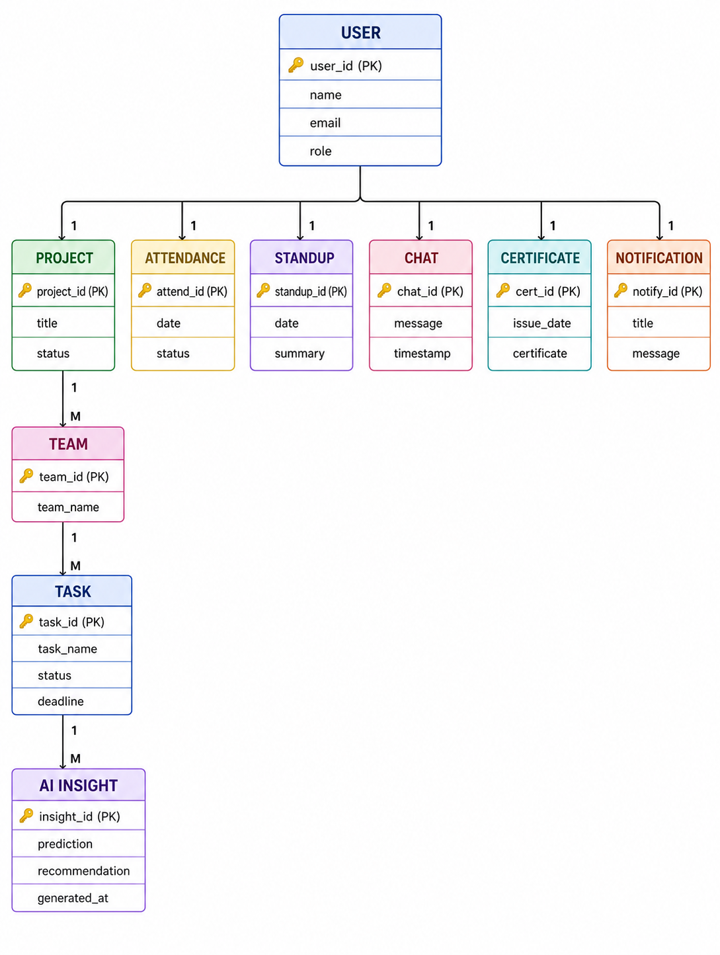
6.Phase-wise Development

6.1 Phase 1 – Pilot
6.1.1 Objective
The Pilot phase is the initial stage of developing the AI-Powered Internship & Project Management System (AIPMS). The primary objective of this phase is to design, develop, and test the core functionalities of the system in a controlled environment with a limited number of users. This phase focuses on validating the system architecture, ensuring the proper functioning of essential modules, and collecting user feedback for future improvements. The pilot implementation helps verify that the system satisfies the fundamental requirements of internship and project management before proceeding to large-scale deployment.
The Pilot phase also establishes a reliable technical foundation for future development. Complex automation is kept limited at this stage so that administrators, mentors, and interns can easily understand the workflows. Feedback from pilot users is documented and used to identify usability issues, missing features, and technical improvements.
6.1.2 Functional Scope
The functional scope of the Pilot phase includes only the essential features required for the first working version of the system.The modules support the basic workflow from user registration and internship assignment to project execution, task tracking, attendance monitoring, daily updates, dashboards, and reports.
User Management Module
• Student (Intern) Registration and Login
• Mentor Registration and Login
• Administrator Login
• Role-Based Access Control
• User Profile Management
Internship Management Module
• Create and Manage Internship Programs
• Assign Interns to Internship Programs
• View Internship Details
• Track Internship Status
Project Management Module
• Create New Projects
• Assign Projects to Interns
• Monitor Project Progress
• Update Project Status
Task Management Module
• Create and Assign Tasks
• Set Task Priorities
• Define Task Deadlines
• Monitor Task Completion Status
Attendance Management Module
• Daily Attendance Recording
• Attendance History
• Attendance Percentage Calculation
Daily Stand-up Module
• Daily Work Update Submission
• Blocker Reporting
• Mentor Review of Daily Updates
AI Recommendation Module
• Recommend Task Priorities
• Suggest Upcoming Deadlines
• Generate Basic Task Summaries
• Provide Simple Productivity Suggestions
Dashboard Module
- Mentor Dashboard
- Admin Dashboard
- Intern Dashboard
- Overall Internship Progress
- Task Completion indicators
- Attendance Summary
Report Generation Module
• Attendance Report
• Weekly Progress Report
• Task Completion Report
• Project Progress Report
6.1.3 Technology Stack
The Pilot phase utilizes a modern and scalable technology stack for efficient development and future enhancements.
Frontend
• React + TypeScript
Backend
• Python FastAPI
Database
• PostgreSQL (Primary Database)
Artificial Intelligence
• Python
• Pandas
• Scikit-learn
• Natural Language Processing (NLP)
• OpenAI API (Optional)
Development Tools
• Visual Studio Code
• Git
• GitHub
• Postman
• Chrome Browser
Testing
- Unit Testing
- Integration Testing
- Basic User Acceptance Testing
6.1.4 Deliverables
At the completion of the Pilot phase, the following deliverables are expected.
• A fully functional authentication system with role-based access.
• Internship management module for creating and assigning internships.
• Project management module for managing projects and monitoring progress.
• Task management module with task assignment, deadline management, and tracking.
• Attendance management system with attendance recording and history.
• Daily stand-up reporting module for interns and mentors.
• Basic AI recommendation module for task prioritization and productivity suggestions.
• Interactive dashboards for Admin, Mentor, and Intern users.
• Report generation module for attendance, task completion, and project progress.
• Initial database with sample records for testing.
• Working prototype ready for pilot testing and evaluation.
6.1.5 Exit Criteria
The Pilot phase will be considered successfully completed when the following conditions are satisfied.
• All planned core modules are developed and integrated successfully.
• Authentication and role-based access control operate correctly.
• Internship and project information can be created, managed, and updated.
• Tasks can be assigned, monitored, and completed without errors.
• Attendance records are stored and retrieved accurately.
• Daily stand-up reports are submitted and reviewed successfully.
• AI recommendations provide meaningful task prioritization and summaries.
• Reports are generated correctly for all required modules.
• Unit testing and integration testing are completed with no critical defects.
• The system is stable and ready for evaluation by a limited group of users before proceeding to the Scale-Up phase.

6.2 Phase 2 – Scale-Up
6.2.1 Objective
The Scale-Up phase focuses on enhancing the AI-Powered Internship & Project Management System (AIPMS) by introducing advanced features, improving system performance, and supporting a larger number of users. The primary objective of this phase is to strengthen collaboration among administrators, mentors, and interns while improving AI-powered functionalities and preparing the system for deployment across multiple departments or organizations.
6.2.2 Functional Scope
The functional scope of the Scale-Up phase extends the Pilot version by incorporating additional features that improve usability, efficiency, and scalability.

User Management Module
- Multi-Department User Management
- Advanced Role-Based Access Control
- User Profile Update
- Password Recovery and Account Management
- Department-Level Permissions
- User Activity Tracking
Internship Management Module
- Internship Approval Workflow
- Internship Progress Tracking
- Batch-Wise Internship Management
- Internship Completion Certificate Generation
- Automated Onboarding and Offboarding
- Internship Evaluation and Feedback
Project Management Module
• Team-Based Project Management
• Project Milestone Tracking
• Project Document Upload and Sharing
• Project Progress Analytics
Task Management Module
• Recurring Task Assignment
• Task Dependency Management
• Automated Task Notifications
• Task Performance Monitoring
Attendance Management Module
• Attendance Analytics Dashboard
• Leave Request and Approval
• Monthly Attendance Reports
• Attendance Performance Analysis
Daily Stand-up Module
• Daily Work Log Management
• Mentor Feedback System
• Weekly Stand-up Summary
• Work History Tracking
AI Recommendation Module
• Smart Task Prioritization
• Personalized Learning Recommendations
• AI-Based Productivity Analysis
• Risk Prediction for Delayed Tasks
Dashboard Module
• Advanced Analytics Dashboard
• Department-wise Performance Dashboard
• Mentor Performance Dashboard
• Internship and Project Progress Visualization
Report Generation Module
• Internship Performance Report
• Team Performance Report
• Mentor Evaluation Report
• Monthly and Semester Reports
• Export Reports in PDF and Excel Formats
6.2.3 Technology Stack
The Scale-Up phase utilizes enhanced technologies to improve system scalability, security, and performance.
Frontend
• React.js + TypeScript
Backend
• Python FastAPI
Database
• PostgreSQL
Artificial Intelligence
• Python
• Pandas
• Scikit-learn
• Natural Language Processing (NLP)
• OpenAI API
• Machine Learning Models
Development Tools
• Visual Studio Code
• Git
• GitHub
• Postman
• Docker
Security
- Token-Based API Authentication
- Permission Controls
- Input Validation
6.2.4 Deliverables
At the completion of the Scale-Up phase, the following deliverables are expected.
• Enhanced internship management module.
• Team-based project management system.
• Advanced task management with automated notifications.
• Attendance analytics and leave management module.
• AI-powered recommendation and productivity analysis module.
• Advanced dashboards with analytical reports.
• Report generation with PDF and Excel export.
• Secure REST APIs for system integration.
• Optimized database supporting a large number of users.
• Stable application ready for enterprise-level testing.
6.2.5 Exit Criteria
The Scale-Up phase will be considered successfully completed when the following conditions are satisfied.
• All advanced modules are implemented and integrated successfully.
• The system supports multiple departments and a larger number of users.
• AI recommendation features operate accurately and efficiently.
• Advanced dashboards display real-time project and internship analytics.
• Reports are generated correctly in PDF and Excel formats.
• Performance testing confirms system scalability and stability.
• Security testing validates authentication and data protection mechanisms.
• User Acceptance Testing (UAT) is completed successfully.
• The system is ready to proceed to the Enterprise Scale phase.

6.3 Phase 3 – Enterprise Scale
6.3.1 Objective
The Enterprise Scale phase is the final stage of developing the AI-Powered Internship & Project Management System (AIPMS). The primary objective of this phase is to deploy the system at an enterprise level by enhancing scalability, security, reliability, and advanced AI capabilities. This phase enables the system to support multiple organizations, departments, mentors, and interns while ensuring high performance, seamless integration, and efficient project and internship management.
6.3.2 Functional Scope
The functional scope of the Enterprise Scale phase focuses on implementing enterprise-level features for large-scale deployment.
User Management Module
- Multi-Organization User Management
- Single Sign-On (SSO) Authentication
- Advanced Role and Permission Management
- User Activity Monitoring
- Centralized Identity Management
Internship Management Module
• Multi-Organization Internship Management
• Internship Performance Analytics
• Automated Internship Completion Process
• Digital Certificate Generation
Project Management Module
• Enterprise Project Portfolio Management
• Cross-Team Project Collaboration
• Advanced Project Performance Analytics
• Resource Allocation and Planning
Task Management Module
• AI-Based Task Scheduling
• Automated Task Assignment
• Real-Time Task Tracking
• Advanced Task Performance Analytics
Attendance Management Module
• Biometric and QR Code Attendance Integration
• Real-Time Attendance Monitoring
• Attendance Analytics Dashboard
• Automated Attendance Reports
Daily Stand-up Module
• AI-Based Daily Stand-up Summary
• Automated Progress Tracking
• Team Performance Monitoring
• Workload Analysis
AI Recommendation Module
• AI Mentor Assistance
• Predictive Project Risk Analysis
• Intelligent Resource Recommendations
• AI-Based Performance Evaluation
Dashboard Module
• Enterprise Analytics Dashboard
• Organization-Wide Performance Dashboard
• Real-Time Monitoring Dashboard
• Executive Decision Support Dashboard
Report Generation Module
• Enterprise Performance Reports
• Organization Analytics Reports
• AI-Based Performance Reports
• Custom Report Generation
• Automated PDF and Excel Reports
6.3.3 Technology Stack
The Enterprise Scale phase utilizes enterprise-grade technologies to support high availability, scalability, and security.

Frontend
• React+TypeScript
Backend
• Python FastAPI
Database
• PostgreSQL
Artificial Intelligence
• Python
• Pandas
• Scikit-learn
• Natural Language Processing (NLP)
• OpenAI API
• Machine Learning Models
Cloud & Deployment
• Docker
• Kubernetes
• AWS
Development Tools
• Visual Studio Code
• Git
• GitHub
Reliability
- Load Balancing
- Monitoring
- Centralized Logging
- Automated Backup and Recovery

6.3.4 Deliverables
At the completion of the Enterprise Scale phase, the following deliverables are expected.
• Fully deployed enterprise-level internship and project management system.
• AI-powered project and internship monitoring.
• Enterprise analytics dashboards with real-time insights.
• Multi-organization management support.
• Advanced security and authentication mechanisms.
• Automated AI-based reporting and performance analysis.
• Cloud-ready and scalable application deployment.
• REST API integration with external systems.
• High-performance database supporting thousands of users.
• Production-ready application for enterprise deployment.
6.3.5 Exit Criteria
The Enterprise Scale phase will be considered successfully completed when the following conditions are satisfied.
• All enterprise-level modules are fully implemented and integrated.
• The system supports multiple organizations and a large number of concurrent users.
• AI-powered recommendations and analytics operate accurately and efficiently.
• Cloud deployment is completed successfully.
• Security, performance, and scalability testing are completed without critical issues.
• All enterprise dashboards and reports function correctly.
• The application meets production-quality standards.
• Final User Acceptance Testing (UAT) is completed successfully.
• The system is fully operational and ready for real-world enterprise.
6.4 Phase 4 – Intelligent Enterprise AI Platform
6.4.1 Objective
The objective of Phase 4 is to transform the AI-Powered Internship & Project Management System (AIPMS) into a fully intelligent enterprise platform. This phase focuses on integrating advanced Artificial Intelligence, automation, predictive analytics, and enterprise collaboration tools to improve efficiency, scalability, and decision-making. The system will support large organizations with thousands of users while reducing manual work through intelligent automation.
6.4.2 Functional Scope
The Phase 4 implementation includes the following advanced features:
Multi-Agent AI System
- AI Mentor Agent
- Project Manager Agent
- HR & Attendance Agent
- Recruitment Agent
- Learning Agent
- Report Generation Agent
- Code Review Agent
- Admin Agent
Each AI agent performs a specialized task while collaborating with other agents to automate workflows.
Autonomous Workflow Management
- Automatic task assignment
- Smart project scheduling
- Deadline monitoring
- Automatic reminder generation
- AI-based workload balancing .
Predictive Analytics
- Predict internship completion rates
- Predict project success
- Identify project risks
- Forecast resource requirements
- Predict intern performance .
AI Decision Support
- Recommend the best project allocation
- Suggest learning paths
- Recommend recruitment decisions
- Generate management reports
- Provide intelligent insights for administrators.
Executive Dashboards
- Real-time analytics
- Productivity reports
- Attendance statistics
- AI performance metrics
- Placement analytics
- Project completion statistics.
Cross-Organization Collaboration
- Support multiple organizations
- Shared internship opportunities
- Industry collaboration
- Mentor collaboration
- Cross-team project management.
Enterprise Integrations
- HRMS Integration
- LMS Integration
- Microsoft Teams Integration
- Slack Integration
- GitHub Integration
- Google Calendar Integration
- Email and Notification Services.
6.4.3 Technologies Used
The enterprise platform may use:
- React + TypeScript
- FastAPI (Python)
- PostgreSQL
- Redis
- Docker
- Kubernetes
- OpenAI/Gemini
- Pinecone/ChromaDB
- LangGraph
- AWS
- Centralized Logging and Alerting
6.4.4 Expected Outcomes
After the successful implementation of Phase 4, the AI-Powered Internship & Project Management System (AIPMS) is expected to deliver significant operational, educational, and business benefits through intelligent automation and advanced Artificial Intelligence capabilities. The expected outcomes are as follows:
- Reduce manual work by 70–80% through AI-driven automation of attendance management, project monitoring, report generation, task scheduling, and administrative processes.
- Improve mentor productivity by automating intern monitoring, performance evaluation, stand-up analysis, and report preparation, allowing mentors to focus on guidance and skill development.
- Increase project completion rates by enabling intelligent task prioritization, proactive risk prediction, workload balancing, and real-time project tracking.
- Provide faster AI-based recommendations for project allocation, learning paths, recruitment decisions, and performance improvement, enabling quicker and more effective decision-making.
- Enhance internship management efficiency through continuous performance monitoring, personalized AI mentoring, automated notifications, and progress analytics.
- Support enterprise-scale deployments with a scalable cloud-native architecture capable of managing multiple organizations, departments, mentors, interns, and thousands of concurrent users.
- Improve collaboration across organizations by supporting cross-team project management, shared internship opportunities, centralized communication, and seamless enterprise integrations.
- Enable data-driven decision-making using AI-powered dashboards, predictive analytics, executive reports, and real-time performance metrics to support strategic planning and resource optimization.
Overall, Phase 4 transforms AIPMS into an intelligent enterprise platform that improves operational efficiency, enhances user productivity, delivers better internship outcomes, and provides a scalable foundation for future AI-driven innovation.
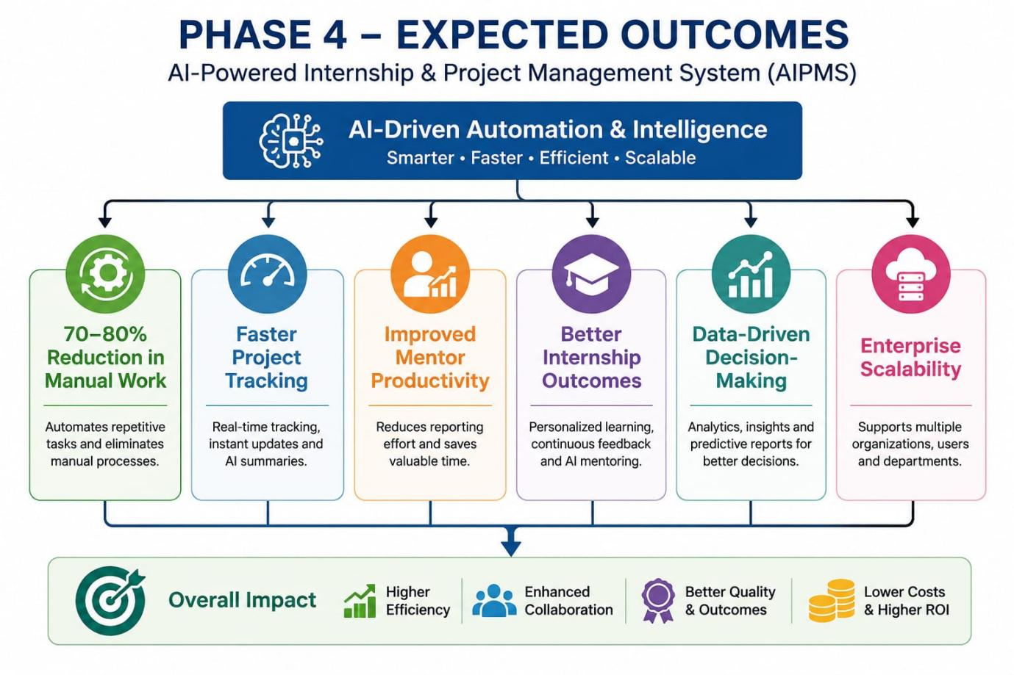

After implementing Phase 4, the system is expected to:
- Reduce manual work by 70–80%
- Improve mentor productivity
- Increase project completion rates
- Provide faster AI-based recommendations
- Enhance internship management efficiency
- Support enterprise-scale deployments
- Improve collaboration across organizations
- Enable data-driven decision-making .

6.4.5 Future Scope
Future enhancements may include:
- Voice AI Mentor
- Mobile application (Android & iOS)
- QR/Biometric Attendance
- Digital Certificate Verification
- AI-powered recruitment automation
- Advanced cybersecurity features
- Multilingual AI support
- Blockchain-based certificate verification
- IoT integration for smart attendance
- AI-Based Career Guidance
- Skill-Gap Analysis and Personalized Learning
- Advanced Compliance and Audit Automation

6.5 Cross-Phase Supporting Improvements

The following supporting areas should be implemented progressively across all phases.These topics are directly related to the functional scope and ensure that AIPMS remains secure, reliable, maintainable, and ready for future expansion.

6.5.1 Security and Privacy

- Role-Based and Permission-Based Access
- SSO for Enterprise Deployments
- HTTPS and Encrypted Communication
- Secure API Authentication
- Input Validation

6.5.2 Testing and Quality Assurance

- Unit Testing
- Integration Testing
- API Testing
- System Testing
- User Acceptance Testing

6.5.3 Data Management
- Structured Database Design
- Validation Rules and Constraints
- Database Indexing
- Created and Updated Timestamps
- Audit Logs

6.5.4 Deployment and DevOps

- Separate Development, Testing, Staging, and Production Environments
- Git Version Control
- Docker-Based Deployment
- Automated Backups
- Rollback Procedures

6.5.5 Monitoring and Analytics

- API Response-Time Monitoring
- Database Performance Monitoring
- Error Tracking
- Security Event Monitoring
- User Activity Analytics
- AI Recommendation Performance

    - Responsible AI and Governance

- Human Oversight for High-Impact Decisions
- Explainable AI Recommendations
- AI Accuracy Monitoring
- Bias Evaluation
- Logs for Important AI Actions

TESTING
7.1 Testing Strategy
The AIPMS application was tested using a structured testing approach to ensure that all modules function correctly and meet the project requirements. Testing was performed at multiple levels, including Unit Testing, Integration Testing, and System Testing.
The main objectives of testing were:
- Verify that each module functions correctly.
- Ensure smooth communication between frontend, backend, and database.
- Validate user authentication and authorization.
- Test AI-generated summaries and reports.
- Identify and fix defects before deployment.
- Ensure system reliability, performance, and security.
7.2 Test Cases
Test Case ID | Test Scenario | Expected Result | Status
TC-01 | User Login | User logs in successfully with valid credentials | Pass
TC-02 | Invalid Login | Display "Invalid Username or Password" | Pass
TC-03 | Google OAuth Login | User authenticated successfully | Pass
TC-04 | Create Project | Project created successfully | Pass
TC-05 | Assign Task | Task assigned to intern | Pass
TC-06 | Submit Daily Stand-up | Stand-up saved successfully | Pass
TC-07 | Attendance Login | Login time recorded | Pass
TC-08 | Attendance Logout | Logout time recorded | Pass
TC-09 | AI Daily Summary | AI generates project summary | Pass
TC-10 | Dashboard Loading | Dashboard displays correct information | Pass
TC-11 | Notification | Email/Slack notification sent | Pass
TC-12 | Performance Report | Report generated successfully | Pass

7.3 Unit Testing
Unit testing was conducted to verify the functionality of individual modules independently.
Modules tested include:
- Authentication Module
- User Management Module
- Attendance Module
- Project Management Module
- Task Management Module
- Daily Stand-up Module
- AI Summary Module
- Notification Module
- Example:
Module | Test | Result
Login API | Valid credentials | Pass
Login API | Invalid credentials | Pass
Attendance API | Login timestamp | Pass
Task API | Create task | Pass
AI Summary API | Generate summary | Pass
7.4 Integration Testing
Integration testing verified communication between different components of the system.
The following integrations were tested:
- Frontend ↔ FastAPI Backend
- Backend ↔ PostgreSQL Database
- Backend ↔ Redis Cache
- Backend ↔ AI Model
- Backend ↔ Slack/Email Notification Service
- Google OAuth ↔ Authentication Module

Expected Outcome
- Data flows correctly between components.
- Authentication works across all modules.
- AI-generated summaries are stored and displayed correctly.
7.5 System Testing
System testing evaluated the complete AIPMS application as a whole.
The following functionalities were verified:
- User Registration and Login
- Role-Based Access Control
- Attendance Tracking
- Project Management
- Task Assignment
- Daily Stand-up Submission
- AI Daily Summary Generation
- Dashboard Visualization
- Notification System
- Report Generation
The system performed according to the functional requirements without major issues.
7.6 API Testing
API testing validates that all REST APIs function correctly and return expected responses.
API Endpoint | Method | Expected Result
/login | POST | User authenticated successfully
/projects | GET | List of projects returned
/tasks | POST | Task created successfully
/attendance/login | POST | Login time recorded
/attendance/logout | POST | Logout time recorded
/standup | POST | Stand-up submitted successfully
/ai/summary | POST | AI-generated summary returned
Tools Used
- Postman
- Swagger UI (FastAPI)

7.7 Security Testing
Security testing ensures that the system protects sensitive user and project data.
Tests Performed
- JWT Authentication Validation
- Role-Based Access Control (Admin, Mentor, Intern)
- Password Encryption
- SQL Injection Testing
- Cross-Site Scripting (XSS) Prevention
- Unauthorized API Access Testing
- Secure Session Management
7.7.1 Security Architecture
Security is a fundamental aspect of the AI Integrated Project Management System (AIPMS). The platform is designed to protect sensitive organizational data, user credentials, AI-generated insights, and project information through multiple layers of security. AIPMS implements authentication, authorization, encryption, secure communication, application security, and continuous monitoring to ensure confidentiality, integrity, and availability of data
7.7.2 Authentication
Authentication verifies the identity of users before granting access to the system. AIPMS supports secure authentication mechanisms to ensure that only authorized users can access system resources.
JWT (JSON Web Token) Authentication
AIPMS uses JWT-based authentication for secure API access. After successful login, the server generates a signed JWT token containing user information and role details. This token is included in subsequent API requests and verified by the backend before processing.
Features
- Stateless authentication
- Secure API access
- Token expiration
- Refresh token support
- Reduced server-side session management
OAuth2 Authentication
OAuth2 enables secure authentication through trusted third-party identity providers.
Supported providers may include:
- Google
- Microsoft Azure Active Directory
- GitHub (optional)
Benefits
- Single Sign-On (SSO)
- Improved user convenience
- Secure external authentication
- Reduced password management
7.7.3 RBAC
After authentication, AIPMS enforces Role-Based Access Control (RBAC) to ensure users can access only the resources permitted for their role.
Role-Based Access Control (RBAC)
The system defines the following user roles:
Super Admin
- Manage all users
- Create organizations
- Configure system settings
- Monitor platform activity
- Generate system reports
HR
- Manage intern recruitment
- Upload resumes
- Assign interns
- Track onboarding progress
- Generate HR reports
Mentor
- Create and assign tasks
- Monitor intern performance
- Review stand-ups
- Access AI Mentor recommendations
- Evaluate project progress
Intern
- View assigned tasks
- Submit daily stand-ups
- Mark attendance
- Upload project work
- Interact with AI Mentor
- View learning recommendations
Benefits
- Prevents unauthorized access
- Protects sensitive organizational data
- Simplifies permission management
- Supports secure multi-user environments
7.7.4 Password Security
AIPMS implements industry-standard password security mechanisms to protect user credentials.
Password Hashing using BCrypt
Passwords are never stored in plain text. Before storing, passwords are hashed using the BCrypt algorithm with automatic salting.
Advantages
- Strong password encryption
- Resistant to brute-force attacks
- Prevents password leakage
- Industry-standard hashing algorithm
Strong Password Policy
Users are required to create strong passwords.
Requirements include:
- Minimum 8–12 characters
- Uppercase letters
- Lowercase letters
- Numbers
- Special characters
Additional features:
- Password expiration (optional)
- Password reset via secure email
- Password history enforcement
7.7.5 Secure Communication
All communication between clients and servers is encrypted to protect sensitive information.
HTTPS
AIPMS uses HTTPS for all web communication to ensure secure transmission of data between users and the application.
Benefits:
- Secure login
- Protected API communication
- Data confidentiality
- Protection against man-in-the-middle attacks
TLS Encryption
Transport Layer Security (TLS) encrypts all communication channels.
TLS protects:
- Login credentials
- Attendance data
- Project information
- AI responses
- Uploaded documents
Sensitive information transferred between:
- React Frontend
- API Gateway
- FastAPI Backend
- PostgreSQL
- AI Services
7.7.6 Data Protection
AIPMS safeguards stored data using encryption and secure storage mechanisms.
Encryption at Rest
Sensitive database information is encrypted before storage.
Protected data includes:
- User information
- Project details
- Attendance records
- AI insights
- Reports
- Uploaded files
Secure File Storage
Uploaded files such as:
- Resumes
- Certificates
- Project documents
- Reports
- Images
are securely stored with controlled access permissions.
Database Backup
Regular automated backups ensure business continuity.
Backup strategy includes:
- Daily backups
- Incremental backups
- Disaster recovery support
- Secure backup storage
7.7.7 Application Security
AIPMS protects the application from common web security vulnerabilities.
SQL Injection Prevention
Database queries are secured using:
- Parameterized queries
- ORM (SQLAlchemy)
- Prepared statements
Benefits:
- Prevents malicious SQL execution
- Protects database integrity
- Secures sensitive records
7.7.8 Cross-Site Scripting (XSS) Protection
User inputs are sanitized and validated before rendering.
Protection mechanisms:
- Input sanitization
- Output encoding
- Content Security Policy (CSP)
7.7.9 Cross-Site Request Forgery (CSRF) Protection
CSRF protection prevents attackers from executing unauthorized requests on behalf of authenticated users.
Security mechanisms:
- CSRF tokens
- SameSite cookies
- Secure request validation
7.7.10 Rate Limiting
Rate limiting restricts the number of API requests a user can make within a specified time period to prevent abuse, brute-force attacks, and server overload.
Benefits
- Prevents API abuse
- Protects against brute-force attacks
- Improves system performance
7.7.10 Audit Logs
Audit logs record important user and system activities such as logins, task updates, attendance, and administrative actions for monitoring and security.
Benefits
- Improves accountability
- Supports troubleshooting
- Assists in security audits
7.7.11 Encryption at Rest
Encryption at Rest secures data stored in databases and file storage, ensuring sensitive information remains protected from unauthorized access.
Benefits
- Protects stored data
- Enhances data confidentiality
- Improves data security

7.7.12 Encryption in Transit
Encryption in Transit protects data exchanged between the frontend, backend, database, and AI services using HTTPS and TLS protocols.
Benefits
- Secures data transmission
- Prevents unauthorized interception
- Ensures data integrity and confidentiality
Expected Outcome
- Only authorized users can access protected resources.
- Sensitive data remains secure.
- Common web vulnerabilities are prevented.
7.8 Load Testing
Load testing measures how the application performs under multiple concurrent users.
Test Scenarios
- 500 concurrent user logins
- Simultaneous attendance submissions
- Multiple task assignments
- AI summary generation requests
- Dashboard access by many users
Performance Metrics
- Response Time
- Throughput
- CPU Usage
- Memory Usage
- Error Rate
Expected Outcome
- Stable performance under expected user load.
- No crashes or significant performance degradation.
7.9 AI Model Evaluation
Since AIPMS includes AI agents, their performance should also be evaluated.
The AI components of AIPMS are evaluated using quantitative and qualitative metrics to ensure accurate, reliable, and context-aware responses. These metrics assess the performance of AI features such as the AI Mentor, Resume Analyzer, Skill Gap Analysis, Interview Assistant, and RAG-based Knowledge Assistant.
Metric | Description
Response Accuracy | Measures the correctness of AI-generated responses.
Precision | Evaluates how many retrieved responses are relevant to the user's query.
Recall | Measures how effectively the AI retrieves all relevant information from the knowledge base.
Hallucination Rate | Measures the percentage of incorrect or fabricated AI-generated information. Lower values indicate better reliability.
Latency | Measures the average time taken by the AI to generate a response after receiving a request.
User Satisfaction | Evaluates user feedback based on response quality, usefulness, and overall experience.
Retrieval Accuracy (RAG) | Measures the accuracy of retrieving relevant documents from the Vector Database (Pinecone/ChromaDB) before generating the final response.
Benefits
- Improves AI response quality.
- Reduces incorrect or fabricated responses.
- Enhances retrieval accuracy for RAG-based features.
- Ensures fast and reliable AI performance.
- Improves user satisfaction and trust in the system.

Evaluation Criteria
- Accuracy of Daily Summary Generation
- Blocker Detection Accuracy
- Resume Screening Accuracy
- Performance Score Consistency
- AI Response Time
- Hallucination Rate
- User Feedback Score
Expected Outcome
- AI generates meaningful and accurate summaries.
- Recommendations are relevant and explainable.
- AI responses are delivered within an acceptable time.
7.10 User Acceptance Testing (UAT)
User Acceptance Testing verifies that the application satisfies business requirements and is ready for deployment.
Participants
- Super Admin
- Mentor/Team Lead
- HR/Admin
- Interns
Test Scenarios
- User Login
- Project Creation
- Task Assignment
- Attendance Tracking
- Daily Stand-up Submission
- AI Summary Review
- Dashboard Usage
- Report Generation
Acceptance Criteria
- All business requirements are met.
- Users can complete their tasks without errors.
- AI features provide useful insights.
- The system is easy to use and reliable.
7.11 Test Results
The testing process confirmed that the AIPMS platform satisfies the required functional and integration requirements.
Summary of Results
Testing Type | Total Tests | Passed | Failed
Unit Testing | 20 | 20 | 0
Integration Testing | 12 | 12 | 0
System Testing | 15 | 15 | 0
7.12 User Interface Design
The AIPMS provides role-based dashboards tailored to the responsibilities of different users. Each dashboard presents relevant information, analytics, and actions to improve productivity and decision-making.
Admin Dashboard
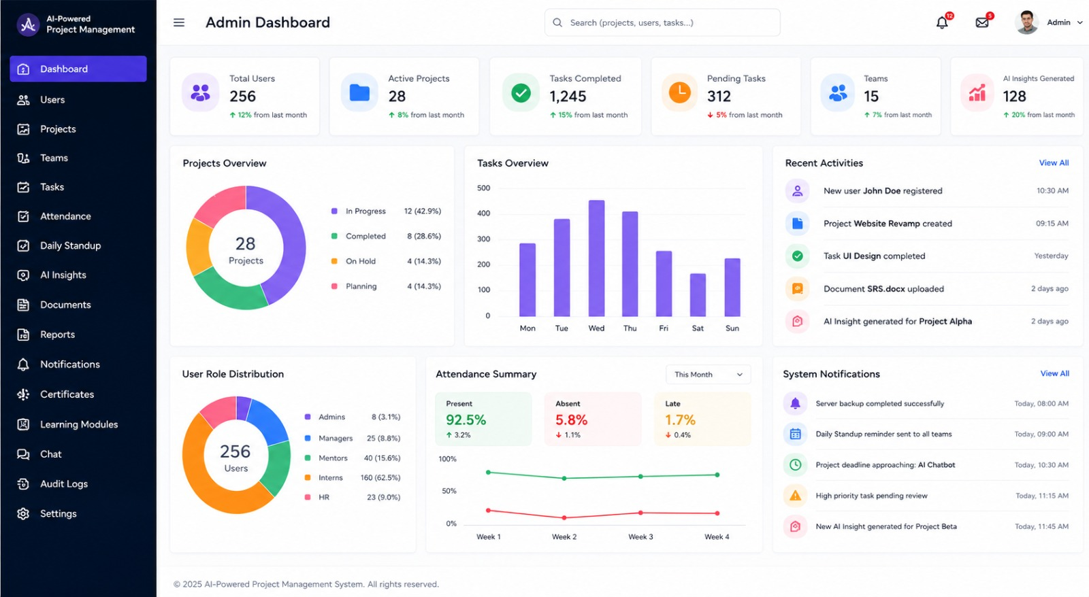
Mentor Dashboard
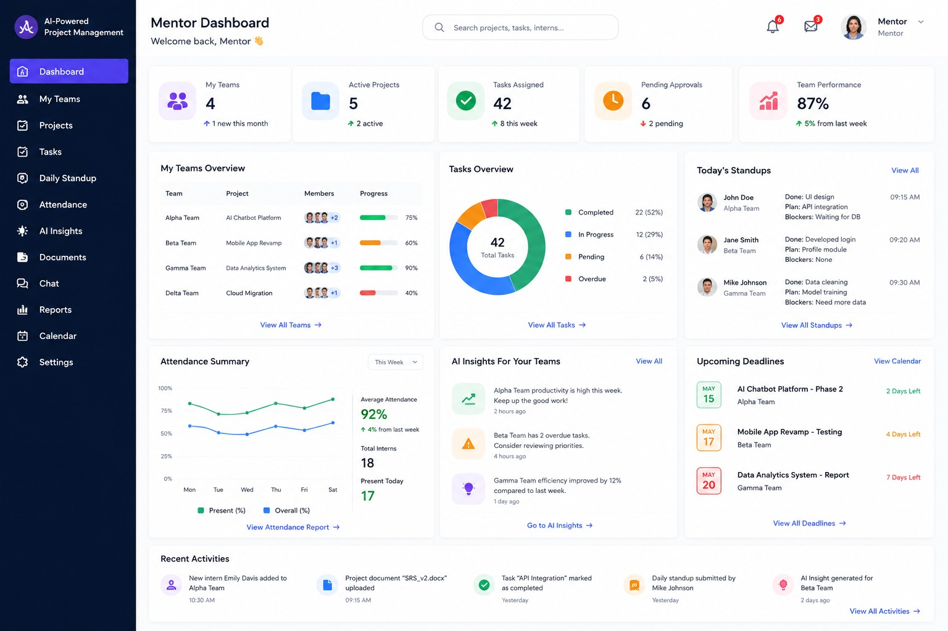
Intern Dashboard
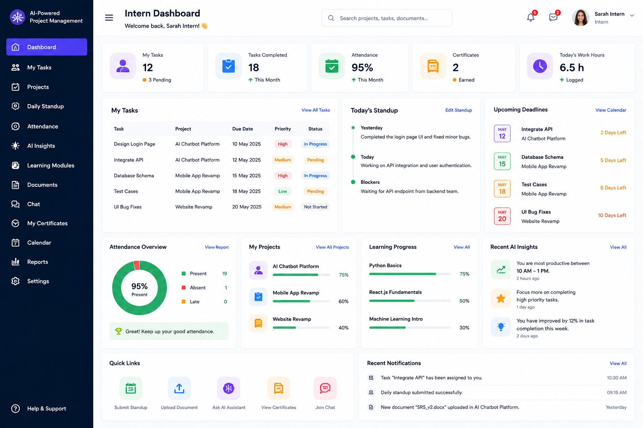
HR Dashboard
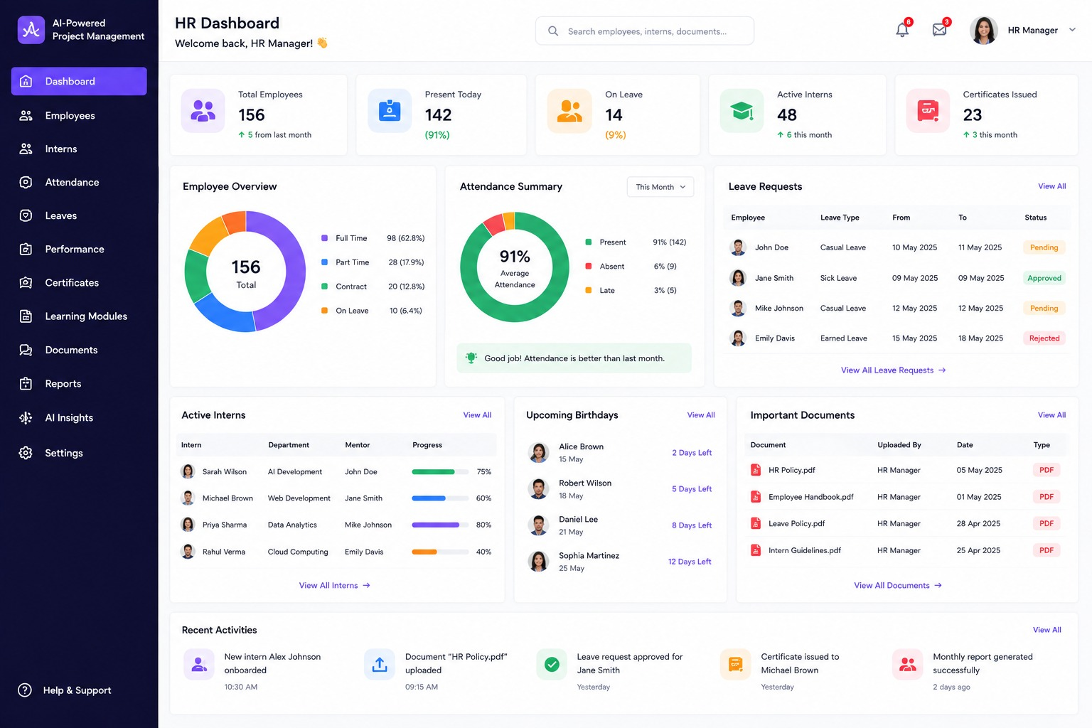
AI Dashboard
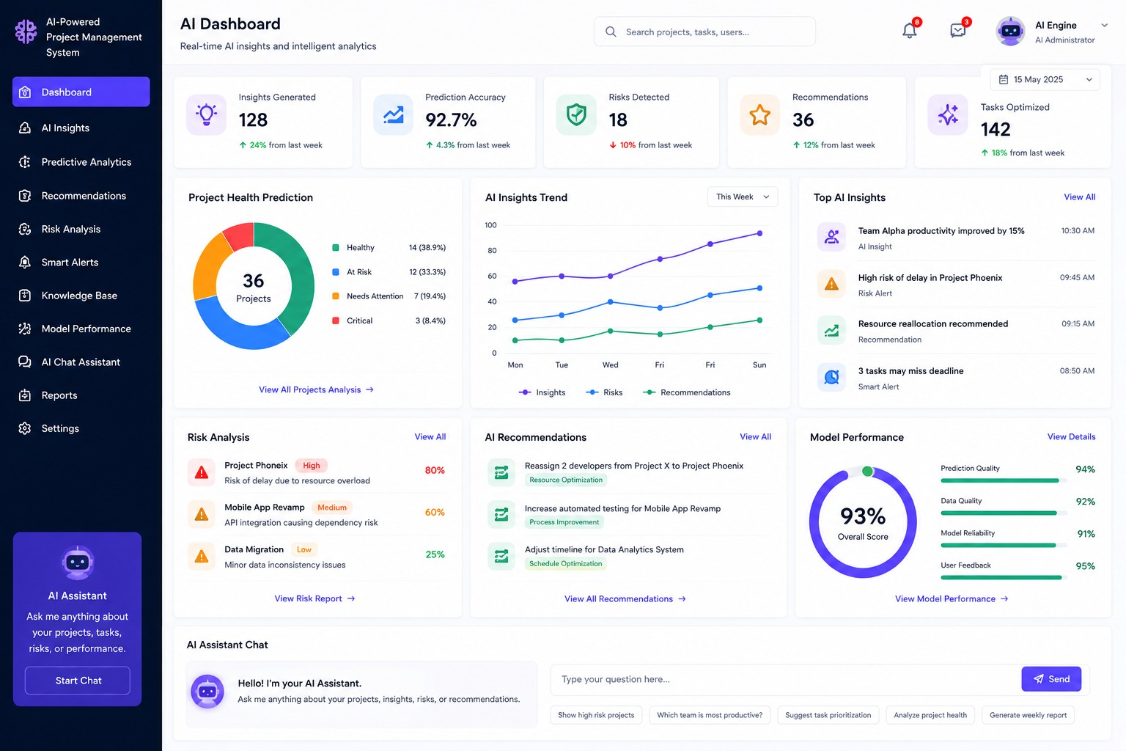
ExecutiveDashboard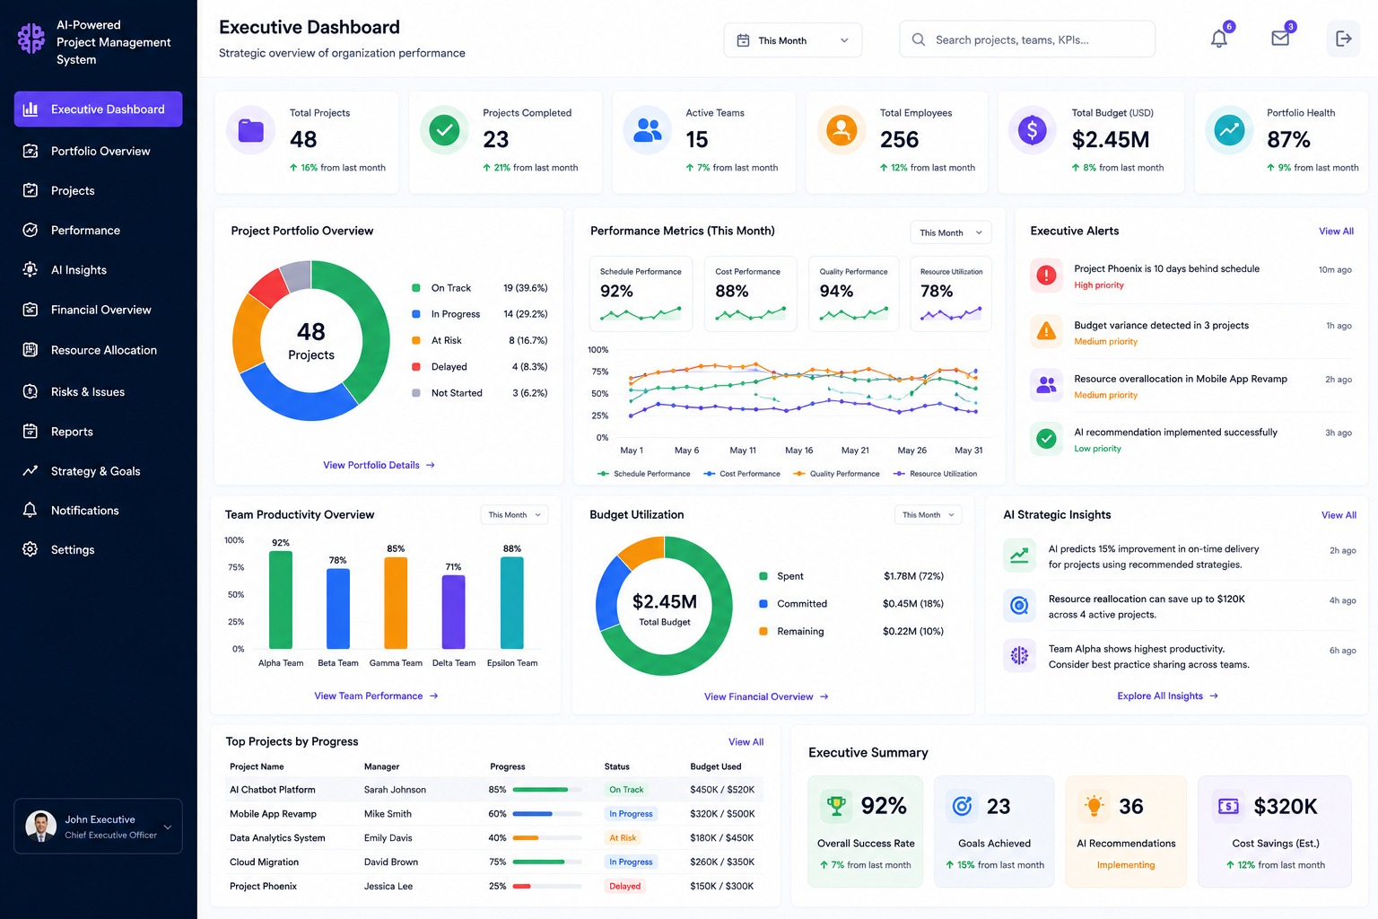

Dashboard KPIs
The AIPMS dashboards provide real-time Key Performance Indicators (KPIs) to help administrators, mentors, HR personnel, and executives monitor organizational performance, project progress, and intern productivity.
KPI | Description
Active Interns | Number of interns currently active in projects.
Projects Completed | Total number of successfully completed projects.
Attendance Percentage | Overall attendance rate of interns and employees.
Productivity Score | AI-calculated productivity based on task completion, attendance, and performance.
AI Risk Score | AI-generated score indicating the risk level of project delays or issues.
Delayed Tasks | Number of tasks that have exceeded their deadlines.
Learning Progress | Percentage of completed learning modules and assigned courses.
Skill Gap Index | AI assessment of the difference between current and required skills.
Mentor Rating | Average mentor evaluation score based on intern performance and feedback.
Completion Rate | Percentage of completed tasks, projects, or internship objectives.
Benefits
- Real-time project monitoring
- AI-driven performance insights
- Early identification of project risks
- Improved decision-making
- Better mentor and intern evaluation
- Enhanced organizational productivity

PERFORMANCE METRICS & SYSTEM
8.1 Introduction & Performance Baseline
To ensure the AI-Powered Internship & Project Management System (AIPMS) operates smoothly under enterprise-scale loads, strict Performance Metrics and Service Level Agreements (SLAs) have been established. The system uses a high-performance stack comprising React (Frontend), FastAPI (Backend), PostgreSQL (Database), and Redis (Caching), supported by asynchronous task processing for AI workloads to ensure fast response times.
Performance Category | Target Parameter | SLA Criteria & Description
API Latency Target | < 300 ms | Average response time for non-AI REST API requests (e.g., login, attendance, task creation).
System Uptime SLA | 99.9% | High availability guaranteed through Docker containerization and Kubernetes auto-healing.
Concurrent Users | 10,000+ Users | Simultaneous active user capacity supported via Redis caching and horizontal cloud scaling.
AI Response Time | < 5 seconds | Maximum latency for Large Language Model (LLM) inference, multi-agent workflows, and RAG context retrieval.

8.2 Subsystem Latency Benchmarks

To keep the application highly responsive, specific response time limits are assigned to each architectural component:
Authentication & JWT Validation: < 100 ms (handled via Redis in-memory lookup).
Database Read/Write Transactions: < 150 ms (optimized using indexing in PostgreSQL).
Static Asset Rendering: < 200 ms (cached and served via Nginx reverse proxy).
Message Queue Task Dispatch: < 50 ms (processed via Kafka/RabbitMQ).
AI Agent Workflow Executions: < 5,000 ms (5 seconds) (offloaded asynchronously so user interface does not freeze).

8.3 Multi-Agent AI System Metrics
Since AIPMS utilizes a Multi-Agent AI architecture (Mentor Agent, Project Manager Agent, Code Reviewer Agent, etc.), specific quality and response standards are monitored for AI tasks.
Blocker Detection Accuracy: > 95% accuracy in flagging project blockers from daily stand-ups.
Resume Screening Accuracy: > 90% skill-matching accuracy compared to manual HR reviews.
Hallucination Rate: < 2% error rate by grounding responses using RAG (Retrieval-Augmented Generation) and Vector Databases (Pinecone/ChromaDB).
AI Agent Throughput: Up to 500 concurrent AI requests/minute using parallel processing with LangGraph / CrewAI.

8.4 Load Testing & Performance Results
Load testing was conducted using automated tools (Postman and Locust) to simulate peak traffic and evaluate overall system stability.

Key Load Testing Outcomes
Concurrent Load Handling: Simulated up to 10,000 active users simultaneously performing clock-ins, task status updates, and report generation without system failure.
Peak Hour Stability: Standard transactional API response times consistently remained under 300 ms during simulated high-traffic morning stand-up hours.
Async AI Processing: Stand-up text processing and sentiment scoring offloaded to background workers successfully delivered reports within 3.2 to 4.8 seconds, satisfying the < 5 sec SLA.
Error Rate: System HTTP 5xx error rate remained below 0.01% during maximum stress testing.
.

Future Enhancements

9.1 Introduction
The AI-Powered Internship & Project Management System (AIPMS) has been designed as a scalable platform that can be enhanced with advanced technologies in the future. While the current version provides comprehensive internship and project management features, several improvements can further increase its functionality, usability, and enterprise readiness.

The following enhancements can be implemented in future versions of the system.

9.2 Mobile Application
A dedicated mobile application can be developed using React Native or Flutter to allow users to access AIPMS from smartphones and tablets.
Features:
Mobile login and authentication
Attendance marking
Task updates
Daily stand-up submission
Push notifications
Dashboard access

Benefits:
Access from anywhere
Improved user convenience
Faster communication
Real-time notifications

9.3 Multi-Agent AI Architecture
9.3.1 Introduction
To transform AIPMS into an intelligent enterprise platform, the system adopts a Multi-Agent AI Architecture instead of relying on a single AI assistant. In this architecture, multiple specialized AI agents collaborate to automate internship management, project monitoring, recruitment, attendance tracking, learning guidance, report generation, and administrative operations.
Each AI agent performs a dedicated role while communicating with other agents through an AI orchestration framework. This distributed intelligence improves automation, scalability, decision-making, and user experience. The architecture enables AIPMS to provide personalized assistance, reduce manual intervention, and support enterprise-scale deployments.
9.3.2 Multi-Agent AI Architecture
The Multi-Agent AI Architecture consists of the following intelligent agents:
1. AI Mentor Agent
The AI Mentor Agent provides personalized guidance and continuous support to interns throughout their internship journey.
Responsibilities
- Monitor intern progress
- Track daily stand-up submissions
- Identify inactive interns
- Recommend learning resources
- Detect missed deadlines
- Provide performance feedback
- Answer internship-related queries
Benefits
- Personalized mentoring
- Reduced mentor workload
- Early identification of learning gaps
- Improved intern engagement
2. AI Project Manager Agent
The AI Project Manager Agent automates project planning and monitoring activities.
Responsibilities
- Intelligent task allocation
- Sprint planning
- Deadline prediction
- Workload balancing
- Resource optimization
- Risk prediction
- Project progress monitoring
Benefits
- Improved project planning
- Better task distribution
- Reduced project delays
- Increased productivity

3. HR & Attendance Agent
The HR & Attendance Agent automates HR processes and attendance management.
Responsibilities
- Attendance tracking
- Leave management
- Working hour calculation
- Attendance analytics
- Internship onboarding
- Employee verification
Benefits
- Automated attendance management
- Reduced HR effort
- Accurate attendance reports
- Improved transparency

4. Recruitment Agent
The Recruitment Agent assists organizations in identifying suitable internship candidates.
Responsibilities
- Resume screening
- Skill extraction
- Candidate ranking
- Domain matching
- Interview scheduling support
Benefits
- Faster recruitment
- Improved candidate selection
- Reduced manual screening
5. Learning Agent
The Learning Agent provides personalized learning recommendations based on intern performance.
Responsibilities
- Skill gap analysis
- Personalized learning paths
- Course recommendations
- Certification tracking
- Learning progress monitoring
Benefits
- Continuous skill improvement
- Personalized learning experience
- Better internship outcomes

6. Report Generation Agent
The Report Generation Agent automatically prepares reports and dashboards.
Responsibilities
- Daily reports
- Weekly reports
- Monthly reports
- Attendance reports
- Productivity reports
- Performance reports
- Executive dashboards
Benefits
- Faster report generation
- Reduced manual work
- Real-time analytics
7. Code Review Agent
The Code Review Agent automatically evaluates source code submitted by interns.
Responsibilities
- Code quality analysis
- Bug detection
- Coding standard verification
- Complexity analysis
- Documentation review
- Best practice recommendations
Benefits
- Improved code quality
- Faster code reviews
- Reduced mentor workload
8. Admin Agent
The Admin Agent supervises the overall platform and coordinates AI services.
Responsibilities
- User management
- Role management
- AI agent monitoring
- System configuration
- Security monitoring
- Dashboard management
Benefits
- Simplified administration
- Centralized monitoring
- Better security
- Efficient system management

9.3.3 AI Agent Orchestration Framework
To enable collaboration among all AI agents, AIPMS uses a Multi-Agent AI orchestration framework.
Framework | Purpose
LangGraph | Coordinates AI workflows using graph-based execution and manages communication between multiple agents.
CrewAI | Enables role-based collaboration among specialized AI agents to accomplish complex tasks efficiently.
Microsoft AutoGen | Supports autonomous conversations and task execution between multiple AI agents with minimal human intervention.

9.3.4 Multi-Agent Workflow
- User submits a request through the AIPMS interface.
- The AI Orchestrator receives and analyzes the request.
- The request is forwarded to the appropriate AI agent.
- Multiple agents collaborate when necessary.
- The processed response is returned to the user.
- All interactions are stored for future analysis and continuous learning.

9.3.5 Advantages of Multi-Agent AI Architecture
- Specialized AI agents improve task accuracy.
- Parallel processing reduces response time.
- Personalized assistance for interns and mentors.
- Reduced manual administrative effort.
- Better internship and project monitoring.
- Improved scalability for enterprise deployment.
- Intelligent decision-making through collaborative AI.
- Easy integration with Large Language Models such as OpenAI GPT and Google Gemini.
- Supports autonomous workflow automation.
- Enhances overall system productivity and efficiency.

9.4 Cloud Deployment
Future versions of the AI-Powered Internship & Project Management System (AIPMS) can be deployed on leading cloud platforms such as Amazon Web Services (AWS). Cloud deployment provides high availability, scalability, security, and reliable access to the application from anywhere.
Features
- Cloud hosting for web application and backend services
- Automatic database backup and recovery
- High availability with load balancing
- Auto-scaling based on user traffic
- Secure cloud storage for project documents
- Disaster recovery and fault tolerance
- Centralized monitoring and logging
Benefits
- Access the platform from any location
- Improved application reliability
- Better system performance
- Reduced infrastructure and maintenance costs
- Easy scalability for enterprise deployments
- Enhanced data security and backup management

9.5 Video Meeting Integration
The system can be integrated with popular video conferencing platforms to facilitate seamless communication between mentors, interns, and project teams. This feature enables virtual mentoring sessions, project discussions, and interview meetings directly from the AIPMS platform.
Possible Integrations
- Google Meet
- Microsoft Teams
- Zoom
Features
- Schedule virtual meetings
- Join meetings directly from AIPMS
- Automatic meeting reminders
- Calendar synchronization
- Meeting history and attendance tracking
- Screen sharing support
- Team collaboration during project reviews
Benefits
- Improved communication between mentors and interns
- Simplified mentoring sessions
- Better collaboration among project teams
- Reduced dependency on third-party applications
- Increased flexibility for remote internships

9.6 Voice Assistant
A voice-enabled AI assistant can be integrated into AIPMS to allow users to perform tasks using voice commands. This feature enhances accessibility and provides a hands-free interaction experience.
Features
- Voice-based login assistance
- Voice search for projects and tasks
- Voice-enabled attendance marking
- Voice-based task updates
- Dashboard navigation through voice commands
- AI-powered voice mentor assistance
- Voice reminders for meetings and deadlines
Benefits
- Hands-free system operation
- Faster interaction with the application
- Improved accessibility for all users
- Enhanced user experience
- Increased productivity through voice automation
9.7 Advanced Analytics
Future versions of AIPMS can include advanced analytics dashboards that provide deeper insights into internship performance, project progress, and organizational productivity. AI-driven analytics help mentors and administrators make informed decisions based on real-time data.
Analytics Features
- Internship performance trends
- Attendance analytics
- Task completion statistics
- Productivity graphs
- Project progress reports
- Mentor performance reports
- AI-generated predictive analytics
- Skill gap analysis dashboards
- Project risk prediction reports
- Executive performance dashboards
Benefits
- Better decision-making through data-driven insights
- Early identification of project risks
- Improved intern performance monitoring
- Enhanced productivity tracking
- Real-time organizational analytics
- Better resource allocation and planning
- Increased operational efficiency

9.8 Multi-Language Support
To support users from different regions, the system can provide interfaces in multiple languages.
Supported Languages (Example)
English
Telugu
Hind
Tamil
Kannada

Benefits:
Improved accessibility
Better user experience
Wider adoption across organizations

9.9 Additional Future Enhancements
The following features can also be added in future releases:
AI Chatbot for instant user support
Email and SMS notifications
Real-time push notification
Calendar integration
Biometric attendance system
QR code-based attendance
Document management system
Internship certificate generation
Resume builder for interns
Job recommendation system
Third-party HR and payroll integration
Predictive analytics for project completion
Multi-organization (multi-tenant) support
Dark mode and UI customization

9.10 Benefits of Future Enhancements
The implementation of these enhancements will:
Increase automation using AI.
Improve communication and collaboration.
Support remote and hybrid work environments.\
Enable access from mobile devices.
Enhance system scalability and reliability.
Provide better analytics and reporting.
Improve overall user experience.
Prepare the system for enterprise-level deployment.
9.11 Future Integrations
To enhance collaboration and enterprise capabilities, AIPMS can be integrated with the following platforms:
Integration | Purpose
GitHub | Repository management, commit tracking, and code analytics
GitLab | Source code management and CI/CD integration
Azure DevOps | Agile planning, repositories, and deployment pipelines
Jira | Project and issue synchronization
Microsoft Teams | Team collaboration and notifications
Slack | Real-time messaging and AI notifications
Google Calendar | Task deadlines, meetings, and reminders
Microsoft Outlook | Email notifications and calendar synchronization
Zoom | Online meetings and interview scheduling
Benefits
- Improved collaboration
- Automated notifications
- Better project tracking
- Enterprise integration
- Enhanced productivity

9.12 Business Value
The AI Integrated Project Management System (AIPMS) delivers significant value by automating project management activities, improving collaboration, and enabling AI-driven decision-making. It helps organizations efficiently manage interns, mentors, HR teams, and project managers while reducing manual effort and increasing overall productivity.
- Reduction in Manual Work
AIPMS automates repetitive administrative tasks such as attendance tracking, task assignment, progress monitoring, stand-up summary generation, report creation, and notification management. AI agents analyze project data and provide recommendations without requiring continuous manual supervision.
Business Impact
- Reduces manual administrative work by approximately 70–80%.
- Minimizes human errors in project tracking and reporting.
- Allows mentors and managers to focus on strategic activities rather than routine operations.

- Faster Project Tracking
The platform provides real-time dashboards for monitoring project progress, task completion, attendance, deadlines, and team performance. AI continuously analyzes project status and identifies delays or potential risks.
Business Impact
- Real-time visibility into project progress.
- Faster identification of project bottlenecks.
- Improved on-time project delivery.
- Better coordination between interns, mentors, and project managers.
- Improved Mentor Productivity
AI Mentor assists mentors by monitoring intern activities, identifying inactive members, recommending task prioritization, generating performance insights, and preparing automated stand-up summaries.
Business Impact
- Reduces the time mentors spend on routine monitoring.
- Enables mentors to supervise more interns effectively.
- Improves mentoring quality through AI-driven recommendations.
- Enhances communication between mentors and team members.

- Better Internship Outcomes
AIPMS continuously evaluates intern performance using attendance, task completion, code contributions, learning progress, and AI-generated feedback. Personalized recommendations help interns improve their skills throughout the internship.
Business Impact
- Higher intern engagement and productivity.
- Faster skill development through AI-guided learning.
- Improved project completion rates.
- Better internship experience and learning outcomes.

- Data-Driven Decision Making
AIPMS transforms operational data into meaningful insights using AI analytics and interactive dashboards. Managers can make informed decisions based on project performance, productivity metrics, and predictive analysis.
Business Impact
- Better resource allocation.
- Early identification of project risks.
- Performance-based decision making.
- Accurate reporting for management and stakeholders.
- Predictive insights for project planning.

- Enterprise Scalability
The system is designed using a scalable cloud-native architecture with containerization, load balancing, and modular AI services. It can efficiently support organizations ranging from small teams to large enterprises.
Business Impact
- Supports hundreds to thousands of concurrent users.
- Easily accommodates additional AI agents and business modules.
- Suitable for multi-team, multi-project, and multi-department environments.
- Ready for deployment on cloud platforms such as AWS.
- Supports future business expansion with minimal infrastructure changes.

10. Cost Estimation
The cost estimation for AIPMS includes development, cloud infrastructure, AI service usage, maintenance, licensing, and operational expenses. These estimates help organizations evaluate the financial feasibility of deploying and maintaining the platform.
10.1 Development Effort
The development cost includes system analysis, UI/UX design, frontend and backend development, AI integration, database implementation, testing, and deployment.
Estimated Effort
- Requirements Analysis
- UI/UX Design
- Frontend Development
- Backend Development
- AI Module Development
- Database Design
- Testing & Deployment

10.2 Cloud Infrastructure
The application is designed for deployment on AWS using managed cloud services.
Infrastructure Components
- Amazon EC2 / ECS
- Amazon RDS (PostgreSQL)
- Amazon S3
- Amazon ElastiCache (Redis)
- API Gateway
- CloudWatch

10.3 AI API Usage
AI capabilities are powered by external Large Language Models (LLMs).
AI Services
- OpenAI GPT API or Google Gemini API
- Embedding API
- Vector Database (Pinecone/ChromaDB)
The AI usage cost depends on:
- Number of API requests
- Number of active users
- Token consumption
- Embedding generation

10.4 Maintenance Cost
Regular maintenance is required to ensure system reliability and security.
Activities include:
- Bug fixes
- Security updates
- Performance optimization
- Database maintenance
- AI model updates
- Feature enhancements

10.5 Licensing Cost
Licensing costs depend on the technologies and services used.
Possible licensing includes:
- OpenAI/Gemini API subscription
- Vector Database subscription (if using Pinecone)
- AWS cloud services
- Domain name and SSL certificate (if applicable)
Most development frameworks used in AIPMS (React, FastAPI, PostgreSQL, Redis) are open source and do not require licensing fees.

10.6 Operational Cost
Operational costs include the day-to-day expenses of running the platform.
These include:
- Cloud hosting
- Database storage
- AI API usage
- Backup and monitoring
- Network bandwidth
- Technical support

Conclusion
11.1 Summary
The AI Powered Internship & Project Management System is a smart web-based platform designed to simplify internship and project management for students, mentors, and administrators. The system uses Artificial Intelligence to automate tasks such as project recommendations, internship matching, progress tracking, task assignment, and performance evaluation. It reduces manual work, improves communication, and provides real-time updates. The project was developed using modern web technologies with a user-friendly interface, making it efficient, reliable, and easy to use.
Mobile Application
A dedicated mobile application will be developed for Android and iOS platforms to enable students, mentors, HR personnel, and administrators to access the platform from anywhere. The application will provide all major functionalities available in the web version while ensuring a responsive and user-friendly experience.
Features
- Task and project management
- Attendance marking
- Daily stand-up submission
- AI Mentor chat
- Push notifications
- Dashboard access
- Profile management
- Offline synchronization
Benefits
- Access from anywhere
- Improved user experience
- Real-time notifications
- Increased productivity

11.2 Benefits
The proposed system offers several benefits:
Automates internship and project management processes.
Uses AI to recommend suitable internships and projects based on students' skills and interests.
Enables real-time progress tracking and task monitoring.
Reduces paperwork and manual errors.
Improves communication between students, mentors, and administrators.
Saves time through automated notifications and report generation.
Enhances productivity and decision-making using AI insights.
Provides secure data management with role-based access.
QR Code / Biometric Attendance
The traditional attendance system will be upgraded using QR Code scanning and biometric authentication. This enhancement ensures secure and accurate attendance recording while preventing proxy attendance.
Features
- QR Code scanning
- Fingerprint authentication
- Face recognition (Future)
- Attendance reports
- Geo-location verification
- Attendance analytics
Benefits
- Eliminates proxy attendance
- Faster attendance process
- Accurate attendance records
- Improved security

11.3 Voice AI Mentor
A Voice AI Mentor will be introduced to provide real-time guidance through voice interactions. Students can ask project-related questions, receive learning recommendations, and get instant feedback without typing, making the learning experience more interactive.
The implementation of the AI Powered Internship & Project Management System successfully demonstrates how Artificial Intelligence can improve internship and project management. The system provides accurate recommendations, efficient task management, and continuous progress monitoring. It enhances the overall experience for students and mentors by making the management process more transparent, organized, and efficient. The project achieved its objectives by providing a centralized platform that supports effective collaboration and better decision-making.
11.4 LMS (Learning Management System) Integration
The platform can be integrated with Learning Management Systems (LMS) to provide access to online courses, assignments, quizzes, certifications, and learning resources. This integration will help students improve their technical and professional skills.
11.5 HRMS Integration
Integration with Human Resource Management Systems (HRMS) will enable seamless management of recruitment, onboarding, employee records, internship completion, and performance evaluation within a single platform
11.6 Microsoft Teams / Slack Integration
The system can integrate with Microsoft Teams and Slack to enable instant notifications, project discussions, meeting reminders, task updates, and team collaboration, improving communication among students, mentors, and administrators.
11.7 GitHub Integration
GitHub integration will allow the platform to monitor code commits, pull requests, repository contributions, and project activity. This data can be used to evaluate coding performance and provide AI-based productivity insights.
11.8 Calendar Integration
Integration with Google Calendar or Microsoft Outlook Calendar will help users schedule meetings, project deadlines, interviews, stand-up meetings, and important events. Automatic reminders will ensure better time management and task completion.
11.9 Digital Certificate Verification
The system will generate digitally signed internship and project completion certificates with QR codes or unique verification IDs. Employers and institutions can verify the authenticity of certificates online, ensuring security and preventing certificate forgery.

These enterprise features will transform the platform into a comprehensive AI-driven internship and project management solution capable of supporting large organizations with improved automation, collaboration, and scalability.

