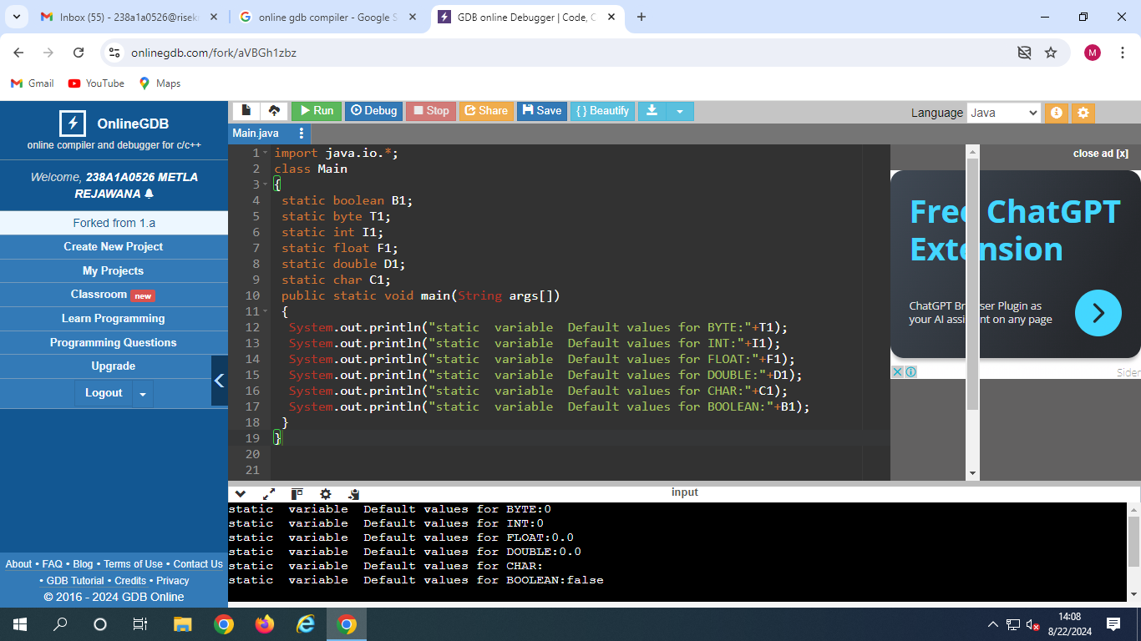

Output:

static variable Default values for BYTE:0

static variable Default values for INT:0

static variable Default values for FLOAT:0.0

static variable Default values for DOUBLE:0.0

static variable Default values for CHAR:

static variable Default values for BOOLEAN:false