Software Requirements Specification (SRS)
Standard: IEEE 830 Format
Project Title: A Tool for Automating Pre-Penetration Testing Reconnaissance
Team Members / Roll Numbers:
Muhmmad Asim 23PWBCS0984,
Muhammad Sattar 23PWBCS0963,
Talal Rashid 23PWBCS1002
Instructor: Ms. Kanwal Aniq
Date: 10-12-2025

1 Introduction

1.1 Purpose
This SRS defines the functional and non-functional requirements for a web-based tool that automates the reconnaissance phase of penetration testing by orchestrating OSINT sources and security APIs. The audience includes student developers, reviewers, and future maintainers who will design, implement, test, and evaluate the system.

1.2 Scope
The product discovers and enriches publicly available information about a target (domain/IP) using approved OSINT methods. It aggregates results from multiple providers, normalizes them, applies simple classification (e.g., CIA Triad-inspired impact), and exports reports (CSV/PDF). Intrusive testing (e.g., active exploitation) is out of scope.

1.3 Definitions, Acronyms, and Abbreviations
OSINT – Open-Source Intelligence;
API – Application Programming Interface;
CIA Triad – Confidentiality, Integrity, Availability;
ROI – Return on Investment;
CSV – Comma-Separated Values.

1.4 References
Project Proposal and Week-wise Plan (internal).
Public API documentation for OSINT/security providers (e.g., Shodan).
University/department policies on ethical security testing.

1.5 Overview
Section 2 describes the product context and users. Section 3 lists detailed functional and non-functional requirements, interfaces, and features. Section 4 includes system models. Section 5 captures additional policies and constraints. Appendices provide glossary and schema notes.

2 Overall Description

2.1 Product Perspective
The tool is a standalone web application with adapters for third-party OSINT/security APIs. It can run on a lab machine or a low-cost VM, storing results locally for analysis and export.

2.2 Product Functions
- Accept target input (domain or IP).
- Resolve and pre-process input (DNS lookups, normalization).
- Query OSINT/security providers (e.g., Shodan).
- Merge and deduplicate results into a unified schema.
- Classify assets and findings by impact.
- Present results in a web UI; export CSV/PDF.

2.3 User Characteristics
Primary users: security students, analysts, and instructors familiar with basic networking and recon concepts. Admin users manage API keys and configuration. No advanced programming knowledge required to operate the UI.

2.4 Constraints
- API rate limits and fair-use policies.
- Non-intrusive/ethical usage only; approved targets.
- Limited budget: prefer free/open-source stack.
- Base hardware: dual-core CPU, 4–8 GB RAM, stable internet.

2.5 Assumptions and Dependencies
- Internet access and availability of provider APIs.
- User supplies valid targets and has permission.
- Free/student tiers suffice for lab-scale runs.
- Python (Flask/Django) and a lightweight DB are available.

3 Specific Requirements

3.1 Functional Requirements
ID | Requirement Description | Priority (H/M/L)
FR1 | The system shall allow the user to submit a target (domain or IP) via web form. | H
FR2 | The system shall validate and normalize the input (DNS resolution, formatting). | H
FR3 | The system shall query at least one OSINT/security API (e.g., Shodan) for target data. | H
FR4 | The system shall support plugging in additional providers via adapters. | M
FR5 | The system shall merge, deduplicate, and standardize provider outputs into a unified schema. | H
FR6 | The system shall classify discovered assets/findings by impact (High/Medium/Low). | M
FR7 | The system shall present results in a paginated, filterable web UI. | M
FR8 | The system shall export results to CSV and PDF. | H
FR9 | The system shall store session results locally for later review. | M
FR10 | The system shall provide an admin page to configure API keys and limits. | H

3.2 Non-Functional Requirements
Performance: First response for a single-provider query should be returned within 10–20 seconds under free-tier limits.
Reliability/Availability: The system should handle provider timeouts with retries and show partial results when available.
Security/Privacy: API keys must be stored securely (env vars/vault). Do not store sensitive PII. Role-based access for admin settings.
Maintainability/Scalability: Provider adapters must be modular; adding a new provider should not require core refactoring.
Usability/Accessibility: Clear status indicators, export buttons, and help tooltips; accessible on desktop and mobile browsers.

3.3 External Interface Requirements
User Interface: Web dashboard with pages for input, results, and admin configuration.
Hardware Interface: Standard workstation or VM; internet connectivity; optional proxy.
Software Interface: Python runtime, Flask/Django, requests/HTTP clients, CSV/PDF libraries, SQLite/PostgreSQL.
Communication Interface: HTTPS to provider APIs; local HTTP(S) for the web UI.

3.4 System Features
Feature: Recon Orchestration
Description: Orchestrates provider calls, collects and unifies results.
Inputs: Target (domain/IP), provider API keys.
Processing: Sequential or parallel provider calls; schema mapping; dedupe.
Outputs: Unified result set, UI view, CSV/PDF export.

4 System Models
Use Case Diagram:
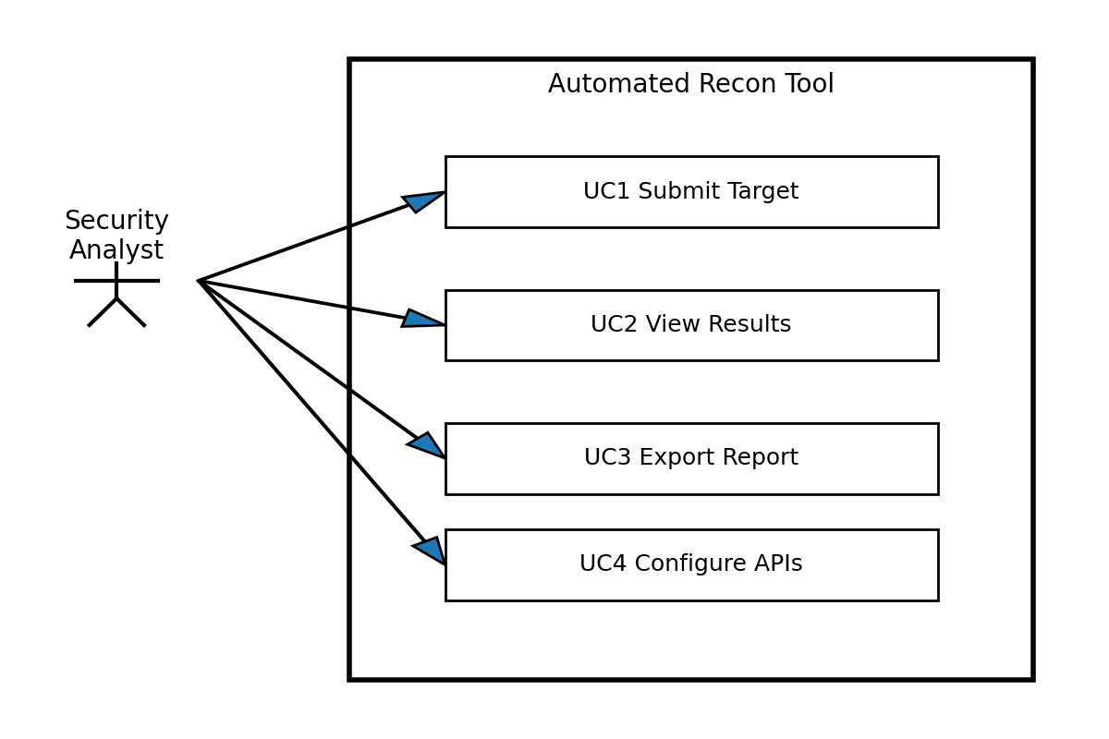
Level-0 Data Flow Diagram (DFD):
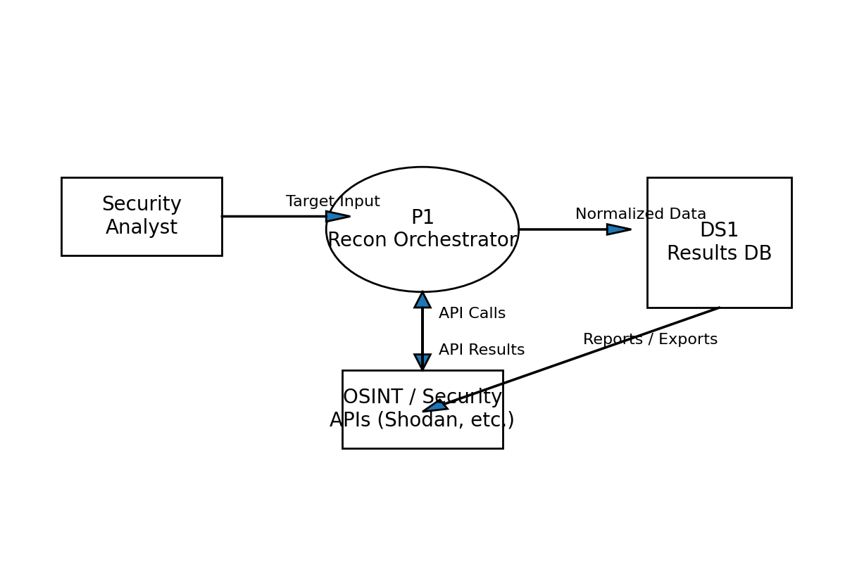

5 Other Requirements
Backup & Recovery: Exported reports should be archived weekly; DB snapshots retained for at least one term.
Ethical/Legal Constraints: Use only for approved targets; comply with provider Terms of Service and institutional policy.
Standards & Compliance: Follow basic secure coding practices (input validation, key management).

6 Appendices
Glossary: Target, Asset, Finding, Adapter, Export, Session.
Sample Unified Schema (high-level): asset_id, type, hostname, ip, port, service, evidence, source, timestamp, impact.

