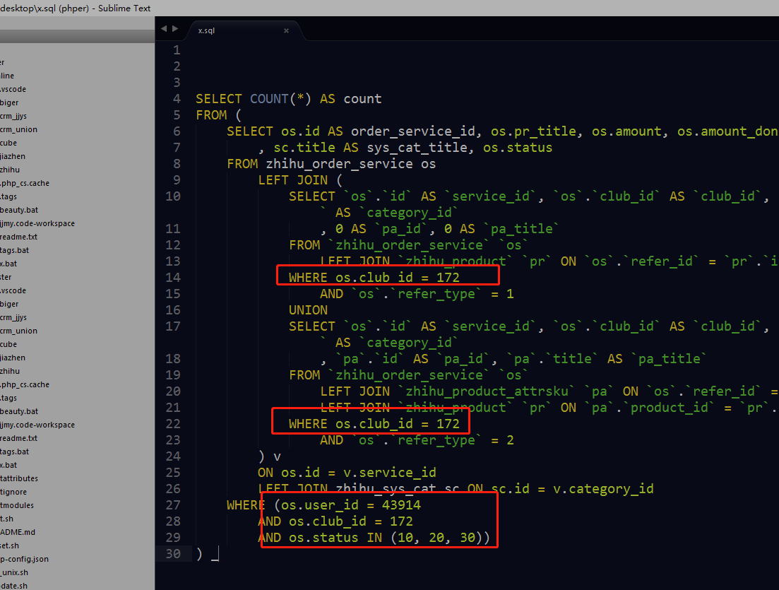

-- 原语句
SELECT COUNT(*) AS count
FROM (
SELECT os.id AS order_service_id, os.pr_title, os.amount, os.amount_done, sc.id AS sys_cat_id
, sc.title AS sys_cat_title, os.status
FROM zhihu_order_service os
LEFT JOIN (
SELECT `os`.`id` AS `service_id`, `os`.`club_id` AS `club_id`, `pr`.`id` AS `pr_id`, `pr`.`title` AS `pr_title`, `pr`.`sys_cat_id` AS `category_id`
, 0 AS `pa_id`, 0 AS `pa_title`
FROM `zhihu_order_service` `os`
LEFT JOIN `zhihu_product` `pr` ON `os`.`refer_id` = `pr`.`id`
WHERE os.club_id = 172
AND `os`.`refer_type` = 1
UNION
SELECT `os`.`id` AS `service_id`, `os`.`club_id` AS `club_id`, `pr`.`id` AS `pr_id`, `pr`.`title` AS `pr_title`, `pr`.`sys_cat_id` AS `category_id`
, `pa`.`id` AS `pa_id`, `pa`.`title` AS `pa_title`
FROM `zhihu_order_service` `os`
LEFT JOIN `zhihu_product_attrsku` `pa` ON `os`.`refer_id` = `pa`.`id`
LEFT JOIN `zhihu_product` `pr` ON `pa`.`product_id` = `pr`.`id`
WHERE os.club_id = 172
AND `os`.`refer_type` = 2
) v
ON os.id = v.service_id
LEFT JOIN zhihu_sys_cat sc ON sc.id = v.category_id
WHERE (os.user_id = 43914
AND os.club_id = 172
AND os.status IN (10, 20, 30))
) _

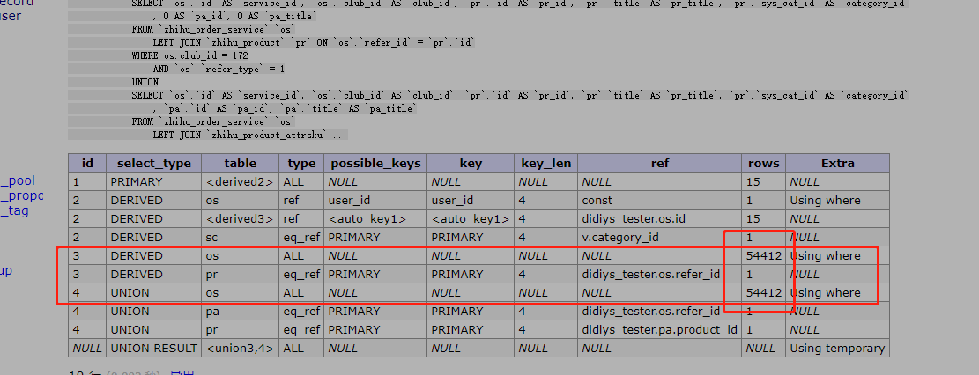

优化方案:

缩小os的过滤条件,把5万条减下来.
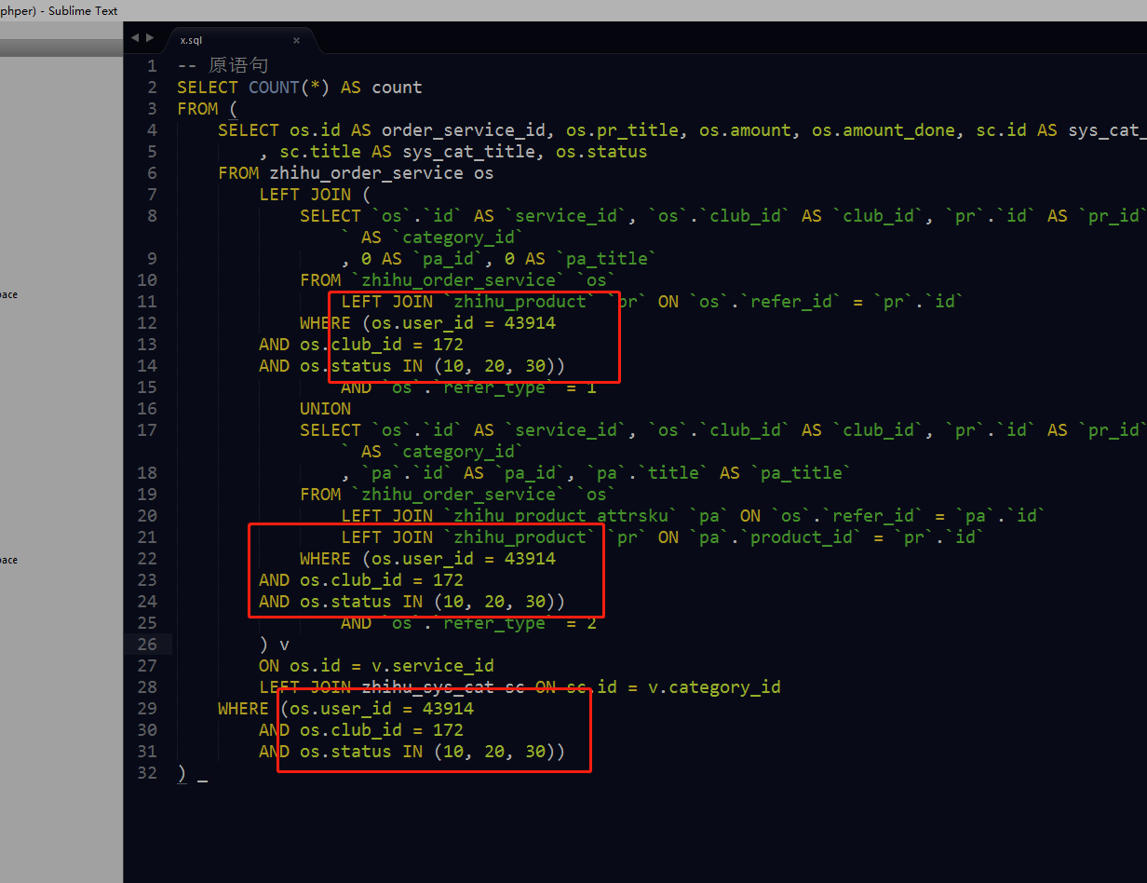

-- 修复后语句
SELECT COUNT(*) AS count
FROM (
SELECT os.id AS order_service_id, os.pr_title, os.amount, os.amount_done, sc.id AS sys_cat_id
, sc.title AS sys_cat_title, os.status
FROM zhihu_order_service os
LEFT JOIN (
SELECT `os`.`id` AS `service_id`, `os`.`club_id` AS `club_id`, `pr`.`id` AS `pr_id`, `pr`.`title` AS `pr_title`, `pr`.`sys_cat_id` AS `category_id`
, 0 AS `pa_id`, 0 AS `pa_title`
FROM `zhihu_order_service` `os`
LEFT JOIN `zhihu_product` `pr` ON `os`.`refer_id` = `pr`.`id`
WHERE (os.user_id = 43914
AND os.club_id = 172
AND os.status IN (10, 20, 30))
AND `os`.`refer_type` = 1
UNION
SELECT `os`.`id` AS `service_id`, `os`.`club_id` AS `club_id`, `pr`.`id` AS `pr_id`, `pr`.`title` AS `pr_title`, `pr`.`sys_cat_id` AS `category_id`
, `pa`.`id` AS `pa_id`, `pa`.`title` AS `pa_title`
FROM `zhihu_order_service` `os`
LEFT JOIN `zhihu_product_attrsku` `pa` ON `os`.`refer_id` = `pa`.`id`
LEFT JOIN `zhihu_product` `pr` ON `pa`.`product_id` = `pr`.`id`
WHERE (os.user_id = 43914
AND os.club_id = 172
AND os.status IN (10, 20, 30))
AND `os`.`refer_type` = 2
) v
ON os.id = v.service_id
LEFT JOIN zhihu_sys_cat sc ON sc.id = v.category_id
WHERE (os.user_id = 43914
AND os.club_id = 172
AND os.status IN (10, 20, 30))
) _

