5-LABORATORIYA ISHI

Mavzu: Logistic Regression yordamida imtihondan o‘tishni prognoz qilish

Maqsad
Ushbu laboratoriya ishining maqsadi:
- Binary classification modelini qurish
- Logistic Regression algoritmini o‘rganish
- Confusion Matrix hisoblash
- Accuracy, Precision, Recall aniqlash
- Natijani grafik orqali tahlil qilish

Kerakli vositalar
- Python 3.10+
- Pandas
- Scikit-learn
- Matplotlib
O‘rnatish:
pip install pandas scikit-learn matplotlib

Nazariy asos
Logistic Regression — natija 0 yoki 1 bo‘lgan masalalar uchun ishlatiladi.
Sigmoid funksiyasi:
σ(z)=11+e−z\sigma(z) = \frac{1}{1 + e^{-z}}σ(z)=1+e−z1​
Natija 0–1 oralig‘ida chiqadi.

Logistic regression ishlash jarayoni
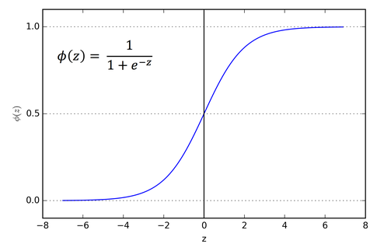
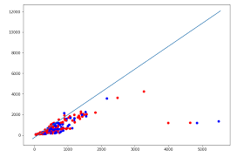
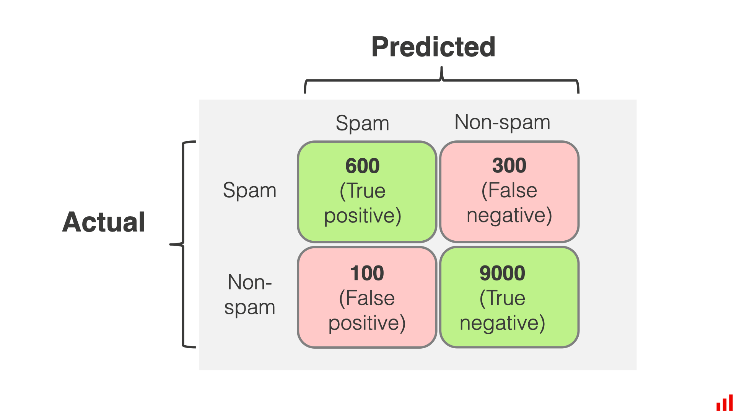

Ishlash tartibi (Step-by-Step)

1-qadam: Dataset yaratish
exam.csv
hours_studied,attendance,passed
2,50,0
3,60,0
5,70,1
7,80,1
1,40,0
8,90,1
6,75,1
4,65,0

2-qadam: Dataset yuklash
import pandas as pd

df = pd.read_csv("exam.csv")
print(df.head())

3-qadam: X va y ajratish
X = df[["hours_studied", "attendance"]]
y = df["passed"]

4-qadam: Train-test ajratish
from sklearn.model_selection import train_test_split

X_train, X_test, y_train, y_test = train_test_split(
X, y, test_size=0.25, random_state=42
)

5-qadam: Model yaratish va o‘qitish
from sklearn.linear_model import LogisticRegression

model = LogisticRegression()
model.fit(X_train, y_train)

6-qadam: Bashorat qilish
pred = model.predict(X_test)
print("Bashorat:", pred)

7-qadam: Baholash
from sklearn.metrics import confusion_matrix, accuracy_score, precision_score, recall_score

cm = confusion_matrix(y_test, pred)
acc = accuracy_score(y_test, pred)
prec = precision_score(y_test, pred)
rec = recall_score(y_test, pred)

print("Confusion Matrix:\n", cm)
print("Accuracy:", acc)
print("Precision:", prec)
print("Recall:", rec)

8-qadam: Decision boundary grafik
import matplotlib.pyplot as plt
import numpy as np

plt.scatter(df["hours_studied"], df["attendance"], c=df["passed"])
plt.xlabel("Hours Studied")
plt.ylabel("Attendance")
plt.title("Classification Visualization")
plt.show()

To‘liq kod (Yakuniy variant)

# Pandas kutubxonasini chaqiramiz.
# Pandas jadval (DataFrame) ko‘rinishidagi ma'lumotlarni o‘qish va qayta ishlash uchun ishlatiladi.
import pandas as pd

# Matplotlib kutubxonasining pyplot modulini chaqiramiz.
# Bu grafiklar chizish uchun ishlatiladi.
import matplotlib.pyplot as plt

# Numpy kutubxonasi matematik hisoblashlar uchun ishlatiladi.
import numpy as np

# Datasetni train va test qismga ajratish uchun funksiya
from sklearn.model_selection import train_test_split

# Logistic Regression modelini chaqiramiz
from sklearn.linear_model import LogisticRegression

# Modelni baholash uchun metrikalar
# confusion_matrix – xatolar jadvali
# accuracy_score – umumiy aniqlik
# precision_score – modelning to‘g‘ri ijobiy bashoratlari
# recall_score – modelning haqiqiy ijobiylarni topish qobiliyati
from sklearn.metrics import confusion_matrix, accuracy_score, precision_score, recall_score

# CSV fayldagi datasetni o‘qiymiz
# exam.csv faylida talabalar haqidagi ma'lumotlar saqlangan
df = pd.read_csv("exam.csv")

# Modelga kiruvchi mustaqil o‘zgaruvchilar (features)
# hours_studied – talabaning o‘qigan soatlari
# attendance – darsga qatnashish foizi
X = df[["hours_studied", "attendance"]]

# Model bashorat qiladigan natija (target)
# passed – talaba imtihondan o‘tgan (1) yoki yiqilgan (0)
y = df["passed"]

# Datasetni ikki qismga bo‘lamiz
# 75% – modelni o‘qitish (training)
# 25% – modelni test qilish (testing)
# random_state=42 – natija har safar bir xil chiqishi uchun
X_train, X_test, y_train, y_test = train_test_split(
X, y, test_size=0.25, random_state=42
)

# Logistic Regression modelini yaratamiz
model = LogisticRegression()

# Modelni train dataset yordamida o‘qitamiz
# Model X_train ma'lumotlariga qarab y_train ni o‘rganadi
model.fit(X_train, y_train)

# Test dataset uchun bashorat qilamiz
# Model X_test ma'lumotiga qarab natija chiqaradi
pred = model.predict(X_test)

# Confusion matrix hisoblaymiz
# Bu model nechta to‘g‘ri va nechta noto‘g‘ri bashorat qilganini ko‘rsatadi
cm = confusion_matrix(y_test, pred)

# Modelning umumiy aniqligi (Accuracy)
# To‘g‘ri bashoratlar ulushi
acc = accuracy_score(y_test, pred)

# Precision – model "passed" deb aytganda qanchasi haqiqatan ham o‘tgan
prec = precision_score(y_test, pred)

# Recall – haqiqiy o‘tgan talabalarni model qanchasi topa olgan
rec = recall_score(y_test, pred)

# Confusion matrix ni ekranga chiqaramiz
print("Confusion Matrix:\n", cm)

# Accuracy qiymatini chiqaramiz
print("Accuracy:", acc)

# Precision qiymatini chiqaramiz
print("Precision:", prec)

# Recall qiymatini chiqaramiz
print("Recall:", rec)

# Grafik chizamiz
# X o‘qi – o‘qigan soatlar
# Y o‘qi – qatnashish
# Rang – passed ustuniga qarab belgilanadi (0 yoki 1)
plt.scatter(df["hours_studied"], df["attendance"], c=df["passed"])

# X o‘qi nomi
plt.xlabel("Hours Studied")

# Y o‘qi nomi
plt.ylabel("Attendance")

# Grafik sarlavhasi
plt.title("Classification")

# Grafikni ekranda ko‘rsatish
plt.show()

Tekshirish bosqichi
Talaba tekshiradi:
✅ Model o‘qitildi
✅ Confusion matrix chiqdi
✅ Accuracy > 0.7 bo‘lishi kerak
✅ Grafik chizildi

📌 Hisobot topshirish talabi
Talaba topshiradi:
- Python kodi
- Confusion matrix skrinshoti
- Grafik
- 8-10 qatordan iborat tahlil:
  - Qancha talaba to‘g‘ri klassifikatsiya qilindi?
  - Accuracy nimani bildiradi?
  - Precision va Recall farqi nima?

Baholash mezoni
Mezoni | Ball
Model ishlashi | 35
Confusion matrix | 20
Accuracy/Precision/Recall | 20
Grafik | 10
Tahlil | 15

