6-LABORATORIYA ISHI

Mavzu: K-Nearest Neighbors (KNN) algoritmi yordamida kasallikni aniqlash

Maqsad
Ushbu laboratoriya ishining maqsadi:
- KNN algoritmini tushunish
- Masofa (distance) tushunchasini o‘rganish
- K qiymatini tanlash
- Modelni o‘qitish va baholash
- Accuracy hisoblash

Kerakli vositalar
- Python 3.10+
- Pandas
- Scikit-learn
- Matplotlib
O‘rnatish:
pip install pandas scikit-learn matplotlib

Nazariy asos
KNN — masofaga asoslangan algoritm.
Yangi nuqta eng yaqin K ta qo‘shni asosida klassifikatsiya qilinadi.
Eng ko‘p ishlatiladigan masofa — Evklid masofasi: 2 o‘lchovli (2D) fazoda formulasi
Agar ikki nuqta berilgan bo‘lsa:
- A(x₁, y₁)
- B(x₂, y₂)
unda masofa:
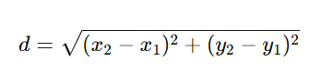 ​
3 o‘lchovli (3D) fazoda. Agar nuqtalar:
- A(x₁, y₁, z₁)
- B(x₂, y₂, z₂)
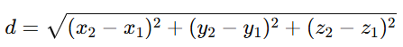

KNN ishlash prinsipi
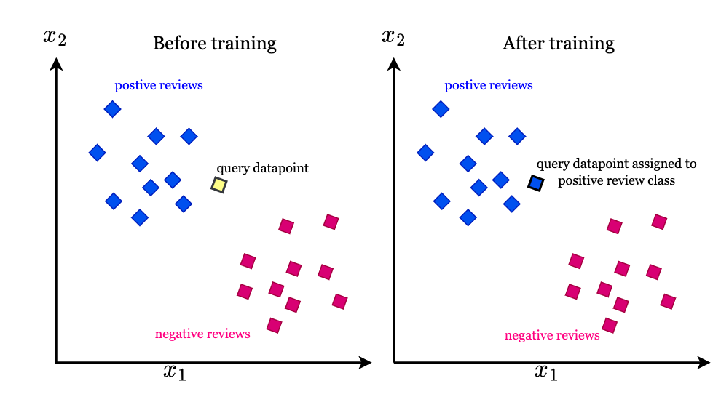
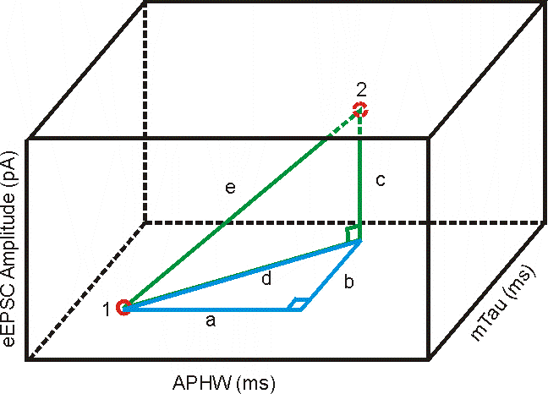
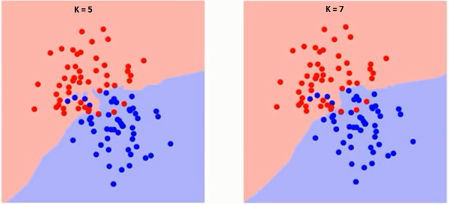

Ishlash tartibi (Step-by-Step)

1-qadam: Dataset yaratish
disease.csv
temperature,heart_rate,disease
36.5,70,0
37.0,75,0
38.5,90,1
39.0,95,1
36.8,72,0
38.8,92,1
37.5,80,0
39.2,100,1
0 — sog‘lom
1 — kasal

2-qadam: Dataset yuklash
import pandas as pd

df = pd.read_csv("disease.csv")
print(df.head())

3-qadam: X va y ajratish
X = df[["temperature", "heart_rate"]]
y = df["disease"]

4-qadam: Train-test ajratish
from sklearn.model_selection import train_test_split

X_train, X_test, y_train, y_test = train_test_split(
X, y, test_size=0.25, random_state=42
)

5-qadam: KNN model yaratish
from sklearn.neighbors import KNeighborsClassifier

model = KNeighborsClassifier(n_neighbors=3)
model.fit(X_train, y_train)

6-qadam: Bashorat qilish
pred = model.predict(X_test)
print("Bashorat:", pred)

7-qadam: Accuracy hisoblash
from sklearn.metrics import accuracy_score, confusion_matrix

acc = accuracy_score(y_test, pred)
cm = confusion_matrix(y_test, pred)

print("Accuracy:", acc)
print("Confusion Matrix:\n", cm)

8-qadam: K qiymatini tekshirish
for k in range(1,6):
model = KNeighborsClassifier(n_neighbors=k)
model.fit(X_train, y_train)
pred = model.predict(X_test)
print("K =", k, "Accuracy:", accuracy_score(y_test, pred))

To‘liq kod (Yakuniy variant)
import pandas as pd
from sklearn.model_selection import train_test_split
from sklearn.neighbors import KNeighborsClassifier
from sklearn.metrics import accuracy_score, confusion_matrix

df = pd.read_csv("disease.csv")

X = df[["temperature", "heart_rate"]]
y = df["disease"]

X_train, X_test, y_train, y_test = train_test_split(
X, y, test_size=0.25, random_state=42
)

model = KNeighborsClassifier(n_neighbors=3)
model.fit(X_train, y_train)

pred = model.predict(X_test)

print("Accuracy:", accuracy_score(y_test, pred))
print("Confusion Matrix:\n", confusion_matrix(y_test, pred))

Tekshirish bosqichi
Talaba tekshiradi:
✅ Model o‘qitildi
✅ Accuracy chiqdi
✅ Confusion matrix ko‘rsatildi
✅ K qiymati sinab ko‘rildi

Hisobot topshirish talabi
Talaba topshiradi:
- Python kodi
- Confusion matrix skrinshoti
- 8-10 qatordan iborat tahlil:
  - Qaysi K eng yaxshi natija berdi?
  - K oshsa nima bo‘ladi?
  - Masofa nima asosida hisoblanadi?

Baholash mezoni
Mezoni | Ball
Model ishlashi | 35
Accuracy | 20
K qiymatini tahlil | 20
Confusion matrix | 10
Tahlil yozish | 15

