The first visualization we generated is a correlation matrix. The correlation matrix gives us an overview of correlations between factors within our data.

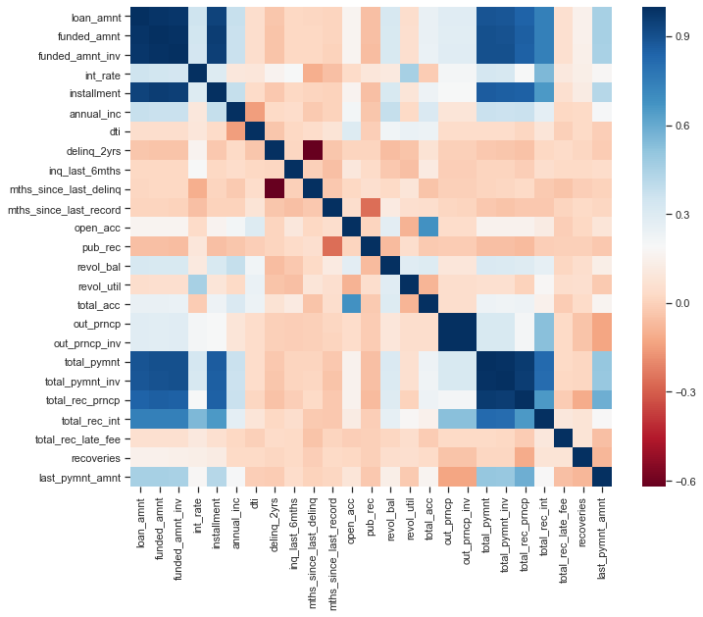

Our main goal is to identify factors that contribute to a loan being successfully paid in full. The good loans and bad loans were sorted in the data, and that allowed us to compare the loan status against other factors.

The pie charts below show that longer term loans have a higher percent of bad loans. We used this information in guide a further exploration into how the term of a loan impacts the likelihood of the loan being paid off.

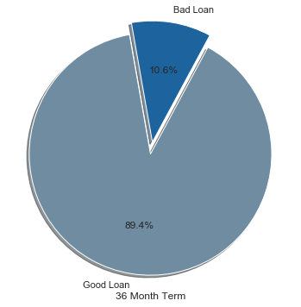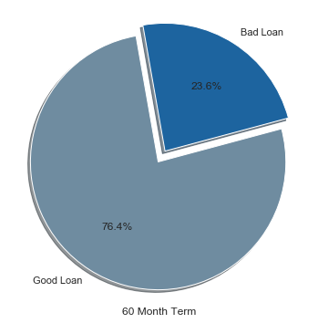

The visualizations below show the breakout of the average loan amount and interest rate of the loans by the status of the loan. The data is also broken out to show the term of the loan. This allows us to get a better understanding of the pie charts above by showing that shorter term loan amounts and interest rates are, on average, lower than longer term rate. Both of these factors most likely contribute to a higher percentage of short term loans being paid off.  
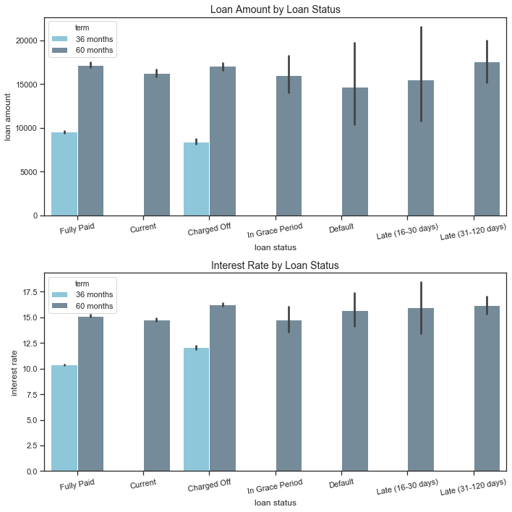

We explored this trend further with a categorical plot in Seaborn. In this visualization, we are able to view the average and data distribution of the loan amounts and interest rate.

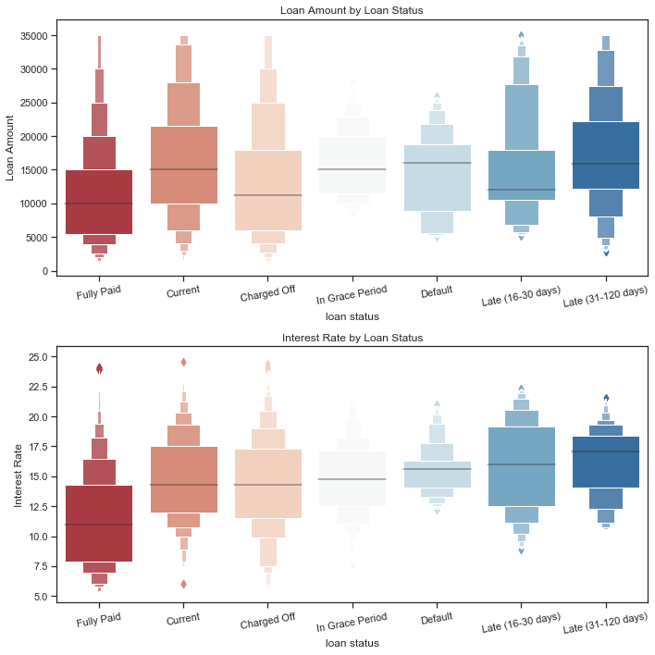

We also looked at how the purpose of the loan impacts the amount of the loan, and whether or not the loan is good or bad. Once again, it looks like loans that are awarded in large amounts are more difficult for borrowers to repay. Specifically, it appears that housing and small business loans are less successfully paid off than loans awarded for other purposes.

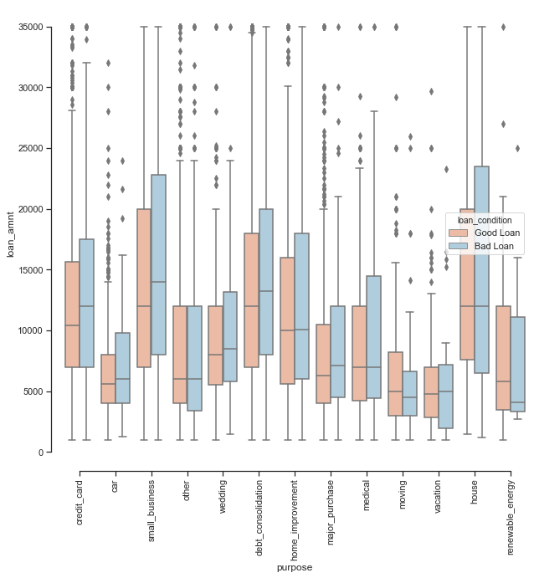

This visualization allows us to compare the distribution of the amount applied for by the borrower and the amount awarded to the borrower. Both of these distributions are the same, which tells us that if a qualified borrower applies for a loan, they will most likely receive the amount they applied for in full.

