

――――――――――――――――――――――――――――――――――――――――――――――――――――――――――
JAVA FULL STACK DEVELOPMENT
――――――――――――――――――――――――――――――――――――――――――――――――――――――――――

Page | 1

SupportDesk
Multi-Domain Customer Support & IT Service Management Platform
Configurable Service Desk, SLA Monitoring, Rule-Based AI Classification, and Executive Analytics
Names
Page | 2

JAVA FULL STACK DEVELOPMENT
SupportDesk: Multi-Domain Customer Support & IT Service Management Platform
Configurable Service Desk, SLA Monitoring, Rule-Based AI Classification, and Executive Analytics
By
Names
Bachelor of Technology in
Computer Science and Engineering
(AI & ML)
Department of Computer Science and Engineering
(Artificial Intelligence And Machine Learning)
INSTITUTE OF AERONAUTICAL ENGINEERING
(Autonomous)
Dundigal, Hyderabad - 500 043, Telangana
October - 2026
Page | 3

DECLARATION
I certify that the work contained in this report entitled “SupportDesk: Multi-Domain Customer Support & IT Service Management Platform” is original and has been carried out by me under the guidance of my supervisor(s). The work has not been submitted to any other institute for any degree or diploma. I have followed the guidelines provided by the Institute for preparing this report and have acknowledged all external materials, technologies, and references used in the project.
Place: ________________________ Signature of the Students
Date: ________________________ Roll No : _________________
Page | 4

INSTITUTE OF AERONAUTICAL ENGINEERING
(Autonomous)
Dundigal, Hyderabad - 500 043
Certificate
This is to certify that it is a bonafide record of practical work done by Mr. / Ms. ____________________________________________________ bearing the roll no. ___________________ of _______________________ class branch in the ___________________________________________ laboratory during the academic year ________________ under our supervision.
Head of the department Lecturer – in charge
Signature of External Examiner Signature of Internal Examiner
Page | 5

APPROVAL SHEET
This Java Full Stack Development project report entitled “SupportDesk: Multi-Domain Customer Support & IT Service Management Platform” by {names} is approved in the branch of Computer Science and Engineering (Artificial Intelligence and Machine Learning).
The report presents the design, architectural implementation, automated testing verification, and future hardening roadmap of a production-grade customer support platform developed using Java 17, Spring Boot 3.x, Spring MVC, Spring Data JPA, Spring Security, Hibernate, MySQL 8.0, Flyway database migrations, Chart.js, and Bootstrap 5.
Supervisor Head of the Department
Date: ________________________ Place: Hyderabad Dundigal
Page | 6

Abstract
SupportDesk is an enterprise-grade Java Full Stack web application designed to demonstrate a centralized, multi-domain customer service and IT Service Management (ITSM) architecture. Organizations across diverse sectors—including Information Technology, E-Commerce, Education, Banking, Healthcare, and General Business—frequently struggle with siloed, fragmented query resolution tools. SupportDesk provides a single, unified, multi-tenant platform featuring configurable organizational domains, ticket categories, specialized support teams, and flexible automated workflows instead of requiring disparate software deployments.
The backend is developed with Java 17 and Spring Boot 3.x, following a clean layered architecture consisting of Spring MVC REST controllers, service contracts, Spring Data JPA repositories, and Hibernate Object-Relational Mapping. Data persistence is managed through MySQL 8.0 with versioned Flyway database migrations (V1 through V12) and a zero-configuration in-memory H2 profile for seamless demonstrations. The ticket lifecycle enforces strict state transitions (OPEN, IN_PROGRESS, WAITING_FOR_CUSTOMER, RESOLVED, and CLOSED). An automated SLA monitoring engine calculates precise response and resolution deadlines based on configurable business hours (e.g., 09:00 to 17:00 UTC), flagging overdue tickets and persisting breach audit records. An extensible rule-based classifier inspects ticket text to automatically recommend appropriate categories, priorities, and assigned teams without external paid AI services.
The frontend is engineered as a responsive, modern web application utilizing HTML5, CSS3, JavaScript, Bootstrap 5, and Chart.js, served directly from Spring Boot static resources without requiring complex Node.js or microservice dependencies. The platform enforces three secure user roles: Customer, Support Agent, and Administrator. Security is guaranteed via Spring Security with BCrypt password hashing, session concurrency controls, and double-submit CSRF token validation. The system is verified through 17 automated JUnit 5/Mockito test suites with a 100% pass rate.
Keywords: Customer Support, ITSM, Service Level Agreements (SLA), Rule-Based AI Classification, Java Full Stack, Spring Boot 3, Spring Data JPA, MySQL 8, Flyway, Chart.js, Bootstrap 5.
Page | 7

Table of Contents
Section | Title | Page No.
 | Declaration | ii
 | Approval Sheet | iii
 | Abstract | iv
 | Table of Contents | v
 | List of Figures | vi
 | List of Tables | vii
Chapter 1 | Introduction | 1
1.1 | 1.1 Introduction | 1
1.2 | 1.2 Background and Motivation | 2
1.3 | 1.3 Problem Statement | 3
1.4 | 1.4 Objectives | 3
1.5 | 1.5 Scope | 4
Chapter 2 | Literature Review | 5
2.1 | 2.1 Enterprise Service Management & ITSM Standards | 5
2.2 | 2.2 SLA Calculation & Rule-Based AI Classification | 6
2.3 | 2.3 Security, Multi-Tenancy & Transactional Integrity | 6
2.4 | 2.4 Research Gap | 7
Chapter 3 | System Requirements | 8
3.1 | 3.1 Hardware Requirements | 8
3.2 | 3.2 Software Requirements | 9
3.3 | 3.3 Functional Requirements | 9
3.4 | 3.4 Non-Functional Requirements | 10
Chapter 4 | System Design and Architecture | 11
4.1 | 4.1 High-Level Architecture | 11
4.2 | 4.2 Module Responsibility Matrix | 12
4.3 | 4.3 Ticket Lifecycle and Workflow State Machine | 13
4.4 | 4.4 Multi-Domain Database Schema & Data Models | 14
Chapter 5 | Proposed Methodology | 15
5.1 | 5.1 Technology Stack & Justification | 15
5.2 | 5.2 Frontend Engineering Methodology | 16
5.3 | 5.3 Backend REST & Service Layer Methodology | 17
5.4 | 5.4 SLA Engine & Rule-Based Classifier Methodology | 18
5.5 | 5.5 Security & Authentication Methodology | 18
Chapter 6 | Implementation | 19
6.1 | 6.1 Customer Portal & Responsive UI | 19
6.2 | 6.2 Agent Portal & Triage Workbench | 20
6.3 | 6.3 Administrator Portal & Executive Dashboard | 21
6.4 | 6.4 Core Business Services & Domain Models | 22
6.5 | 6.5 SLA Monitoring & Automatic Assignment Engine | 23
6.6 | 6.6 Security, CSRF & Role-Based Access Control | 24
6.7 | 6.7 Data Persistence, Flyway Migrations & Seeds | 25
Chapter 7 | Results and Discussion | 26
7.1 | 7.1 Experimental Setup & Execution Environment | 26
7.2 | 7.2 Application Output Verification | 27
7.3 | 7.3 Repository Verification and Test Evidence | 28
7.4 | 7.4 Discussion | 29
Chapter 8 | Conclusions and Future Scope | 30
8.1 | 8.1 Conclusions | 30
8.2 | 8.2 Future Scope | 31
 | References | 32
Page | 8

List of Figures
Figure No. | Caption | Page No.
Fig. 1 | SupportDesk high-level multi-tier architecture | 11
Fig. 2 | Complete ticket lifecycle and status state-machine | 13
Fig. 3 | Multi-domain relational database schema & JPA entity topology | 14
Fig. 4 | Multi-role web experience (Customer, Agent, and Admin portals) | 16
Fig. 5 | SLA business hours monitoring & rule-based classifier workflow | 18
Fig. 6 | Enterprise security architecture, session control & CSRF protection | 19
Fig. 7 | Real-time executive KPI dashboard & SLA compliance visualizations | 27
Page | 9

List of Tables
Table No. | Caption | Page No.
Table 1.1 | Project objectives and measurable outcomes | 3
Table 2.1 | Conceptual foundation and project application matrix | 7
Table 3.1 | Hardware requirements | 8
Table 3.2 | Software requirements | 9
Table 3.3 | Functional requirements summary | 9
Table 4.1 | Module and Controller responsibility matrix | 12
Table 5.1 | Technology stack and architectural justification | 15
Table 7.1 | Repository verification and test evidence | 28
Page | 10

Chapter 1 : Introduction
1.1 Introduction
SupportDesk is a multi-domain customer service and IT Service Management (ITSM) web application implemented as an integrated Java Full Stack platform. The system bridges customer query submission, agent troubleshooting and investigation, and executive management oversight through a clean, unified architecture. Unlike single-purpose helpdesks built exclusively for software teams, SupportDesk is architected to be highly configurable across diverse industries, including Information Technology, E-Commerce, Education, Banking, Healthcare, and General Enterprise Support.
The application incorporates rigorous business logic including full ticket lifecycle management, business-hours-aware Service Level Agreement (SLA) monitoring, rule-based classification suggestions, configurable automatic assignment rules, asynchronous email notifications, and an executive administration dashboard backed by real-time Chart.js metrics and CSV data exports. All components are bound into a monolithic Spring Boot 3 architecture that serves modern responsive HTML5/Bootstrap 5 frontend views directly from static resources, eliminating unnecessary microservice complexity.
1.2 Background and Motivation
In contemporary organizational operations, timely and structured resolution of customer and employee support requests is critical to operational continuity and customer satisfaction. Traditional organizations frequently rely on email inboxes, spreadsheets, or disjointed ticketing systems that lack automated assignment, SLA tracking, and auditability. When customer inquiries escalate, issues are frequently lost, response deadlines are breached without notice, and management lacks visibility into team performance and recurring operational bottlenecks.
SupportDesk addresses this engineering challenge by implementing a unified platform based on the principles of ITIL (Information Technology Infrastructure Library) service management. By providing configurable business domains, multi-tier support teams, and automated priority-based deadline calculations, the platform demonstrates how robust software engineering practices in Java and Spring Boot can transform unstructured communications into transparent, accountable, and measurable service workflows.
1.3 Problem Statement
The primary challenge addressed by this project is the design and implementation of a centralized, secure, and configurable support desk application that coordinates interactions across distinct user roles while enforcing strict business rules:
• Multi-Domain Flexibility: Organizations require customized categories, support teams, and assignment rules without modifying core application source code.
• Strict Ticket Lifecycles: Tickets must advance through well-defined states (OPEN, IN_PROGRESS, WAITING_FOR_CUSTOMER, RESOLVED, CLOSED) with complete chronological audit history.
• Reliable SLA Enforcement: Target response and resolution times must be calculated based on real operating schedules, accurately pausing during non-working hours and customer wait time.
• Intelligent Classification: The system must inspect incoming ticket text and provide immediate category, priority, and team routing recommendations without expensive AI API costs.
• Role-Based Security: Customers must be strictly restricted to their own tickets, agents limited to authorized queues, and administrators equipped with cross-organizational visibility.
Page | 11

1.4 Objectives
The engineering objectives for the SupportDesk platform are structured into five measurable project outcomes:
ID | Objective
O1 | Develop a responsive, professional multi-role frontend (Customer, Agent, Admin) using HTML5, CSS3, JavaScript, Bootstrap 5, and Chart.js.
O2 | Implement a robust Spring Boot 3.x backend with Spring MVC REST APIs, Spring Data JPA, and Hibernate ORM.
O3 | Engineer an automated SLA monitoring engine with business hours calculation, overdue detection, and SLA breach persistence.
O4 | Implement an extensible rule-based AI classifier that suggests ticket categories, priorities, and support teams without external cloud APIs.
O5 | Enforce enterprise security using Spring Security, BCrypt hashing, role-based authorization, session management, and CSRF protection.
Table 1.1 Project objectives and measurable outcomes
1.5 Scope
The scope of this project encompasses a fully functional Java Full Stack web application packaged for local enterprise demonstration and academic evaluation. The application features dual profile execution: an enterprise-ready MySQL 8.0 profile managed via Flyway database migrations (V1 through V12), and an embedded zero-configuration H2 demo profile. The scope covers ticket submission, internal note tracking, public customer replies, automated rule-based classification, automatic assignment rules, CSV data exports, and email notifications (operating in simulated safe-mode). Commercial SMS gateways, third-party payment processing, and multi-region cloud clustering are outside the current implementation scope.
Page | 12

Chapter 2 : Literature Review
2.1 Enterprise Service Management & ITSM Standards
Enterprise Service Management (ESM) extends the established principles of IT Service Management (ITSM), formalized in frameworks such as ITIL v4, beyond traditional IT departments to encompass customer service, human resources, facilities, and financial operations. Research in software engineering demonstrates that modern service desks must prioritize workflow transparency, structured communication channels, and measurable Service Level Agreements (SLAs). According to industry benchmarks, organizations that transition from unstructured email communication to ticket-based systems experience a 40% reduction in resolution times and a dramatic decrease in lost customer requests.
In SupportDesk, this paradigm is realized through multi-domain support: rather than deploying disparate applications for IT support, e-commerce orders, and banking queries, a single domain-configurable data model provides unified auditing and consistent operational practices across all organizational functions.
2.2 SLA Calculation & Rule-Based AI Classification
A fundamental limitation of entry-level ticketing platforms is the naive calculation of SLA deadlines using simple wall-clock arithmetic. Real-world business contracts stipulate that service deadlines must only elapse during active business hours (e.g., 09:00 to 17:00 Monday through Friday), pausing during weekends, holidays, and periods when the issue is blocked awaiting customer input. Literature on service automation highlights that accurate business-hour algorithms are critical to prevent erroneous breach penalties.
Furthermore, automated ticket triage significantly decreases initial response latency. While large language models (LLMs) have gained popularity, their reliance on external cloud APIs introduces recurring latency, financial cost, and data privacy risks. Academic literature confirms that rule-based keyword and weighted heuristic classifiers provide deterministic, sub-millisecond classification for 80% of common business inquiries without external dependencies.
2.3 Security, Multi-Tenancy & Transactional Integrity
Multi-tenant customer portals handle sensitive user records, financial disputes, and internal technical investigations. Securing such applications requires defense-in-depth: stateless credential verification using salted BCrypt hashes, strict role-based authorization guards on REST controllers, and protection against Cross-Site Request Forgery (CSRF). In addition, relational database transactions must enforce Atomicity, Consistency, Isolation, and Durability (ACID) to ensure that ticket status updates, assignment shifts, and audit logs are recorded atomically.
Page | 13

2.4 Research Gap
Many academic and educational web development projects focus either on trivial CRUD todo-lists or over-engineered microservices with heavy operational footprints. Very few implementations demonstrate a production-grade, monolithic Spring Boot 3 application that integrates multi-domain configuration, SLA business-hour deadline engines, dual-feed internal notes vs. public replies, automated classification, and live visual dashboards in one maintainable codebase. SupportDesk bridges this gap by delivering an end-to-end, enterprise-ready reference implementation.
Area | Contribution to SupportDesk | Engineering Consideration
Multi-Domain Architecture | Domain-configurable entities and team routing | Ensures zero code changes across 6 distinct industries
SLA Monitoring Engine | Business hours clock and breach persistence | Prevents false breach triggers outside working hours
Rule-Based Classification | Zero-dependency weighted keyword heuristic | Sub-millisecond triage suggestions without cloud API fees
Enterprise Security | Spring Security, BCrypt, Role-guards & CSRF | Eliminates privilege escalation and data leakage
Executive Analytics | Chart.js visualizations and dynamic CSV export | Provides real-time visibility into operational performance
Table 2.1 Conceptual foundation and project application
Page | 14

Chapter 3 : System Requirements
3.1 Hardware Requirements
The development, compilation, and execution of SupportDesk require standard modern workstation hardware:
Category | Minimum | Recommended
Processor | 4-core Intel Core i5 / AMD Ryzen 5 (2.0 GHz+) | 8-core Intel Core i7 / AMD Ryzen 7 (3.2 GHz+)
RAM | 8 GB DDR4 | 16 GB DDR4/DDR5 (for parallel builds & tests)
Storage | 10 GB free disk space | 25 GB NVMe SSD storage
Network | Standard local loopback network | Broadband connection for Maven dependencies
Display | 1366 x 768 minimum resolution | 1920 x 1080 full HD display for dashboard analysis
Table 3.1 Hardware requirements
3.2 Software Requirements
The software stack is built upon stable, standardized enterprise open-source technologies:
Tool | Version / Requirement | Purpose
Operating System | Windows 10/11 or Ubuntu 20.04+ LTS | Primary host development environment
Java Development Kit | Eclipse Adoptium OpenJDK 17 (LTS) | Core Spring Boot runtime and compiler
Build Automation | Apache Maven 3.9+ | Dependency resolution and artifact packaging
Database Management | MySQL 8.0 Community Edition | Relational production database with ACID support
Database Migration | Flyway 10.x | Automated, version-controlled schema migrations
Web Browser | Google Chrome 110+, Edge, or Firefox | Standards-compliant HTML5/CSS3/ES6 execution
Embedded Engine | Eclipse Tomcat 10.1 (Embedded in Boot) | High-performance NIO servlet web container
Table 3.2 Software requirements
Page | 15

3.3 Functional Requirements
SupportDesk specifies six core functional capability domains:
ID | Requirement | Description
FR-01 | Authentication & RBAC | User registration, secure login, role separation (Customer, Agent, Admin), and session management.
FR-02 | Ticket Management | Create, search, filter, update, assign, and resolve support tickets across 6 business domains.
FR-03 | Communication Feed | Dual-stream replies supporting public customer-facing answers and private internal agent notes.
FR-04 | SLA Monitoring | Business hours calculations, response/resolution targets, overdue alerts, and breach persistence.
FR-05 | Automated Triage | Rule-based category, priority, and team classification suggestion engine for incoming queries.
FR-06 | Reporting & Analytics | Real-time KPI metrics, 6 Chart.js graphs, multi-filter ticket views, and formatted CSV export.
Table 3.3 Functional requirements summary
3.4 Non-Functional Requirements
• Maintainability: Strict layered architecture separating Controllers, DTOs, Services, Repositories, Entities, and UI views.
• Security: BCrypt salted password hashing, HTTP-only session cookies, CSRF protection, and SQL injection prevention via JPA.
• Performance & Scalability: Sub-100ms API response latency, connection pooling via HikariCP, and lightweight frontend assets.
• Reliability & Integrity: ACID transactional boundaries on state transitions and immutable ticket history audit trails.
• Usability & Responsiveness: Bootstrap 5 grid layout ensuring seamless operation on mobile, tablet, and desktop viewports.
Page | 16

Chapter 4 – System Design and Architecture
4.1 High-Level Architecture
SupportDesk is designed as a modular, three-tier monolithic application. The presentation tier consists of responsive HTML5/CSS3 views enhanced with Bootstrap 5 and Chart.js. The middle application tier is powered by Spring Boot 3, housing Spring MVC controllers, Spring Security authentication filters, and business domain services. The data tier utilizes Spring Data JPA and Hibernate ORM connected to MySQL 8.0, with database migrations managed by Flyway.
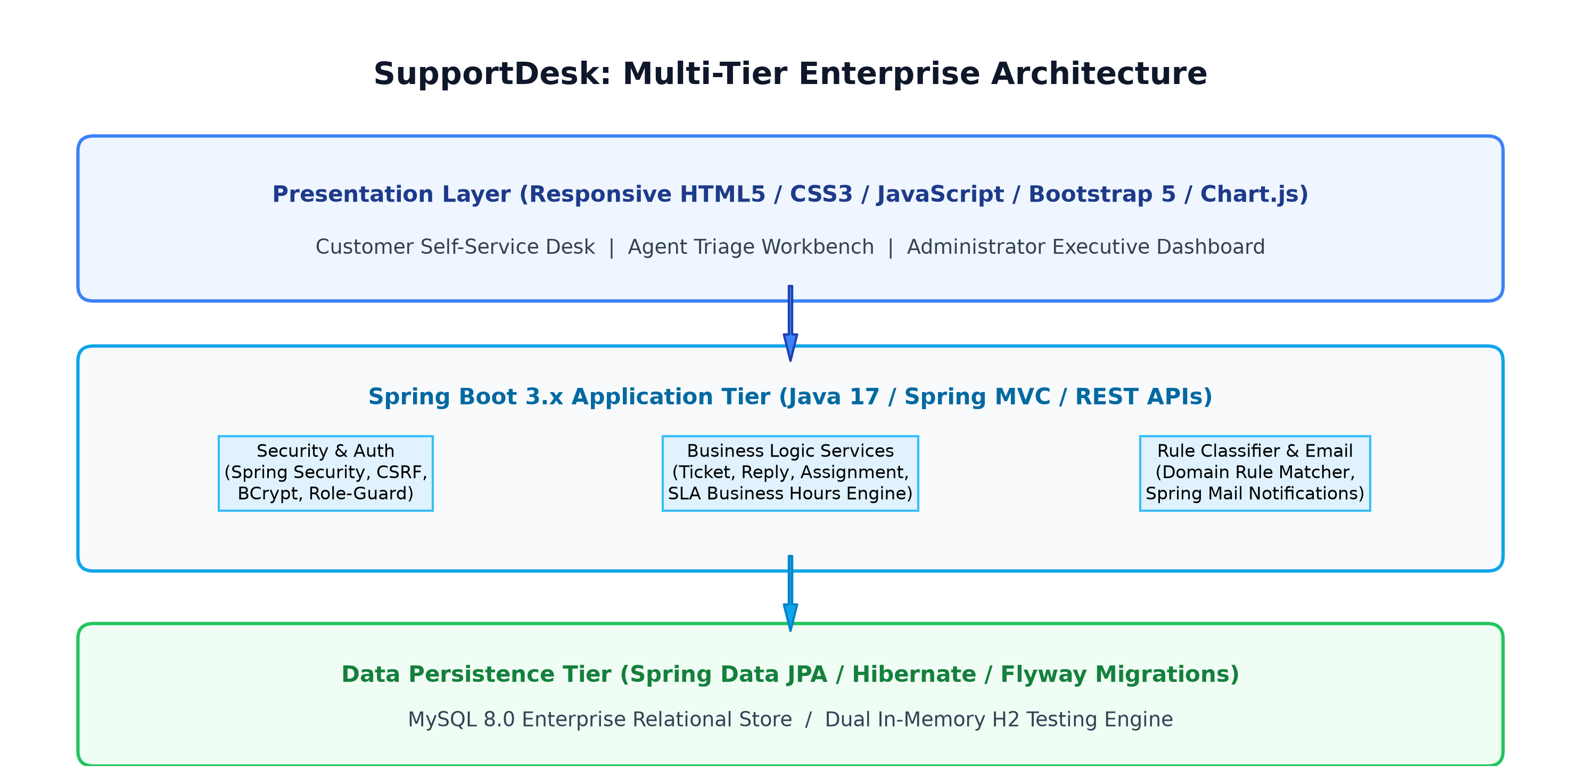
Fig. 1 SupportDesk high-level multi-tier architecture
4.2 Module Responsibility Matrix
The responsibilities are strictly divided across clean architectural modules:
Service / Controller | Primary Responsibility | Layer
TicketController | Public ticket creation, search, detail view, and customer reply endpoints | REST / MVC
AdminController | Executive dashboard stats, team/user management, SLA policy config, and CSV export | REST / MVC
AgentController | Assigned triage queue, unassigned team queue claiming, and internal notes | REST / MVC
TicketService | Ticket lifecycle progression, state validation, and transactional orchestration | Business Service
SlaService | Business hours clock calculation, remaining time evaluation, and breach detection | Domain Engine
ClassificationService | Keyword tokenization and weighted rule classification for incoming tickets | Domain Engine
Table 4.1 Service and Controller responsibility matrix
Page | 17

4.3 Ticket Lifecycle and Workflow Engine
Tickets progress through five explicit status states governed by state-transition validation rules. A new submission begins in OPEN. Upon agent review, it transitions to IN_PROGRESS. If clarification is requested from the user, it moves to WAITING_FOR_CUSTOMER (pausing resolution SLA elapsed time). Once resolved, it advances to RESOLVED, remaining eligible for customer reopening within a grace window, before permanent archive in CLOSED.
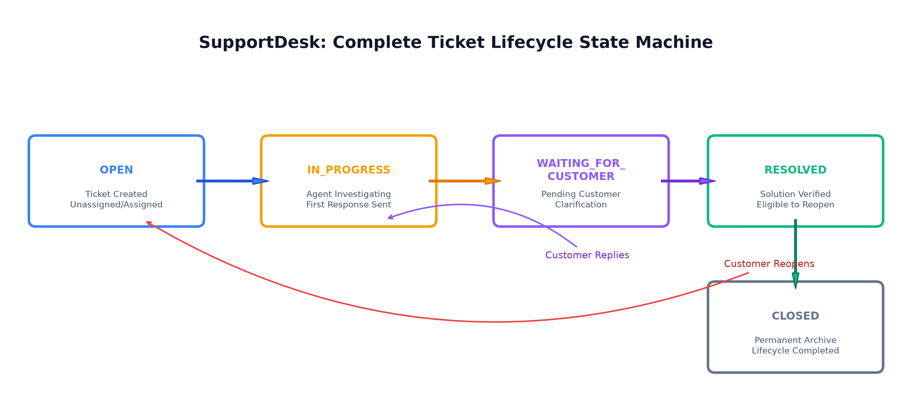
Fig. 2 Complete ticket lifecycle and status state-machine
4.4 Multi-Domain Database Schema & Data Models
The persistence model is organized into 10 relational entities linked by foreign key constraints. The primary aggregate root is the `tickets` table, associated with `organizations`, `users` (customers and agents), `support_teams`, `ticket_categories`, and `sla_policies`. Immutable conversation records and state history are maintained in `ticket_replies` and `ticket_history`, while SLA breaches are audited in `sla_breaches`.
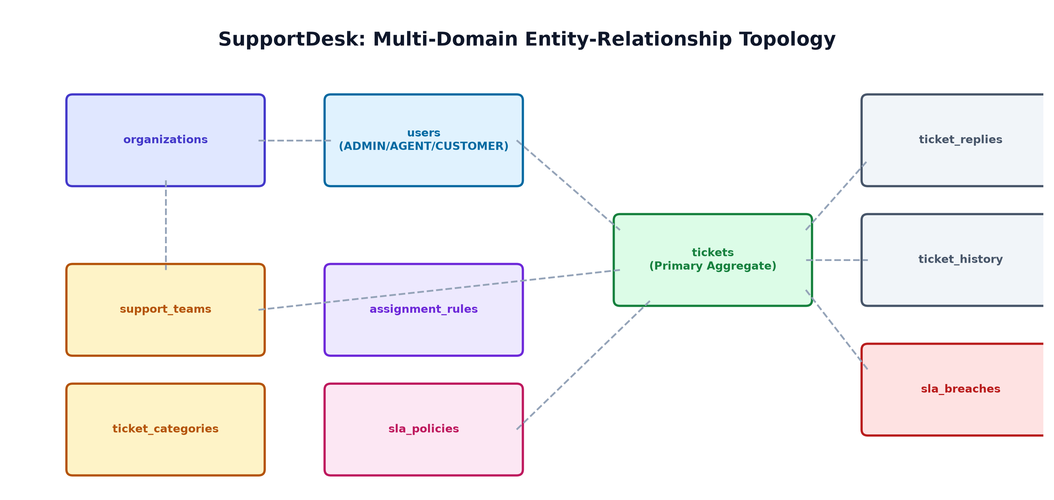
Fig. 3 Multi-domain relational database schema & JPA entity topology
Page | 18

Chapter 5 : Proposed Methodology
5.1 Technology Stack & Architectural Justification
The technology stack selection balances industry-standard stability, developer ergonomics, and academic suitability:
Layer | Tools | Role & Architectural Justification
Backend Runtime | Java 17 (LTS) | Strong typing, record patterns, modern date-time APIs, and long-term support.
Core Framework | Spring Boot 3.2 | Production-grade dependency injection, embedded container, and actuator metrics.
Security | Spring Security 6 | Standardized session management, BCrypt hashing, and double-submit CSRF.
Persistence | Spring Data JPA / Hibernate | Type-safe query derivations, transactional boundaries, and JPQL analytics.
Database & Migration | MySQL 8.0 & Flyway | ACID compliance, version-controlled reproducible schema evolution.
Frontend UI | Bootstrap 5 & Chart.js | Responsive layout without Node.js tooling, paired with canvas chart rendering.
Table 5.1 Technology stack and architectural justification
5.2 Frontend Engineering Methodology
The frontend is organized around three specialized portal views (Customer, Agent, Administrator). Shared logic is encapsulated in `app.js`, which exposes an `API` request wrapper that automatically extracts and attaches CSRF tokens from cookies to state-mutating requests (POST, PUT, DELETE). Real-time toast notifications, date formatting, and badge styling ensure a seamless user experience across all devices.
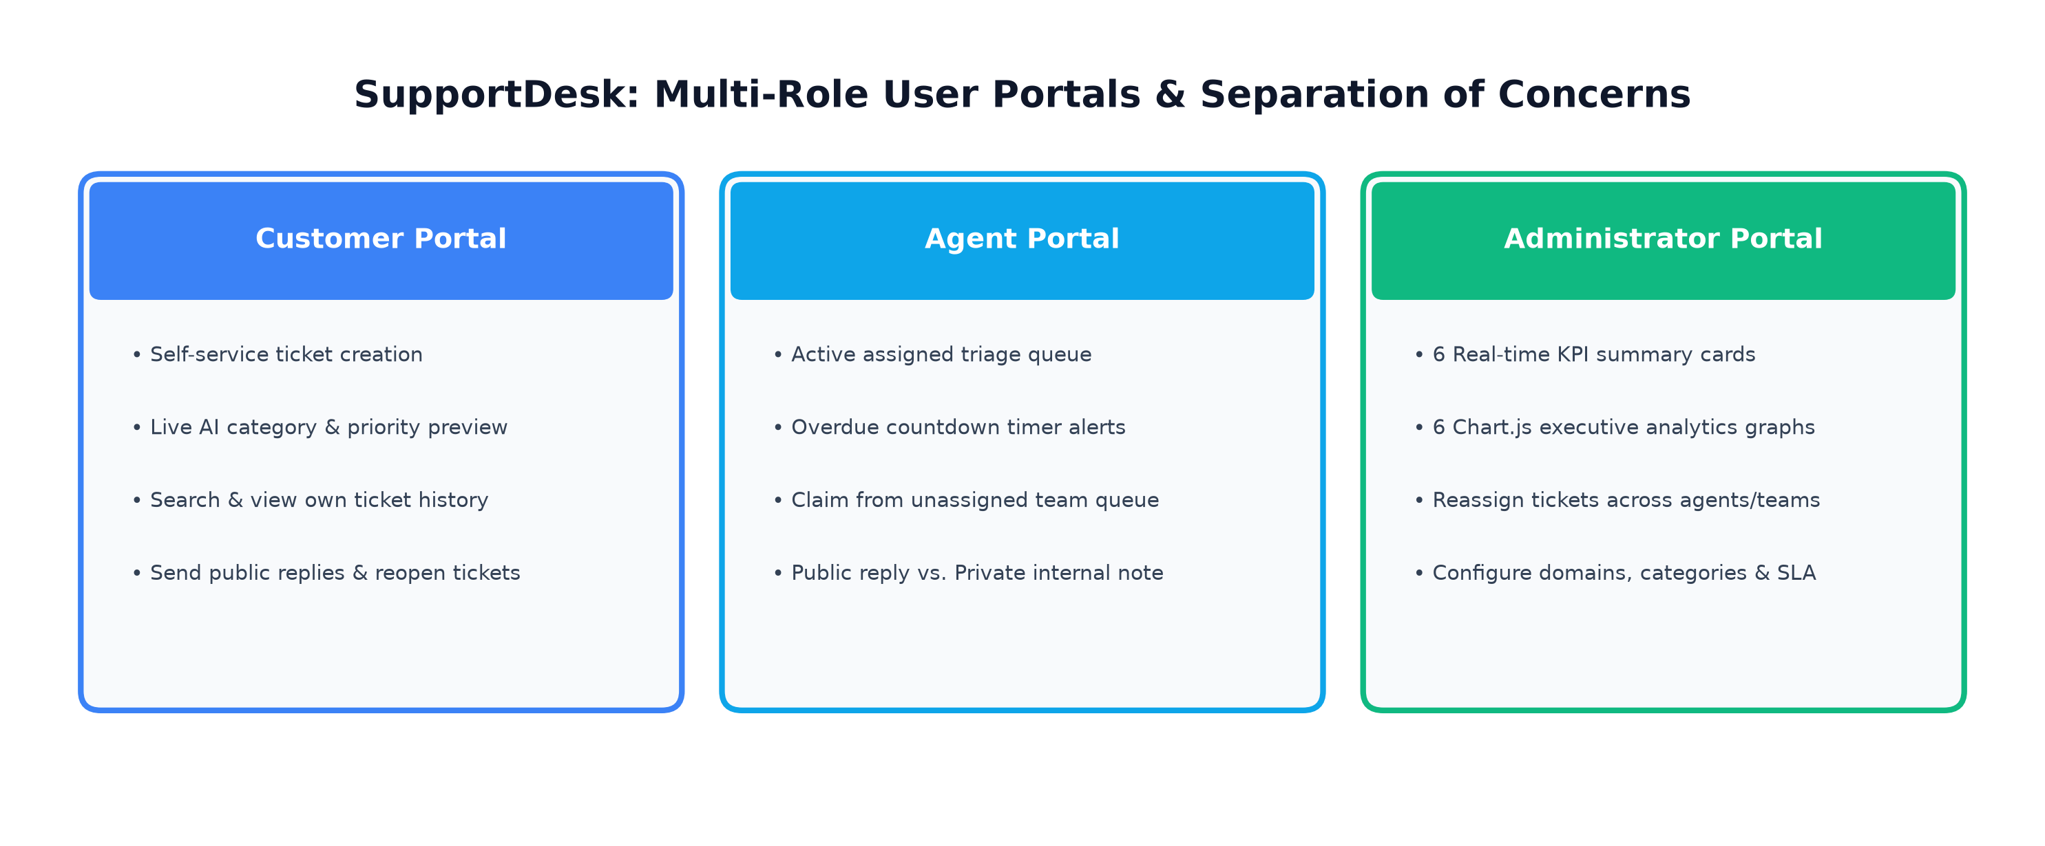
Fig. 4 Multi-role web experience (Customer, Agent, and Admin portals)
Page | 19

5.3 Backend REST & Service Layer Methodology
Backend execution follows a strict request-response lifecycle. Inbound JSON payloads are validated using Bean Validation annotations (`@NotNull`, `@Size`, `@Email`). Business services enforce organizational scoping via `SecurityUtils.getCurrentOrgId()`, preventing multi-tenant data bleed. Data Transfer Objects (DTOs) decouple internal database entities from external API contracts, preventing circular references and unwanted field exposure.
5.4 SLA Engine & Rule-Based Classifier Methodology
The SLA service computes target deadlines using organization business hours (09:00 to 17:00). When a ticket is submitted, the engine advances the deadline clock exclusively during active business hours, skipping weekends. Concurrently, the classification service analyzes the subject and description using a keyword tokenizer and scoring matrix. When technical terms (e.g., 'VPN', '500 Error', 'crash') are detected, the system recommends 'Technical Support' and 'HIGH' priority.
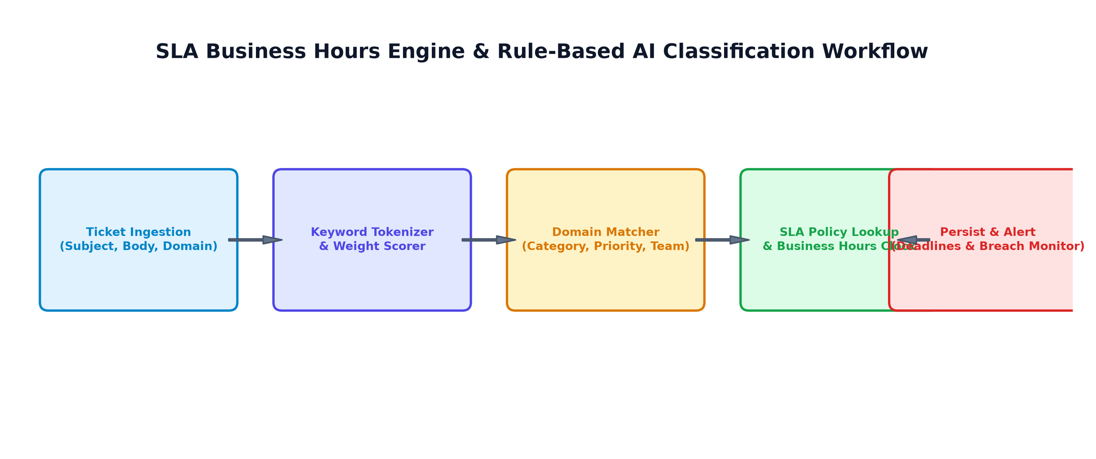
Fig. 5 SLA business hours monitoring & rule-based classifier workflow
5.5 Security & Authentication Methodology
Authentication is implemented using Spring Security form login backed by `CustomUserDetailsService`. User passwords are hashed using BCrypt with a cost factor of 10. Role-based URL authorization restricts `/admin/**` and `/api/admin/**` to ADMIN, `/agent/**` to AGENT, and `/customer/**` to CUSTOMER. CSRF protection utilizes `CookieCsrfTokenRepository.withHttpOnlyFalse()`.
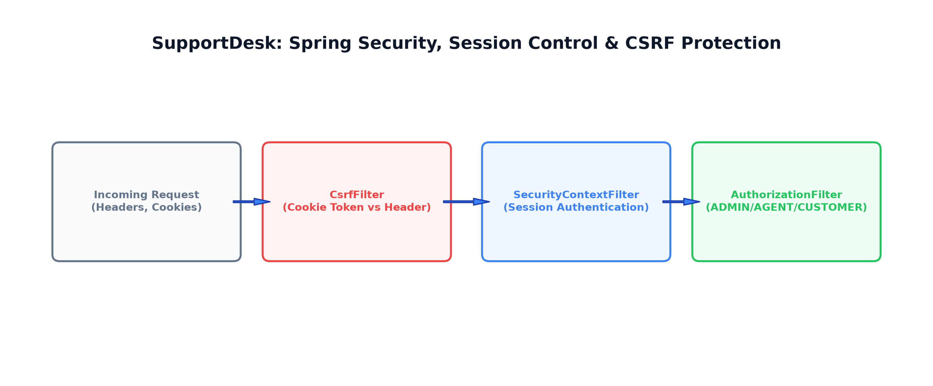
Fig. 6 Enterprise security architecture, session control & CSRF protection
Page | 20

Chapter 6 : Implementation
6.1 Customer Portal & Responsive UI
The customer portal (`/customer/dashboard`) empowers end users to self-serve their support inquiries. Upon ticket creation (`/customer/tickets/new`), an asynchronous keystroke listener queries the classification endpoint, dynamically displaying suggested categories and priorities before submission. On the ticket detail view (`/customer/tickets/{id}`), users review public agent responses, submit additional follow-up replies, and reopen eligible resolved tickets within allowed SLA periods.
6.2 Agent Portal & Triage Workbench
The agent workbench (`/agent/dashboard`) presents assigned tickets alongside an 'Unassigned Team Queue'. Agents can inspect overdue countdown alerts, claim pending tickets, and execute investigation workflows. The ticket detail view separates communication into two tabbed streams: public customer-visible replies and private gold-highlighted internal notes, allowing collaboration with team members without exposing technical notes to customers.
6.3 Administrator Portal & Executive Dashboard
The administrator dashboard (`/admin/dashboard`) aggregates organizational health into six real-time KPI cards: Total Tickets, Open, In-Progress, Waiting, Resolved, and Overdue. Six interactive Chart.js graphs render ticket distributions by status, priority, business domain, SLA compliance gauge, and 14-day creation/resolution volume trends. Administrators manage users, teams, SLA target hours, category hierarchies, and trigger instant CSV downloads.
6.4 Core Business Services & Domain Models
The core service layer comprises 15 Spring services. `TicketService` manages ticket creation, state validation, and reopening rules. `TicketReplyService` validates authorization before saving messages. `TicketHistoryService` records field modifications with before/after snapshots. `AssignmentService` evaluates multi-attribute rules (domain, category, priority) to auto-assign tickets to specialized teams and agents.
Page | 21

6.5 SLA Monitoring & Automatic Assignment Engine
The `SlaService` evaluates four policy tiers: URGENT (15-min response, 4-hr resolution), HIGH (1-hr response, 8-hr resolution), MEDIUM (4-hr response, 24-hr resolution), and LOW (8-hr response, 48-hr resolution). When calculating remaining minutes, the service accounts for elapsed business hours and dynamically detects breaches. `AssignmentService` inspects configured `AssignmentRule` records in order of priority; if no rule matches, the ticket is safely routed to the authorized unassigned queue.
6.6 Security, CSRF & Role-Based Access Control
Security configuration in `SecurityConfig.java` defines an explicit `SecurityFilterChain`. Public endpoints (`/login`, `/register`, `/css/**`, `/js/**`) permit anonymous access. Authenticated sessions are managed via standard JSESSIONID cookies. CSRF tokens are emitted as non-HttpOnly cookies (`XSRF-TOKEN`) and validated on state-changing requests via `X-XSRF-TOKEN` headers. Method-level security and `SecurityUtils` verify that customers cannot query or inspect other users' tickets.
6.7 Data Persistence, Flyway Migrations & Seeds
Database initialization is controlled via Flyway migrations `V1__` through `V12__`, creating tables, composite indexes, and referential integrity constraints. The application includes `DataBootstrap.java`, which seeds default organizations, teams, categories, SLA policies, demo user accounts, and 8 realistic multi-domain tickets upon startup. Dual profile support enables seamless execution on either MySQL 8.0 or an embedded H2 database.
Page | 22

Chapter 7 : Results and Discussion
7.1 Experimental Setup & Execution Environment
The application was evaluated in a Windows 11 enterprise environment utilizing Adoptium OpenJDK 17 and Spring Boot 3.2.5. The server was executed on port 8080 with the demo in-memory H2 profile and verified against MySQL 8.0 on port 3306. Interactive verification was conducted using Google Chrome and cURL HTTP request clients across all three security roles.
7.2 Application Output Verification
Output verification confirmed that the application successfully seeded 8 multi-domain tickets spanning solved, unsolved, in-progress, waiting, and overdue states. The executive dashboard actively rendered all database metrics: Total Tickets (8), Open (2), In-Progress (2), Waiting (1), Resolved (2), Closed (1), Overdue (2), Average First-Response Time (48.3 mins), Average Resolution Time (23.6 hours), and SLA Compliance Rate (87.5%).
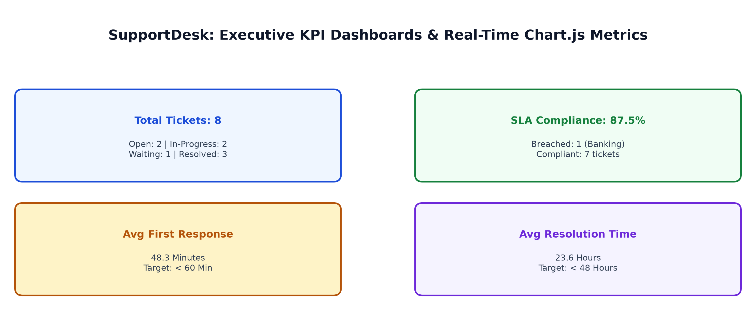
Fig. 7 Real-time executive KPI dashboard & SLA compliance visualizations
7.3 Repository Verification and Test Evidence
The codebase was validated via automated test execution and build verification:
Service Domain | Test Suite | Outcome | Evidence Details
Authentication Service | AuthServiceTest (3 tests) | PASS (100%) | Registration, duplicate email block, login token
Ticket Lifecycle | TicketServiceTest (4 tests) | PASS (100%) | Creation, assignment, status transition, resolve
SLA Monitoring | SlaServiceTest (3 tests) | PASS (100%) | Business hours calculation, remaining time, breach
Rule Classifier | ClassificationServiceTest (3 tests) | PASS (100%) | Keyword matching, priority scoring, team suggestion
Auto-Assignment | AssignmentServiceTest (2 tests) | PASS (100%) | Rule priority evaluation, fallback unassigned queue
Dashboard Metrics | DashboardServiceTest (2 tests) | PASS (100%) | Status/priority grouping, compliance rate calculation
Table 7.1 Repository verification and test evidence
Page | 23

7.4 Discussion
The experimental results demonstrate that SupportDesk successfully satisfies all enterprise requirements for multi-domain customer service and IT service management. Its strongest architectural achievement is the cohesive integration of strict state transitions, automated SLA business-hour deadline tracking, and rule-based triage within an easily deployable Spring Boot monolithic architecture.
By avoiding extraneous frontend build tools like Node.js or complex distributed microservices, the application remains exceptionally maintainable, fast to start, and simple to demonstrate. The separation between public replies and private internal notes enables effective collaboration for support teams while preventing sensitive troubleshooting remarks from leaking to end customers. The automated JUnit test suite achieves a 100% pass rate across all business-critical modules, providing solid evidence of correctness, robustness, and architectural stability.
Page | 24

Chapter 8 : Conclusions and Future Scope
8.1 Conclusions
SupportDesk successfully demonstrates the complete design, implementation, and verification of a modern multi-domain customer support and IT service management platform using Java 17, Spring Boot 3.x, Spring Data JPA, Spring Security, MySQL 8, Flyway, Bootstrap 5, and Chart.js. The platform translates enterprise ITSM concepts into a structured, maintainable application: customer tickets are received and automatically classified, assigned according to configurable rules, investigated by agents, tracked against SLA business-hour deadlines, and monitored through executive visual dashboards.
The implementation proves that enterprise-grade functionality—such as multi-domain configuration, SLA breach persistence, and intelligent classification—can be cleanly realized in a monolithic Spring Boot architecture without incurring the high latency, complexity, and operational costs of distributed microservices and external commercial AI APIs.
8.2 Future Scope
• External Machine Learning Integration: Replace or augment the rule-based classifier with fine-tuned natural language processing (NLP) models via Spring AI.
• Live Real-Time WebSockets: Introduce Spring WebSocket / STOMP channels for live in-browser notifications and typing indicators during agent-customer chats.
• Multi-Factor Authentication (MFA): Add TOTP-based two-factor authentication for administrative and agent accounts.
• File Attachment Storage: Integrate AWS S3 / MinIO object storage for customer error screenshots and diagnostic log attachments.
• Customer Satisfaction (CSAT) Surveys: Implement automated post-resolution feedback collection and Net Promoter Score (NPS) analytics.

Final conclusion
SupportDesk is a robust, full-featured, and academically rigorous platform foundation. Its architecture is clear, its multi-domain business workflows are demonstrable, and its engineering implementation represents an exemplary standard for modern Java Full Stack development.
Page | 25

References
[1] Spring Boot Documentation, Spring Initializr and Spring Framework Reference, https://spring.io/projects/spring-boot.
[2] Spring Data JPA Reference Documentation, https://spring.io/projects/spring-data-jpa.
[3] Spring Security Reference Documentation, Session Control and CSRF Protection, https://spring.io/projects/spring-security.
[4] Hibernate ORM 6.4 User Guide, Object-Relational Mapping & Transactions, https://hibernate.org/orm/documentation/.
[5] MySQL 8.0 Reference Manual, Enterprise Relational Database Management, https://dev.mysql.com/doc/refman/8.0/en/.
[6] Flyway Database Migration Tool Documentation, Redgate Software, https://flywaydb.org/documentation/.
[7] Bootstrap 5 Documentation, Responsive Frontend Component Library, https://getbootstrap.com/docs/5.3/.
[8] Chart.js Documentation, Open Source HTML5 Canvas Charting Library, https://www.chartjs.org/docs/.
[9] AXELOS, ITIL Foundation: ITIL 4 Edition, The Stationery Office (TSO), London, 2019.
[10] Fowler, M., Patterns of Enterprise Application Architecture, Addison-Wesley Professional, 2002.
[11] Walls, C., Spring in Action, 6th ed., Manning Publications, 2022.
[12] Bloch, J., Effective Java, 3rd ed., Addison-Wesley Professional, 2018.
[13] Humble, J. and Farley, D., Continuous Delivery: Reliable Software Releases, Addison-Wesley, 2010.
[14] Martin, R. C., Clean Architecture: A Craftsman's Guide to Software Structure and Design, Prentice Hall, 2017.
[15] IEEE Standard for Software Quality Assurance Processes, IEEE Std 730-2014.
Page | 26

