# 先对 max_depth，min_child_weight两组参数进行调参

# 最优 max_depth=3， min_child_weight=3，得分：0.78699

# 次优 max_depth=7， min_child_weight=4，得分：0.78245

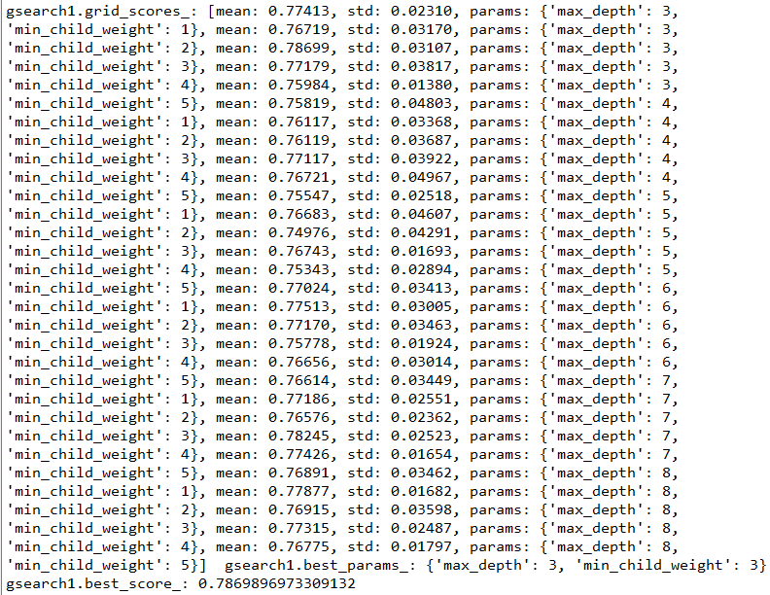

# 在 max_depth=3，min_child_weight=3情况下调参 gamma

# 测试结果 最优：gamma=0.2

# 次优：gamma=0.4

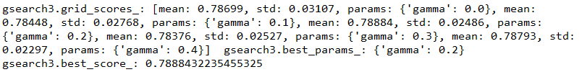

# 下面在 max_depth=3，min_child_weight=3，gamma=0条件下，调整 subsample，colsample_bytree的参数

# 结果 最优：subsample=0.9, colsample_bytree=0.8

# 次优：subsample=0.8, colsample_bytree=0.8

# 得到第一组参数：max_depth=3，min_child_weight=3，gamma=0.2,subsample=0.9,colsample_bytree=0.8

# 得到第二组参数：max_depth=3，min_child_weight=3，gamma=0.2,subsample=0.8,colsample_bytree=0.8

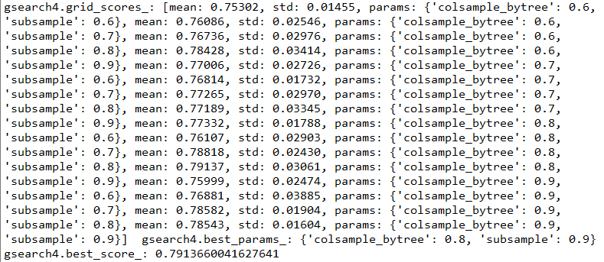

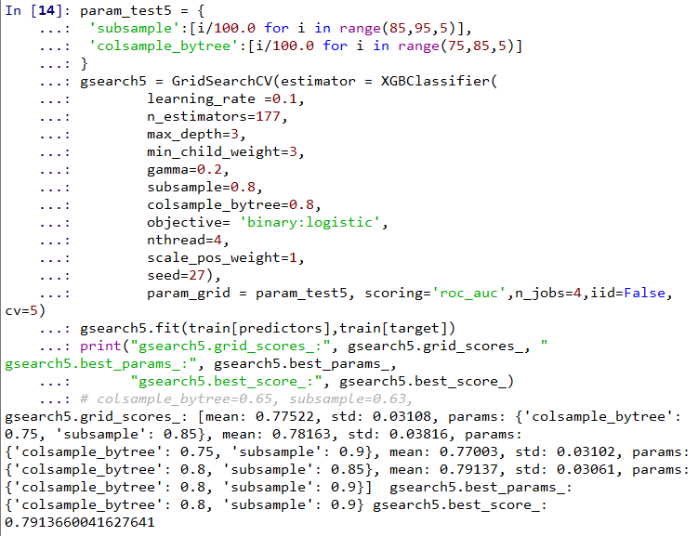

#下面在max_depth=3，min_child_weight=3，gamma=0.4条件下，对subsample，colsample_bytree进行调参

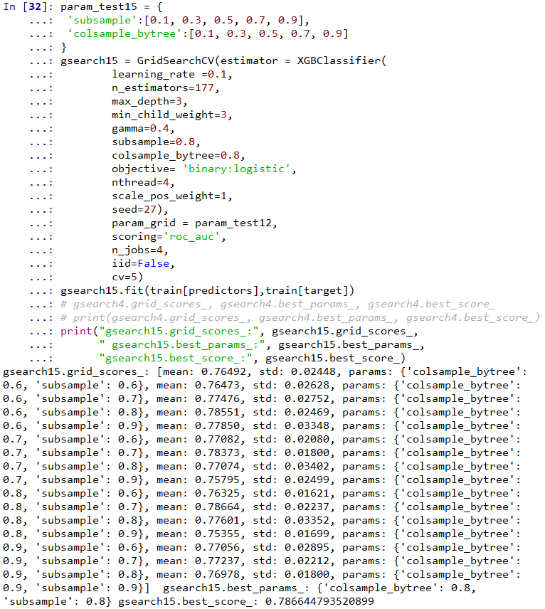

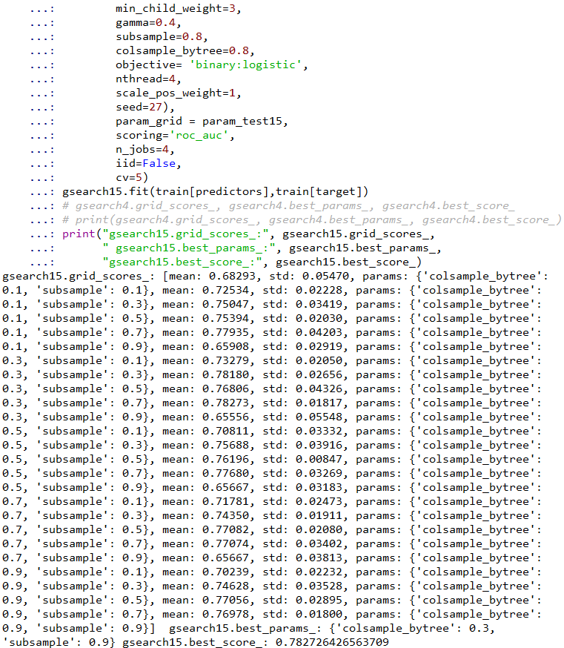

# 得到第三组参数：max_depth=3，min_child_weight=3，gamma=0.4,subsample=0.9,colsample_bytree=0.5

# 得到第四组参数：max_depth=3，min_child_weight=3，gamma=0.4,subsample=0.95,colsample_bytree=0.5

# 这里对max_depth=7，min_child_weight=4条件下，对gamma 进行调参

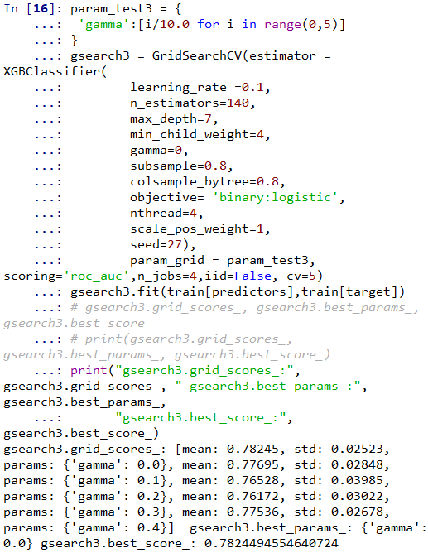

# 结果 最优：gamma=0

# 次优：gamma=0.1

# 在max_depth=7,min_child_weight=4,gamma=0条件下，对subsample，colsample_bytree进行调参

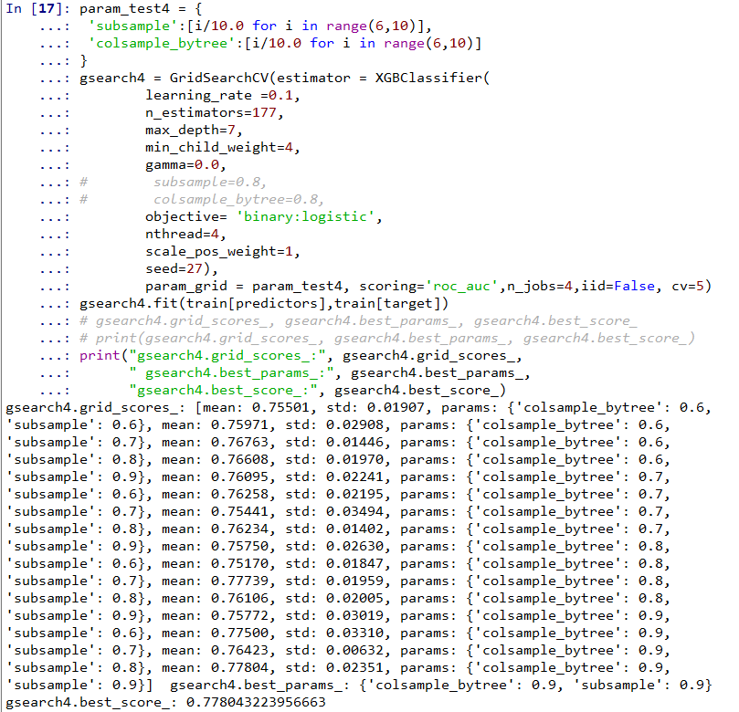

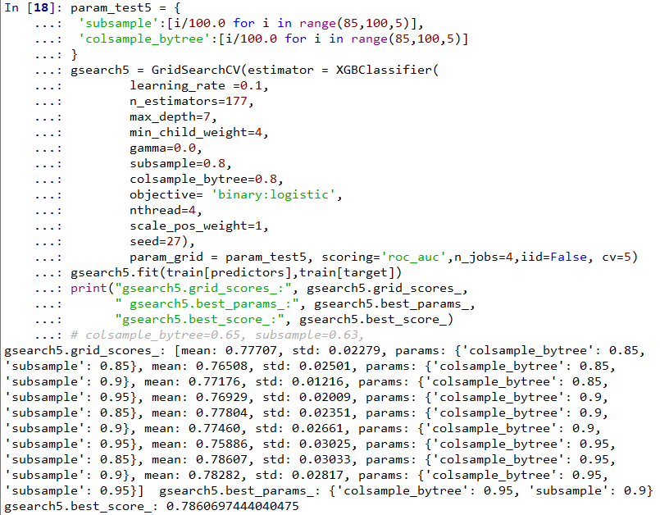

# 结果 最优：subsample=0.9，colsample_bytree=0.95

# 次优：subsample=0.95， colsample_bytree=0.95

# 得到第五组参数：max_depth=7，min_child_weight=4，gamma=0,subsample=0.9,colsample_bytree=0.95

# 得到第六组参数：max_depth=7，min_child_weight=4，gamma=0,subsample=0.95,colsample_bytree=0.95

# 在max_depth=7,min_child_weight=4,gamma=0.1条件下，对subsample，colsample_bytree进行调参

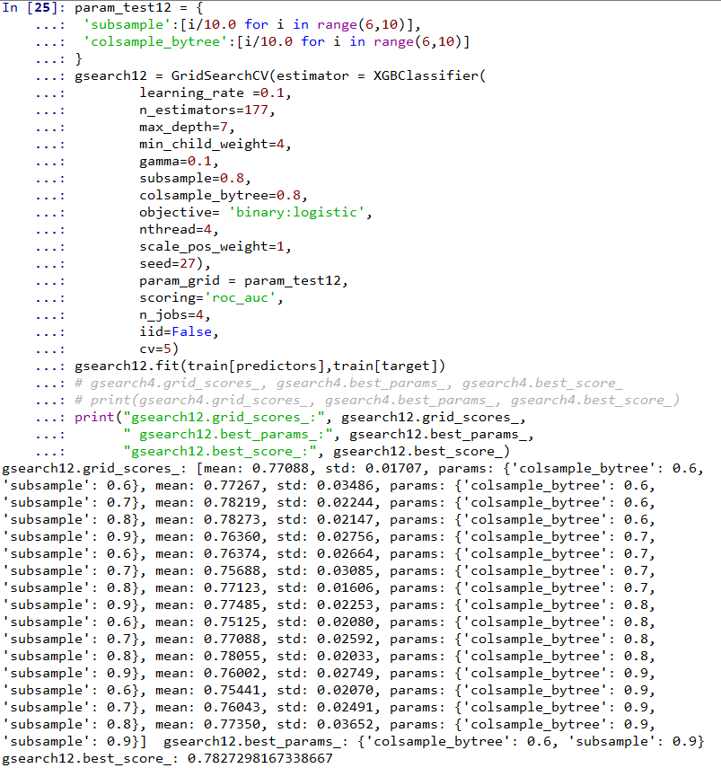

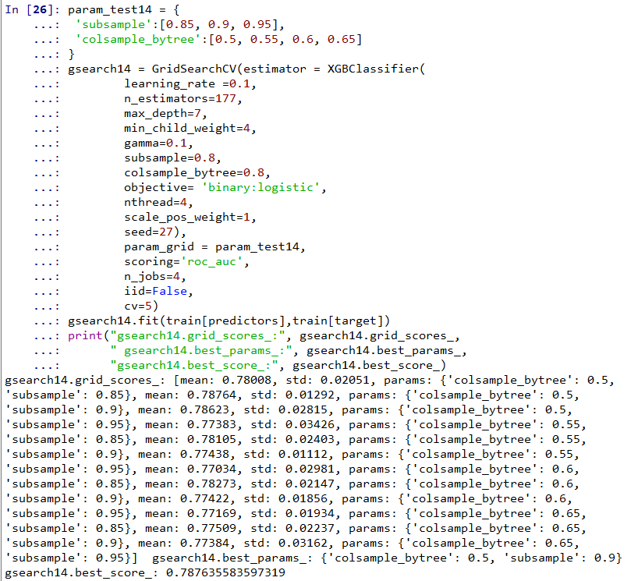

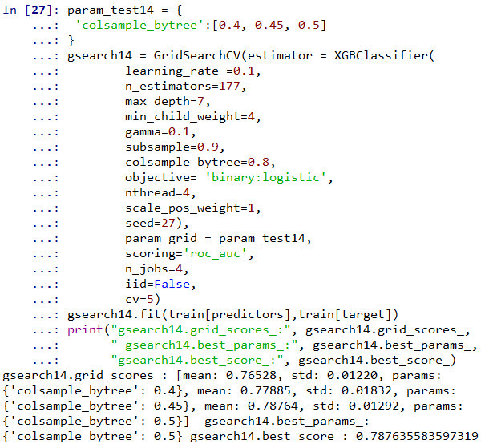

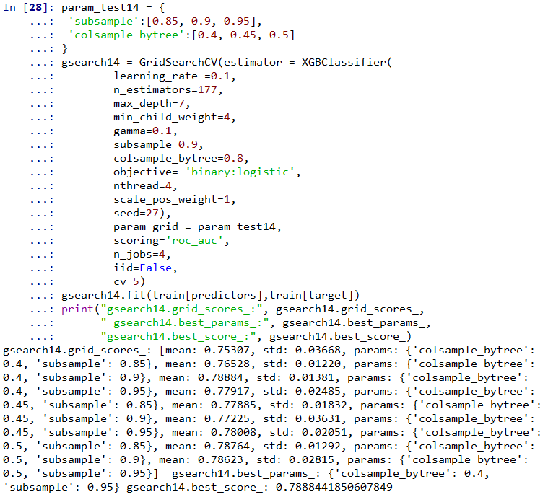

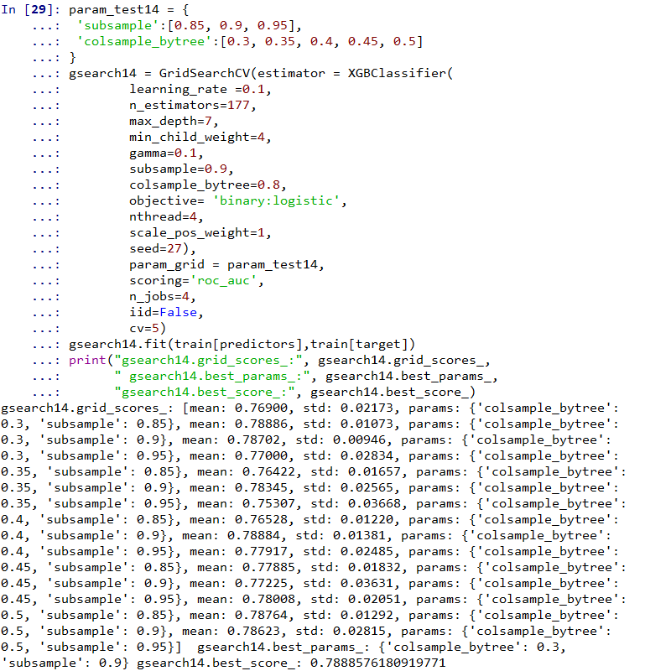

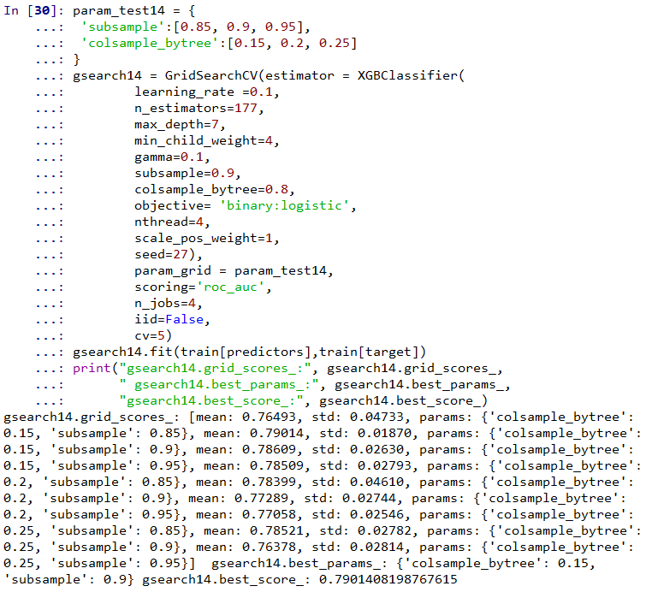

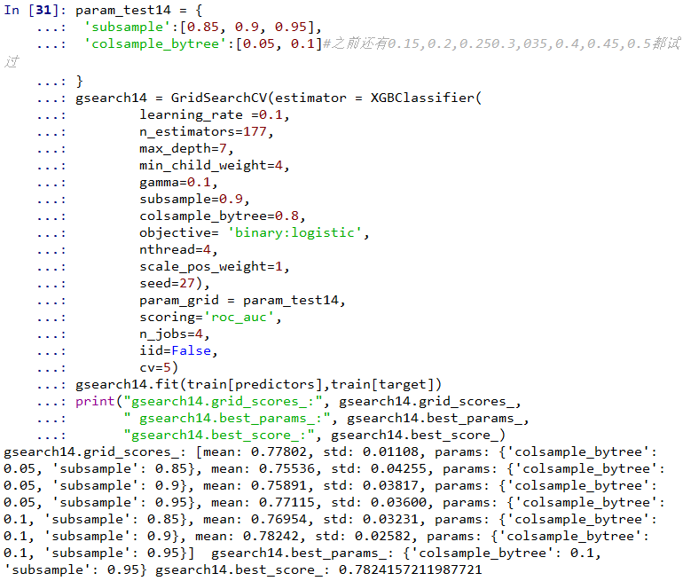

# 结果 最优：subsample=0.9，colsample_bytree=0.15

# 次优：subsample=0.9， colsample_bytree=0.3

# 得到第七组参数：max_depth=7，min_child_weight=4，gamma=0.1,subsample=0.9,colsample_bytree=0.15

# 得到第八组参数：max_depth=7，min_child_weight=4，gamma=0.1,subsample=0.9,colsample_bytree=0.3

# 下面再对reg_alpha,reg_lambda 进行调参

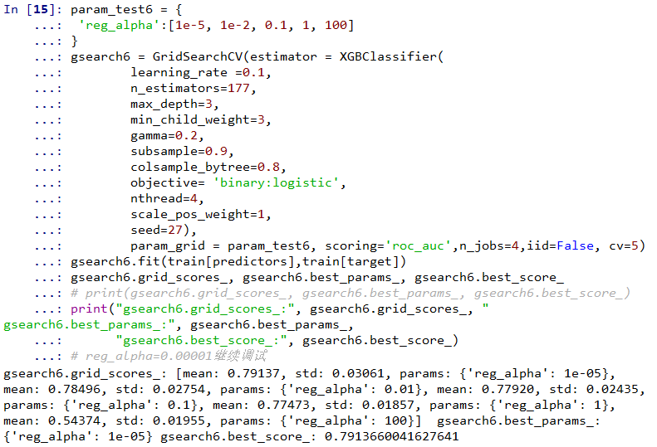

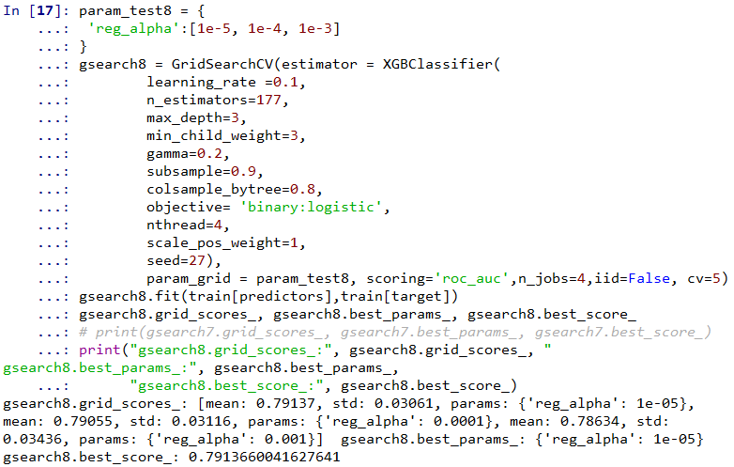

#下面对reg_lambda进行调参

