**МІНІСТЕРСТВО ОСВІТИ І НАУКИ УКРАЇНИ**

**НАЦІОНАЛЬНОМУ УНІВЕРСИТЕТІ “ЛЬВІВСЬКА ПОЛІТЕХНІКА”**

**Кафедра систем штучного інтелекту**

**Лабораторна робота №10**

з дисципліни

# «Об’єктно-орієнтоване програмування»

**Виконав:**

студент групи КН-107

Бєлан В.Ю

**Прийняв:**

Асистент кафедри СШІ

Швороб І.Б

Львів – 2018 р.

**Код програми:**

# 1)

**import** java.io.*;

**public** **class** Career **implements** Serializable{ **public** String Date; **public** String Viddil;

**public** String Position;

**public** **void** setDate(String Date) { **this**.Date = Date;

}

**public** String getDate() {

**return** Date;

}

**public** **void** setViddil(String Viddil) { **this**.Viddil = Viddil;

}

**public** String getViddil() {

**return** Viddil;

}

**public** **void** setPosition(String Position) {

**this**.Position = Position;

}

**public** String getPosition() { **return** Position;

}

}

# 2)

**import** java.io.*;

**public** **class** Characteristics **implements** Serializable{

**private** String Ability;

**private** **int** Point;

**public** **void** setAbility(String Ability) {

**this**.Ability = Ability;

}

**public** String getAbility() {

**return** Ability;

}

**public** **void** setPoint(**int** Point) { **this**.Point = Point;

}

**public** **int** getPoint() { **return** Point;

}

}

# 3)

**import** java.io.*;

**public** **class** Execution {

**public** **static** **void** main(String[] args) **throws** Exception { SerializeClass worker = **new** SerializeClass(); worker.setEducation("Lviv Politecnic"); worker.setPassport("MyPassport"); worker.setPrice(10000); worker.career.setDate("14.05.2018"); worker.career.setPosition("CEO"); worker.career.setViddil("Microsoft Corporation"); worker.characteristics.setAbility("DataBase and Java Working");

worker.characteristics.setPoint(10); System.***out***.println(worker.getEducation());

System.***out***.println(worker.getPassport());

System.***out***.println(worker.getPrice());

System.***out***.println(worker.career.getDate());

System.***out***.println(worker.career.getPosition());

System.***out***.println(worker.career.getViddil());

System.***out***.println(worker.characteristics.getAbility());

System.***out***.println(worker.characteristics.getPoint());

FileOutputStream fileoutputstream = **new** FileOutputStream("Saved.txt");

ObjectOutputStream objectoutputstream = **new**

ObjectOutputStream(fileoutputstream); objectoutputstream.writeObject(worker); objectoutputstream.close();

FileInputStream fileinputstream = **new** FileInputStream("Saved.txt");

ObjectInputStream objectinputstream = **new**

ObjectInputStream(fileinputstream);

SerializeClass newWorker = (SerializeClass) objectinputstream.readObject();

objectinputstream.close();

System.***out***.println(newWorker.getEducation());

System.***out***.println(newWorker.getPassport());

System.***out***.println(newWorker.getPrice());

System.***out***.println(newWorker.career.getDate());

System.***out***.println(newWorker.career.getPosition());

System.***out***.println(newWorker.career.getViddil());

System.***out***.println(newWorker.characteristics.getAbility());

System.***out***.println(newWorker.characteristics.getPoint());

}

}

# 4)

**import** java.io.*;

**public** **class** SerializeClass **implements** Serializable{

**private** String Passport; **private** String Education;

**private** **double** Price;

Career career = **new** Career();

Characteristics characteristics = **new** Characteristics();

**public** **void** setPassport(String Passport) {

**this**.Passport = Passport;

}

**public** String getPassport() { **return** Passport;

}

**public** **void** setEducation(String Education) { **this**.Education = Education;

}

**public** String getEducation() { **return** Education;

}

**public** **void** setPrice(**double** Price) { **this**.Price = Price;

}

**public** **double** getPrice() {

**return** Price;

}

}

**Результат роботи програми:**

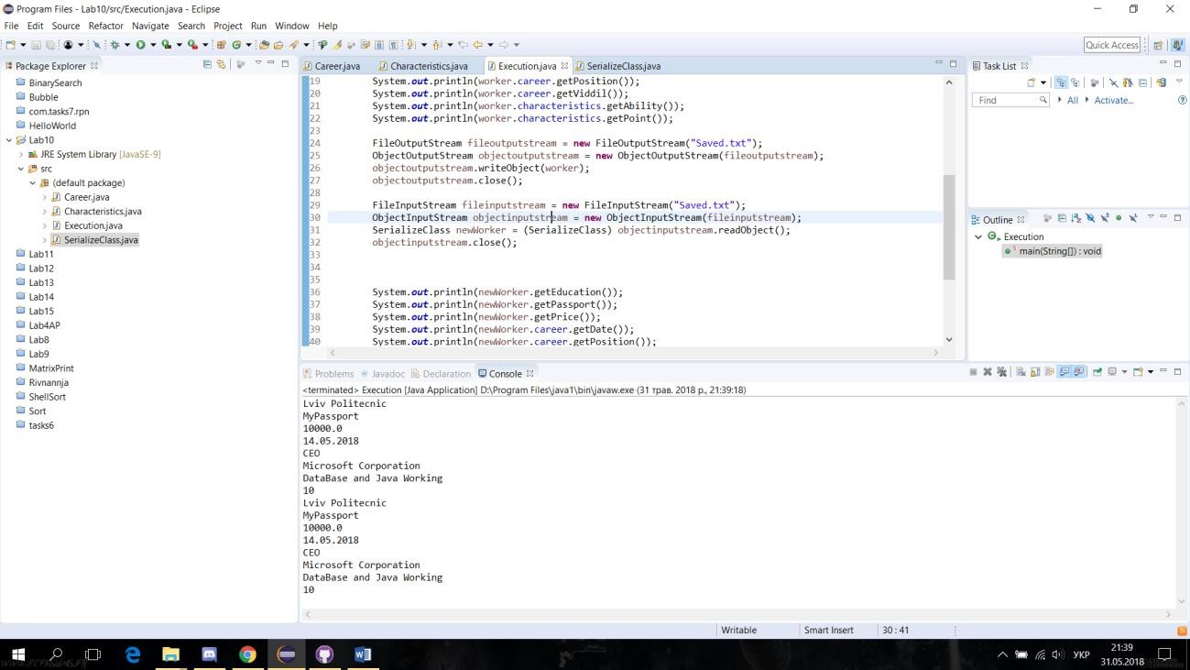

Рис.1 Результат роботи програми