**МІНІСТЕРСТВО ОСВІТИ І НАУКИ УКРАЇНИ**

**НАЦІОНАЛЬНОМУ УНІВЕРСИТЕТІ “ЛЬВІВСЬКА ПОЛІТЕХНІКА”**

**Кафедра систем штучного інтелекту**

**Лабораторна робота №14**

з дисципліни

«Об’єктно-орієнтоване програмування»

**Виконав:**

студент групи КН-107

Бєлан В.Ю

**Прийняв:**

Асистент кафедри СШІ

Швороб І.Б

Львів – 2018 р.

**Код програми:**

1)

package week14; import java.io.FileOutputStream; import java.io.IOException; import java.io.ObjectOutputStream; import java.io.Serializable; import java.util.Collections; import java.util.LinkedList;

public class lab14 implements Serializable {

private static LinkedList<TradePoint> list = new LinkedList<>(); private static int find(TradePoint value){ return list.indexOf(value);

}

private static void remove(TradePoint value){

list.remove(value);

}

private static void add(TradePoint value){ list.add(value);

}

private static void sort(LinkedList<TradePoint> list){ Collections.sort(list, (object1, object2) ->

object1.name.getName().compareTo(object2.name.getName()));

}

public static void main(String[] args) throws IOException { TradePoint tradePoint = new TradePoint( "Bob", "Adress",123,

"Programmer", "Monday", "20:00");

TradePoint secondPoint = new TradePoint( "Andrew",

"MainStreet",880553535, "Trader", "Sunday", "18:00");

TradePoint thirdPoint = new TradePoint( "Joe",

"SalmanelaStreet",742625725, "Cook", "Tuesday", "17:00");

TradePoint forthPoint = new TradePoint( "Anton", "RynokStreet",450236234,

"Manger", "Wednesday", "9:00"); add(tradePoint); add(secondPoint); add(thirdPoint); add(forthPoint); for (Object i: list) System.out.println(i); sort(list);

System.out.println(); for (Object i: list) System.out.println(i); remove(thirdPoint); for (Object i: list) System.out.println(i);

System.out.println("Find index of tradepoint " + find(tradePoint));

FileOutputStream fos = new FileOutputStream("temp.out"); ObjectOutputStream oos = new ObjectOutputStream(fos); oos.writeObject(list);

oos.flush(); oos.close();

}

}

2)

package week14;

import java.io.Serializable; import java.util.*;

class Name implements Serializable{

public String name; Name(String name){ this.name = name;

}

public void setName(String name){

this.name = name;

}

public String getName(){

return name;

} }

class Adress implements Serializable{

public String adress; Adress(String adress){ this.adress = adress;

}

public void setAdress(String adress){

this.adress = adress;

}

public String getAdress(){

return adress;

} }

class Number implements Serializable{ public ArrayList<Integer> numbers; Number(int number){

this.numbers = new ArrayList<>(); numbers.add(number);

}

public void addNumbers(int newNumber){ numbers.add(newNumber);

}

public ArrayList getNumbers(){

return numbers;

}

@Override public String toString(){

return numbers.toString();

} }

class Specialization implements Serializable{ public String specialization; Specialization(String specialization){ this.specialization = specialization;

}

public void setSpecialization(String specialization){

this.specialization = specialization;

}

public String getSpecialization(){ return specialization;

} } class Schedule implements Serializable{ public HashMap<String,String> schedule; Schedule(String day, String time){ this.schedule = new HashMap<>(); schedule.put(day,time);

}

public void addNewWorkingDay(String day, String time){

schedule.put(day,time);

}

public void setSchedule(String day, String time){ schedule.replace(day,time);

}

public void ShowSchedule(){ for(Map.Entry<String, String> x : schedule.entrySet()){

System.out.println(x.getKey() + " " + x.getValue());

}

}

public HashMap<String, String> getSchedule() {

return schedule;

}

@Override public String toString(){ return schedule.toString();

}

}

class TradePoint implements Serializable {

Name name;

Adress adress;

Specialization specialization;

Number number; Schedule schedule;

public TradePoint( String name1, String adress1, int number1, String specialization1, String day, String time){ this.name = new Name(name1); this.adress = new Adress(adress1);

this.specialization = new Specialization(specialization1);

this.number = new Number(number1);

this.schedule = new Schedule(day,time);

}

public String ShowAllData(){

String str = name.getName() + " " + adress.getAdress() + " " + specialization.getSpecialization() + " " + number + " " + schedule; return str;

}

@Override public String toString(){

return ShowAllData();

} }

public class Main {

public static void main(String args[]) {

TradePoint tradePoint = new TradePoint( "Name", "Adress",123,

"Programmer", "Monday", "20:00");

TradePoint secondPoint = new TradePoint( "Andrew",

"MainStreet",880553535, "Trader", "Sunday", "18:00");

System.out.println(tradePoint);

System.out.println(secondPoint);

}

}

**Результат роботи програми:**

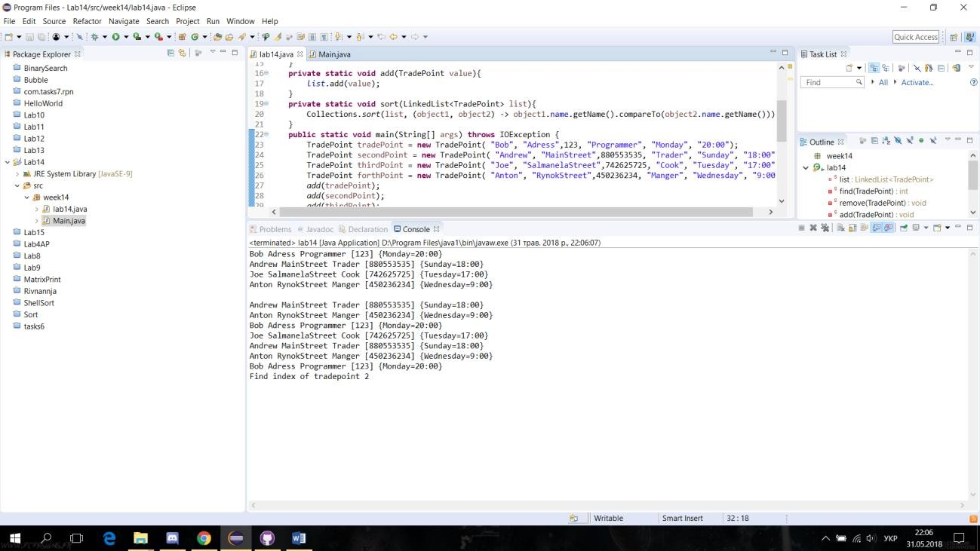

Рис.1 Результат роботи програми