**МІНІСТЕРСТВО ОСВІТИ І НАУКИ УКРАЇНИ**

**НАЦІОНАЛЬНОМУ УНІВЕРСИТЕТІ “ЛЬВІВСЬКА ПОЛІТЕХНІКА”**

**Кафедра систем штучного інтелекту**

**Лабораторна робота №15**

з дисципліни

«Об’єктно-орієнтоване програмування»

**Виконав:**

студент групи КН-107

Бєлан В.Ю

**Прийняв:**

Асистент кафедри СШІ

Швороб І.Б

Львів – 2018 р.

**Код програми:**

1)

package week15;

import javafx.application.Application; import javafx.beans.property.SimpleStringProperty; import javafx.collections.FXCollections; import javafx.collections.ObservableList; import javafx.event.ActionEvent; import javafx.geometry.Insets; import javafx.scene.Group; import javafx.scene.Scene; import javafx.scene.control.Button; import javafx.scene.control.Label; import javafx.scene.control.TableColumn; import javafx.scene.control.TableView; import javafx.scene.control.TextField;

import javafx.scene.control.cell.PropertyValueFactory; import javafx.scene.layout.HBox; import javafx.scene.layout.VBox; import javafx.scene.text.Font;

import javafx.stage.Stage;

public class Controller extends Application {

private final TableView<TradePoint> table = new TableView<>();

private final ObservableList<TradePoint> data = FXCollections.observableArrayList(

new TradePoint( "Bruce", "1SalmanelaStreet","vdsvsdv", "Rich",

"Tuesday", "17:00"), new TradePoint( "Jason", "2SalmanelaStreet","iyx553535", "Cook",

"Tuesday", "11:00"),

new TradePoint( "Steve", "3SalmanelaStreet","d880553535",

"Soldier", "Tuesday", "16:00"),

new TradePoint( "Thor", "4SalmanelaStreet","fg880553535",

"Superhero", "Tuesday", "14:00"),

new TradePoint( "Joe", "5SalmanelaStreet","qwadfggfhhn", "Cook",

"Tuesday", "17:00"));

final HBox hb = new HBox();

public static void main(String[] args) {

launch(args);

}

@Override

public void start(Stage stage) {

Scene scene = new Scene(new Group());

stage.setTitle("Trade Points"); stage.setWidth(650);

stage.setHeight(550);

final Label label = new Label("Trade Point"); label.setFont(new Font("Arial", 20));

table.setEditable(true);

TableColumn nameCol = new TableColumn("Name");

nameCol.setMinWidth(100); nameCol.setCellValueFactory(

new PropertyValueFactory<>("name"));

TableColumn adressCol = new TableColumn("Adress");

adressCol.setMinWidth(100); adressCol.setCellValueFactory(

new PropertyValueFactory<>("adress"));

TableColumn numberCol = new TableColumn("Number");

numberCol.setMinWidth(100); numberCol.setCellValueFactory(

new PropertyValueFactory<>("number"));

TableColumn specializationCol = new TableColumn("Specialization"); specializationCol.setMinWidth(100); specializationCol.setCellValueFactory(

new PropertyValueFactory<>("specialization"));

TableColumn dayCol = new TableColumn("Day");

dayCol.setMinWidth(100); dayCol.setCellValueFactory(

new PropertyValueFactory<>("day"));

TableColumn timeCol = new TableColumn("Time");

timeCol.setMinWidth(100); timeCol.setCellValueFactory(

new PropertyValueFactory<>("time"));

table.setItems(data);

table.getColumns().addAll(nameCol, adressCol, numberCol, specializationCol, dayCol, timeCol);

final TextField addName = new TextField(); addName.setPromptText("Name");

addName.setMaxWidth(nameCol.getPrefWidth());

final TextField addAdress = new TextField(); addAdress.setMaxWidth(adressCol.getPrefWidth()); addAdress.setPromptText("Adress");

final TextField addNumbers = new TextField(); addNumbers.setMaxWidth(numberCol.getPrefWidth()); addNumbers.setPromptText("Number");

final TextField addSpecialization = new TextField(); addSpecialization.setMaxWidth(specializationCol.getPrefWidth()); addSpecialization.setPromptText("Specialization");

final TextField addDay = new TextField(); addDay.setMaxWidth(dayCol.getPrefWidth()); addDay.setPromptText("Day");

final TextField addTime = new TextField(); addTime.setMaxWidth(timeCol.getPrefWidth()); addTime.setPromptText("Time");

final Button addButton = new Button("Add"); addButton.setOnAction((ActionEvent e) -> {

data.add(new TradePoint( addName.getText(), addAdress.getText(), addNumbers.getText(), addSpecialization.getText(), addDay.getText(), addTime.getText())); addName.clear(); addAdress.clear(); addNumbers.clear(); addSpecialization.clear(); addDay.clear();

addTime.clear();

});

hb.getChildren().addAll(addName, addAdress, addNumbers, addSpecialization, addDay, addTime, addButton); hb.setSpacing(10);

final VBox vbox = new VBox();

vbox.setSpacing(10); vbox.setPadding(new Insets(10, 0, 0, 10)); vbox.getChildren().addAll(label, table, hb);

((Group) scene.getRoot()).getChildren().addAll(vbox);

stage.setScene(scene); stage.show();

}

public static class TradePoint{ private final SimpleStringProperty name; private final SimpleStringProperty adress; private final SimpleStringProperty number; private final SimpleStringProperty specialization; private final SimpleStringProperty day; private final SimpleStringProperty time;

private TradePoint(String name1, String adress1, String number1, String specialization1, String day1, String time1){ this.name = new SimpleStringProperty(name1); this.adress = new SimpleStringProperty(adress1); this.number = new SimpleStringProperty(number1); this.specialization = new SimpleStringProperty(specialization1); this.day = new SimpleStringProperty(day1);

this.time = new SimpleStringProperty(time1);

}

public String getName() {

return name.get();

}

public void setName(String fName) {

name.set(fName);

}

public String getAdress() { return adress.get();

}

public void setAdress(String fName) {

adress.set(fName);

}

public String getNumber() {

return number.get();

}

public void setNumber(String fName) {

number.set(fName);

}

public String getSpecialization() {

return specialization.get();

}

public void setSpecialization(String fName) {

specialization.set(fName);

}

public String getDay() { return day.get();

}

public void setDay(String fName) {

day.set(fName);

}

public String getTime() { return time.get();

}

public void setTime(String fName) {

time.set(fName);

}

}

}

**Результат роботи програми:**

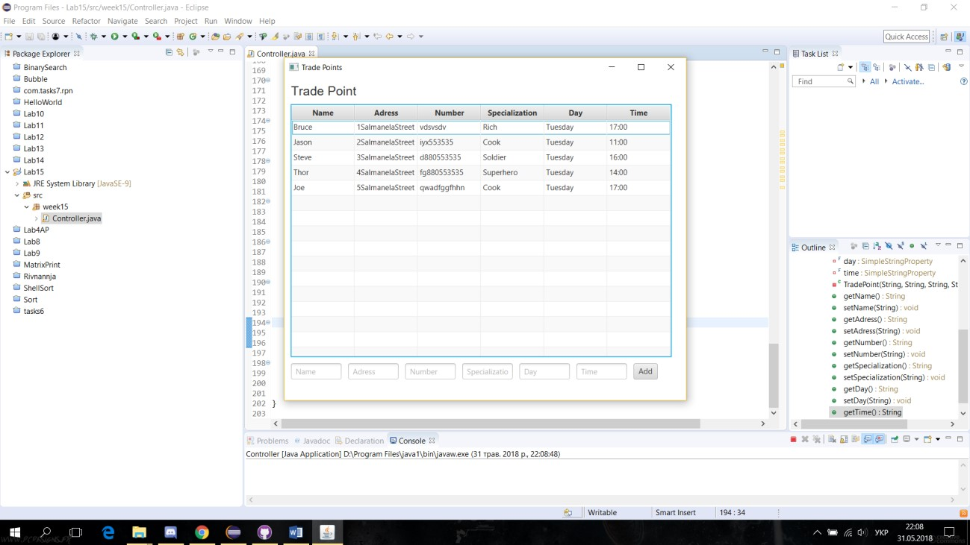

Рис.1 Результат роботи програми