**Lab 3 Report**

This lab is about Binary Search Trees (BST) using a linked implementation. Assume that only integers are stored in the BST.

I create 2 classes, and they are

* Node
* MyTree

**Task 1**

This task is about class Node. Just create some pointers and a integer attribute as content.

**Task 2**

This task is about class MyTree. And I write all these methods on paper and I implement insert in two way. On of them is in recursion and the other is in looping. Although looping is soluted in stack. But I don’t know which one is better.

**Task 3**

Just a test and the result is following:

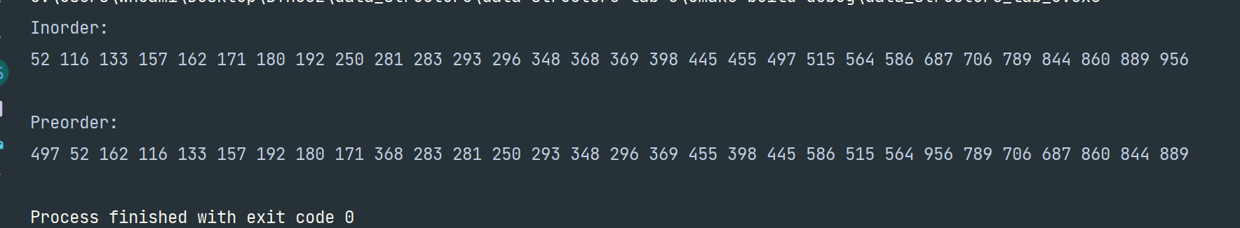

And I try many times:

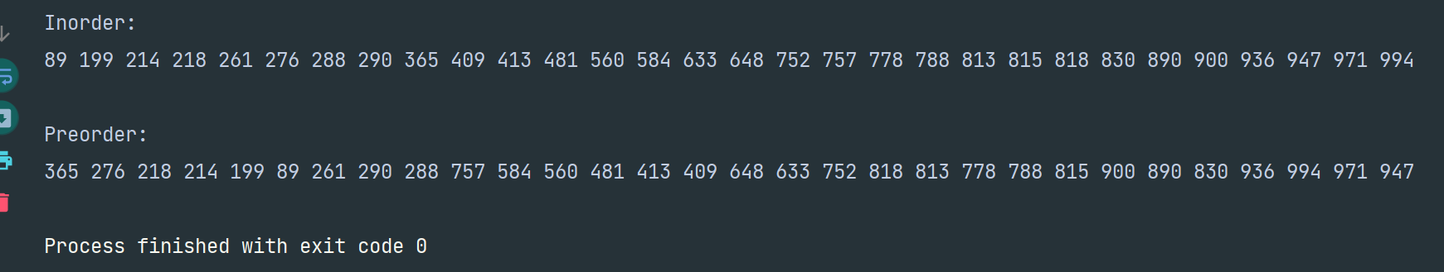

**Task 4**

Use paper and pencil.

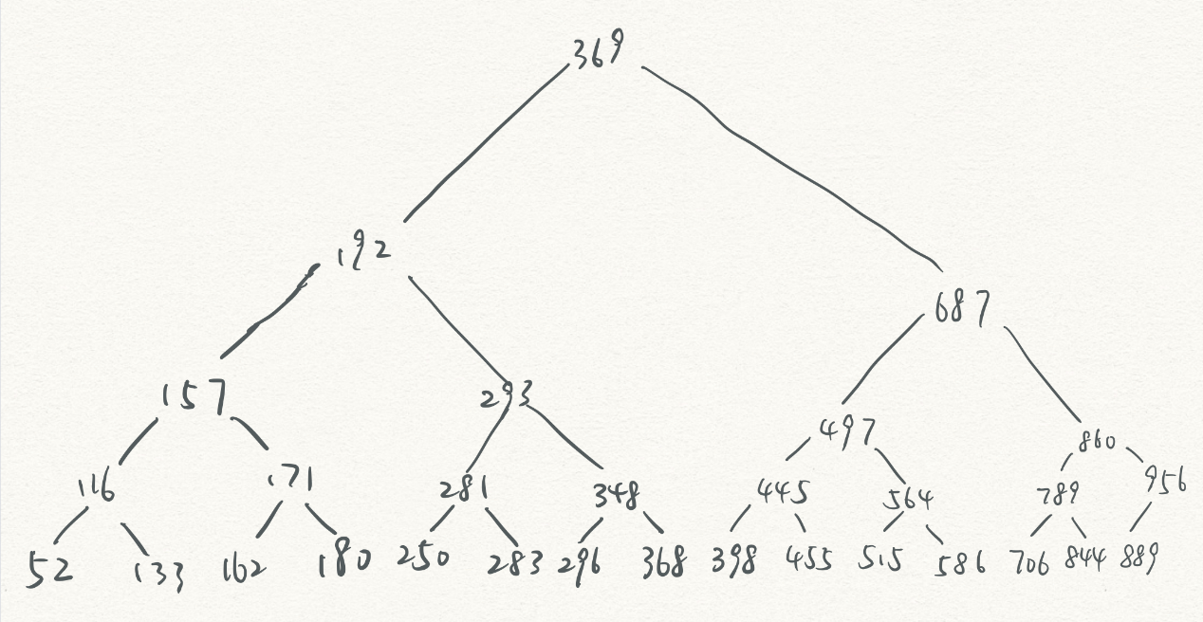

And the height is 4