  - -PROJECT REPORT ON
STATISTICAL ANALYSIS OF CAFFEINE INTAKE AMONG STUDENTS OF FACULTY OF SCIENCE
(The ABC Insights: Analyzing Brewed Chai Coffee Caffeine)

A REPORT SUBMITTED TO


DEPARTMENT OF STATISTICS

FACULTY OF SCIENCE

THE MAHARAJA SAYAJIRAO UNIVERSITY OF BARODA

  - IN PARTIAL FULFILMENT OF THE CURRICULUM OF B.SC. (HONS.) DEGREE IN STATISTICS.
YEAR – 2025

GUIDE: PROJECT MEMBERS:
  - Dr. (Mrs.) M.N. Shah Jamil Mahida
  - Mr. Vijay K Gupta Nikita Sharma
  - Rajvee Shah
  - Savantsinh Rathod
  - Tanya Chaurasia

DECLARATION

We here declare that the work presented in this project titled “STATISTICAL ANALYSIS OF CAFFEINE INTAKE AMONG STUDENTS OF FACULTY OF SCIENCE” is the result of our independent work, submitted to the Department of Statistics, at The Maharaja Sayajirao University of Baroda, as a part of our journey towards earning our Bachelor of Science degree, we undertook an exciting project under the expert guidance of Dr. (Mrs.) M.N. Shah and
Mr. Vijay K Gupta. This project showcases our original research efforts and represents a significant milestone in our academic journey. Importantly, the findings presented here have not been shared with any other University or Institute.

Place: Vadodara
Date:
Signatures of the Students:
- Jamil Mahida
(8022011438)
- Nikita Sharma
(8022003536)
- Rajvee Shah
(8022003585)
- Savantsinh Rathod
(8021028568)
- Tanya Chaurasia
(8022000639)

CERTIFICATE

  - This is to certify that Jamil Mahida, Nikita Sharma, Rajvee Shah, Savantsinh Rathod, and Tanya Chaurasia have successfully and satisfactorily completed the project titled:

“STATISTICAL ANALYSIS OF CAFFEINE INTAKE
AMONG STUDENTS OF FACULTY OF SCIENCE”
(The ABC Insights: Analyzing Brewed Chai Coffee Caffeine)

As a team for the academic year 2024-25, they have submitted their work to the Department of Statistics as partial fulfillment of the requirements for a Bachelor's Degree in Statistics and have represented their original work under the supervision and guidance of Dr. (Mrs.) M.N. Shah and Mr. Vijay K Gupta
and I wish them great success in the future.

Prof. V. A. Kalamkar Dr. (Mrs.) M.N. Shah
Head of Department Guide

Mr. Vijay K Gupta
Guide

ACKNOWLEDGEMENT

  - We would like to express our heartfelt gratitude to all those who supported and guided us throughout the completion of our group project titled “STATISTICAL ANALYSIS OF CAFFEINE INTAKE AMONG STUDENTS OF FACULTY OF SCIENCE”
  - First and foremost, we are sincerely thankful to Dr. (Mrs.) M.N. Shah and Mr. Vijay K Gupta, our project supervisors, thank you for their valuable guidance, timely feedback, and continuous encouragement throughout this study. Their insights and expertise played a crucial role in shaping this project.
  - We also extend our gratitude to Prof. V. A. Kalamkar, Head of Department, and the Department of Statistics for providing us with the necessary resources and a supportive academic environment to carry out this research.
We extend our gratitude to H.O.D. Prof. Ashutosh Bedekar, Dr. (Mrs.) Jigyasa and Ms. Hetvi from the Department of Chemistry for their invaluable support, and expertise throughout the course of our project.
  - Special thanks to all the faculty students who participated in our survey and contributed their honest responses, without which this research would not have been possible.
  - We also acknowledge the support of our classmates, friends, and families for their cooperation, motivation, and understanding during the project duration.
  - Finally, we would like to thank each other as team members for the teamwork, shared responsibilities, and dedication that made this project successful.

CONTENTS
- Abstract
- Introduction
- Objectives
- Market data
      - Data outside campus
      - Conclusions from market data
- Data collection plan
      - Population considered
      - Pilot survey
- Reliability test
- Sampling plan
- Chemical test for caffeine detection
- Sample Data presentation
- Normality test
- Statistical analysis
- Sip Smart: Stay below 200!!!
- Appendix 1
- Appendix 2
- Reference
ABSTRACT

This study explores the caffeine consumption habits of faculty students with a focus on brand preferences, intake patterns, and related wellness indicators such as sleep and focus levels. Data were collected through structured surveys and analysed using statistical methods. Key variables included caffeine intake (mg/day), preferred caffeine brands, reasons for intake, and lifestyle factors.
Data visualisation highlights the most consumed caffeine brands, daily intake trends, and the relationship between caffeine consumption and perceived focus and sleep duration.
The findings provide insights into student health behaviours and offer a valuable tool for educators, health advisors, and policymakers to monitor and address caffeine-related wellness concerns on campus.
MOTIVATION:
The increasing prevalence of caffeine consumption among faculty students highlights the need to understand consumption patterns, brand influences, and associated health impacts. This study examines the growing trend of caffeine use, its effects on academic performance and health (e.g., sleep disturbances, anxiety), and the role of peer influence. Findings will provide evidence-based guidance for promoting student wellness.
GUIDLINES:
Recommended intake limits: The study references the ICMR guideline of 300 mg/day as the recommended maximum caffeine intake. This threshold should be used when interpreting the reported consumption levels.
DISCLAIMER:
The caffeine values presented in this project are intended as general estimates. Actual caffeine content may vary due to differences in preparation methods, ingredient quality, serving sizes, and individual preferences.

INTRODUCTION

Caffeine, a widely consumed natural stimulant, is commonly found in coffee, tea, energy drinks, chocolate, and certain medications. Chemically known as 1,3,7-Trimethylxanthine, caffeine primarily acts on the central nervous system (CNS), where it increases alertness and reduces fatigue. Its pervasive use across various products and its physiological effects make caffeine a significant focus for research on human health and behavior.

Caffeine exerts its stimulant effects by blocking adenosine receptors in the brain. Adenosine is a neurotransmitter responsible for inducing feelings of tiredness and promoting relaxation. By inhibiting its activity, caffeine leads to an increase in the levels of dopamine and norepinephrine, key neurotransmitters that enhance alertness and concentration. This biochemical interaction results in elevated heart rate, improved vigilance, and a temporary boost in mood, making caffeine a widely used aid for combating fatigue and enhancing mental performance.

OBJECTIVES

- Examine patterns and trends in consumption, including factors such as frequency, amount and brand.
- Analyze the relationship between caffeine consumption and health factor like sleep quality.
- Investigate the reasons for beginning caffeine consumption and the withdrawal symptoms related to health issues.
- Determine the correlation between caffeine intake and academic performance and focus intervals.
- Explore the relationship between average caffeine intake based on gender, year of study and department.

MARKET DATA

To gain a comprehensive understanding of caffeine consumption patterns among students, market data was collected on caffeine-containing products available across the Faculty of science campus. The data collection focused on recording detailed information about products sold in stalls, shops, and cafes. For each item, attributes such as product name, type (e.g., coffee, tea, energy drinks, soft drinks, or chocolate), brand, serving size, and caffeine content (in milligrams).
Data collection methods included direct observation, informal interviews with store staff, photographic documentation of product displays, and referencing online databases for standard caffeine values. The collected data were analysed using descriptive statistics and visualized through charts and graphs to identify trends in product availability, pricing, and consumption. This market study serves to inform broader research on student health, lifestyle choices, and the potential risks associated with excessive caffeine intake.

DATA OUTSIDE CAMPUS
Taking a 1 km radius into consideration for all the shops that sell beverages containing caffeine

.

- OBJECTIVES FOR MARKET DATA COLLECTION
1. Brands used for tea and coffee near campus.
2. Average size of cup used for tea and coffee.

- QUESTIONNAIRE FOR MARKET DATA COLLECTION
1. Name of the shop/café/restaurant
2. Types of beverages
3. Brands for tea
4. Brands for coffee
5. Size of tea/coffee cup

CONCLUSIONS FROM MARKET DATA
- Tea and Coffee Cup Size
The market data analysis on caffeine products around campus revealed significant variation in serving sizes, particularly among coffee and tea drink offerings. The most commonly available cup sizes for brewed coffee ranged from small (50ml) to large (250ml), with medium-sized options (approximately 100ml) being the most frequently purchased. These findings highlight the role of cup size in influencing total caffeine intake and suggest that serving size is a key factor in daily consumption patterns.
Most popular Coffee and Tea cup sizes are 100ml.

2. Brand Analysis
The brand analysis of tea and coffee products across campus revealed distinct patterns in availability, popularity, and consumer preference. Coffee from major instant coffee brands such as Nescafé and Sunrise dominated retail shelves. These brands were offered in a variety of formats, including sachets, ready-to-drink bottles, and freshly brewed options in campus cafés. Tea offerings included brands like WaghBakri, which appeared mainly at stalls in fresh-brew settings. Students showed a stronger preference for branded coffee, particularly during high-stress periods like exams, while local tea stalls were preferred for tea consumption. These findings suggest that both coffee and tea brands share a common foothold in availability.

- COFFEE
The most popular brand turns out to be Nescafé and Sunrise.

- TEA

The most popular brand turns out to be WaghBakri.

DATA COLLECTION PLAN
POPULATION CONSIDERED
The primary focus was on undergraduate and postgraduate students of the Faculty of Science, as they represent the largest consumer base of on-campus caffeine products and are most likely to be influenced by academic schedules, stress, and lifestyle factors that affect caffeine consumption.
Participants were drawn from a diverse range of academic disciplines, including different departments, to ensure broad representation. Both residential and commuting students were included to account for differences in access and buying habits. Data collection points were randomly chosen from a list of faculty students' data.
N=3829 students
PILOT SURVEY
Objective: Test a questionnaire measuring caffeine consumption among university students.

Sample: 30 students [Randomly selected from the campus between lectures.]

Output:
- Number of incomplete or skipped questions.
- Feedback on question clarity.

Findings: No participants found any questions confusing.

Adjustments:
- Reworded unclear questions (E.g., Combination with other substances)
- Added option for caffeine intake location.

Conclusions:
- We have the population proportion for sample size determination. (p=0.7)
- Brand-specific questions were changed to location-specific for accuracy.

RELIABILITY TEST
Cronbach's Alpha:
A Measure of Internal Consistency

Cronbach’s alpha is used to assess the reliability or internal consistency of a set of items in a scale or questionnaire. It determines how closely related the items are as a group and whether they are all measuring the same underlying construct.
A high Cronbach’s alpha (typically above 0.70) indicates that the items exhibit a strong degree of correlation and consistency, suggesting that they can be reliably combined into a single composite score.
The most common method to compute Cronbach’s alpha is:
$$α=\left[\frac{k}{k-1}\right]\left[1-\frac{\sum{S_{i}^{2}}}{S_{t}^{2}}\right]$$
Where,
k = Number of items in the scale
$S^{2}i$ = Variance of each individual item
$S^{2}t$ = Variance of the total score (sum of all items for each respondent)
This formula adjusts the average inter-item covariance relative to the overall variance, accounting for the number of items.
$α1=\left[\frac{k}{k-1}\right]\left[1-\frac{\sum{S_{i}^{2}}}{S_{t}^{2}}\right]$=$\left[\frac{50}{50-1}\right]\left[1-\frac{18.354}{28.8092}\right]$= 0.483881

$α2=\left[\frac{k}{k-1}\right]\left[1-\frac{\sum{S_{i}^{2}}}{S_{t}^{2}}\right]$=$\left[\frac{50}{50-1}\right]\left[1-\frac{12.477}{36.5575}\right]$= 0.675169

$α3=\left[\frac{k}{k-1}\right]\left[1-\frac{\sum{S_{i}^{2}}}{S_{t}^{2}}\right]$=$\left[\frac{50}{50-1}\right]\left[1-\frac{17.6034}{18.5471}\right]$= 0.0636

$α=$ $α2+α3$ = 0.675169 + 0.0636 = 0.738769

$α1$ as Demographic factors (like age, gender, income, etc.) are external to the scale or test being measured. They do not reflect how the items on a test relate to each other, but rather provide background information about respondents.
Thus we exclude its value and sum up the other two.
Conclusion: By the value of alpha we can conclude that our questionnaire is reliable enough.

Demographic Items
Item | Coding
1. Age | 17=0, 18=1, 19=2,  20=3, 21=3, 22=4, 23=5, 24=6
2. Gender | Male=1, Female=2
3. Academic year | FY=1, SY=2, TY=3, Prev=4, Final=5
4. Department | Alphabetic to numeric

Caffeine Consumption and Health Factors
Item | Coding
5. Caffeine intake | Yes=1, No=0
6. Coffee (frequency) | 1,2,3
7. Tea (frequency) | 1,2,3
8. Energy drinks (frequency) | 1,2,3
9. Chocolates and gums (frequency) | 1,2,3
10. Health factors | Yes=1, No=0
11. Reason for consumption | Yes=1, No=0

Behavioural and Health Data
Item | Coding
12. CGPA | As the value mentioned
13. Focus Interval (hours) | Numeric value as it is
14. Sleep hours per night | 3-5=1, 5-7=2, 7-9=3, 9-11=4, more than 11=5
15. Age started using caffeine | 0-5(1), 6-10(2), 11-15(3), 16-20(4), 21 and above(5)

SAMPLING PLAN
To ensure the data collected was representative of the broader campus population, a combination of simple random sampling and stratified sampling methods was employed.
Stratified Sampling:
- Divide the population into subgroups (strata) (e.g., year-wise) and sample from each.
- Example: Selecting students from first-year, Second-Year, etc., proportionally.

Simple Random Sampling (SRS):
- Every individual has an equal chance of selection from every stratum.
- Example: Randomly selecting student IDs from each stratum.
These methods enhanced the precision of comparisons across student segments and helped reveal variations in caffeine consumption influenced by academic demands. Together, these sampling approaches ensured both breadth and depth in the faculty data, strengthening the reliability and generalizability of the study’s conclusions.

SAMPLE SIZE DETERMINATION
- Population size=3829
- Margin of error = 5% (acceptable difference between sample statistic and population parameter)
- z-value=1.96
- population proportion=$\frac{21}{30}$=0.7
(proportion of people consuming caffeine)

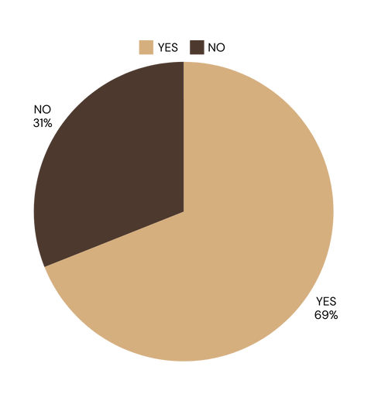

$n= \frac{Z^{2}p(1-p)}{E^{2}}$ =$\frac{{\left(1.96\right)}^{2}\left(0.7\right)(0.3)}{{(0.05)}^{2}}$
$$n=322.6944$$
$$n\left(adj.\right)=\frac{n}{1+\frac{n-1}{N}}$$
$$n\left(adj.\right)=\frac{322.6944}{1+\frac{322.6944-1}{3829}}$$
$$n\left(adj.\right)=297.68≈298$$

PROPORTIONAL ALLOCATION

Year of study | Count of students | Propotion of students | Final student count for sampling
F.Y | 1069 | 27.92% | 80
S.Y | 720 | 18.80% | 62
T.Y | 943 | 24.63% | 76
M.sc (Prev.) | 593 | 15.49% | 41
M.sc (Final) | 504 | 13.16% | 39

CHEMICAL TEST FOR CAFFEIENE DETECTION

QUANTITATIVE ANALYSIS OF CAFFEINE
BY IODOMETRIC BACK TITRATION

INTRODUCTION: Iodometric back titration is a redox titration method used to determine the quantity of a reducing agent, such as caffeine, in a sample. This method is used in our project to analyse caffeine content in beverages like tea and coffee.

ABSTRACT: The method is based on the oxidation-reduction reaction between caffeine and iodine (I2I_2I2​), which is back-titrated with sodium thiosulfate (Na2S2O3Na_2S_2O_3Na2​S2​O3​).
- Caffeine (C₈H₁₀N₄O₂) reacts with an excess of iodine (I2I_2I2​) in acidic conditions.
- The remaining iodine (which did not react with caffeine) is titrated against a standard solution of sodium thiosulfate (Na2S2O3Na_2S_2O_3Na2​S2​O3​) using starch as an indicator.

MATERIALS:
- Caffeine sample (tea, coffee, soft drink, or pure caffeine)
- Iodine solution (I2​) – oxidizing agent
- Potassium iodide (KI) – enhances iodine solubility
- Sodium thiosulfate (Na2S2O3​) – titrant
- Hydrochloric acid (HCl) – acid medium
- Starch solution – indicator (turns blue in presence of iodine)

METHOD:
1. Transfer 1g of standard tea/coffee powder to 100ml of water to prepare the solution and boil it for 30min in a conical flask to extract caffeine and add 7ml sulfuric acid.
2. Add 17ml of standardized iodine solution to the mixture and swirl gently, brown-red precipitate will form.
3. Filter the solution.
4. Take down the initial reading of burette.
5. Titrate the filtrate against a standard sodium thiosulphate solution (Na2S2O3).
6. Add a few drops of starch solution when the titrand becomes pale brown.
7. Slowly run Na2S2O3 until titrand become colorless from dark blue.
8. Take final reading of burette
9. Repeat the above steps until two to three consistent results are obtained.

READINGS:
Burette readings for different sample
- NesCafe
- Kg Patel
- Dwarkesh

FORMULAS:
- Molarity=$\frac{(grams taken*1000)}{molecular weight\left(g\right)*volume(ml)}$
- Moles=$\frac{grams taken}{molecular weight(g)}$
- Molarity=$\frac{moles*1000}{volume(ml)}$
- Moles=$\frac{molarity*volume(ml)}{1000}$

BALANCED EQUATION:
I2​+2Na2​S2​O3​→2NaI+Na2​S4​O6​

CALCULATIONS:
Original moles of Na2S2O3(x)=$\frac{B.R.}{1000}0.1=$
Original moles of I2=$\frac{17}{1000}0.1=0.0017$
For 1mol of I2 we need 2mol of Na2S2O3
Moles of I2 reacted with Na2S2O3(y)=$\frac{x}{2}=$
Moles of I2 reacted with caffeine(z)=0.0017-y=
Moles=$\frac{grams taken}{molecular weight}$ ⇒ $z=\frac{M}{194.19}$ (for caffeine)

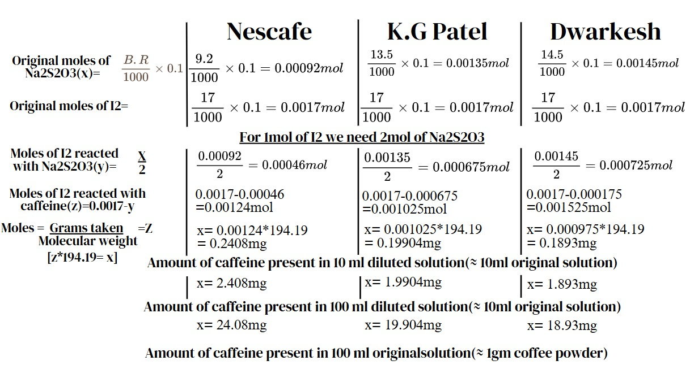

[per 2 gm in a 100ml cup]
DATA PRESENTATION
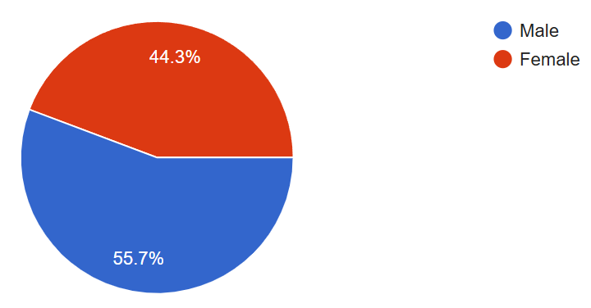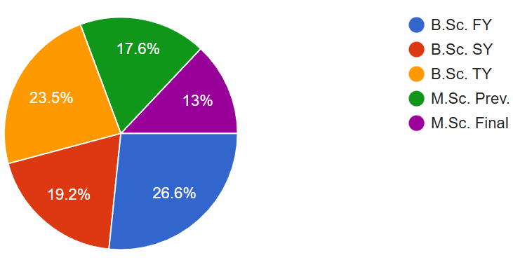
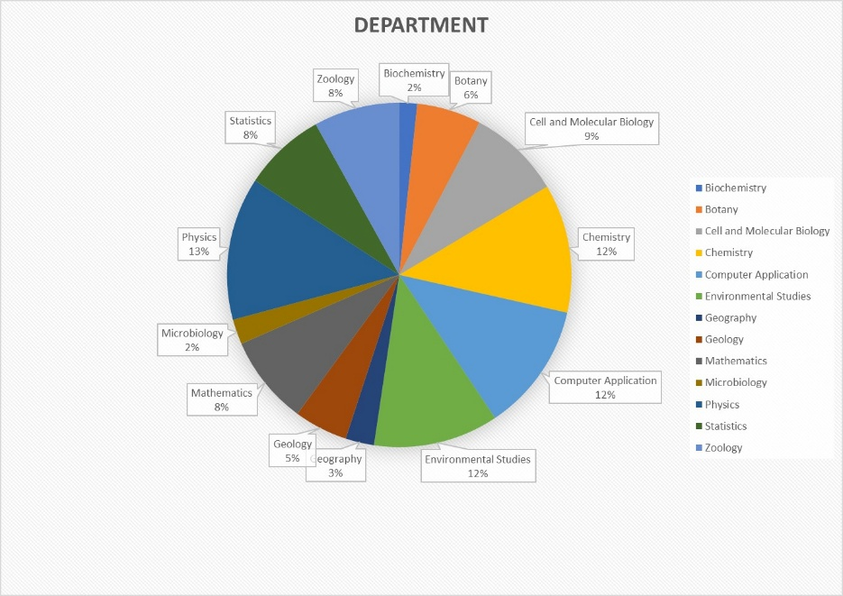
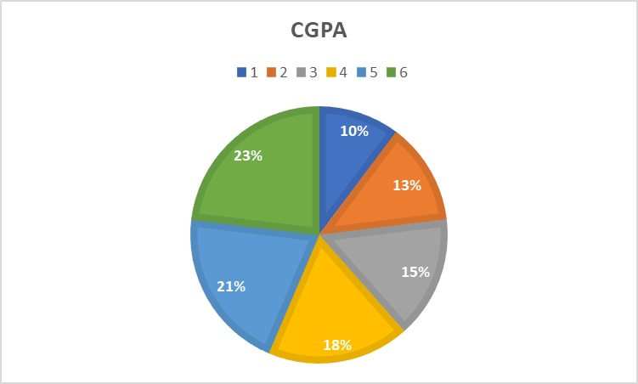
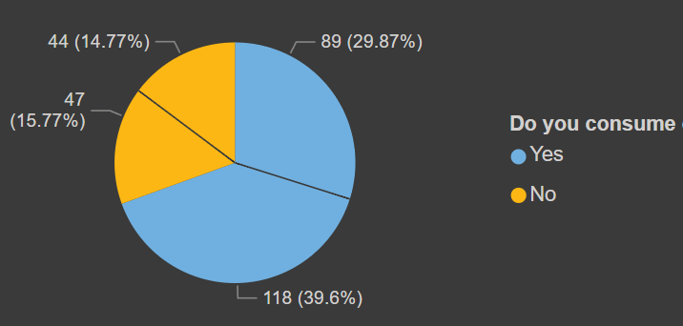
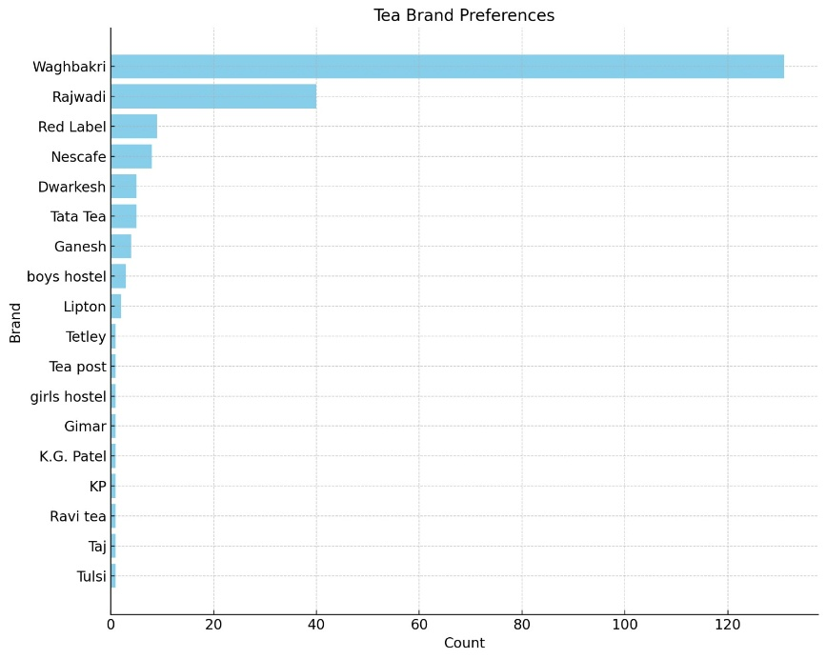
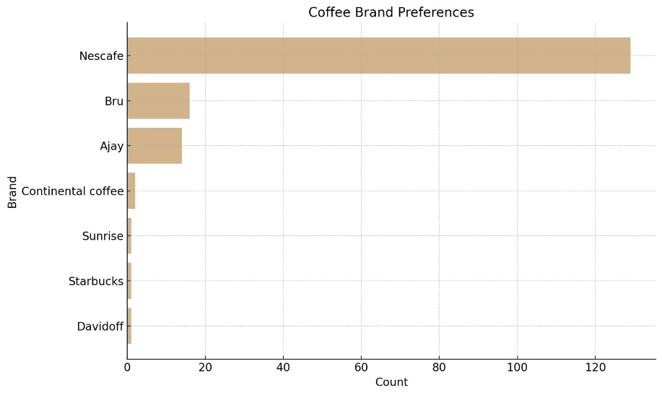
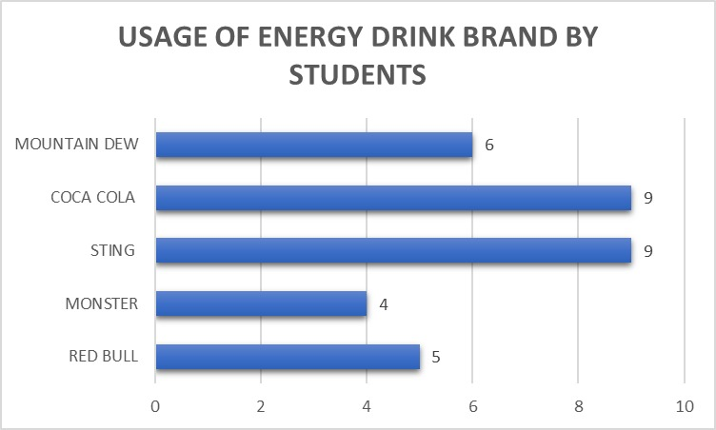
NORMALITY TEST
For regular days data
HISTOGRAM: it is a graphical tool used to assess whether a dataset follows a normal distribution. If the data is normally distributed, the histogram will have a bell-shaped curve, symmetric around the mean.
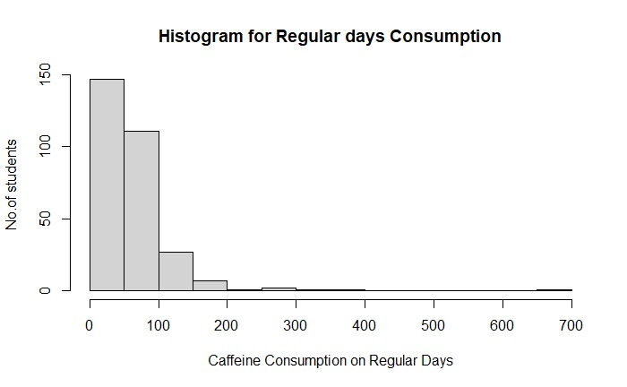
The histogram for caffeine intake the data is Rightly-Skewed (If most individuals consume low amounts of caffeine, but a few consume very high amounts, the histogram will have a long tail to the right.)
SHAPIRO WILK TEST
The Shapiro-Wilk test is a statistical test used to assess whether a dataset follows a normal distribution. It evaluates the null hypothesis that the sample data comes from a normally distributed population.
(H₀): The data on regular days caffeine intake is normally distributed.
(H₁): The data on regular days caffeine intake is not normally distributed.
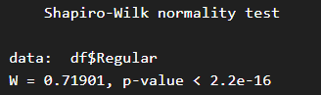
Interpretation: Data is not normally distributed (i.e., the p-value (2.2e-16) is less than the significance level 0.05), the conclusion is that your regular days caffeine intake data does not follow a normal distribution.
For exam days data
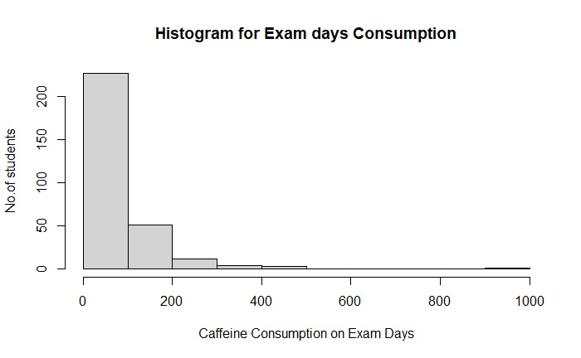
The histogram for caffeine intake the data is Rightly-Skewed Distribution (If most individuals consume low amounts of caffeine, but a few consume very high amounts, the histogram will have a long tail to the right.)
SHAPIRO WILK TEST
(H₀): The data on exam days caffeine intake is normally distributed.
(H₁): The data on exam day intake is not normally distributed.
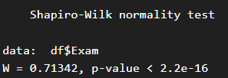
Interpretation: Data is not normally distributed (i.e., the p-value (2.2e-16) is less than the significance level 0.05), the conclusion is that your exam days caffeine intake data does not follow a normal distribution.

STATISTICAL ANALYSIS
- Examine patterns and trends in consumption, including factors such as frequency, amount and brand.

- CONSUMPTION PROPORTION:

OBSERVATION

Male Consumption:
- 39.6% (118 males) responded positively (consume caffeine).
- 14.77% (44 males) responded negatively (do not consume caffeine).

Female Consumption:
- 15.77% (47 females) responded negatively (do not consume caffeine).
- 29.87% (89 females) responded positively (consume caffeine).

This highlights a higher overall percentage of males consuming caffeine compared to females, as observed from our sample data collected.

ACADEMIC YEAR WISE
Yes
OBSERVATION

Caffeine consumption is highest in undergrad years, especially in FY and TY.
It drops in MSc years, possibly due to more balanced routines and maturity.

- BRAND PREFERENCES:
TEA BRANDS
OBSERVATION
- Waghbakri is the most preferred brand, accounting for 59.55% of the total responses, indicating its significant popularity.
- Brands like Lipton (0.45%) and Girnar (0.45%) represent the least preferred choices from our sample data.

COFFEE BRANDS

OBSERVATION
- Nescafe dominates with 78.18% (129 responses), highlighting its widespread popularity as the preferred coffee brand.
- Other brands like Continental Coffee (1.21%, 2 responses), Davidoff, Starbucks, and Sunrise occupy negligible portions.

ENERGY DRINKS BRANDS

OBSERVATION
- The graph highlights Coca-Cola's dominance in this dataset, with Red Bull and Monster also holding notable positions.

REGULAR DAYS VS. EXAM DAYS CONSUMPTION
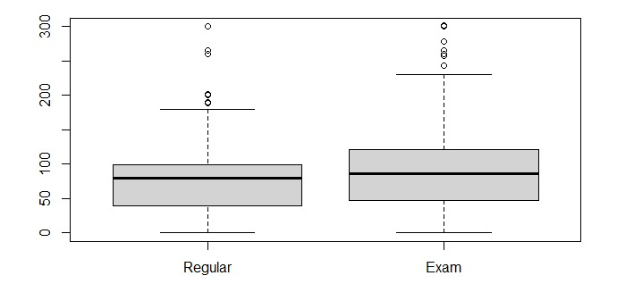
OBSERVATION
Students significantly increase caffeine consumption during exams.

THE WILCOXON RANK SUM TEST

Also known as the Mann-Whitney U-test, is a non-parametric statistical test used to compare two independent groups. Ideal when the data does not follow a normal distribution.

H0: Median caffeine intake on exam days is not higher than on regular days
H1: Median caffeine intake on exam days is higher than on regular days

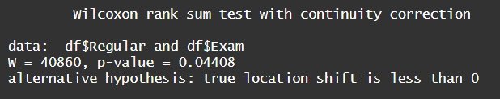

- Rejection criteria: p value [0.04408] <0.05, thus rejecting H0 at 5% level of significance.
- The Wilcoxon rank sum test indicates that the median caffeine consumption in the Exam category is significantly higher than in the Regular category.

- Examine the relationship between caffeine consumption and sleep quality

REGULAR DAYS

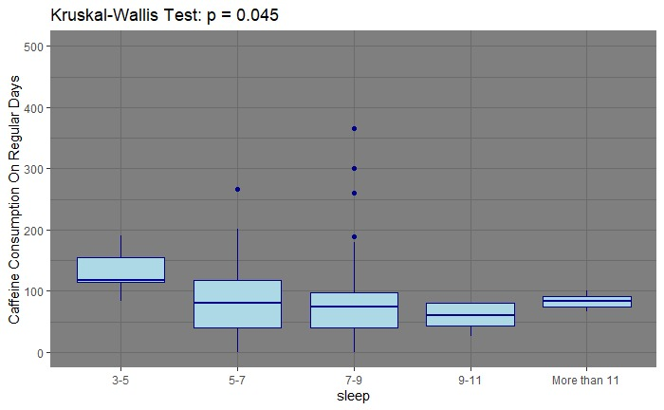

OBSERVATION

- Short sleep durations (3-5 hours) are linked with increased caffeine consumption, possibly as a coping mechanism to fatigue.
- Longer sleep durations (9+ hours) correspond to lower caffeine intake, suggesting that better sleep reduces the need for stimulants.
- Individuals falling within moderate sleep categories (5-9 hours) show a balance between caffeine dependency and sleep quality.

Kruskal-Wallis Rank Sum Test
A non-parametric statistical test used to determine if there are significant differences between the medians of three or more independent groups. It is often used when the assumptions of normality required for parametric tests (like ANOVA) are not met.

(H₀): There is no significant difference in sleep intervals across different levels of caffeine intake.
(H₁): There is a significant difference in sleep intervals across different levels of caffeine intake.

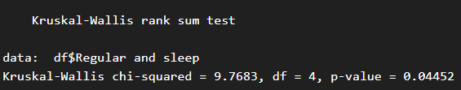

- Rejection criteria: p value [0.04452] <0.05, thus rejecting H0 at 5% level of significance.
- The test indicates that there is a significant difference in sleep intervals across different levels of caffeine intake. In other words, caffeine intake has an effect on sleep intervals.

Jonckheere-Terpstra Test
A nonparametric statistical test used to determine if there is a monotonic trend (ordered relationship) between an ordinal independent variable and a continuous or ordinal dependent variable. It is particularly useful when you expect a consistent increase or decrease in the dependent variable as the independent variable changes.

(H₀): There is no ordered difference in sleep hours across different levels of caffeine intake.
(H₁): There is a decreasing trend in sleep hours across different levels of caffeine intake.

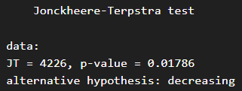

- Rejection criteria: p value [0.01786] <0.05, thus rejecting H0 at 5% level of significance.
- The test indicates that there is a decreasing trend in sleep hours across different levels of caffeine intake.

EXAM DAYS

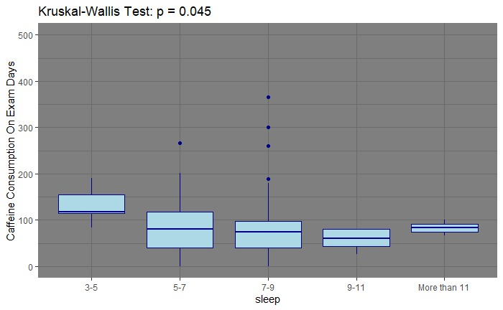
OBSERVATION

- Higher median caffeine intake. Indicates that individuals with shorter sleep durations likely rely more on caffeine to compensate for fatigue and boost alertness.
- Caffeine intake stabilizes with slightly lower medians. Reflects a balance between moderate sleep duration and a reduced dependency on caffeine.
- Lower median caffeine consumption. Suggests better-rested individuals have less need for caffeine during.

Kruskal-Wallis Rank Sum Test
(H₀): There is no significant difference in sleep intervals across different levels of caffeine intake.
(H₁): There is a significant difference in sleep intervals across different levels of caffeine intake.
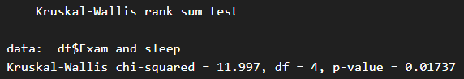
- Rejection criteria: p value [0.01737] <0.05, thus rejecting H0 at 5% level of significance.
- The test indicates that there is a significant difference in sleep intervals across different levels of caffeine intake. In other words, caffeine intake has an effect on sleep intervals.
- These results suggest that caffeine consumption likely disrupts sleep patterns.

Jonckheere-Terpstra Test
(H₀): There is no ordered difference in sleep hours across different levels of caffeine intake. In other words, the distribution of sleep hours is the same across all caffeine intake levels.
(H₁): There is a decreasing trend in sleep hours across different levels of caffeine intake.

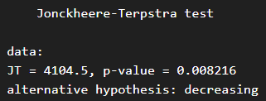

Rejection criteria: p value [0.008216] <0.05, thus rejecting H0 at 5% level of significance.
The test indicates that there is a decreasing trend in sleep hours across different levels of caffeine intake.
Showing reduction in sleep duration with higher intake in case of regular intake.

- Investigate the reasons for beginning caffeine consumption and the withdrawal symptoms related to health issues.

Color | Intensity of Occurrence
Red | Severe intensity
Dark Red | High intensity
Light Red | Moderate-high intensity
Yellow | Moderate intensity
Light Yellow | Low-moderate intensity
Green | Low intensity
Light Green | Lowest intensity

REASONS FOR CONSUMPTION
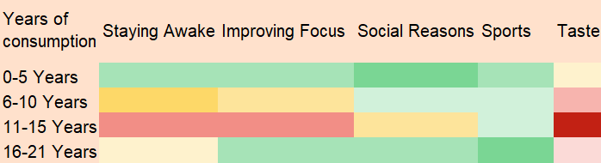
- Taste appears to be a universal driver across all age groups, peaking in intensity.
- Motives like "Staying Awake" and "Improving Focus" begin to matter more from adolescence onward, aligning with academic and lifestyle changes.
HEALTH CONDITIONS
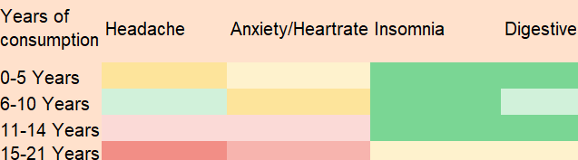
- Both headaches and anxiety/increased heart rate issues show increasing severity with longer caffeine consumption, particularly after 11 years, suggesting long-term exposure amplifies these effects.
- Digestive issues remain relatively mild probably because people not accepting it due to shyness or limelight issues.
- Insomnia being a serious health condition, has not been very prominently found in our dataset.
- Determine the relation between caffeine intake and academic performance and focus intervals.

FOCUS INTERVAL REGULAR
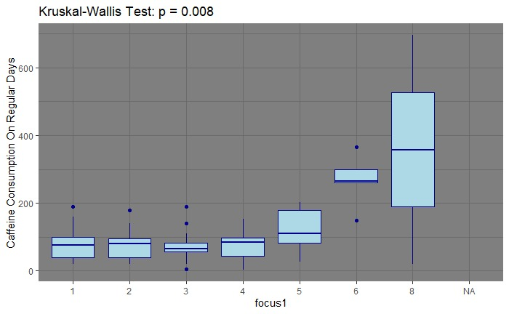

OBSERVATION
The boxplot visually supports the test result by showing variations in medians and spreads among the different focus groups. Observing distinct differences in the central tendencies (medians) or dispersion across different focus levels reinforces the conclusion that focus (or the related grouping) is linked with different caffeine consumption behaviors.

Kruskal-Wallis Rank Sum Test
(H₀): The distributions of caffeine intake are the same across all focus interval groups.
(H₁): At least one focus group has a different distribution of caffeine intake compared to the others.

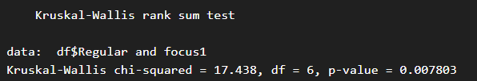
- Rejection criteria: The p-value (0.007803) is less than the significance level of 0.05, indicating that the null hypothesis is rejected.
- This means there is significant variability in caffeine consumption across the focus interval groups on regular days. Different focus groups consume caffeine at varying levels.
Jonckheere-Terpstra Test
(H₀): There is no ordered trend in focus interval levels with increasing caffeine intake.
(H₁): As caffeine intake increases, the focus interval tends to increase.
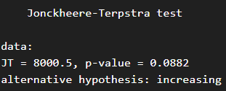
- Rejection criteria: The p-value (0.0882) is above 0.05, indicating there isn’t a significant difference in caffeine consumption across focus interval groups on regular days.
- This suggests that caffeine intake does not varies depending on individuals’ focus levels.

FOCUS INTERVAL EXAM
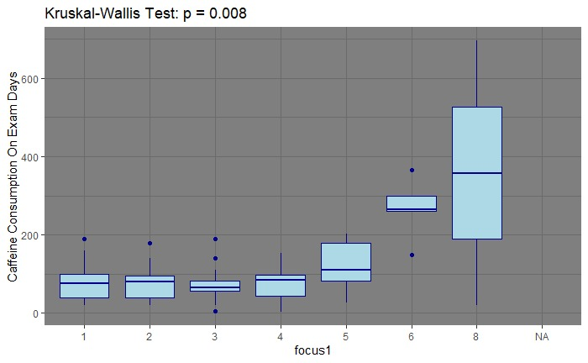

OBSERVATION:
The significant increasing trend suggests that higher focus intervals correlate with greater caffeine consumption. This implies that students may rely on caffeine as a tool to boost or sustain their focus during high-stress periods like exams.
Students with lower focus levels show more consistent and lower caffeine consumption. This could mean they either rely less on caffeine or have other barriers affecting their focus, such as sleep deprivation or stress.

Kruskal-Wallis Rank Sum Test
(H₀): The distributions of caffeine intake are the same across all focus interval groups.
(H₁): At least one focus group has a different distribution of caffeine intake compared to the others.

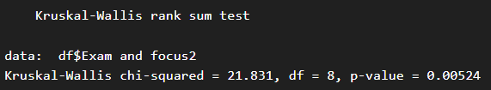

- Rejection criteria: Since the p-value (0.00524) is below the common significance level of 0.05, the null hypothesis is rejected. This means there are statistically significant differences in caffeine consumption among the focus interval groups during exams.
- Higher focus intervals are likely linked to increased caffeine consumption during exams, reflecting caffeine’s role as a cognitive enhancer.
- The focus interval groups with lower focus might consume less caffeine, suggesting either a lower reliance on stimulants or different coping mechanisms during exams.
Jonckheere-Terpstra Test
(H₀): There is no ordered trend in focus interval levels with increasing caffeine intake.
(H₁): As caffeine intake increases, the focus interval tends to increase.
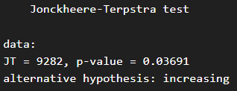
- Rejection criteria: The p-value (0.03691) is below 0.05, meaning the result is statistically significant.
- This indicates that higher caffeine consumption during exams correlates with higher focus intervals, suggesting that students may rely on caffeine to enhance focus under exam-related stress.

CGPA REGULAR

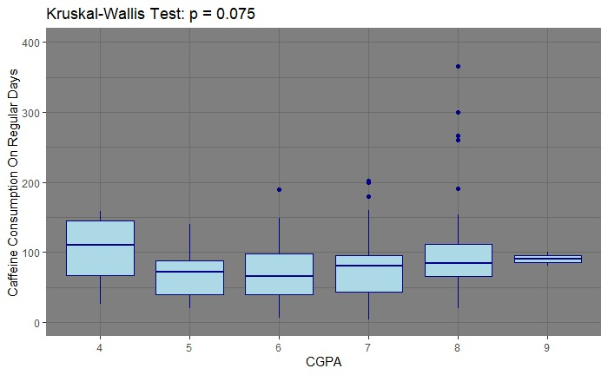
Kruskal-Wallis Rank Sum Test
(H₀): There is no significant difference in CGPA across different levels of caffeine intake. In other words, caffeine intake does not affect CGPA.
(H₁): There is a significant difference in CGPA across different levels of caffeine intake.
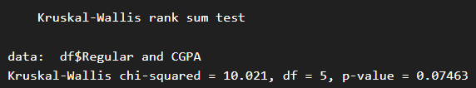

- Rejection criteria: The p-value (> 0.05) suggests no significant relationship between caffeine consumption and CGPA during regular days. Academic performance does not strongly influence caffeine consumption under normal conditions.

- The overall interpretation is that every-day caffeine consumption does not vary significantly across different CGPA categories. This means that within the sample analyzed, academic performance (CGPA) is not a strong predictor of regular caffeine intake.

CGPA EXAM
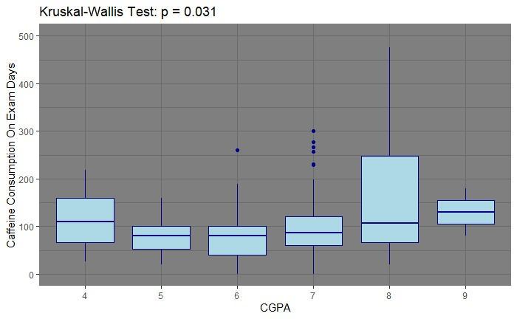

OBSERVATION:
The boxplot and test results indicate a significant association between CGPA and Exam time caffeine intake, suggesting that CGPA might be a predictor. The visual representation reinforces these differences, showing distinct medians and spreads across groups.
The Kruskal-Wallis Rank Sum Test
(H₀): There is no significant difference in CGPA across different levels of caffeine intake.
(H₁): There is a significant difference in CGPA across different levels of caffeine intake.
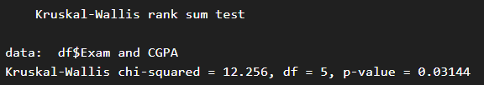

- A p-value of 0.03144 (which is less than the common significance level of 0.05) leads us to reject the null hypothesis.
- This means we have evidence that the distribution of caffeine intake significantly differs among the CGPA groups. In practical terms, students with different CGPA ranges do not consume caffeine in a similar fashion during exam periods.
Jonckheere-Terpstra Test
(H₀): There is no ordered trend in CGPA across levels of caffeine intake.
(H₁): Caffeine intake increases, CGPA tends to increase.

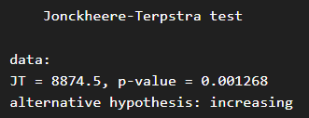

- With a very low p-value (0.001268), the JT test strongly rejects the null hypothesis of no ordered trend. This result indicates a significant monotonic trend—in this context, as caffeine intake increases during exam periods, the CGPA also tends to be higher. This suggests that higher caffeine consumption is associated with better academic performance based on the rank-ordering of CGPA levels.
INSIGHTS
These findings may suggest that, during exam periods, students who consume more caffeine might be the ones who perform better academically. There are several possible interpretations:
- Enhanced Alertness: Caffeine could be providing a performance edge by enhancing alertness and concentration during critical exam periods.
- Self-Selection: It could also be that more motivated or higher performing students are more likely to use caffeine as part of their exam preparation routine.
- Behavioral Patterns: The observed trend might reflect underlying behavioral and lifestyle factors; for example, students who are proactive about studying may also adopt other effective study strategies including strategic caffeine use.

- Explore the relationship between average caffeine intake based on gender and year of study.
GENDER
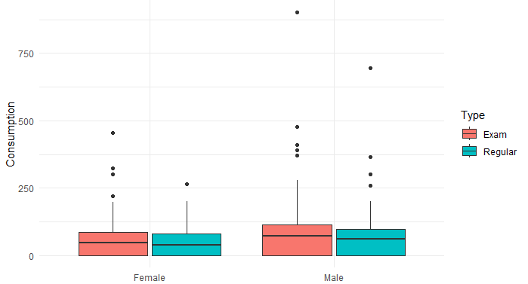
Regular Consumption:
H0: No difference in median of regular consumption between girls and boys.
H1: Difference in median of regular consumption between girls and boys.
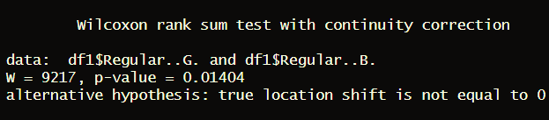
- Here, the p-value of 0.01404 is less than threshold of 0.05.
- This means we reject the null hypothesis—which states that there is difference in the distributions (or medians) between the two groups.

Exam Consumption:
H0: No difference in median of exam consumption between girls and boys.
H1: Difference in median of exam consumption between girls and boys.

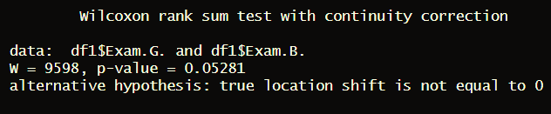
- The p-value here is 0.05281, which is slightly above 0.05.
- Formally, we do not reject the null hypothesis at the 0.05 level. This suggests that there isn’t strong evidence of a statistically significant difference between the two groups under exam conditions.

INSIGHTS
- Consistent Gender Differences on Regular Days: The significant difference on regular days implies that habitual factors and everyday lifestyle differences lead to divergent caffeine consumption profiles between girls and boys. This might reflect differences in routine behaviors, preferences, or social environments.
- Stressful Conditions May Level Consumption: The borderline result during exams hints that the heightened demands and stress of exam periods might cause both genders to converge toward similar caffeine consumption levels, or at least make differences less distinct.

ACADEMIC YEAR
REGULAR
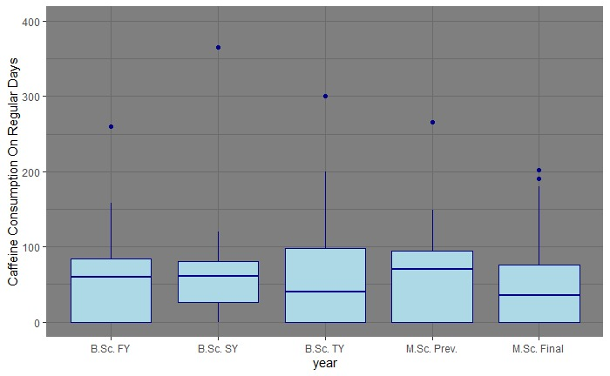
- The general trend shows that caffeine intake increases as students progress through their academic journey, peaking in the M.Sc. Previous Year. This aligns with the increasing academic demands and stress levels at higher education levels.

EXAM
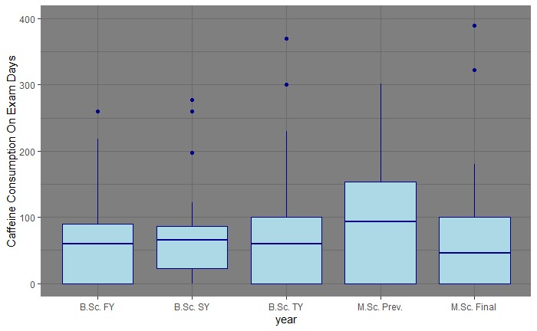

- The trend of increasing median scores and wider variability highlights academic growth and challenges faced at higher levels of education.
"Sip Smart: Stay Below 200!"
To educate students on safe caffeine consumption practices and raise awareness about the risks of exceeding the recommended limit (200 mg).
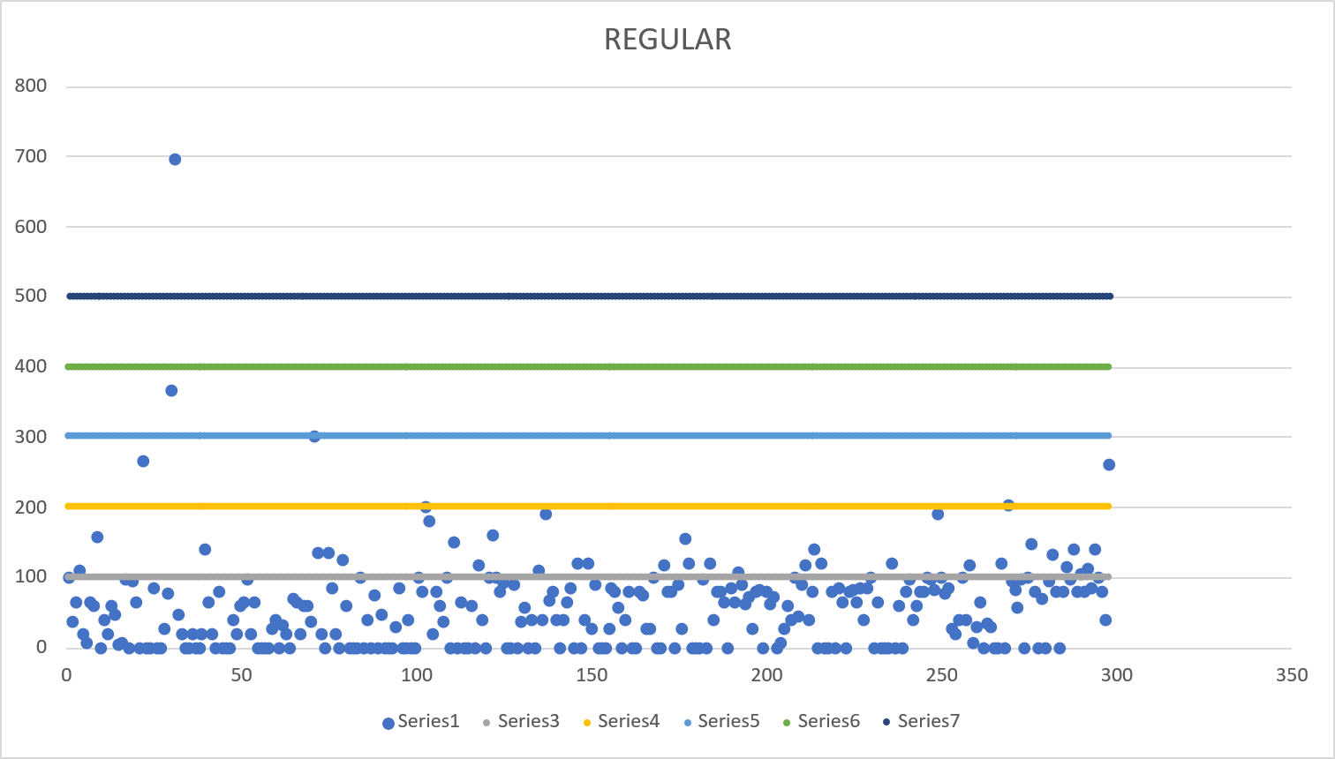
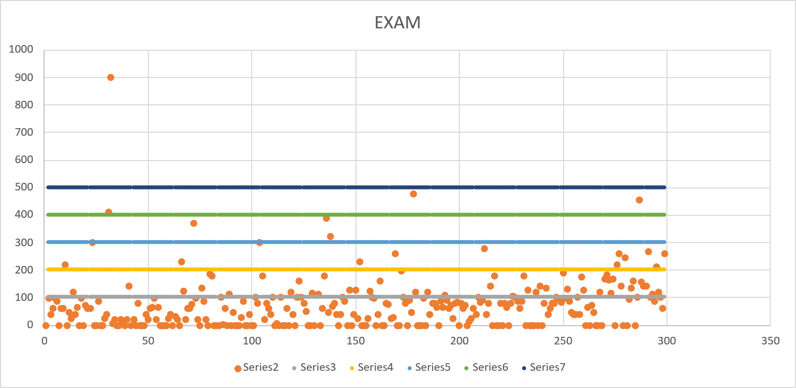

- The majority of orange dots fall below the 200-unit benchmark, aligning with healthy caffeine habits.
- A notable portion of the dots exceed the safe limit, indicating the need for intervention and awareness among students about the risks of overconsumption.
- It is also observed that the difference in increase in consumption is more during exam days than in regular days, which makes it appropriate for the University to conduct a seminar before the caffeine levels intake peaks.

APPENDIX 1

QUESTIONNAIRE FOR MARKET DATA
- Name of the shop/cafe/ restaurant. *
- Types of beverages.
    - Regular tea
    - Green tea
    - Coffee
    - Black coffee
    - Other:
- Number of cups
- Amount of caffeine
- Brands for tea.
- Brands for coffee.
- Size of cup(tea/coffee)
    - 100ml
    - 150ml
    - 200ml
    - 250ml
    - Other:
- Comments

APPENDIX 2

QUESTIONNAIRE FOR CAFFEINE CONSUMPTION
Statistical Analysis on Caffeine Consumption
  - Name*
  - Age*
  - Gender*
    - Male
    - Female
  - Academic Year*
    - Bsc. FY
    - Bsc. SY
    - Bsc. TY
    - Msc. Previous
    - Msc. Final
  - Principal Subject*
    - Botany
    - Statistics
    - Microbiology
    - Geology
    - Mathematics
    - Cell and Molecular Biology
    - Zoology
    - Geography
    - Chemistry
    - Physics
    - Computer Application
    - Environmental Studies
    - Biochemistry
  - Cumulative Avg. CGPA*
    - 4
    - 5
    - 6
    - 7
    - 8
    - 9>
  - Do you consume caffeine?*
    - Yes
    - No
  - COFFEE CONSUMPTION
Frequency count
 | 0 | 1 | 2 | 3 | 4 | >4
Black Coffee
Cold Coffee
Regular Coffee

- Brands
- Nescafe
- Ajays
- Bru
- Other:

- TEA CONSUMPTION
Frequency count
 | 0 | 1 | 2 | 3 | 4 | >4
Regular
Black
Green

- Brands
- Rajwadi
- Waghbakri
- Dwarkesh
- Lipton
- Tea Post
- Red Label
- Nescafe
- Other:
- ENERGY DRINKS
Frequency count
 | 0 | 1 | 2 | 3 | 4 | >4 | once a week
Red Bull
Monster
Sting
Coca Cola
Mountain Dew
Others

- CHOCLATE AND GUMS
Frequency count
 | 0 | 1 | 2 | 3 | 4 | >4
Milky Bar, Munch, Kitkat
Center fresh, boomer etc

- HEALTH AFFECTS
- Reason for caffeine consumption *
- Staying awake
- Improving focus
- Social reasons [peer pressure]
- Sports [physical activity]
- Other:
- Focus Interval (on a linear scale in hours)
- Sleep hours per night*
- 1-3
- 3-5
- 5-7
- 7-9
- 9-11
- more than 11
- Health Conditions*
- Anxiety [Tremors]
- Insomnia
- Increased Heart Rate
- Digestive issues
- Headaches
- Other:
- At what age did you start consuming caffeine?*
- Have you ever tried reducing caffeine content*
- Yes
- No

REFERENCES
1. What does caffeine do to your body?
Medically reviewed by Deborah Weatherspoon, Ph.D., MSN — Written by Peter Morales-Brown — Updated on July 24, 2023
https://www.medicalnewstoday.com/articles/285194#benefits

2. Predictors of the Quality of Life of University Students: A Cross-Sectional Study
José Carmelo Adsuar Sala: Academic Editor
https://www.ncbi.nlm.nih.gov/pmc/articles/PMC9564890/

3. Caffeine Content of Specialty Coffees
Rachel R. McCusker , Bruce A. Goldberger
https://academic.oup.com/jat/article-abstract/27/7/520/784168

4. Motivations Influencing Caffeine Consumption Behaviors among College Students in Korea: Associations with Sleep Quality
https://www.ncbi.nlm.nih.gov/pmc/articles/PMC7231156/

5. How can I measure the caffeine content in drinks?
Jenway team at Bibby Scientific,
https://search.app/5hBoLMSYvu7ReDU68

6. Stress and Quality of Life Among University Students: A Systematic Literature Review
Rafael Pereira, Ivna V. Freire, Bruno G. de Oliveira, Cezar A. Casotti, Eduardo N. Boery
https://www.sciencedirect.com/science/article/pii/S2452301117300305

7. Factors Affecting Female Students’ Academic Achievement at Bahir Dar University
Yeshimebrat Mersha, Alemayehu Bishaw and Firew Tegegne Bahir Dar University, Ethiopia
https://core.ac.uk/download/pdf/222951681.pdf
8. Why Do You Drink Caffeine? The Development of the Motives for Caffeine Consumption Questionnaire (MCCQ) and Its Relationship with Gender, Age and the Types of Caffeinated Beverages
- Csilla Ágoston,
- Róbert Urbán,
- Orsolya Király,
- Mark D. Griffiths,
- Peter J. Rogers &
- Zsolt Demetrovics
https://link.springer.com/article/10.1007/S11469-017-9822-3

9. Chemical Analysis of Caffeine Content in Tea and Coffee Samples
S. Parvathy, Adlet Luiz and Jaya T. Varkey
https://trp.org.in/wp-content/uploads/2016/11/AJSAT-Vol.3-No.1-Jan-June-2014pp.1-4.pdf

10. Extraction and analysis of Caffeine from various brands of tea leaves marketed in India
Marshal Soni
https://www.phytojournal.com/archives/2019/vol8issue1/PartB/9-1-127-635.pdf

