Amity International School, Noida



CS Project
Canteen Application

By-
Name: Manas Prakash
Class: 12-D
Roll. No: 17

INDEX

1. Certificate
2. Acknowledgment
3. Introduction
4. Modules used
5. Source Code
6. Project Output
7. User Manual
8. Bibliography
CERTIFICATE

This is to certify that Manas Prakash of class XII-D, Amity International School, Noida, roll number- 17 has successfully completed his project in computer practical for the AISSCE as prescribed by CBSE in the academic year 2022-23 .
ACKNOWLEDGEMENT

I would like to express my special thanks of gratitude to my teacher Ms. Neha Sinha who gave me the opportunity to do this project and also helped me in doing a lot of Research. I came to know about a lot of new things related to python.

Name Of Student
Manas Prakash

Name Of Teacher
Ms. Neha Sinha
INTRODUCTION

My application is designed to work in our school and provide a systematic approach to how billing is done.

In case a student has to buy a food item and has forgotten his money this application will keep track of it’s name and phone number to add the due money to the sum of the school fees.
MODULES USED

- pymysql
SOURCE CODE
main.py:
import pymysql

FoodIDs = [1, 2, 3, 4, 5, 6, 7, 8, 9, 10, 11, 12]
FoodNames = [
"Veg Sandwich", "Veg Burger", "Veg Patties", "Veg Pizza",
"Red Sauce Pasta", "Veg Chowmein", "Veg Fried Rice", "Veg Manchurian",
"Idli Sambhar", "Dosa", "Coca Cola", "Thums Up"
]
Prices = [30, 50, 30, 80, 100, 60, 60, 70, 70, 90, 40, 40]
Cuisines = [
"Fast Food", "Fast Food", "Fast Food", "Italian", "Italian", "Chinese",
"Chinese", "Chinese", "South Indian", "South Indian", "Beverage",
"Beverage"
]
def fillTables(conn):
cursor = conn.cursor()
noOfItems = 12
for i in range(noOfItems):
query = "INSERT INTO MENU VALUES(%d,'%s','%s',%d);" % (
FoodIDs[i], FoodNames[i], Cuisines[i], Prices[i])
cursor.execute(query)
conn.commit()
cursor.close()
def initConn():
serverIP = "localhost"
username = input("Enter MySQL username: ")
password = input("Enter password: ")
dbName = "canteen"
conn = pymysql.connect(host=serverIP, user=username, passwd=password)
print("")
print(">> Connection established!")
cursor = conn.cursor()
cursor.execute("SHOW DATABASES;")
dbList = cursor.fetchall()
dbPresent = False
for db in dbList:
if dbName not in db:
dbPresent = False
continue
else:
dbPresent = True
break
if not dbPresent:
cursor.execute("CREATE DATABASE " + dbName)
cursor.execute("USE " + dbName)
cursor.execute("""Create table MENU(FoodID int primary key,
FoodName varchar(20) NOT NULL,
Cuisine varchar(20), Price int NOT NULL);""")
cursor.execute("""Create table CUSTOMERS(CustID varchar(4) primary key,
CustName varchar(20) NOT NULL, Orders int, Total int);""")
print(">> Database and Tables generated!")
fillTables(conn)
else:
cursor.execute("USE " + dbName)
print(">> Using existing Database and Tables.")
cursor.close()
return conn
def displayMenu(conn):
print("")
print(
"**********************************************************************"
)
print(
"* *"
)
print(
"* ___ _ _ _ *"
)
print(
"* | / \ / \ | \ *"
)
print(
"* |-- | || || | *"
)
print(
"* |__ \_/ \_/ |_/ __ *"
)
print(
"* / \ __ __ / \ *"
)
print(
"* \__ |-- | \ \ /| / |-- \__ *"
)
print(
"* \ |-- |--/ \ / || |-- \ *"
)
print(
"* \__/ |-- | \ \/ | \__ |-- \__/ *"
)
print(
"* *"
)
print(
"* *"
)
cursor = conn.cursor()
cursor.execute("Select * from MENU;")
rows = cursor.fetchall()
print("* " + "{0:10} {1:20} {2:20} {3:10}".format(
"Food ID", "Food Name", "Cuisine", "Price") + "*")
print(
"* ---------------------------------------------------------- *"
)
for Rec in rows:
foodID = Rec[0]
foodName = Rec[1]
cuisine = Rec[2]
price = Rec[3]
print("* " + "{0:^9}- {1:<18} {2:<14} {3:>10}".format(
foodID, foodName, cuisine, price) + " *")
print(
"* ---------------------------------------------------------- *"
)
print(
"* *"
)
print(
"**********************************************************************"
)

cursor.close()

def billGeneration(conn, details):
cursor = conn.cursor()
custID = details[0]
custName = details[1]
orderedItems = details[2]
orderedItemsQuantity = details[3]
totalPrice = 0
for i in range(len(orderedItems)):
totalPrice += Prices[orderedItems[i] - 1] * orderedItemsQuantity[i]
totalOrders = 0
for i in orderedItemsQuantity:
totalOrders += i
query = "INSERT INTO CUSTOMERS VALUES('%s','%s',%d,%d);" % (
custID, custName, totalOrders, totalPrice)
cursor.execute(query)
conn.commit()
print(
"\n\n*****************************************************************"
)
print("* *")
print("* Food Services *")
print("* *")
print("* Customer ID: " + custID + "\t\t\t\t*")
print("* Customer Name: " + custName + "\t\t\t\t*")
print("* *")
print("* You Ordered: *")
print("* *")
for i in range(len(orderedItems)):
print("*\t", orderedItemsQuantity[i], FoodNames[orderedItems[i] - 1],
" \t-\t", orderedItemsQuantity[i], "x",
Prices[orderedItems[i] - 1], "=",
int(orderedItemsQuantity[i]) * Prices[orderedItems[i] - 1],
"\t\t*")
print("* *")
print("* *")
print("*\t Grand Total: Rs.", totalPrice, "\t\t\t\t\t*")
print("* *")
print("* ****** *")
print("* *")
print("* Thanks for Visiting *")
print("* *")
print("*****************************************************************")

cursor.close()

def takeOrder(conn):
cursor = conn.cursor()
c1 = 'y'
cursor.execute("SELECT * FROM CUSTOMERS;")
noOfEntriesAlready = cursor.fetchall()
cIndex = len(noOfEntriesAlready)
while (c1 == 'y'):
cIndex += 1
orderedItems = []
orderedItemsQuantity = []
custID = "AX" + str(cIndex)
custName = input("Please enter your name: ")
custPhnNo = input("Please enter your mobile number: ")
c2 = 'y'
while (c2 != 'n'):
order = int(
input("What would you like to have? (Enter choice 1-12): "))
if order in FoodIDs:
quantity = int(
input("How many of this would you like to order: "))
if (order not in orderedItems):
orderedItems.append(order)
orderedItemsQuantity.append(quantity)
else:
orderedItemsQuantity[len(orderedItemsQuantity) -
1] += quantity
c2 = input("Would you like to order anything else? (y/n): ")
while (c2 != 'y' and c2 != 'n'):
print("Oops, you entered the wrong option.")
c2 = input(
"Would you like to order anything else? (y/n): ")
else:
print("Sorry, you entered the wrong choice.")
c2 = input("Would you like to place an order again? (y/n): ")
while (c2 != 'y' or c2 != 'n'):
print("Oops, you entered the wrong option.")
c2 = input(
"Would you like to order anything else? (y/n): ")
print(
"Thank you! Please wait while you receive your orders. Here's your bill..."
)
details = [custID, custName, orderedItems, orderedItemsQuantity]
billGeneration(conn, details)
print("")
c1 = input("Are you a new customer? (y/n): ")
print("Thank you for eating at Food Services! Have a great day!")
cursor.close()

def Main():
conn = initConn()
displayMenu(conn)
takeOrder(conn)
conn.close()

Main()
PROJECT OUTPUT

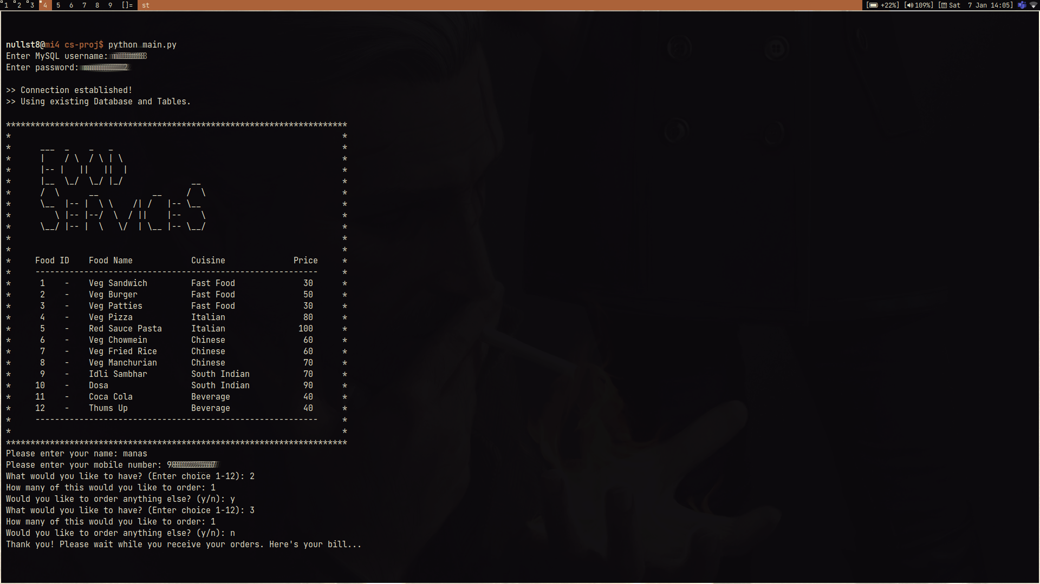

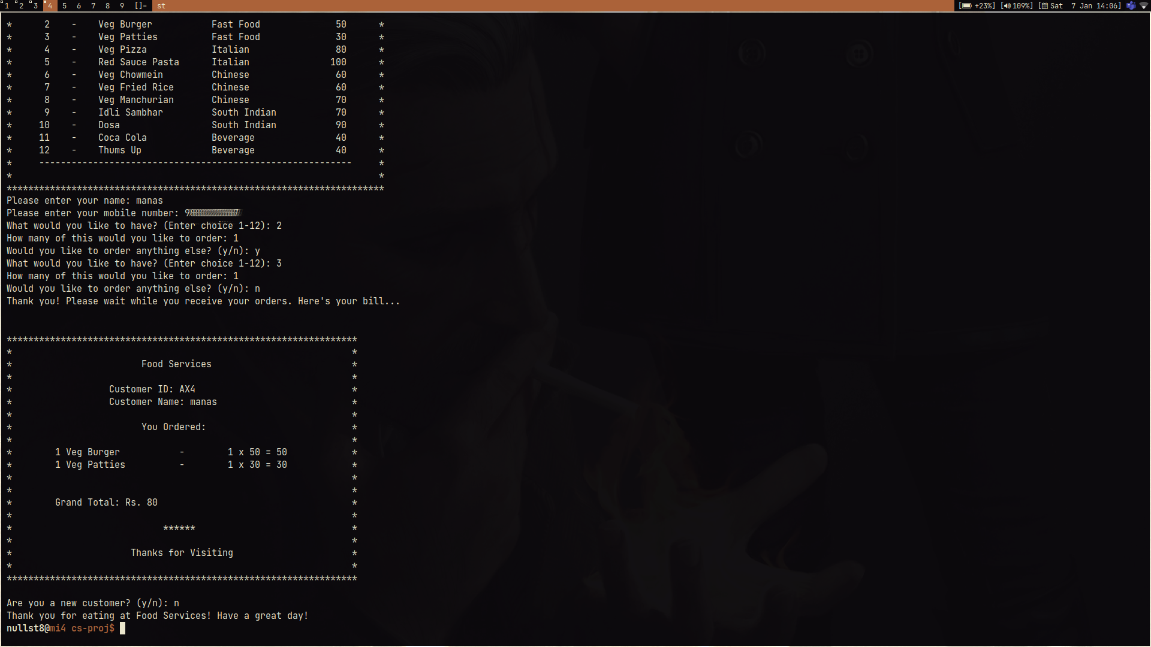
USER MANUAL

The application starts by asking the host for their mysql username and password to make a connection to the required database using the pymysql library.
The program then asks for the name and phone number of the user to create an entry into the database.
The user is then asked to input all the things he/she wants to buy and creates a bill for the same.
BIBLIOGRAPHY

- stackoverflow.com
- docs.python.org

