What is a Process?

A process is any running program. Every command you run creates a new process with its own PID

1. Viewing Processes

Command | Description | Example
ps | Current processes (snapshot) | ps aux = all processes with full info
top | live process monitor | cpu, memory, PID, command
htop | interactive process monitor
pgrep | find process by name | pgrep sshd
pidof | get PID of a program | pidof firefox
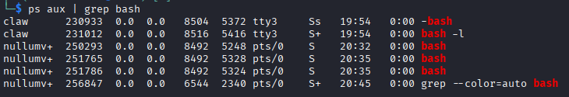
2. Process States

Code | Meaning
R | running
S | Sleeping
D | Uninterruptible sleep usually waiting for disk
T | Stopped
Z | Zombie – process finished but parent hasn’t collected exit status
X | Dead
+ | Foreground process group
… more

3. Starting and Managing Processes

Task | Command | Description
Run in background | command & | Starts process detached from terminal
Bring background job to foreground | fg %1 | %n = %job number
List jobs in current terminal | jobs | See background tasks
Stop current fg process | Ctrl = Z | Stops current process
Resume stopped job | bg %1 | Continues it in background
Run in background safely | nohup command & | Keeps it running even after logout

4. Stopping or Killing Processes

Command | Purpose
kill $PID | Default TERM signal
kill -9 $PID | Force kill
killall $name | Kill all processes with name
pkill $pattern | Kill processes matching pattern

5. Signals
Each process can receive signals / messages

Signal | Name | Meaning
15 | SIGTERM | terminate gracefully
9 | SIGKILL | force kill immediately
19 | SIGSTOP | pause process
18 | SIGCONT | continue paused process

6. Priority and Scheduling
Every process has a nice value (-20 = highest priority, 19 = lowest)

nice -n 10 command
renice -n -5 -p $PID

nice sets priority at start
renice changes priority for running process

