MacroHard WeakEdge

Description:
I've hidden a flag in this file. Can you find it? Forensics is fun.pptm

Type: Forensics

Solving:
1) I downloaded the given file and opened it. My system gave me a warning that it contains macros.
2) I know that pptm files are basically zip files so i can extract it.
3) I extracted in a folder called fun.
4) Then through cmd I listed all files recursively
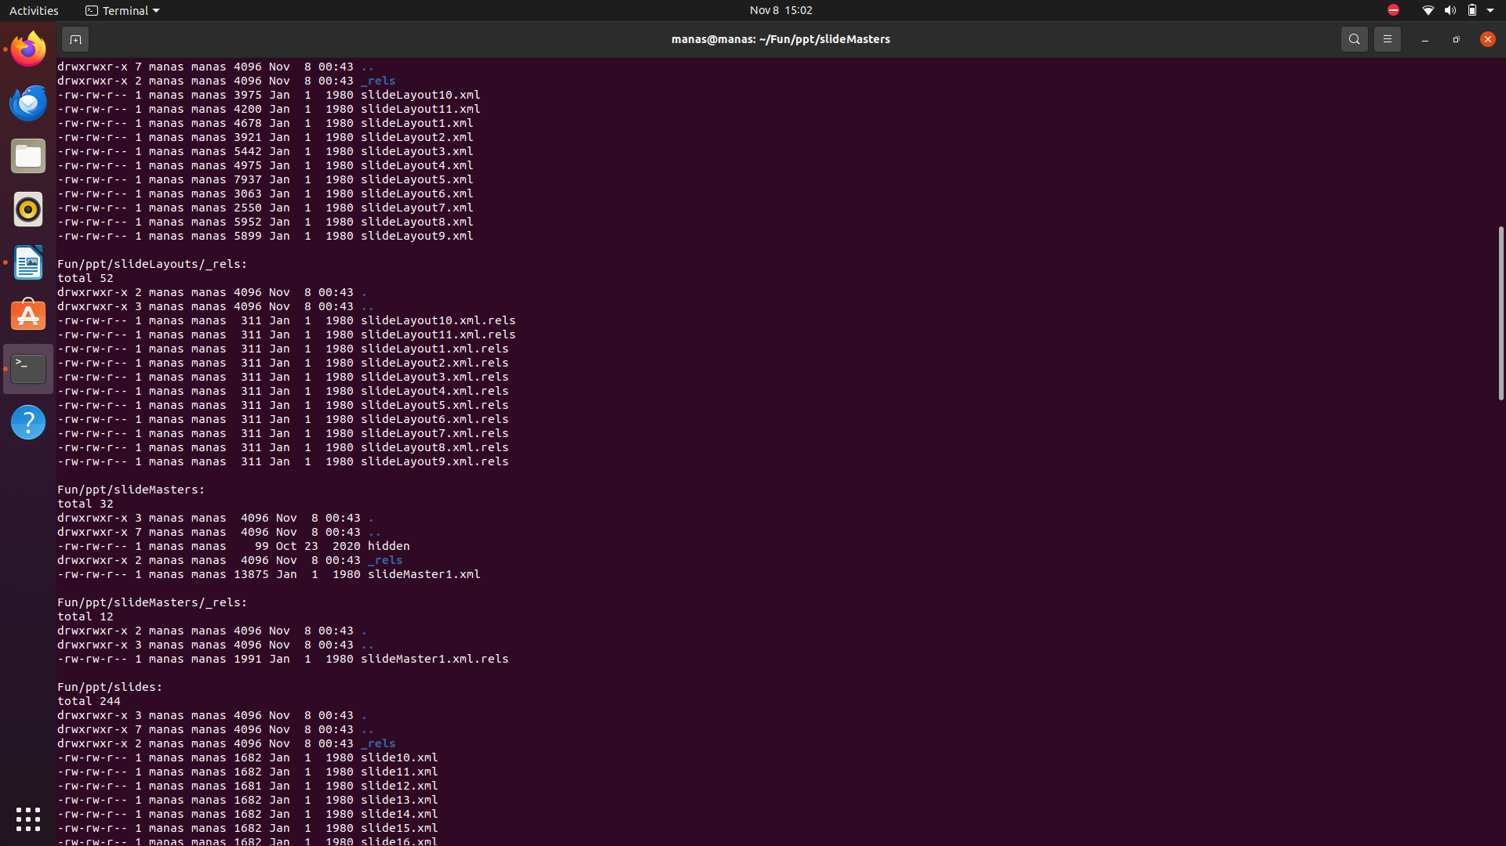
- ls Fun -alR
5) Then inspected the library and found that there is a file called hidden, So i concatted that file and got a random sequence of letters which looked like a cypher.
6) So I examined the cypher which contained capital letters, small letters and numbers which seemed like a base64 cypher.
7) I used the online tool https://www.base64decode.org/
to decypher the text.
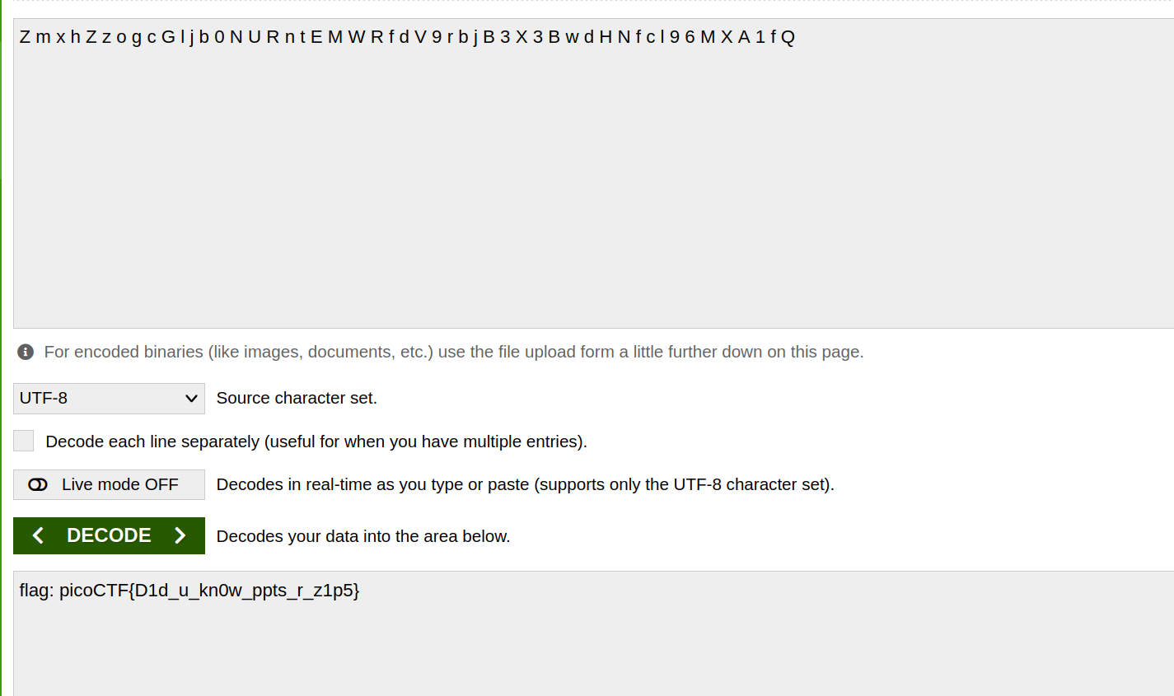
8) I got the flag on decoding the cypher.

Flag: picoCTF{D1d_u_kn0w_ppts_r_z1p5}

