Trivial Flag Transfer Protocol

Description:
Figure out how they moved the flag.

Type: Forensics

Solving:
1) I downloaded the file and captured its packets on wireshark. I observed that it has a lot of TFTP protocol packets.
2) So I exported the TFTP objects and saved all the files in a folder.
3) I observed the files and there were 3 bmp image files and two text file and 1 deb file.
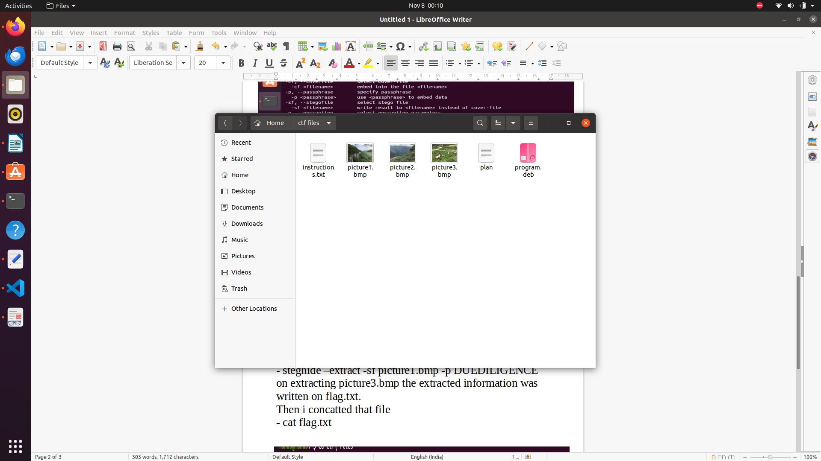
4) I opened instruction.txt which seemed like a random jumble of letters probably a cipher. So I tested it by decrypting with one of the most widely used ceaser cypher (ROT13) using https://gchq.github.io/CyberChef/#recipe=ROT13(true,true,false,13)
and i got a meaningful text:
TFTP DOESNT ENCRYPT OUR TRAFFIC SO WE MUST DISGUISE OUR FLAG TRANSFER. FIGURE OUT A WAY TO HIDE THE FLAG AND I WILL CHECK BACK FOR THE PLAN.
5) This gives us the hint that we can find something meaningful in the file plan. So i opened plan.txt and which was also a jumble of letters so i used the same cypher to decypher it and i got some meaningful text.
I USED THE PROGRAM AND HID IT WITH- DUEDILIGENCE. CHECK OUT THE PHOTOS.
6) I found out that the program was steghide so i installed it using the command
- sudo apt install steghide
Steghide is a steganography program that is able to hide data in various kinds of image- and audio-files.
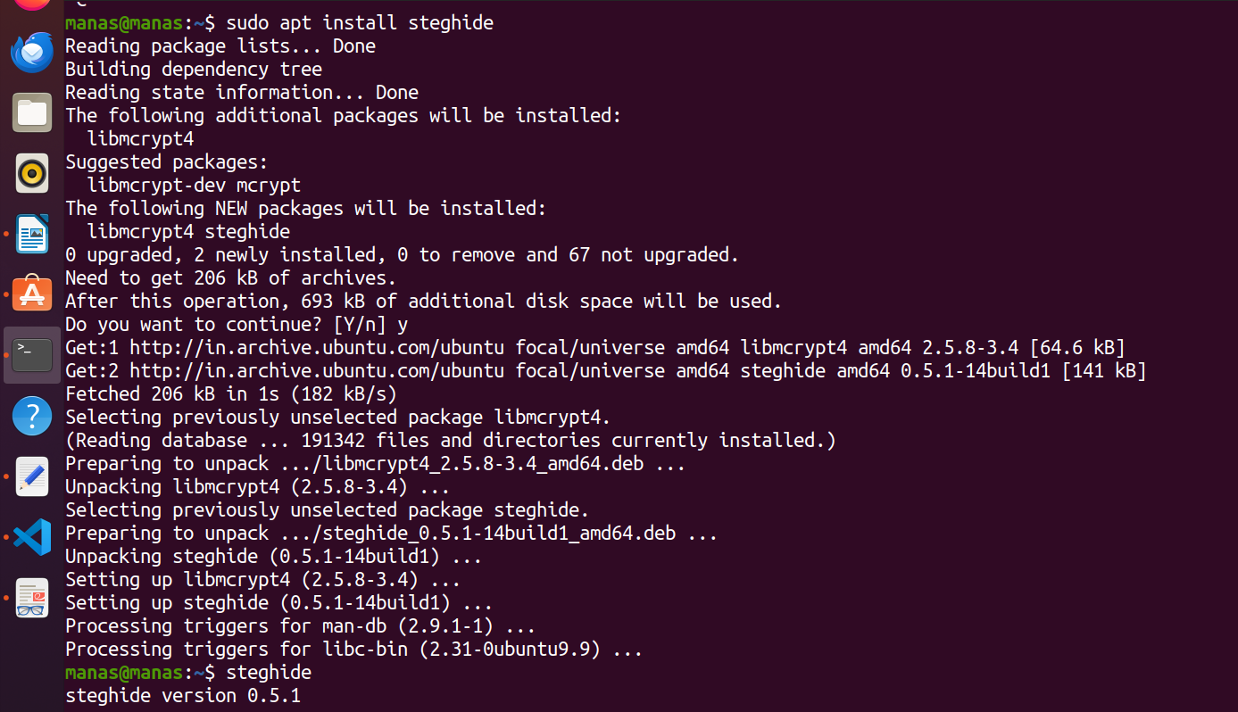
7) I found out how to use it in terminal by
- steghide –help

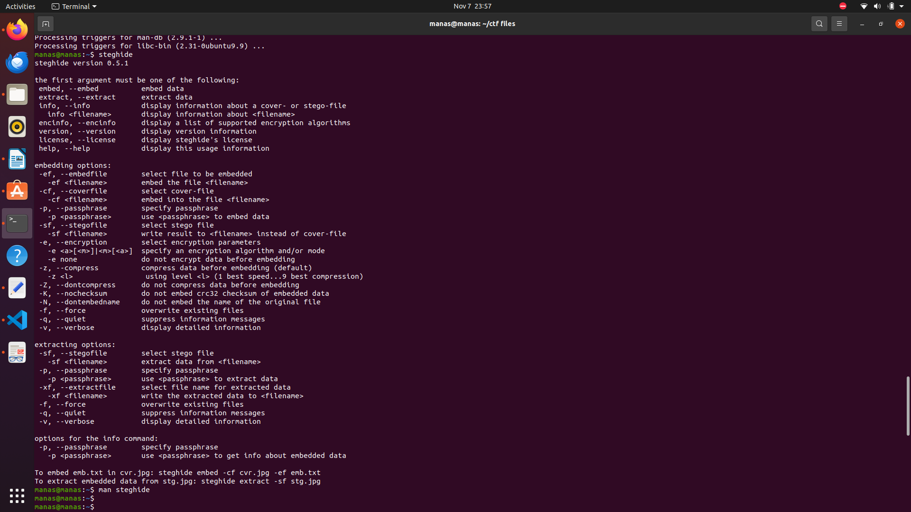
8) So i have to extract the bmp images using steghide and the passphrase given is DUEDILIGENCE. So I extracted the file one by one using the command

- steghide –extract -sf picture1.bmp -p DUEDILIGENCE
on extracting picture3.bmp the extracted information was written on flag.txt.
Then i concatted that file
- cat flag.txt

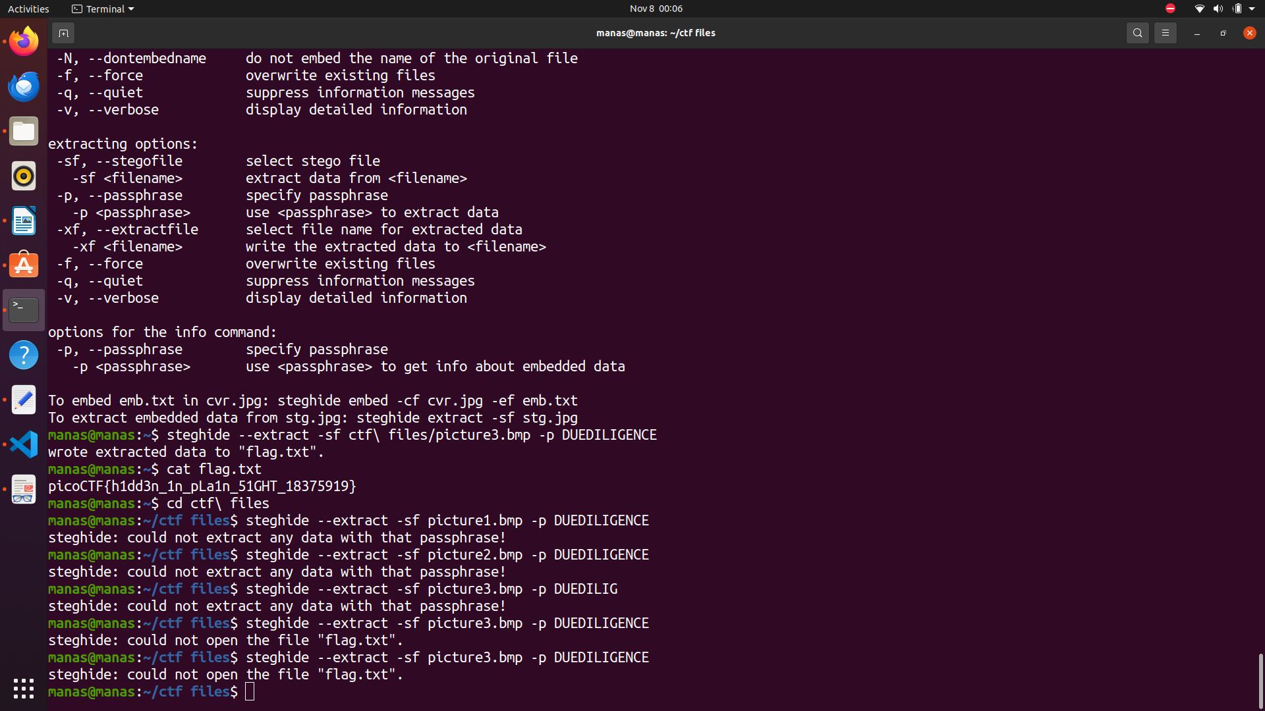

Flag: picoCTF{h1dd3n_1n_pLa1n_51GHT_18375919}

