Week3HW_AirQuality.R

rocke

2023-01-29

library(ggplot2)

## Warning: package 'ggplot2' was built under R version 4.2.2

library(reshape2)

## Warning: package 'reshape2' was built under R version 4.2.2

#Step 1  
air <- data.frame(airquality)  
air

## Ozone Solar.R Wind Temp Month Day  
## 1 41 190 7.4 67 5 1  
## 2 36 118 8.0 72 5 2  
## 3 12 149 12.6 74 5 3  
## 4 18 313 11.5 62 5 4  
## 5 NA NA 14.3 56 5 5  
## 6 28 NA 14.9 66 5 6  
## 7 23 299 8.6 65 5 7  
## 8 19 99 13.8 59 5 8  
## 9 8 19 20.1 61 5 9  
## 10 NA 194 8.6 69 5 10  
## 11 7 NA 6.9 74 5 11  
## 12 16 256 9.7 69 5 12  
## 13 11 290 9.2 66 5 13  
## 14 14 274 10.9 68 5 14  
## 15 18 65 13.2 58 5 15  
## 16 14 334 11.5 64 5 16  
## 17 34 307 12.0 66 5 17  
## 18 6 78 18.4 57 5 18  
## 19 30 322 11.5 68 5 19  
## 20 11 44 9.7 62 5 20  
## 21 1 8 9.7 59 5 21  
## 22 11 320 16.6 73 5 22  
## 23 4 25 9.7 61 5 23  
## 24 32 92 12.0 61 5 24  
## 25 NA 66 16.6 57 5 25  
## 26 NA 266 14.9 58 5 26  
## 27 NA NA 8.0 57 5 27  
## 28 23 13 12.0 67 5 28  
## 29 45 252 14.9 81 5 29  
## 30 115 223 5.7 79 5 30  
## 31 37 279 7.4 76 5 31  
## 32 NA 286 8.6 78 6 1  
## 33 NA 287 9.7 74 6 2  
## 34 NA 242 16.1 67 6 3  
## 35 NA 186 9.2 84 6 4  
## 36 NA 220 8.6 85 6 5  
## 37 NA 264 14.3 79 6 6  
## 38 29 127 9.7 82 6 7  
## 39 NA 273 6.9 87 6 8  
## 40 71 291 13.8 90 6 9  
## 41 39 323 11.5 87 6 10  
## 42 NA 259 10.9 93 6 11  
## 43 NA 250 9.2 92 6 12  
## 44 23 148 8.0 82 6 13  
## 45 NA 332 13.8 80 6 14  
## 46 NA 322 11.5 79 6 15  
## 47 21 191 14.9 77 6 16  
## 48 37 284 20.7 72 6 17  
## 49 20 37 9.2 65 6 18  
## 50 12 120 11.5 73 6 19  
## 51 13 137 10.3 76 6 20  
## 52 NA 150 6.3 77 6 21  
## 53 NA 59 1.7 76 6 22  
## 54 NA 91 4.6 76 6 23  
## 55 NA 250 6.3 76 6 24  
## 56 NA 135 8.0 75 6 25  
## 57 NA 127 8.0 78 6 26  
## 58 NA 47 10.3 73 6 27  
## 59 NA 98 11.5 80 6 28  
## 60 NA 31 14.9 77 6 29  
## 61 NA 138 8.0 83 6 30  
## 62 135 269 4.1 84 7 1  
## 63 49 248 9.2 85 7 2  
## 64 32 236 9.2 81 7 3  
## 65 NA 101 10.9 84 7 4  
## 66 64 175 4.6 83 7 5  
## 67 40 314 10.9 83 7 6  
## 68 77 276 5.1 88 7 7  
## 69 97 267 6.3 92 7 8  
## 70 97 272 5.7 92 7 9  
## 71 85 175 7.4 89 7 10  
## 72 NA 139 8.6 82 7 11  
## 73 10 264 14.3 73 7 12  
## 74 27 175 14.9 81 7 13  
## 75 NA 291 14.9 91 7 14  
## 76 7 48 14.3 80 7 15  
## 77 48 260 6.9 81 7 16  
## 78 35 274 10.3 82 7 17  
## 79 61 285 6.3 84 7 18  
## 80 79 187 5.1 87 7 19  
## 81 63 220 11.5 85 7 20  
## 82 16 7 6.9 74 7 21  
## 83 NA 258 9.7 81 7 22  
## 84 NA 295 11.5 82 7 23  
## 85 80 294 8.6 86 7 24  
## 86 108 223 8.0 85 7 25  
## 87 20 81 8.6 82 7 26  
## 88 52 82 12.0 86 7 27  
## 89 82 213 7.4 88 7 28  
## 90 50 275 7.4 86 7 29  
## 91 64 253 7.4 83 7 30  
## 92 59 254 9.2 81 7 31  
## 93 39 83 6.9 81 8 1  
## 94 9 24 13.8 81 8 2  
## 95 16 77 7.4 82 8 3  
## 96 78 NA 6.9 86 8 4  
## 97 35 NA 7.4 85 8 5  
## 98 66 NA 4.6 87 8 6  
## 99 122 255 4.0 89 8 7  
## 100 89 229 10.3 90 8 8  
## 101 110 207 8.0 90 8 9  
## 102 NA 222 8.6 92 8 10  
## 103 NA 137 11.5 86 8 11  
## 104 44 192 11.5 86 8 12  
## 105 28 273 11.5 82 8 13  
## 106 65 157 9.7 80 8 14  
## 107 NA 64 11.5 79 8 15  
## 108 22 71 10.3 77 8 16  
## 109 59 51 6.3 79 8 17  
## 110 23 115 7.4 76 8 18  
## 111 31 244 10.9 78 8 19  
## 112 44 190 10.3 78 8 20  
## 113 21 259 15.5 77 8 21  
## 114 9 36 14.3 72 8 22  
## 115 NA 255 12.6 75 8 23  
## 116 45 212 9.7 79 8 24  
## 117 168 238 3.4 81 8 25  
## 118 73 215 8.0 86 8 26  
## 119 NA 153 5.7 88 8 27  
## 120 76 203 9.7 97 8 28  
## 121 118 225 2.3 94 8 29  
## 122 84 237 6.3 96 8 30  
## 123 85 188 6.3 94 8 31  
## 124 96 167 6.9 91 9 1  
## 125 78 197 5.1 92 9 2  
## 126 73 183 2.8 93 9 3  
## 127 91 189 4.6 93 9 4  
## 128 47 95 7.4 87 9 5  
## 129 32 92 15.5 84 9 6  
## 130 20 252 10.9 80 9 7  
## 131 23 220 10.3 78 9 8  
## 132 21 230 10.9 75 9 9  
## 133 24 259 9.7 73 9 10  
## 134 44 236 14.9 81 9 11  
## 135 21 259 15.5 76 9 12  
## 136 28 238 6.3 77 9 13  
## 137 9 24 10.9 71 9 14  
## 138 13 112 11.5 71 9 15  
## 139 46 237 6.9 78 9 16  
## 140 18 224 13.8 67 9 17  
## 141 13 27 10.3 76 9 18  
## 142 24 238 10.3 68 9 19  
## 143 16 201 8.0 82 9 20  
## 144 13 238 12.6 64 9 21  
## 145 23 14 9.2 71 9 22  
## 146 36 139 10.3 81 9 23  
## 147 7 49 10.3 69 9 24  
## 148 14 20 16.6 63 9 25  
## 149 30 193 6.9 70 9 26  
## 150 NA 145 13.2 77 9 27  
## 151 14 191 14.3 75 9 28  
## 152 18 131 8.0 76 9 29  
## 153 20 223 11.5 68 9 30

#Step 2  
air <- na.omit(air)  
air

## Ozone Solar.R Wind Temp Month Day  
## 1 41 190 7.4 67 5 1  
## 2 36 118 8.0 72 5 2  
## 3 12 149 12.6 74 5 3  
## 4 18 313 11.5 62 5 4  
## 7 23 299 8.6 65 5 7  
## 8 19 99 13.8 59 5 8  
## 9 8 19 20.1 61 5 9  
## 12 16 256 9.7 69 5 12  
## 13 11 290 9.2 66 5 13  
## 14 14 274 10.9 68 5 14  
## 15 18 65 13.2 58 5 15  
## 16 14 334 11.5 64 5 16  
## 17 34 307 12.0 66 5 17  
## 18 6 78 18.4 57 5 18  
## 19 30 322 11.5 68 5 19  
## 20 11 44 9.7 62 5 20  
## 21 1 8 9.7 59 5 21  
## 22 11 320 16.6 73 5 22  
## 23 4 25 9.7 61 5 23  
## 24 32 92 12.0 61 5 24  
## 28 23 13 12.0 67 5 28  
## 29 45 252 14.9 81 5 29  
## 30 115 223 5.7 79 5 30  
## 31 37 279 7.4 76 5 31  
## 38 29 127 9.7 82 6 7  
## 40 71 291 13.8 90 6 9  
## 41 39 323 11.5 87 6 10  
## 44 23 148 8.0 82 6 13  
## 47 21 191 14.9 77 6 16  
## 48 37 284 20.7 72 6 17  
## 49 20 37 9.2 65 6 18  
## 50 12 120 11.5 73 6 19  
## 51 13 137 10.3 76 6 20  
## 62 135 269 4.1 84 7 1  
## 63 49 248 9.2 85 7 2  
## 64 32 236 9.2 81 7 3  
## 66 64 175 4.6 83 7 5  
## 67 40 314 10.9 83 7 6  
## 68 77 276 5.1 88 7 7  
## 69 97 267 6.3 92 7 8  
## 70 97 272 5.7 92 7 9  
## 71 85 175 7.4 89 7 10  
## 73 10 264 14.3 73 7 12  
## 74 27 175 14.9 81 7 13  
## 76 7 48 14.3 80 7 15  
## 77 48 260 6.9 81 7 16  
## 78 35 274 10.3 82 7 17  
## 79 61 285 6.3 84 7 18  
## 80 79 187 5.1 87 7 19  
## 81 63 220 11.5 85 7 20  
## 82 16 7 6.9 74 7 21  
## 85 80 294 8.6 86 7 24  
## 86 108 223 8.0 85 7 25  
## 87 20 81 8.6 82 7 26  
## 88 52 82 12.0 86 7 27  
## 89 82 213 7.4 88 7 28  
## 90 50 275 7.4 86 7 29  
## 91 64 253 7.4 83 7 30  
## 92 59 254 9.2 81 7 31  
## 93 39 83 6.9 81 8 1  
## 94 9 24 13.8 81 8 2  
## 95 16 77 7.4 82 8 3  
## 99 122 255 4.0 89 8 7  
## 100 89 229 10.3 90 8 8  
## 101 110 207 8.0 90 8 9  
## 104 44 192 11.5 86 8 12  
## 105 28 273 11.5 82 8 13  
## 106 65 157 9.7 80 8 14  
## 108 22 71 10.3 77 8 16  
## 109 59 51 6.3 79 8 17  
## 110 23 115 7.4 76 8 18  
## 111 31 244 10.9 78 8 19  
## 112 44 190 10.3 78 8 20  
## 113 21 259 15.5 77 8 21  
## 114 9 36 14.3 72 8 22  
## 116 45 212 9.7 79 8 24  
## 117 168 238 3.4 81 8 25  
## 118 73 215 8.0 86 8 26  
## 120 76 203 9.7 97 8 28  
## 121 118 225 2.3 94 8 29  
## 122 84 237 6.3 96 8 30  
## 123 85 188 6.3 94 8 31  
## 124 96 167 6.9 91 9 1  
## 125 78 197 5.1 92 9 2  
## 126 73 183 2.8 93 9 3  
## 127 91 189 4.6 93 9 4  
## 128 47 95 7.4 87 9 5  
## 129 32 92 15.5 84 9 6  
## 130 20 252 10.9 80 9 7  
## 131 23 220 10.3 78 9 8  
## 132 21 230 10.9 75 9 9  
## 133 24 259 9.7 73 9 10  
## 134 44 236 14.9 81 9 11  
## 135 21 259 15.5 76 9 12  
## 136 28 238 6.3 77 9 13  
## 137 9 24 10.9 71 9 14  
## 138 13 112 11.5 71 9 15  
## 139 46 237 6.9 78 9 16  
## 140 18 224 13.8 67 9 17  
## 141 13 27 10.3 76 9 18  
## 142 24 238 10.3 68 9 19  
## 143 16 201 8.0 82 9 20  
## 144 13 238 12.6 64 9 21  
## 145 23 14 9.2 71 9 22  
## 146 36 139 10.3 81 9 23  
## 147 7 49 10.3 69 9 24  
## 148 14 20 16.6 63 9 25  
## 149 30 193 6.9 70 9 26  
## 151 14 191 14.3 75 9 28  
## 152 18 131 8.0 76 9 29  
## 153 20 223 11.5 68 9 30

#Step 3  
hist(air$Ozone)

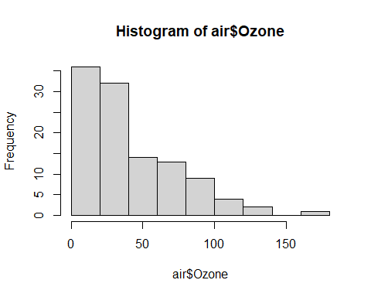

hist(air$Solar.R)

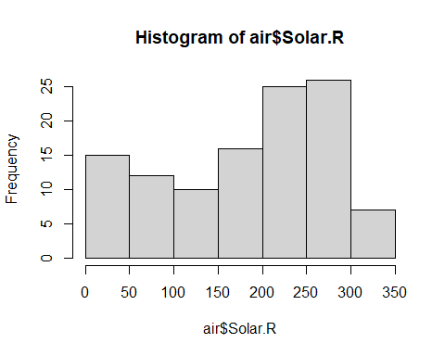

hist(air$Wind)

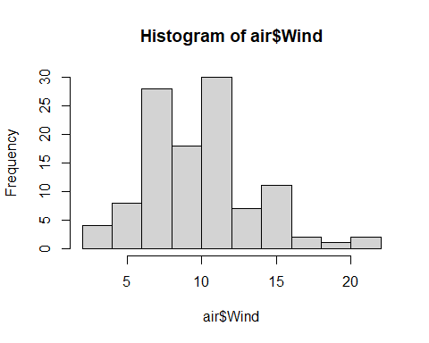

hist(air$Temp)

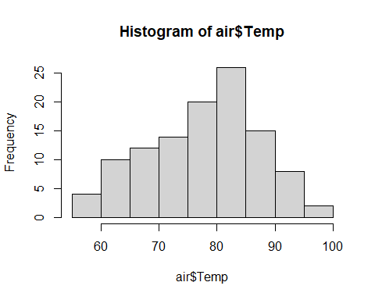

air$ScaleWind <- round(air$Wind)  
boxplot(ScaleWind~Ozone, data=air)

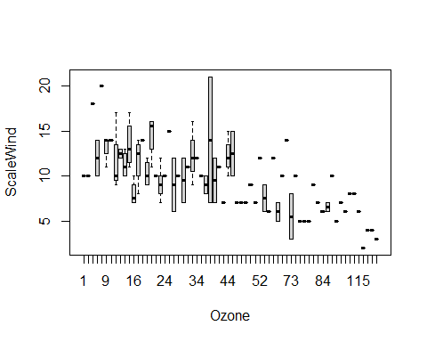

#Step 4  
air$Date <- as.Date(paste(1973,air$Month,air$Day, sep= "-"))  
ozoneGraph <- ggplot(data=air, aes(x=Date, y=Ozone)) +  
 geom_line(color="red")  
ozoneGraph

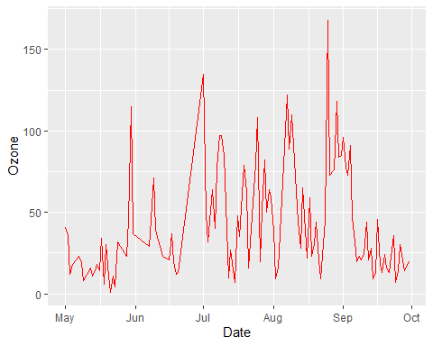

solarGraph <- ggplot(data=air, aes(x=Date, y=Solar.R)) +  
 geom_line(color="cyan")  
solarGraph

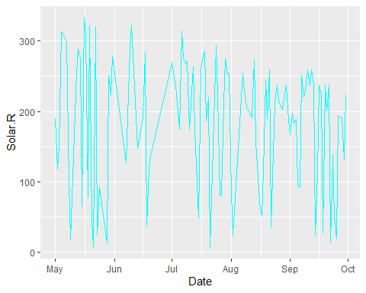

scaleWindGraph <- ggplot(data=air, aes(x=Date, y=ScaleWind)) +  
 geom_line(color="green")  
scaleWindGraph

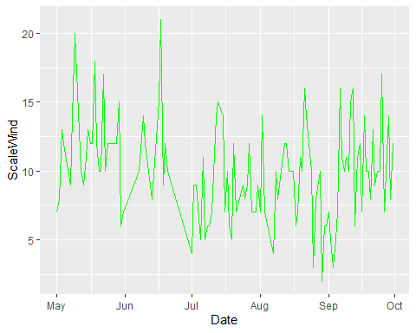

tempGraph <- ggplot(data=air, aes(x=Date, y=Temp)) +  
 geom_line(color="red")  
tempGraph

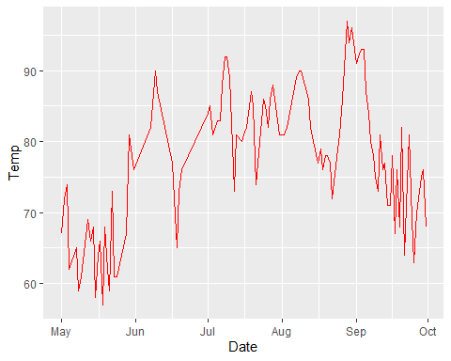

air$ScaleWind <- air$ScaleWind*10  
meltAir <- melt(air, value.name = "value", id = c("Month","Day","Date","Wind"))  
  
allGraph <- ggplot(data=meltAir, aes(x=Date, y=value, group=variable)) +  
 geom_line(aes(color=variable))  
allGraph

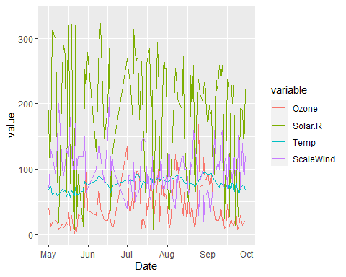

#Step 5  
meltAir

## Month Day Date Wind variable value  
## 1 5 1 1973-05-01 7.4 Ozone 41  
## 2 5 2 1973-05-02 8.0 Ozone 36  
## 3 5 3 1973-05-03 12.6 Ozone 12  
## 4 5 4 1973-05-04 11.5 Ozone 18  
## 5 5 7 1973-05-07 8.6 Ozone 23  
## 6 5 8 1973-05-08 13.8 Ozone 19  
## 7 5 9 1973-05-09 20.1 Ozone 8  
## 8 5 12 1973-05-12 9.7 Ozone 16  
## 9 5 13 1973-05-13 9.2 Ozone 11  
## 10 5 14 1973-05-14 10.9 Ozone 14  
## 11 5 15 1973-05-15 13.2 Ozone 18  
## 12 5 16 1973-05-16 11.5 Ozone 14  
## 13 5 17 1973-05-17 12.0 Ozone 34  
## 14 5 18 1973-05-18 18.4 Ozone 6  
## 15 5 19 1973-05-19 11.5 Ozone 30  
## 16 5 20 1973-05-20 9.7 Ozone 11  
## 17 5 21 1973-05-21 9.7 Ozone 1  
## 18 5 22 1973-05-22 16.6 Ozone 11  
## 19 5 23 1973-05-23 9.7 Ozone 4  
## 20 5 24 1973-05-24 12.0 Ozone 32  
## 21 5 28 1973-05-28 12.0 Ozone 23  
## 22 5 29 1973-05-29 14.9 Ozone 45  
## 23 5 30 1973-05-30 5.7 Ozone 115  
## 24 5 31 1973-05-31 7.4 Ozone 37  
## 25 6 7 1973-06-07 9.7 Ozone 29  
## 26 6 9 1973-06-09 13.8 Ozone 71  
## 27 6 10 1973-06-10 11.5 Ozone 39  
## 28 6 13 1973-06-13 8.0 Ozone 23  
## 29 6 16 1973-06-16 14.9 Ozone 21  
## 30 6 17 1973-06-17 20.7 Ozone 37  
## 31 6 18 1973-06-18 9.2 Ozone 20  
## 32 6 19 1973-06-19 11.5 Ozone 12  
## 33 6 20 1973-06-20 10.3 Ozone 13  
## 34 7 1 1973-07-01 4.1 Ozone 135  
## 35 7 2 1973-07-02 9.2 Ozone 49  
## 36 7 3 1973-07-03 9.2 Ozone 32  
## 37 7 5 1973-07-05 4.6 Ozone 64  
## 38 7 6 1973-07-06 10.9 Ozone 40  
## 39 7 7 1973-07-07 5.1 Ozone 77  
## 40 7 8 1973-07-08 6.3 Ozone 97  
## 41 7 9 1973-07-09 5.7 Ozone 97  
## 42 7 10 1973-07-10 7.4 Ozone 85  
## 43 7 12 1973-07-12 14.3 Ozone 10  
## 44 7 13 1973-07-13 14.9 Ozone 27  
## 45 7 15 1973-07-15 14.3 Ozone 7  
## 46 7 16 1973-07-16 6.9 Ozone 48  
## 47 7 17 1973-07-17 10.3 Ozone 35  
## 48 7 18 1973-07-18 6.3 Ozone 61  
## 49 7 19 1973-07-19 5.1 Ozone 79  
## 50 7 20 1973-07-20 11.5 Ozone 63  
## 51 7 21 1973-07-21 6.9 Ozone 16  
## 52 7 24 1973-07-24 8.6 Ozone 80  
## 53 7 25 1973-07-25 8.0 Ozone 108  
## 54 7 26 1973-07-26 8.6 Ozone 20  
## 55 7 27 1973-07-27 12.0 Ozone 52  
## 56 7 28 1973-07-28 7.4 Ozone 82  
## 57 7 29 1973-07-29 7.4 Ozone 50  
## 58 7 30 1973-07-30 7.4 Ozone 64  
## 59 7 31 1973-07-31 9.2 Ozone 59  
## 60 8 1 1973-08-01 6.9 Ozone 39  
## 61 8 2 1973-08-02 13.8 Ozone 9  
## 62 8 3 1973-08-03 7.4 Ozone 16  
## 63 8 7 1973-08-07 4.0 Ozone 122  
## 64 8 8 1973-08-08 10.3 Ozone 89  
## 65 8 9 1973-08-09 8.0 Ozone 110  
## 66 8 12 1973-08-12 11.5 Ozone 44  
## 67 8 13 1973-08-13 11.5 Ozone 28  
## 68 8 14 1973-08-14 9.7 Ozone 65  
## 69 8 16 1973-08-16 10.3 Ozone 22  
## 70 8 17 1973-08-17 6.3 Ozone 59  
## 71 8 18 1973-08-18 7.4 Ozone 23  
## 72 8 19 1973-08-19 10.9 Ozone 31  
## 73 8 20 1973-08-20 10.3 Ozone 44  
## 74 8 21 1973-08-21 15.5 Ozone 21  
## 75 8 22 1973-08-22 14.3 Ozone 9  
## 76 8 24 1973-08-24 9.7 Ozone 45  
## 77 8 25 1973-08-25 3.4 Ozone 168  
## 78 8 26 1973-08-26 8.0 Ozone 73  
## 79 8 28 1973-08-28 9.7 Ozone 76  
## 80 8 29 1973-08-29 2.3 Ozone 118  
## 81 8 30 1973-08-30 6.3 Ozone 84  
## 82 8 31 1973-08-31 6.3 Ozone 85  
## 83 9 1 1973-09-01 6.9 Ozone 96  
## 84 9 2 1973-09-02 5.1 Ozone 78  
## 85 9 3 1973-09-03 2.8 Ozone 73  
## 86 9 4 1973-09-04 4.6 Ozone 91  
## 87 9 5 1973-09-05 7.4 Ozone 47  
## 88 9 6 1973-09-06 15.5 Ozone 32  
## 89 9 7 1973-09-07 10.9 Ozone 20  
## 90 9 8 1973-09-08 10.3 Ozone 23  
## 91 9 9 1973-09-09 10.9 Ozone 21  
## 92 9 10 1973-09-10 9.7 Ozone 24  
## 93 9 11 1973-09-11 14.9 Ozone 44  
## 94 9 12 1973-09-12 15.5 Ozone 21  
## 95 9 13 1973-09-13 6.3 Ozone 28  
## 96 9 14 1973-09-14 10.9 Ozone 9  
## 97 9 15 1973-09-15 11.5 Ozone 13  
## 98 9 16 1973-09-16 6.9 Ozone 46  
## 99 9 17 1973-09-17 13.8 Ozone 18  
## 100 9 18 1973-09-18 10.3 Ozone 13  
## 101 9 19 1973-09-19 10.3 Ozone 24  
## 102 9 20 1973-09-20 8.0 Ozone 16  
## 103 9 21 1973-09-21 12.6 Ozone 13  
## 104 9 22 1973-09-22 9.2 Ozone 23  
## 105 9 23 1973-09-23 10.3 Ozone 36  
## 106 9 24 1973-09-24 10.3 Ozone 7  
## 107 9 25 1973-09-25 16.6 Ozone 14  
## 108 9 26 1973-09-26 6.9 Ozone 30  
## 109 9 28 1973-09-28 14.3 Ozone 14  
## 110 9 29 1973-09-29 8.0 Ozone 18  
## 111 9 30 1973-09-30 11.5 Ozone 20  
## 112 5 1 1973-05-01 7.4 Solar.R 190  
## 113 5 2 1973-05-02 8.0 Solar.R 118  
## 114 5 3 1973-05-03 12.6 Solar.R 149  
## 115 5 4 1973-05-04 11.5 Solar.R 313  
## 116 5 7 1973-05-07 8.6 Solar.R 299  
## 117 5 8 1973-05-08 13.8 Solar.R 99  
## 118 5 9 1973-05-09 20.1 Solar.R 19  
## 119 5 12 1973-05-12 9.7 Solar.R 256  
## 120 5 13 1973-05-13 9.2 Solar.R 290  
## 121 5 14 1973-05-14 10.9 Solar.R 274  
## 122 5 15 1973-05-15 13.2 Solar.R 65  
## 123 5 16 1973-05-16 11.5 Solar.R 334  
## 124 5 17 1973-05-17 12.0 Solar.R 307  
## 125 5 18 1973-05-18 18.4 Solar.R 78  
## 126 5 19 1973-05-19 11.5 Solar.R 322  
## 127 5 20 1973-05-20 9.7 Solar.R 44  
## 128 5 21 1973-05-21 9.7 Solar.R 8  
## 129 5 22 1973-05-22 16.6 Solar.R 320  
## 130 5 23 1973-05-23 9.7 Solar.R 25  
## 131 5 24 1973-05-24 12.0 Solar.R 92  
## 132 5 28 1973-05-28 12.0 Solar.R 13  
## 133 5 29 1973-05-29 14.9 Solar.R 252  
## 134 5 30 1973-05-30 5.7 Solar.R 223  
## 135 5 31 1973-05-31 7.4 Solar.R 279  
## 136 6 7 1973-06-07 9.7 Solar.R 127  
## 137 6 9 1973-06-09 13.8 Solar.R 291  
## 138 6 10 1973-06-10 11.5 Solar.R 323  
## 139 6 13 1973-06-13 8.0 Solar.R 148  
## 140 6 16 1973-06-16 14.9 Solar.R 191  
## 141 6 17 1973-06-17 20.7 Solar.R 284  
## 142 6 18 1973-06-18 9.2 Solar.R 37  
## 143 6 19 1973-06-19 11.5 Solar.R 120  
## 144 6 20 1973-06-20 10.3 Solar.R 137  
## 145 7 1 1973-07-01 4.1 Solar.R 269  
## 146 7 2 1973-07-02 9.2 Solar.R 248  
## 147 7 3 1973-07-03 9.2 Solar.R 236  
## 148 7 5 1973-07-05 4.6 Solar.R 175  
## 149 7 6 1973-07-06 10.9 Solar.R 314  
## 150 7 7 1973-07-07 5.1 Solar.R 276  
## 151 7 8 1973-07-08 6.3 Solar.R 267  
## 152 7 9 1973-07-09 5.7 Solar.R 272  
## 153 7 10 1973-07-10 7.4 Solar.R 175  
## 154 7 12 1973-07-12 14.3 Solar.R 264  
## 155 7 13 1973-07-13 14.9 Solar.R 175  
## 156 7 15 1973-07-15 14.3 Solar.R 48  
## 157 7 16 1973-07-16 6.9 Solar.R 260  
## 158 7 17 1973-07-17 10.3 Solar.R 274  
## 159 7 18 1973-07-18 6.3 Solar.R 285  
## 160 7 19 1973-07-19 5.1 Solar.R 187  
## 161 7 20 1973-07-20 11.5 Solar.R 220  
## 162 7 21 1973-07-21 6.9 Solar.R 7  
## 163 7 24 1973-07-24 8.6 Solar.R 294  
## 164 7 25 1973-07-25 8.0 Solar.R 223  
## 165 7 26 1973-07-26 8.6 Solar.R 81  
## 166 7 27 1973-07-27 12.0 Solar.R 82  
## 167 7 28 1973-07-28 7.4 Solar.R 213  
## 168 7 29 1973-07-29 7.4 Solar.R 275  
## 169 7 30 1973-07-30 7.4 Solar.R 253  
## 170 7 31 1973-07-31 9.2 Solar.R 254  
## 171 8 1 1973-08-01 6.9 Solar.R 83  
## 172 8 2 1973-08-02 13.8 Solar.R 24  
## 173 8 3 1973-08-03 7.4 Solar.R 77  
## 174 8 7 1973-08-07 4.0 Solar.R 255  
## 175 8 8 1973-08-08 10.3 Solar.R 229  
## 176 8 9 1973-08-09 8.0 Solar.R 207  
## 177 8 12 1973-08-12 11.5 Solar.R 192  
## 178 8 13 1973-08-13 11.5 Solar.R 273  
## 179 8 14 1973-08-14 9.7 Solar.R 157  
## 180 8 16 1973-08-16 10.3 Solar.R 71  
## 181 8 17 1973-08-17 6.3 Solar.R 51  
## 182 8 18 1973-08-18 7.4 Solar.R 115  
## 183 8 19 1973-08-19 10.9 Solar.R 244  
## 184 8 20 1973-08-20 10.3 Solar.R 190  
## 185 8 21 1973-08-21 15.5 Solar.R 259  
## 186 8 22 1973-08-22 14.3 Solar.R 36  
## 187 8 24 1973-08-24 9.7 Solar.R 212  
## 188 8 25 1973-08-25 3.4 Solar.R 238  
## 189 8 26 1973-08-26 8.0 Solar.R 215  
## 190 8 28 1973-08-28 9.7 Solar.R 203  
## 191 8 29 1973-08-29 2.3 Solar.R 225  
## 192 8 30 1973-08-30 6.3 Solar.R 237  
## 193 8 31 1973-08-31 6.3 Solar.R 188  
## 194 9 1 1973-09-01 6.9 Solar.R 167  
## 195 9 2 1973-09-02 5.1 Solar.R 197  
## 196 9 3 1973-09-03 2.8 Solar.R 183  
## 197 9 4 1973-09-04 4.6 Solar.R 189  
## 198 9 5 1973-09-05 7.4 Solar.R 95  
## 199 9 6 1973-09-06 15.5 Solar.R 92  
## 200 9 7 1973-09-07 10.9 Solar.R 252  
## 201 9 8 1973-09-08 10.3 Solar.R 220  
## 202 9 9 1973-09-09 10.9 Solar.R 230  
## 203 9 10 1973-09-10 9.7 Solar.R 259  
## 204 9 11 1973-09-11 14.9 Solar.R 236  
## 205 9 12 1973-09-12 15.5 Solar.R 259  
## 206 9 13 1973-09-13 6.3 Solar.R 238  
## 207 9 14 1973-09-14 10.9 Solar.R 24  
## 208 9 15 1973-09-15 11.5 Solar.R 112  
## 209 9 16 1973-09-16 6.9 Solar.R 237  
## 210 9 17 1973-09-17 13.8 Solar.R 224  
## 211 9 18 1973-09-18 10.3 Solar.R 27  
## 212 9 19 1973-09-19 10.3 Solar.R 238  
## 213 9 20 1973-09-20 8.0 Solar.R 201  
## 214 9 21 1973-09-21 12.6 Solar.R 238  
## 215 9 22 1973-09-22 9.2 Solar.R 14  
## 216 9 23 1973-09-23 10.3 Solar.R 139  
## 217 9 24 1973-09-24 10.3 Solar.R 49  
## 218 9 25 1973-09-25 16.6 Solar.R 20  
## 219 9 26 1973-09-26 6.9 Solar.R 193  
## 220 9 28 1973-09-28 14.3 Solar.R 191  
## 221 9 29 1973-09-29 8.0 Solar.R 131  
## 222 9 30 1973-09-30 11.5 Solar.R 223  
## 223 5 1 1973-05-01 7.4 Temp 67  
## 224 5 2 1973-05-02 8.0 Temp 72  
## 225 5 3 1973-05-03 12.6 Temp 74  
## 226 5 4 1973-05-04 11.5 Temp 62  
## 227 5 7 1973-05-07 8.6 Temp 65  
## 228 5 8 1973-05-08 13.8 Temp 59  
## 229 5 9 1973-05-09 20.1 Temp 61  
## 230 5 12 1973-05-12 9.7 Temp 69  
## 231 5 13 1973-05-13 9.2 Temp 66  
## 232 5 14 1973-05-14 10.9 Temp 68  
## 233 5 15 1973-05-15 13.2 Temp 58  
## 234 5 16 1973-05-16 11.5 Temp 64  
## 235 5 17 1973-05-17 12.0 Temp 66  
## 236 5 18 1973-05-18 18.4 Temp 57  
## 237 5 19 1973-05-19 11.5 Temp 68  
## 238 5 20 1973-05-20 9.7 Temp 62  
## 239 5 21 1973-05-21 9.7 Temp 59  
## 240 5 22 1973-05-22 16.6 Temp 73  
## 241 5 23 1973-05-23 9.7 Temp 61  
## 242 5 24 1973-05-24 12.0 Temp 61  
## 243 5 28 1973-05-28 12.0 Temp 67  
## 244 5 29 1973-05-29 14.9 Temp 81  
## 245 5 30 1973-05-30 5.7 Temp 79  
## 246 5 31 1973-05-31 7.4 Temp 76  
## 247 6 7 1973-06-07 9.7 Temp 82  
## 248 6 9 1973-06-09 13.8 Temp 90  
## 249 6 10 1973-06-10 11.5 Temp 87  
## 250 6 13 1973-06-13 8.0 Temp 82  
## 251 6 16 1973-06-16 14.9 Temp 77  
## 252 6 17 1973-06-17 20.7 Temp 72  
## 253 6 18 1973-06-18 9.2 Temp 65  
## 254 6 19 1973-06-19 11.5 Temp 73  
## 255 6 20 1973-06-20 10.3 Temp 76  
## 256 7 1 1973-07-01 4.1 Temp 84  
## 257 7 2 1973-07-02 9.2 Temp 85  
## 258 7 3 1973-07-03 9.2 Temp 81  
## 259 7 5 1973-07-05 4.6 Temp 83  
## 260 7 6 1973-07-06 10.9 Temp 83  
## 261 7 7 1973-07-07 5.1 Temp 88  
## 262 7 8 1973-07-08 6.3 Temp 92  
## 263 7 9 1973-07-09 5.7 Temp 92  
## 264 7 10 1973-07-10 7.4 Temp 89  
## 265 7 12 1973-07-12 14.3 Temp 73  
## 266 7 13 1973-07-13 14.9 Temp 81  
## 267 7 15 1973-07-15 14.3 Temp 80  
## 268 7 16 1973-07-16 6.9 Temp 81  
## 269 7 17 1973-07-17 10.3 Temp 82  
## 270 7 18 1973-07-18 6.3 Temp 84  
## 271 7 19 1973-07-19 5.1 Temp 87  
## 272 7 20 1973-07-20 11.5 Temp 85  
## 273 7 21 1973-07-21 6.9 Temp 74  
## 274 7 24 1973-07-24 8.6 Temp 86  
## 275 7 25 1973-07-25 8.0 Temp 85  
## 276 7 26 1973-07-26 8.6 Temp 82  
## 277 7 27 1973-07-27 12.0 Temp 86  
## 278 7 28 1973-07-28 7.4 Temp 88  
## 279 7 29 1973-07-29 7.4 Temp 86  
## 280 7 30 1973-07-30 7.4 Temp 83  
## 281 7 31 1973-07-31 9.2 Temp 81  
## 282 8 1 1973-08-01 6.9 Temp 81  
## 283 8 2 1973-08-02 13.8 Temp 81  
## 284 8 3 1973-08-03 7.4 Temp 82  
## 285 8 7 1973-08-07 4.0 Temp 89  
## 286 8 8 1973-08-08 10.3 Temp 90  
## 287 8 9 1973-08-09 8.0 Temp 90  
## 288 8 12 1973-08-12 11.5 Temp 86  
## 289 8 13 1973-08-13 11.5 Temp 82  
## 290 8 14 1973-08-14 9.7 Temp 80  
## 291 8 16 1973-08-16 10.3 Temp 77  
## 292 8 17 1973-08-17 6.3 Temp 79  
## 293 8 18 1973-08-18 7.4 Temp 76  
## 294 8 19 1973-08-19 10.9 Temp 78  
## 295 8 20 1973-08-20 10.3 Temp 78  
## 296 8 21 1973-08-21 15.5 Temp 77  
## 297 8 22 1973-08-22 14.3 Temp 72  
## 298 8 24 1973-08-24 9.7 Temp 79  
## 299 8 25 1973-08-25 3.4 Temp 81  
## 300 8 26 1973-08-26 8.0 Temp 86  
## 301 8 28 1973-08-28 9.7 Temp 97  
## 302 8 29 1973-08-29 2.3 Temp 94  
## 303 8 30 1973-08-30 6.3 Temp 96  
## 304 8 31 1973-08-31 6.3 Temp 94  
## 305 9 1 1973-09-01 6.9 Temp 91  
## 306 9 2 1973-09-02 5.1 Temp 92  
## 307 9 3 1973-09-03 2.8 Temp 93  
## 308 9 4 1973-09-04 4.6 Temp 93  
## 309 9 5 1973-09-05 7.4 Temp 87  
## 310 9 6 1973-09-06 15.5 Temp 84  
## 311 9 7 1973-09-07 10.9 Temp 80  
## 312 9 8 1973-09-08 10.3 Temp 78  
## 313 9 9 1973-09-09 10.9 Temp 75  
## 314 9 10 1973-09-10 9.7 Temp 73  
## 315 9 11 1973-09-11 14.9 Temp 81  
## 316 9 12 1973-09-12 15.5 Temp 76  
## 317 9 13 1973-09-13 6.3 Temp 77  
## 318 9 14 1973-09-14 10.9 Temp 71  
## 319 9 15 1973-09-15 11.5 Temp 71  
## 320 9 16 1973-09-16 6.9 Temp 78  
## 321 9 17 1973-09-17 13.8 Temp 67  
## 322 9 18 1973-09-18 10.3 Temp 76  
## 323 9 19 1973-09-19 10.3 Temp 68  
## 324 9 20 1973-09-20 8.0 Temp 82  
## 325 9 21 1973-09-21 12.6 Temp 64  
## 326 9 22 1973-09-22 9.2 Temp 71  
## 327 9 23 1973-09-23 10.3 Temp 81  
## 328 9 24 1973-09-24 10.3 Temp 69  
## 329 9 25 1973-09-25 16.6 Temp 63  
## 330 9 26 1973-09-26 6.9 Temp 70  
## 331 9 28 1973-09-28 14.3 Temp 75  
## 332 9 29 1973-09-29 8.0 Temp 76  
## 333 9 30 1973-09-30 11.5 Temp 68  
## 334 5 1 1973-05-01 7.4 ScaleWind 70  
## 335 5 2 1973-05-02 8.0 ScaleWind 80  
## 336 5 3 1973-05-03 12.6 ScaleWind 130  
## 337 5 4 1973-05-04 11.5 ScaleWind 120  
## 338 5 7 1973-05-07 8.6 ScaleWind 90  
## 339 5 8 1973-05-08 13.8 ScaleWind 140  
## 340 5 9 1973-05-09 20.1 ScaleWind 200  
## 341 5 12 1973-05-12 9.7 ScaleWind 100  
## 342 5 13 1973-05-13 9.2 ScaleWind 90  
## 343 5 14 1973-05-14 10.9 ScaleWind 110  
## 344 5 15 1973-05-15 13.2 ScaleWind 130  
## 345 5 16 1973-05-16 11.5 ScaleWind 120  
## 346 5 17 1973-05-17 12.0 ScaleWind 120  
## 347 5 18 1973-05-18 18.4 ScaleWind 180  
## 348 5 19 1973-05-19 11.5 ScaleWind 120  
## 349 5 20 1973-05-20 9.7 ScaleWind 100  
## 350 5 21 1973-05-21 9.7 ScaleWind 100  
## 351 5 22 1973-05-22 16.6 ScaleWind 170  
## 352 5 23 1973-05-23 9.7 ScaleWind 100  
## 353 5 24 1973-05-24 12.0 ScaleWind 120  
## 354 5 28 1973-05-28 12.0 ScaleWind 120  
## 355 5 29 1973-05-29 14.9 ScaleWind 150  
## 356 5 30 1973-05-30 5.7 ScaleWind 60  
## 357 5 31 1973-05-31 7.4 ScaleWind 70  
## 358 6 7 1973-06-07 9.7 ScaleWind 100  
## 359 6 9 1973-06-09 13.8 ScaleWind 140  
## 360 6 10 1973-06-10 11.5 ScaleWind 120  
## 361 6 13 1973-06-13 8.0 ScaleWind 80  
## 362 6 16 1973-06-16 14.9 ScaleWind 150  
## 363 6 17 1973-06-17 20.7 ScaleWind 210  
## 364 6 18 1973-06-18 9.2 ScaleWind 90  
## 365 6 19 1973-06-19 11.5 ScaleWind 120  
## 366 6 20 1973-06-20 10.3 ScaleWind 100  
## 367 7 1 1973-07-01 4.1 ScaleWind 40  
## 368 7 2 1973-07-02 9.2 ScaleWind 90  
## 369 7 3 1973-07-03 9.2 ScaleWind 90  
## 370 7 5 1973-07-05 4.6 ScaleWind 50  
## 371 7 6 1973-07-06 10.9 ScaleWind 110  
## 372 7 7 1973-07-07 5.1 ScaleWind 50  
## 373 7 8 1973-07-08 6.3 ScaleWind 60  
## 374 7 9 1973-07-09 5.7 ScaleWind 60  
## 375 7 10 1973-07-10 7.4 ScaleWind 70  
## 376 7 12 1973-07-12 14.3 ScaleWind 140  
## 377 7 13 1973-07-13 14.9 ScaleWind 150  
## 378 7 15 1973-07-15 14.3 ScaleWind 140  
## 379 7 16 1973-07-16 6.9 ScaleWind 70  
## 380 7 17 1973-07-17 10.3 ScaleWind 100  
## 381 7 18 1973-07-18 6.3 ScaleWind 60  
## 382 7 19 1973-07-19 5.1 ScaleWind 50  
## 383 7 20 1973-07-20 11.5 ScaleWind 120  
## 384 7 21 1973-07-21 6.9 ScaleWind 70  
## 385 7 24 1973-07-24 8.6 ScaleWind 90  
## 386 7 25 1973-07-25 8.0 ScaleWind 80  
## 387 7 26 1973-07-26 8.6 ScaleWind 90  
## 388 7 27 1973-07-27 12.0 ScaleWind 120  
## 389 7 28 1973-07-28 7.4 ScaleWind 70  
## 390 7 29 1973-07-29 7.4 ScaleWind 70  
## 391 7 30 1973-07-30 7.4 ScaleWind 70  
## 392 7 31 1973-07-31 9.2 ScaleWind 90  
## 393 8 1 1973-08-01 6.9 ScaleWind 70  
## 394 8 2 1973-08-02 13.8 ScaleWind 140  
## 395 8 3 1973-08-03 7.4 ScaleWind 70  
## 396 8 7 1973-08-07 4.0 ScaleWind 40  
## 397 8 8 1973-08-08 10.3 ScaleWind 100  
## 398 8 9 1973-08-09 8.0 ScaleWind 80  
## 399 8 12 1973-08-12 11.5 ScaleWind 120  
## 400 8 13 1973-08-13 11.5 ScaleWind 120  
## 401 8 14 1973-08-14 9.7 ScaleWind 100  
## 402 8 16 1973-08-16 10.3 ScaleWind 100  
## 403 8 17 1973-08-17 6.3 ScaleWind 60  
## 404 8 18 1973-08-18 7.4 ScaleWind 70  
## 405 8 19 1973-08-19 10.9 ScaleWind 110  
## 406 8 20 1973-08-20 10.3 ScaleWind 100  
## 407 8 21 1973-08-21 15.5 ScaleWind 160  
## 408 8 22 1973-08-22 14.3 ScaleWind 140  
## 409 8 24 1973-08-24 9.7 ScaleWind 100  
## 410 8 25 1973-08-25 3.4 ScaleWind 30  
## 411 8 26 1973-08-26 8.0 ScaleWind 80  
## 412 8 28 1973-08-28 9.7 ScaleWind 100  
## 413 8 29 1973-08-29 2.3 ScaleWind 20  
## 414 8 30 1973-08-30 6.3 ScaleWind 60  
## 415 8 31 1973-08-31 6.3 ScaleWind 60  
## 416 9 1 1973-09-01 6.9 ScaleWind 70  
## 417 9 2 1973-09-02 5.1 ScaleWind 50  
## 418 9 3 1973-09-03 2.8 ScaleWind 30  
## 419 9 4 1973-09-04 4.6 ScaleWind 50  
## 420 9 5 1973-09-05 7.4 ScaleWind 70  
## 421 9 6 1973-09-06 15.5 ScaleWind 160  
## 422 9 7 1973-09-07 10.9 ScaleWind 110  
## 423 9 8 1973-09-08 10.3 ScaleWind 100  
## 424 9 9 1973-09-09 10.9 ScaleWind 110  
## 425 9 10 1973-09-10 9.7 ScaleWind 100  
## 426 9 11 1973-09-11 14.9 ScaleWind 150  
## 427 9 12 1973-09-12 15.5 ScaleWind 160  
## 428 9 13 1973-09-13 6.3 ScaleWind 60  
## 429 9 14 1973-09-14 10.9 ScaleWind 110  
## 430 9 15 1973-09-15 11.5 ScaleWind 120  
## 431 9 16 1973-09-16 6.9 ScaleWind 70  
## 432 9 17 1973-09-17 13.8 ScaleWind 140  
## 433 9 18 1973-09-18 10.3 ScaleWind 100  
## 434 9 19 1973-09-19 10.3 ScaleWind 100  
## 435 9 20 1973-09-20 8.0 ScaleWind 80  
## 436 9 21 1973-09-21 12.6 ScaleWind 130  
## 437 9 22 1973-09-22 9.2 ScaleWind 90  
## 438 9 23 1973-09-23 10.3 ScaleWind 100  
## 439 9 24 1973-09-24 10.3 ScaleWind 100  
## 440 9 25 1973-09-25 16.6 ScaleWind 170  
## 441 9 26 1973-09-26 6.9 ScaleWind 70  
## 442 9 28 1973-09-28 14.3 ScaleWind 140  
## 443 9 29 1973-09-29 8.0 ScaleWind 80  
## 444 9 30 1973-09-30 11.5 ScaleWind 120

heatmap <- ggplot(meltAir, aes(x=Date, y=variable)) + geom_tile(aes(fill=value), colour = "white") +  
 scale_fill_gradient(low = "white", high = "blue")  
heatmap

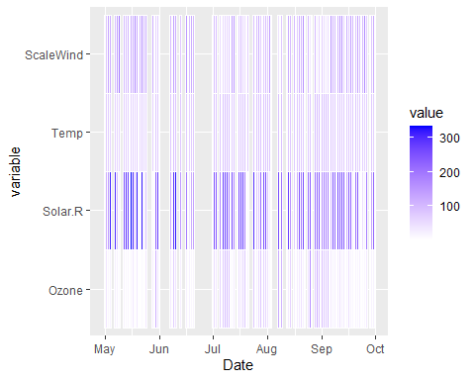

#Step 6  
plot(air$Wind,air$Temp,pch=16,col = air$Solar.R,cex=air$Ozone/50)

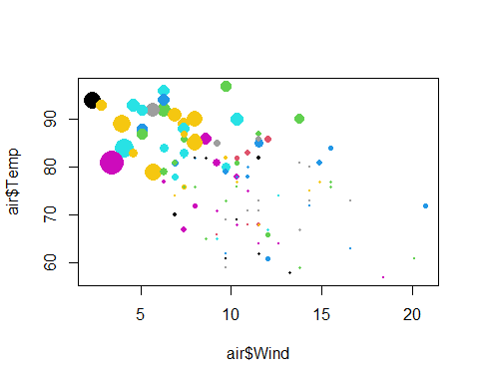

#Step 7  
#Do you see any patterns after exploring the data?  
#Wind, Ozone, and Solar.R spike and dip at around the same times.  
#What was the most useful visualization?  
#The colored line graph was the easiest to follow, the scatterplot was the worst. I'm likely to blame for the scatterplot being so hard to read though.