**项目描述：**Project Description

In this project, students will have the opportunity to propose and develop their own project related to the theme of wildfire. The goal is to encourage students to apply their knowledge obtained from this course to a relevant and meaningful problem in the context of wild fire. In this group project assignment, you and your team member will embark on a creative and meaningful journey to develop an application that reflects the knowledge and skills you have acquired in this course. This project serves as a culmination of your learning experience, aiming to apply what you've learned to solve real-world problems through application development and teamwork. Students are encouraged to explore various aspects of wildfire, such as wildfire detection and monitoring, resource allocation, evacuation planning, data logging and real-time analysis, simulation and forecasting, emergency communication systems, or any other related area of interest. Through this project, students will have the flexibility to showcase their creativity, critical thinking, and technical skills while addressing important challenges in the wildfire problem.

Project Groups

To facilitate collaboration and ensure that every student has an opportunity to work with a team member, group formation will follow the following guidelines:

Two-Person Groups: Students are encouraged to form their own groups consisting of two individuals who share a common interest or preference in the project topic. These groups should be formed voluntarily.

Remaining Students: If there is an odd number of students or if an individual is unable to find a partner, they will be assigned to a group by the faculty. The faculty will make reasonable efforts to create groups that align with students' interests and skills.

Faculty-Assigned Groups: In cases that students are unable to find a partner or request faculty assistance, the faculty can assign groups to ensure that every student is part of a team.

Expected Skills Gained

- Critical and creative thinking

- Developing a user-friendly interface

- Collaborative coding

- Real-world application

- Problem solving

Grading Criteria: Your project will be assessed according to the following criteria

1. Code (20%)

Code Quality: Code should be well-structured, readable, and include comments that explain the design and implementation. Store the code on a GitHub repository.

2. Report (70%)

Description of the project (5%): Provide a description of the project with the project's objectives clearly.

Significance of the Project (5%): Provide background information and explain why the project is meaningful and novel.

Installation and Usage Instructions (5%): Provide clear instructions for installing and using the code.

Code Structure (5%): Present a systematic flow-chart of the code's structure and explanations for easy understanding.

Functionalities and Test Results (15%): List functionalities, describe their functionality briefly, and provide testing results for verification.

Showcasing the Achievement of Project Goals (10%): Provide execution results and discuss how your project achieves the project goals.

Discussion and Conclusions (10%): Address project issues, limitations, and how your course learning was applied.

Overall Quality of Report and Project (15%): Assess the degree of project development, editing, and quality of writing.

3. GitHub (10%)

Ensure all project components are on the GitHub repository.

Set the GitHub repository to public initially.

Submission

Your project submission should include a GitHub repository link containing all the required deliverables for evaluation.

Each student needs to submit their project on Canvas individually even though they submit the same link.

**火情监测系统：**

### **网站名称： **FireWatchPro****

建议：

1、一个地图，进入一个地点，地点可以点击，跳转到**智能监测API** 对应的页面。如果检测到着火，地图页面 弹出红色警告，如果浓烟，黄色警告。无情况就绿色。

-- API也要由一个单独页面。

-- “一个地图，进入一个地点，地点可以点击，跳转到**智能监测API** 对应的页面。”这个操作最好是每个地点都实现数据隔离。

1. 火情情况操作指引

当火情监测系统发出火情警告时，应按照以下规范操作流程进行应对：

### 一、确认火情

1. **查看报警信息**：立即查看火情监测系统发出的报警信息，确认报警位置、时间以及报警类型。

2. **初步判断**：通过监控系统调取报警区域的实时画面，初步判断是否为误报或真实火情。

3. **现场核实**：安排专人携带灭火器等设备前往报警点进行现场核实，确认是否存在火情。

### 二、分级应急响应

- **若为误报**：

- 复位监测系统，并记录误报原因（如设备故障、环境干扰等）。

- 通知维保单位对故障设备进行检修。

- **若为真实火情**：

1. **启动应急预案**：立即启动应急预案，按下系统“联动启动”按钮，激活喷淋、排烟、应急广播等系统。

2. **拨打火警电话**：拨打119报警，详细说明起火位置、火势大小及人员受困情况。

3. **疏散人员**：通过广播或其他方式引导人员疏散，确保人员安全撤离。

4. **现场处置**：如果火势较小，现场人员可使用灭火器等设备进行初期灭火；若火势较大，应立即撤离并等待专业消防队伍处理。

### 三、后续处理

1. **记录与反馈**：将火情处理过程详细记录在案，包括报警时间、核实情况、处置措施等，形成台账。

3. **分析原因**：对误报或真实火情的原因进行深入分析，采取措施防止类似情况再次发生。

**智能监测API：**

**Github地址：https://github.com/num3num/fire-detect-project/tree/main**

输入：监测文件（图片/视频）路径、文件输出路径

输出:

# 返回 警告，着火了,并伴有浓烟

return "Warning,fire is detected,and there is smoke"

# 警告，有浓烟，可能发生火灾

return "Warning,smoke is detected,may cause fire"

# 警告，着火了

return "Warning,fire is detected"

# 无事发生

return ""

**智能监测前端界面:**

**Github地址：**

**登录界面**

**账号:admin 密码:admin**

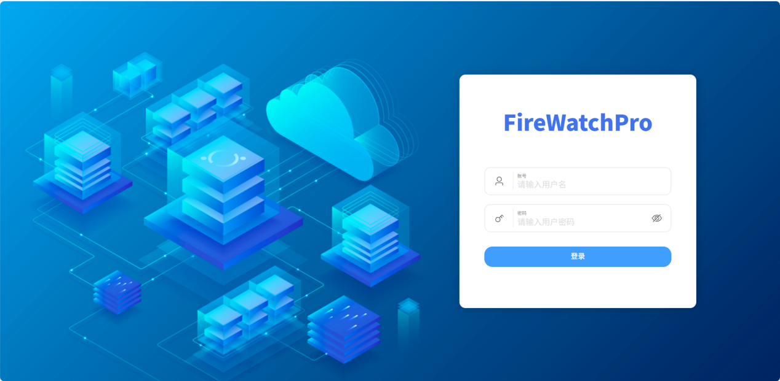

图片路径输入：监测文件（图片/视频）路径(必填)

输出路径输入:文件输出路径(必填)

点击发送,输出:

# 返回 警告，着火了,并伴有浓烟

return "Warning,fire is detected,and there is smoke"

# 警告，有浓烟，可能发生火灾

return "Warning,smoke is detected,may cause fire"

# 警告，着火了

return "Warning,fire is detected"

# 无事发生

return ""

