**Renoir v.0.9.2**

**An OMDB API CLIENT**

1. **About.**

Renoir is a movie management software for windows 7/10.

It scans the folder you indicate for movies and display a list of them, you can then use the web based API OMDB to retrieve the movies information and manage your movies.

Using some filters you can easily find a movie for every day!

1. **Enhancement & bug-fixes**

|  |  |
| --- | --- |
| V.0.9.2 | ADDED : search panel. |
| V.0.9.1 | ADDED : Open file location.  ADDED : Search in combo  FIXED : Context Menu |
| V.0.9.0 | ADDED : search bar  ADDED : Config Manager |

1. **Technology**

Renoir is an open source software for windows written in c++.

It uses a front end from MCF Visual Studio 2015, developed in just three months using the free testing trial mode of VS2015.

It has been successfully tested in windows 7 and 10.

It uses a SQLITE database to store the information, generate a log and cache the movies posters in the folder: %appdata%\Renoir :

%appdata%\Renoir\db\moviesDB.sqlite

%appdata%\Renoir\log\*.log

%appdata%\Renoir\cache\*.jpg

1. **At start, Renoir will ask to select a folder to scan:**

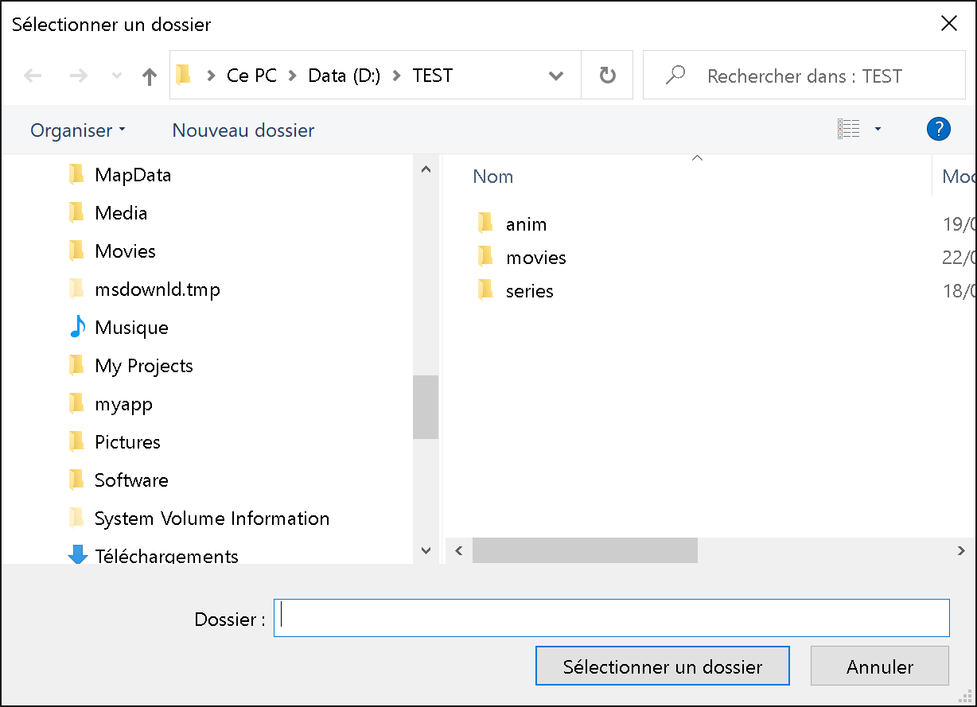

You can access again this function in the menu to add folder to the database.

Then it will ask for your OMDB API KEY.

OMDB offers a web based API to retrieve movies information. You will need to get a free registered key in order to use the API :

[**https://www.omdbapi.com/apikey.aspx**](https://www.omdbapi.com/apikey.aspx)

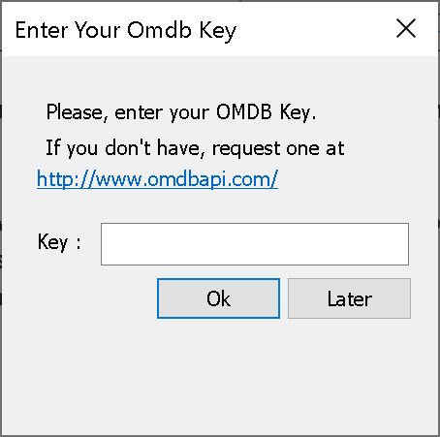

You can access this windows from the menu to enter or modify your key.

The main window will look like this:

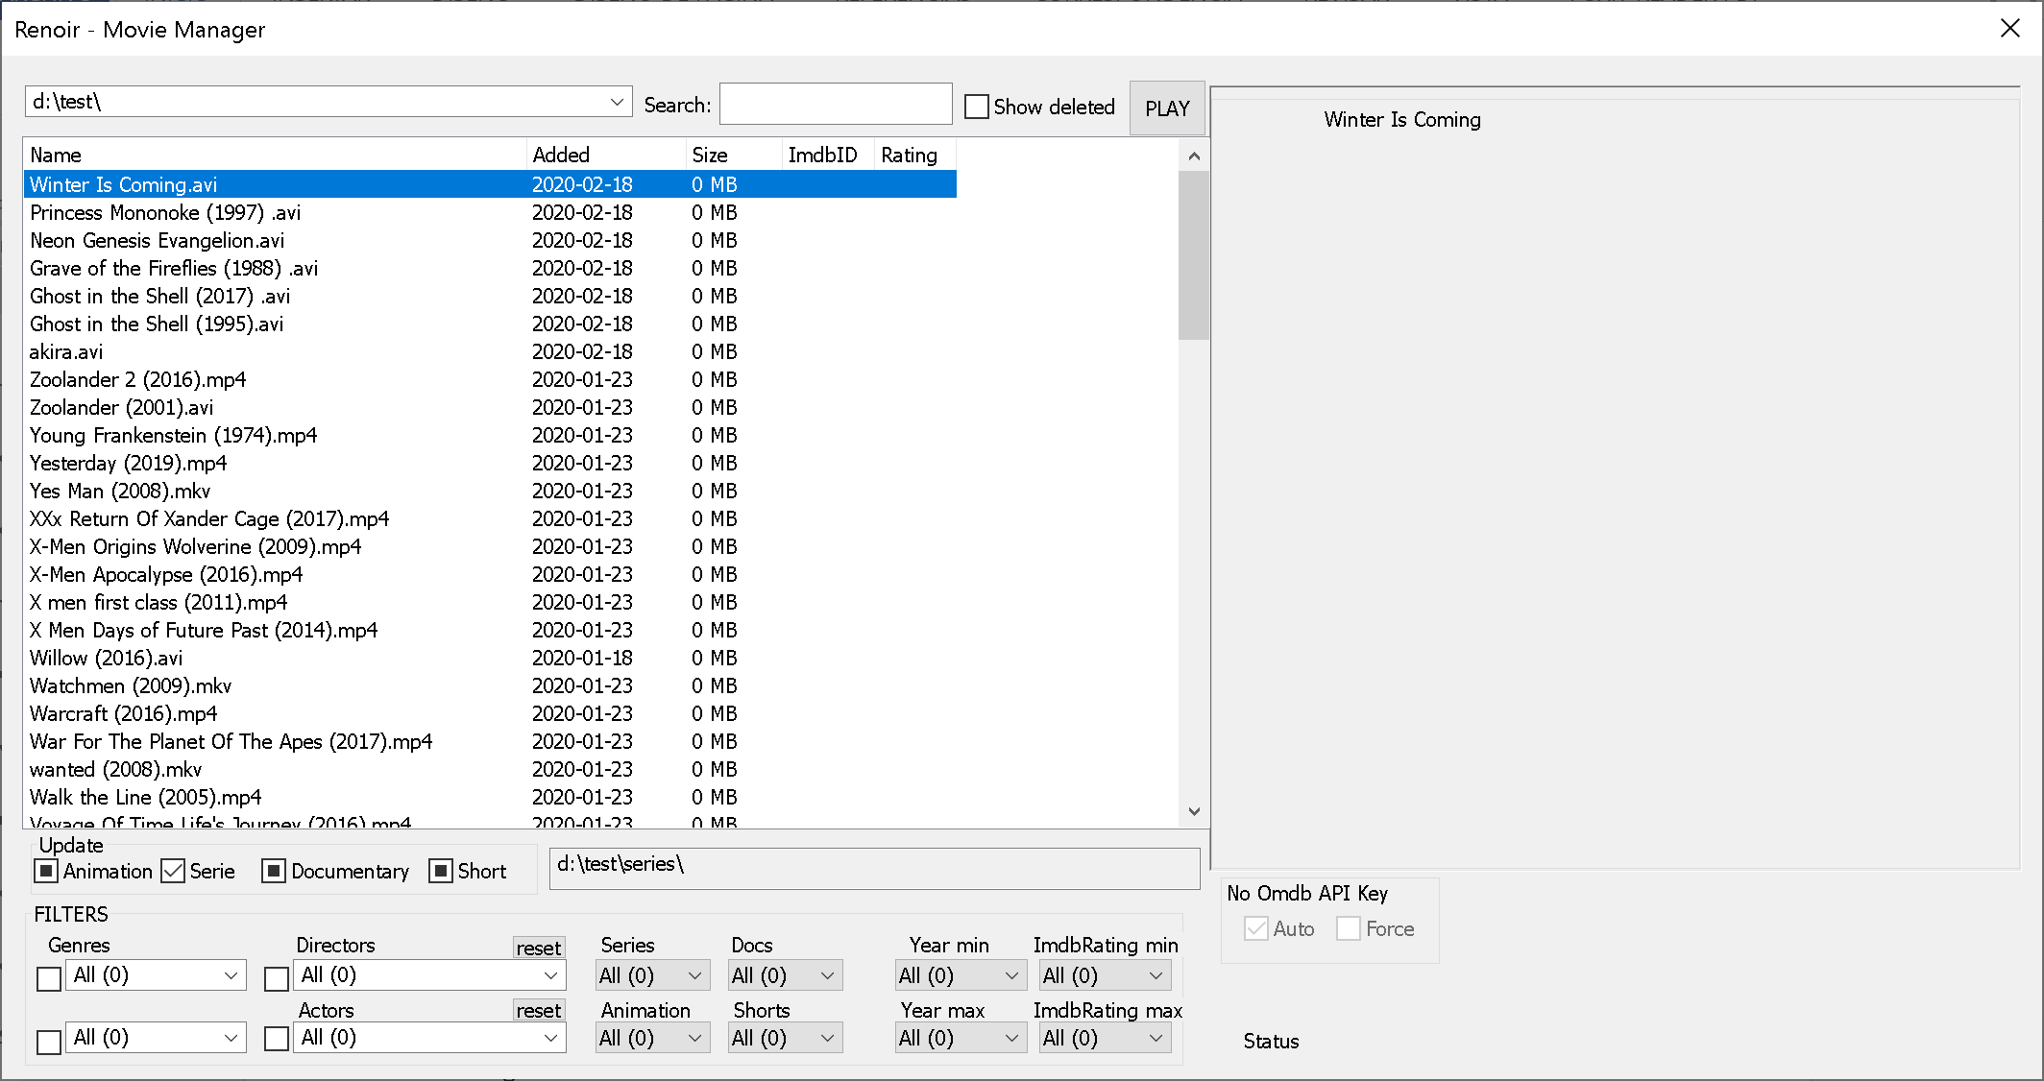

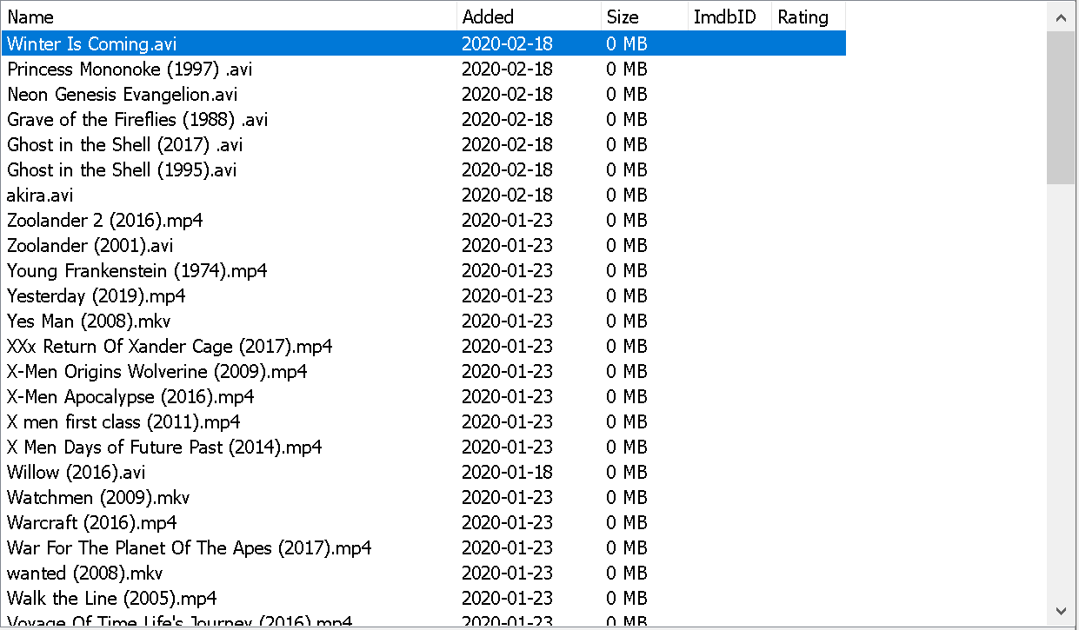The app will automatically scan a folder which has not been scan before but you can manually scan from the menu (needed if you add or remove files).

This windows has three main areas:

* The movies list
* The filters section :



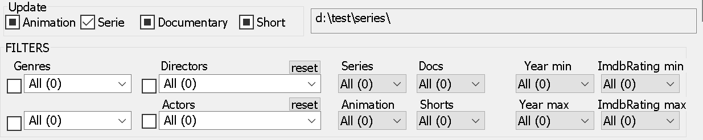

* The movies detailed information in the right panel, now it’s empty, we’ll see later how to get the information.

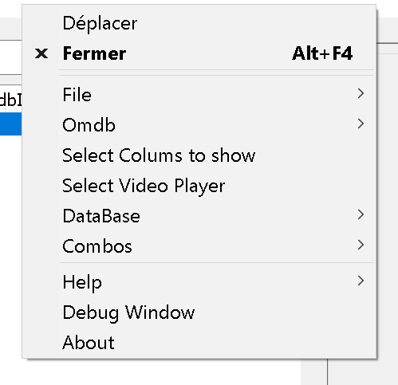Right-click on the TOP bar to access the menu

**[Select columns to show]**

enables you to choose which columns

are displayed in the list.

**[Select Video Player]** let you choose the video

player to use (it has only been tested with VLC

but may work for every popular players)

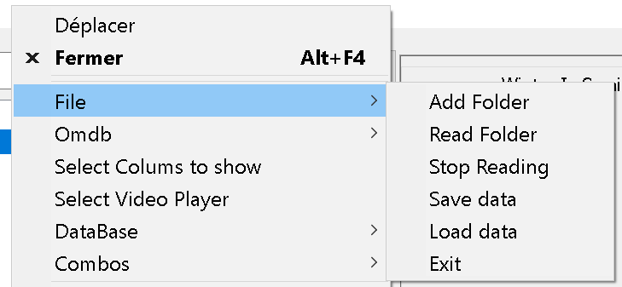

In the file submenu you can

* Add a folder to the database.
* Scan and stop the scanning of the current forlder.
* Save/Load the data from the database to/from a file.
* 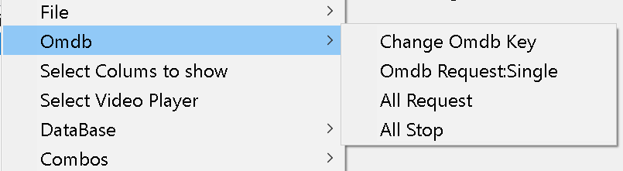Exit the application

From this menu you can:

* Enter or modify the OMDB Key.
* Request information for the selected entry from the list
* Request information for all the movies from your folders (and stop it).

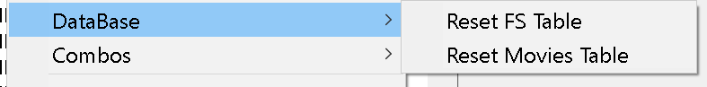

Here you can delete the data from DB

* FS table contains the list scanned from your HD
* Movies table contains data downloaded from OMDB or loaded from a file.

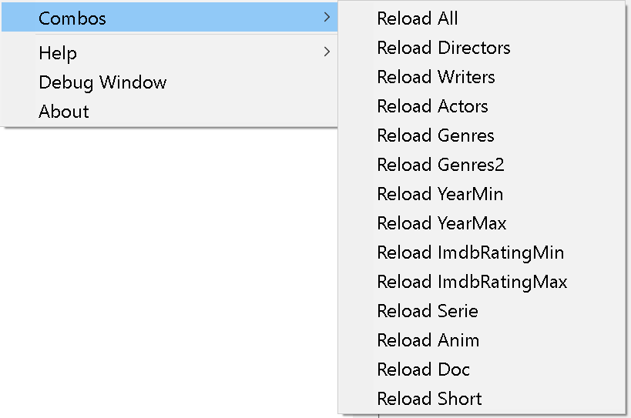

This has a debug purpose, you can reload the lists from the filters.

1. **OMDB Request.**

You can then search for the file data from the WEB BASED OMDB API (You need an internet connection and a valid Key).

If no key has been entered you may see the section as on the right picture, select [Change OMBD Key] from the menu to enter a valid key, provided by OMDB at https://www.omdbapi.com/apikey.aspx.

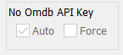 

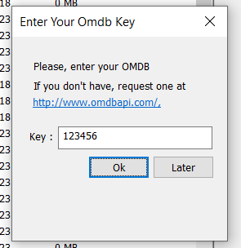

Once you have entered a valid key, the app will make a request for each selected file if the [auto] checkbox is on.

The OMBD request is made by guessing the movie title and the movie year (if found) from the file name. Strange files naming will drive to no data found, represented by “?” in the [ImdbId] column.

If a match is made, the column [ImdbId] will host the unique identifier.

The IMDB ID is a unique movie identification provided by the API, in this application it is used to make the match between a file and a movie, if you edit this field and misspell it you may lose the match.

If the [Force] check box is enable, the request will be also made for a previously unmatched file, identified by a “?” in the [imdbId] column.

You can manually edit this identifier, if so, the [Force] checkbox will make the request for these files too.

If you want to launch a request for every file you can access this funcionnality from the menu :

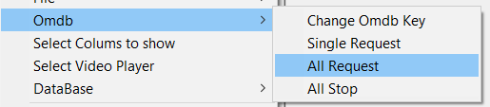

Once downloaded, the information will appear on the right side of the form:

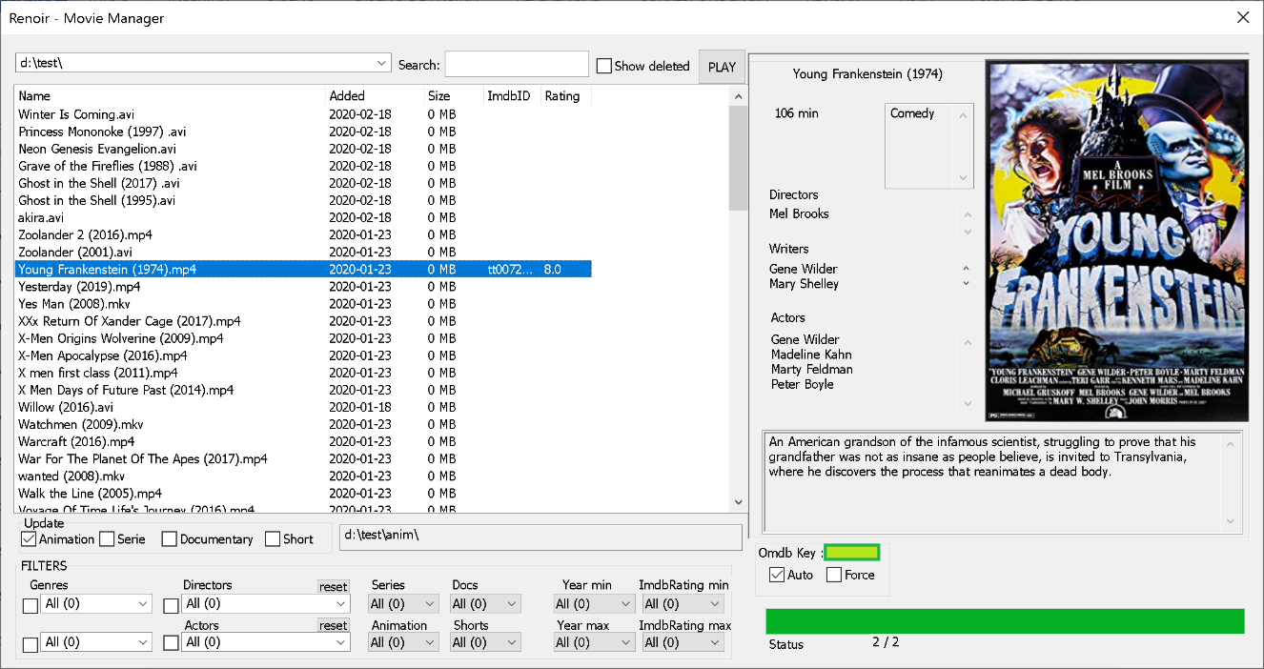

1. **Updating data.**

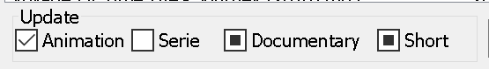

Here, you can specifies if the file corresponds to a Serie (TV show), if it’s an animated movie, a Documentary or a Short.

Indicate that the selected file is not of a specified type



Indicate the status is unknown



indicate that the selected file is of a specified type



Right click on the file open the contextual menu:

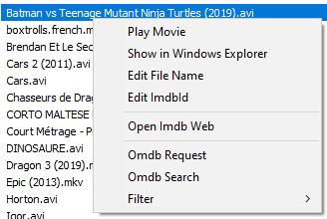

Here you can:

* Play the movie.
* View the file in Windows Explorer.
* Edit the file name (the app will provide a name suggestion).
* Edit the ImdbId to match the correct one if the application didn’t find it.
* Open the Imdb Web site, if the imdbId is filled, the movie page will be shown if not, the app will help you finding the movie.
* open a request to the OMDB API
* Open a search request with the OMDB API
* Filter the list with the data from this movie (Actors and Directors)

1. **OMDB API – Search request.**

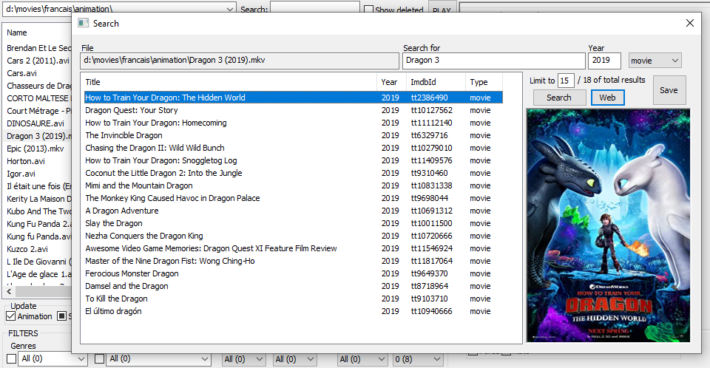When the API can’t find the movie requested, the app will open the search panel.

From this window, you can edit the search, changing the title, the year of release and the type of movie (movie, serie, episode), the request a list of matching movies.

The results are limited in order to avoid long waiting times but you can change the limit (0 indicates no limit).

If you can’t find the movie, you can open a web browser search at imdb.com, the OMDB API seems to provide info only for titles written in English…

If you find the movie, just hit “SAVE” and the movie will be update in the main interface.

1. **Saving the data to a file and loading from file.**

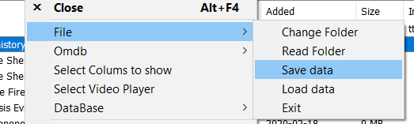

The OMDB API limits to 1.000 request per day, this seems a lot but it may be useful to save the downloaded data to a file from which you can load the data to the application.

This may also be useful if you want to use this application in different folders maintaining the downloaded information from the movies, or you can even share the file between friends.

The data will not contain the files from your hard drive, only the movies information, so you need to scan for files if you start from scratch.

1. **Filtering.**

On top of the list you have this area :



In the left, the drop down edit box, allow you select the folder you want to displays the files from. Knowing that it will display the files of the subfolders too.

In the right edit box, you can filter the entering the name of the file you’re looking for.

Is the app detect that a previously detected file is not present anymore, it won’t show it, you can show these files selecting [Show deleted].

The [PLAY] button launch the multimedia player for the selected file.

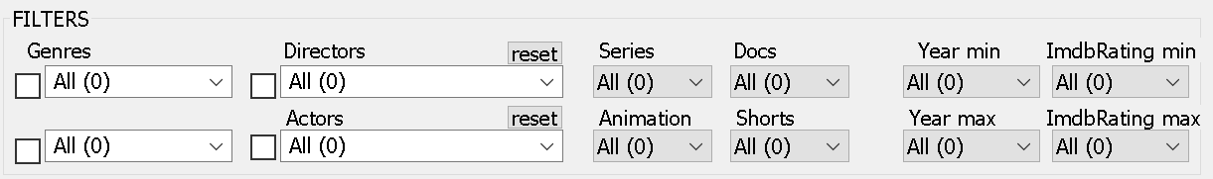

By now, the application only allow to use theses filters, and obviously, it only works for the files whom data has been downloaded.

In the white filter you can selected a field or type down a name to search for it.

The filtering is kept in the database and will be maintained when the app closes.

1. 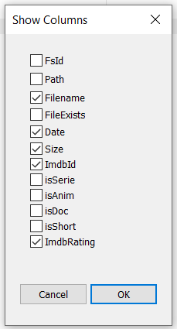**Column Selector**