**AIM: Controlling Raspberry Pi with Telegram**

**Requirements:**

* **Hardware Requirements:**

1. **Resistors**
2. **LEDs**
3. **Jumper Wires**
4. **Breadboard**

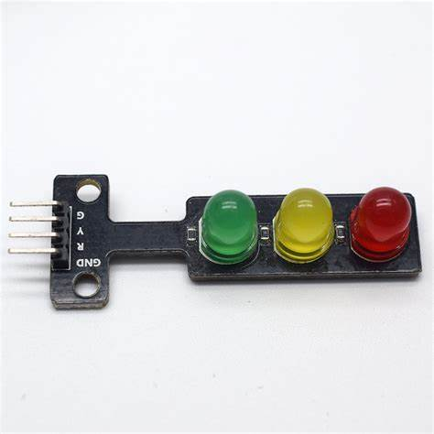

* **Software Requirements:**

1. **Raspbian Strech OS**
2. **Telegram App**

**Steps:**

1. **Connect LEDs to GPIO pins.**

Use jumper wires to connect the anode (long leg) of each LED to different GPIO pins on the Raspberry Pi.

* For example,

**connect**:

* LED 1 to GPIO Pin 17
* LED 2 to GPIO Pin 27
* LED 3 to GPIO Pin 22

2. **Connect GND pin of raspberry Pi to GROUND of LED Module.**

Connect a ground (GND) pin from the Raspberry Pi to the ground rail on the breadboard.

3. **Configure Telegram App & connect it with Rasberry Pi.**

Follow the below steps to configure Telegram with Rasberry Pi.

3. Write Code in **Thonny IDLE**.

**Code:**

import random

import datetime

import time

import telepot

import RPi.GPIO as GPIO

from telepot.loop import MessageLoop

red=31

now= datetime.datetime.now()

GPIO.setmode(GPIO.BOARD)

GPIO.setwarnings(False)

GPIO.setup(red,GPIO.OUT)

GPIO.output(red,0)

def action(msg):

chat_id=msg['chat']['id']

command=msg['text']

print ('Got command:%s'%command)

if 'On' in command:

message= "Turn On"

message=message+"red"

GPIO.output(red,1)

bot.sendMessage(chat_id,"Command received");

if 'Off' in command:

message= "Turn Off"

message=message+"red"

GPIO.output(red,0)

bot.sendMessage(chat_id,"Command received");

bot= telepot.Bot('7504375765:AAEdMmGiN7H1ns9v5V7I0ifrQeskmGEskBQ')

print(bot.getMe())

MessageLoop(bot, action).run_as_thread()

print('I am listening...')

while 1:

time.sleep(10)

**Steps to configure Telegram App:**

Step 1: Download the **TELEGRAM** app

Step 2: Go to the search bar and type **BotFather**

Step 3: Open the BothFather’s chat & type **/start**

Step 4: Then click on **/newbot**

Step 5: Enter username: **TYIT2024_bot** (the username must end with bot)

Step 6: Now we will get an access token

Step 7: Now connect the LED pins & write the code

Step 8: After writing the code, go to the terminal and type the below commands:

**sudo apt-get update**

**sudo apt-get install python3-pip**

**sudo pip install telepot**

**python3 telegram.py (to run the program.)**

***Note:*** *python telegram.py (here telegram.py is the name of our python code file)*

*[the last command will give you the bot details]*

Step 9: Open Telegram and search for the username

Step 10: Click on the username and pass a command **/start**

Step 11: Write **‘On’** or **‘Off’**

**OUTPUT :**

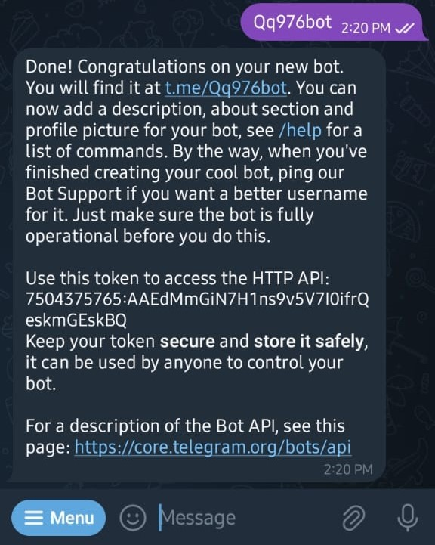 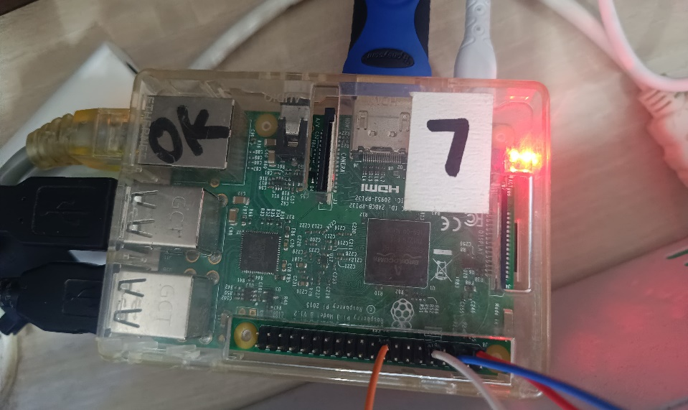

**OUTPUT:**

**Command Prompt :**

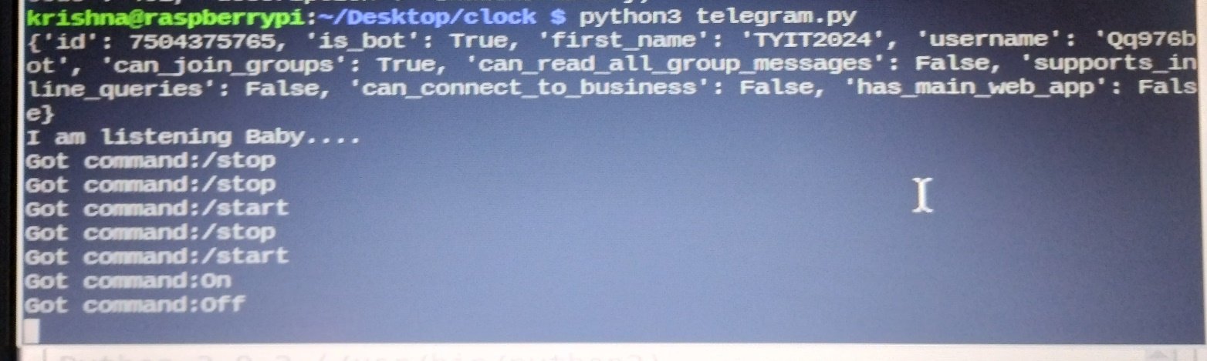

**Development Board:**

