Accident Reporting System Synopsis
Updated on: 2026-03-14

1. Project Title
Accident Reporting System

2. Student Details
Student Name:
UUCMS No: __________

3. Introduction to the Company
The Accident Reporting System is a digital platform designed to allow users to report accidents online, facilitating quick response from authorities and insurance companies.

4. Organizational Study
Nature of Business: Online accident reporting and management platform.
Departments: Management, Technical Team, Customer Support, Emergency Services, Legal.
Infrastructure: Computers, internet servers, emergency contacts, database systems.

5. Problem Identification
Traditional accident reporting involves manual processes, phone calls, or in-person visits, leading to delays and inefficiencies.

6. Disadvantages of Current System
Manual and time-consuming process, lack of real time tracking, Inefficient Communication, Data Inconsistency and Loss, High Response Times, Scalability Issues, Lack of Analytics and Insights, Cost Inefficiency.

7. Advantages of Proposed System
Real-Time Reporting and Tracking, Faster Response Times, Improved Coordination and Communication, Digital Records for Accuracy and Accessibility, Enhanced Accessibility, Data Analytics and Insights , Cost Efficiency, Integration Capabilities.

8. Project Modules
User Registration Module, Login Module, Accident Report Module, Admin Panel, Emergency Contact Module.

Project Objective
The objective of this project is to provide a role-based digital platform to report road accidents quickly, capture accurate incident details, and coordinate emergency response teams in less time. The system improves communication between citizens, police, ambulance services, hospitals, and administrators through a centralized workflow.

Scope of Project
- Citizen module for registering, logging in, and reporting accidents with location and evidence.
- Accident reporting with details such as severity, injuries, weather, road condition, and vehicles involved.
- Image upload support for accident evidence.
- Automatic dispatch notifications to nearby police, ambulance, and hospital users based on distance.
- Responder module for accepting or rejecting dispatch alerts.
- Admin module for analytics, accident monitoring, and user management (view, add, update users).
- Data persistence with SQLite and REST APIs through FastAPI backend.

Features of System
- Role-based authentication: citizen, admin, police, emergency_responder, hospital.
- JWT-based login sessions and protected API routes.
- Multi-step accident reporting form with location capture and accident-between options.
- Support for party-wise vehicle type and vehicle number entry.
- Evidence image upload and static file serving.
- Nearby responder discovery using Haversine distance (configured radius: 50 km).
- Dispatch lifecycle: pending, accepted, rejected, auto_declined.
- Citizen dashboard with report history and dispatch status.
- Responder dashboard with pending alerts and response history.
- Admin dashboard with analytics and full user management tab.

Limitation of System
- Uses SQLite, which is suitable for small to medium workloads but not ideal for very high concurrent traffic.
- No migration framework is currently implemented; schema updates may require database recreation.
- Notifications are currently in-app dispatch notifications; external SMS or email delivery is not implemented.
- No dedicated mobile app yet; system is web-based.
- No offline report submission capability in low-network environments.
- JWT secret key and security settings need hardening for production deployment.

Security Features
- Password hashing using bcrypt via Passlib.
- JWT token-based authentication for API access.
- Role-based access checks (admin-only and responder-only flows).
- Verification gate for emergency personnel accounts.
- Unique email validation during registration and user creation.
- Pydantic request validation to reduce malformed input.
- CORS configuration allowing only configured frontend origins.

Database Tables (Very Important)

Table: users
Stores all application users including citizens, admins, and responders.
Column | Data Type | Constraint / Description
id | INTEGER | Primary Key
name | STRING | Not Null
email | STRING | Unique, Not Null
password | STRING | Hashed password, Not Null
phone | STRING | Nullable
role | STRING | Default citizen
organization | STRING | Nullable
badge_number | STRING | Nullable
latitude | FLOAT | Nullable
longitude | FLOAT | Nullable
is_verified | BOOLEAN | Default false
created_at | DATETIME | Default current UTC time

Table: accidents
Stores reported accident details and incident status.
Column | Data Type | Constraint / Description
id | INTEGER | Primary Key
reporter_id | INTEGER | Foreign Key -> users.id
location | STRING | Not Null
latitude | FLOAT | Not Null
longitude | FLOAT | Not Null
description | TEXT | Not Null
severity | STRING | Default minor
status | STRING | Default reported
vehicle_type | STRING | Nullable
accident_between | STRING | Nullable
party_a_type | STRING | Nullable
party_a_vehicle_number | STRING | Nullable
party_b_type | STRING | Nullable
party_b_vehicle_number | STRING | Nullable
injuries | STRING | Default none
weather_conditions | STRING | Nullable
road_conditions | STRING | Nullable
images | TEXT | JSON array of filenames
emergency_contact_name | STRING | Nullable
emergency_contact_phone | STRING | Nullable
reported_at | DATETIME | Default current UTC time
acknowledged_at | DATETIME | Nullable
resolved_at | DATETIME | Nullable

Table: notifications
Stores dispatch notifications sent to responders.
Column | Data Type | Constraint / Description
id | INTEGER | Primary Key
user_id | INTEGER | Foreign Key -> users.id
accident_id | INTEGER | Foreign Key -> accidents.id
title | STRING | Not Null
message | TEXT | Not Null
type | STRING | Responder type
status | STRING | Default pending
response_message | TEXT | Nullable
distance_km | FLOAT | Nullable
is_read | BOOLEAN | Default false
created_at | DATETIME | Default current UTC time
responded_at | DATETIME | Nullable

Table: emergency_responses
Tracks formal emergency response records linked to accidents and responders.
Column | Data Type | Constraint / Description
id | INTEGER | Primary Key
accident_id | INTEGER | Foreign Key -> accidents.id
responder_id | INTEGER | Foreign Key -> users.id
response_type | STRING | Nullable
status | STRING | Default dispatched
eta_minutes | INTEGER | Nullable
notes | TEXT | Nullable
dispatched_at | DATETIME | Default current UTC time
arrived_at | DATETIME | Nullable
completed_at | DATETIME | Nullable

Table: reports
Stores administrative reports generated from accidents.
Column | Data Type | Constraint / Description
id | INTEGER | Primary Key
accident_id | INTEGER | Foreign Key -> accidents.id
admin_id | INTEGER | Foreign Key -> users.id
details | TEXT | Nullable
action_taken | TEXT | Nullable
created_at | DATETIME | Default current UTC time

Table: emergency_contacts
Stores emergency contact directory entries.
Column | Data Type | Constraint / Description
id | INTEGER | Primary Key
name | STRING | Not Null
phone | STRING | Not Null
email | STRING | Nullable
type | STRING | Default police

Data Flow Diagram (DFD)

DFD Level 0 (Context Diagram)
- External Entity: Citizen -> submits accident report -> Accident Reporting System
- Accident Reporting System -> dispatch alerts -> Police / Ambulance / Hospital
- Responder -> accept or reject dispatch -> Accident Reporting System
- Admin -> views analytics and manages users -> Accident Reporting System
- Accident Reporting System <-> SQLite Database (users, accidents, notifications, reports)

DFD Level 1 (Major Processes)
- P1 Authentication Process: register/login and token generation.
- P2 Accident Reporting Process: collect incident details, store accident record, upload images.
- P3 Dispatch Engine Process: calculate nearby responders and create notifications.
- P4 Response Management Process: responders accept/reject and system auto-declines others.
- P5 Admin Management Process: view analytics, list users, create users, update users.
Textual DFD Representation:
Citizen -> [P2 Report Accident] -> D2 Accidents -> [P3 Dispatch Engine] -> D3 Notifications -> Responders
Responders -> [P4 Respond to Dispatch] -> D3 Notifications + D2 Accidents
Admin -> [P5 Admin Module] <-> D1 Users, D2 Accidents, D4 Reports

Entity Relationship Diagram (ERD)
Key Entities: users, accidents, notifications, emergency_responses, reports, emergency_contacts
- users (1) -> (N) accidents [users.id = accidents.reporter_id]
- users (1) -> (N) notifications [users.id = notifications.user_id]
- accidents (1) -> (N) notifications [accidents.id = notifications.accident_id]
- users (1) -> (N) emergency_responses [users.id = emergency_responses.responder_id]
- accidents (1) -> (N) emergency_responses [accidents.id = emergency_responses.accident_id]
- users (1) -> (N) reports [users.id = reports.admin_id]
- accidents (1) -> (N) reports [accidents.id = reports.accident_id]
Textual ERD Representation:
[USERS] 1-----N [ACCIDENTS]
[USERS] 1-----N [NOTIFICATIONS] N-----1 [ACCIDENTS]
[USERS] 1-----N [EMERGENCY_RESPONSES] N-----1 [ACCIDENTS]
[USERS(Admin)] 1-----N [REPORTS] N-----1 [ACCIDENTS]

Conclusion
The Accident Reporting System provides a complete workflow from incident reporting to emergency dispatch and administrative control. Its role-based architecture and structured database design make it suitable as an academic major project and a practical foundation for future smart-city emergency response enhancements.

DFD and ERD Visual Diagrams

Data Flow Diagram (DFD) - Visual
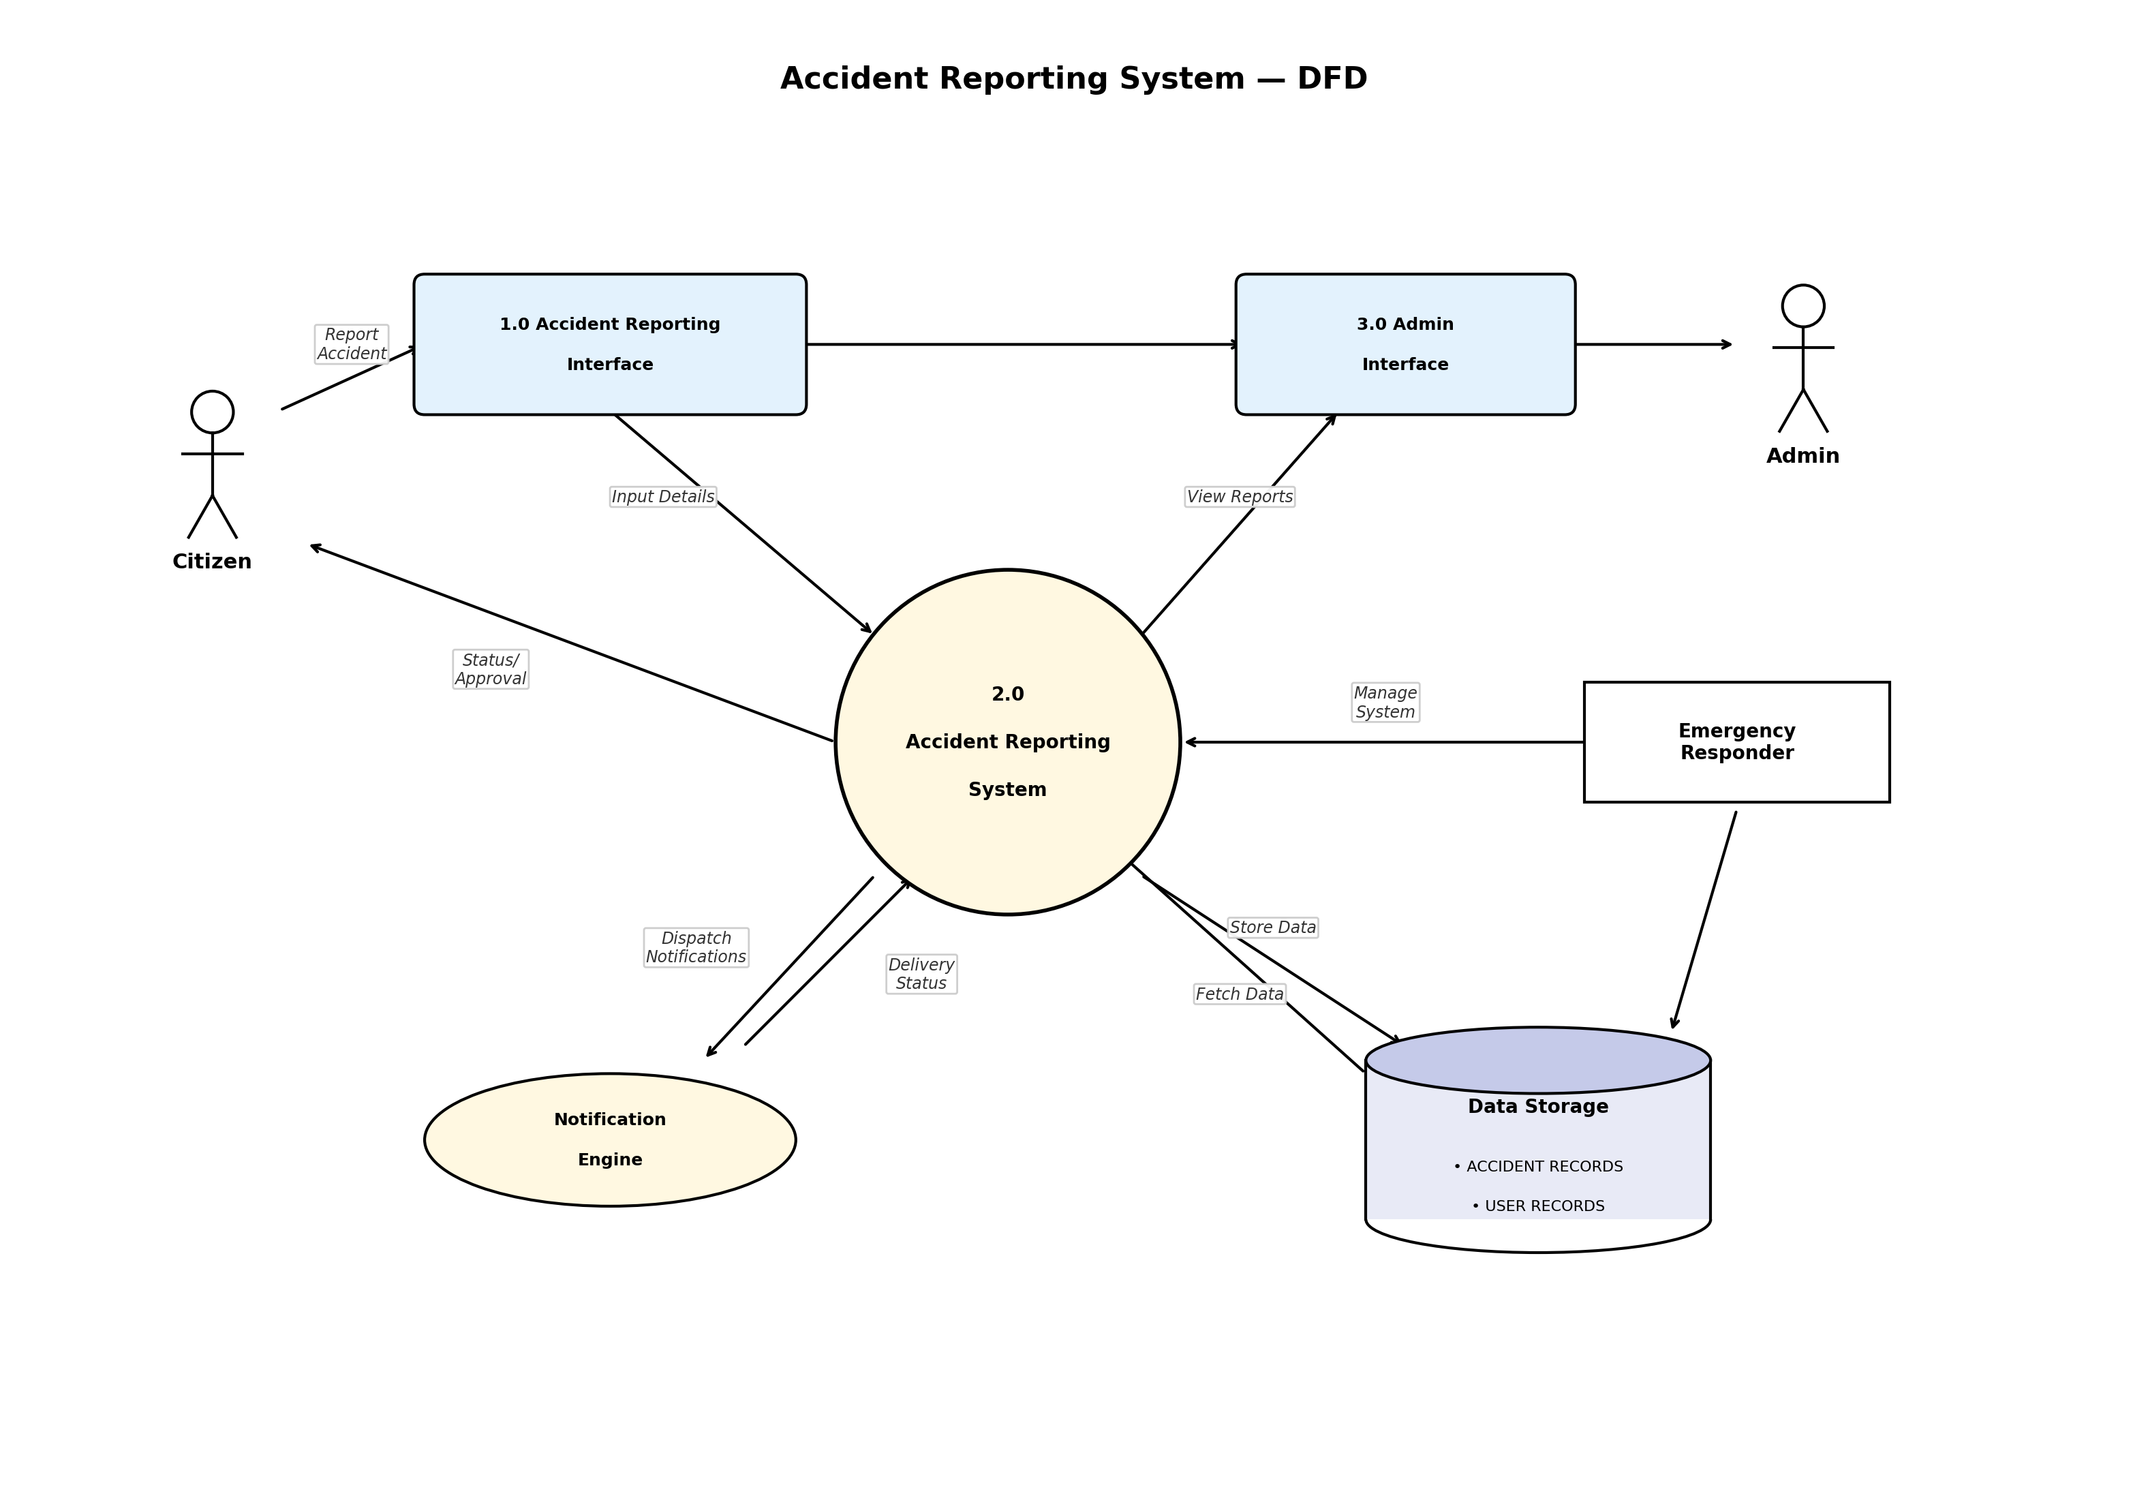

Entity Relationship Diagram (ERD) - Visual
