Smart Clinic Management System Synopsis
Updated on: 2026-03-14

1. Project Title
Smart Clinic Management System

2. Student Details
Student Name:
UUCMS No: __________

3. Introduction to the Company
The Smart Clinic Management System is a digital healthcare platform designed to manage OPD workflows through three secure logins: user (patient), hospital, and admin. It connects hospital discovery, doctor scheduling, appointment booking, consultation records, billing, and report delivery in one centralized system.

4. Organizational Study
Nature of Business: Digital outpatient clinic management and patient service platform.
Departments: Administration, Hospital Operations, Doctor Management, Billing, Technical Support, Security and Compliance.
Infrastructure: Web server, relational database, cloud file storage, notification gateway, secured APIs, and audit logging stack.

5. Problem Identification
Manual clinic operations make it difficult for patients to find suitable hospitals and doctors by locality and condition. Appointment slot conflicts, delayed documentation, and low transparency in billing and reporting reduce efficiency and trust.

6. Disadvantages of Current System
- Manual registration and appointment booking consume time.
- Patients cannot easily filter doctors by locality and medical condition.
- Frequent slot overlap due to non-centralized scheduling.
- Prescriptions, bills, and reports are often delayed or scattered.
- No unified operational monitoring for administrators.

7. Advantages of Proposed System
- Three-role secure login with role-based workflows.
- Condition-to-specialty mapping to suggest relevant doctors.
- Real-time slot visibility for date and time selection.
- Digital prescription, bill, and report download after visit.
- Hospital-side doctor management, billing, and report upload.
- Admin oversight with centralized user and operations control.

8. Project Modules
- User Registration and Authentication Module
- Hospital Discovery and Locality Filter Module
- Condition Mapping and Doctor Recommendation Module
- Appointment and Slot Management Module
- Prescription, Billing, and Report Management Module
- Admin Monitoring and User Control Module

Project Objective
The objective of this project is to provide a role-based smart clinic platform where patients can register, find hospitals by locality, select medical condition, book doctors by specialty and available slots, and download visit documents. Hospitals can manage doctors, generate bills, and upload reports, while admins can monitor all operations and modify users as needed.

Scope of Project
- Patient registration, login, profile management, and locality selection.
- Hospital listing and specialty-wise doctor discovery.
- Appointment booking using date-wise and time-slot-wise availability.
- Hospital management of doctors, schedules, consultation outputs, billing, and reports.
- Admin management of users, hospitals, and platform monitoring.
- Document download center for prescriptions, bills, and reports.

Features of System
- User Login: register, choose locality, enter condition, select doctor, and book slots.
- Hospital Login: maintain doctor records, publish slot calendars, generate bills, upload reports.
- Admin Login: monitor all workflows, add/modify/deactivate users and hospitals.
- Appointment lifecycle tracking: booked, confirmed, completed, cancelled.
- Centralized records and notifications for booking and document updates.

Limitation of System
- System depends on internet and digital literacy of users.
- Specialty suggestion quality depends on condition mapping accuracy.
- External lab and insurance integrations are not part of base version.
- Hospitals must update schedules regularly to avoid stale slots.

Security Features
- Role-Based Access Control (RBAC) for patient, hospital, and admin.
- Password hashing and secure authentication tokens.
- TLS-based transport security for all requests.
- File upload validation for reports and prescriptions.
- Audit logging of login, booking, billing, and admin actions.
- Rate limiting, account lockout, and input validation against attacks.

Database Tables (Very Important)

Table: accounts
Column | Data Type | Constraint / Description
account_id | BIGINT | Primary Key
role | ENUM | PATIENT/HOSPITAL/ADMIN
email | VARCHAR(150) | Unique, Not Null
phone | VARCHAR(20) | Unique, Not Null
password_hash | VARCHAR(255) | Hashed password
is_active | BOOLEAN | Default true
created_at | TIMESTAMP | Creation time
updated_at | TIMESTAMP | Last update time

Table: patient_profiles
Column | Data Type | Constraint / Description
patient_id | BIGINT | Primary Key, Foreign Key -> accounts.account_id
full_name | VARCHAR(120) | Not Null
dob | DATE | Nullable
gender | VARCHAR(20) | Nullable
locality_id | BIGINT | Foreign Key -> localities.locality_id
address_line | VARCHAR(255) | Nullable
emergency_contact | VARCHAR(20) | Nullable

Table: hospital_profiles
Column | Data Type | Constraint / Description
hospital_id | BIGINT | Primary Key, Foreign Key -> accounts.account_id
hospital_name | VARCHAR(180) | Not Null
registration_no | VARCHAR(80) | Unique
locality_id | BIGINT | Foreign Key -> localities.locality_id
contact_phone | VARCHAR(20) | Not Null
onboarding_status | ENUM | PENDING/APPROVED/REJECTED

Table: doctors
Column | Data Type | Constraint / Description
doctor_id | BIGINT | Primary Key
hospital_id | BIGINT | Foreign Key -> hospital_profiles.hospital_id
specialty_id | BIGINT | Foreign Key -> specialties.specialty_id
full_name | VARCHAR(120) | Not Null
experience_years | INT | Default 0
consultation_fee | DECIMAL(10,2) | Not Null
is_active | BOOLEAN | Default true

Table: doctor_slots
Column | Data Type | Constraint / Description
slot_id | BIGINT | Primary Key
doctor_id | BIGINT | Foreign Key -> doctors.doctor_id
slot_date | DATE | Not Null
start_time | TIME | Not Null
end_time | TIME | Not Null
slot_status | ENUM | AVAILABLE/BOOKED/BLOCKED/COMPLETED

Table: appointments
Column | Data Type | Constraint / Description
appointment_id | BIGINT | Primary Key
patient_id | BIGINT | Foreign Key -> patient_profiles.patient_id
hospital_id | BIGINT | Foreign Key -> hospital_profiles.hospital_id
doctor_id | BIGINT | Foreign Key -> doctors.doctor_id
slot_id | BIGINT | Foreign Key -> doctor_slots.slot_id
condition_id | BIGINT | Foreign Key -> medical_conditions.condition_id
appointment_status | ENUM | BOOKED/CONFIRMED/COMPLETED/CANCELLED/NO_SHOW

Table: prescriptions
Column | Data Type | Constraint / Description
prescription_id | BIGINT | Primary Key
appointment_id | BIGINT | Foreign Key -> appointments.appointment_id
doctor_id | BIGINT | Foreign Key -> doctors.doctor_id
diagnosis | TEXT | Not Null
advice | TEXT | Nullable
file_url | VARCHAR(255) | Download path
issued_at | TIMESTAMP | Default current timestamp

Table: bills
Column | Data Type | Constraint / Description
bill_id | BIGINT | Primary Key
appointment_id | BIGINT | Foreign Key -> appointments.appointment_id
patient_id | BIGINT | Foreign Key -> patient_profiles.patient_id
hospital_id | BIGINT | Foreign Key -> hospital_profiles.hospital_id
total_amount | DECIMAL(12,2) | Not Null
payment_status | ENUM | UNPAID/PARTIAL/PAID
generated_at | TIMESTAMP | Default current timestamp

Table: reports
Column | Data Type | Constraint / Description
report_id | BIGINT | Primary Key
appointment_id | BIGINT | Foreign Key -> appointments.appointment_id
patient_id | BIGINT | Foreign Key -> patient_profiles.patient_id
hospital_id | BIGINT | Foreign Key -> hospital_profiles.hospital_id
report_type | VARCHAR(80) | Lab/Scan/Other
file_url | VARCHAR(255) | Stored file path
uploaded_at | TIMESTAMP | Default current timestamp

Table: audit_logs
Column | Data Type | Constraint / Description
log_id | BIGINT | Primary Key
actor_account_id | BIGINT | Foreign Key -> accounts.account_id
action | VARCHAR(120) | Not Null
entity_name | VARCHAR(80) | Not Null
entity_id | BIGINT | Nullable
ip_address | VARCHAR(45) | Nullable
created_at | TIMESTAMP | Default current timestamp

Data Flow Diagram (DFD)

DFD Level 0 (Context Diagram)
- Patient sends registration, condition details, and appointment requests to SCMS.
- Hospital sends doctor schedules, prescriptions, bills, and reports to SCMS.
- Admin sends monitoring and user management commands to SCMS.
- SCMS returns booking confirmations, visit documents, and operational analytics.

DFD Level 1 (Major Processes)
- Process 1: Registration and Authentication.
- Process 2: Hospital discovery and doctor recommendation by specialty.
- Process 3: Appointment and slot management.
- Process 4: Prescription, bill generation, and report upload.
- Process 5: Admin monitoring, approvals, and audit control.

Entity Relationship Diagram (ERD)
Core entities: accounts, patient_profiles, hospital_profiles, doctors, doctor_slots, appointments, prescriptions, bills, reports, and audit_logs.
- One hospital has many doctors.
- One doctor has many slots.
- One patient books many appointments.
- One appointment can produce one or more prescriptions, bills, and reports.
- All critical actions are linked to accounts via audit logs.

Conclusion
The Smart Clinic Management System provides a complete and scalable model for digital outpatient care operations with patient convenience, hospital efficiency, and admin governance through a secure centralized architecture.

DFD and ERD Visual Diagrams

Data Flow Diagram (DFD) - Visual

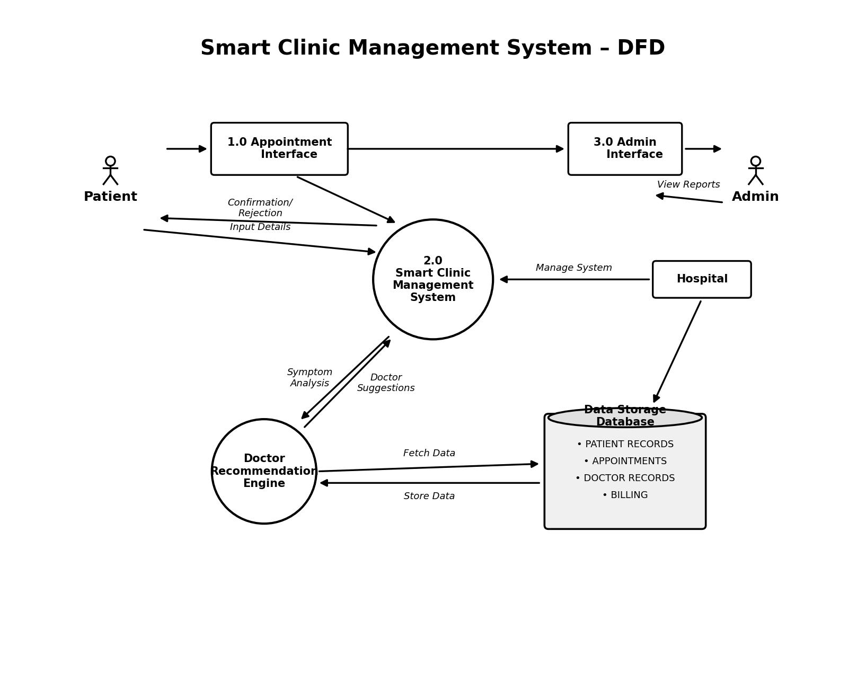

Entity Relationship Diagram (ERD) - Visual

