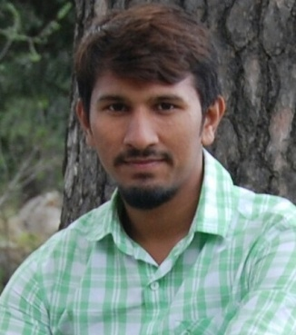

**ZIAB KHALID**

**Personal Information:**

**Father Name : Khalid Mehmood**

**Date of Birth : 19-04-1994**

**Religion : Islam**

**Nationality : Pakistani**

**Domicile : Muzaffargarh (Punjab)**

**Marital Status : Single**

**N.I.C : 32304-8041715-3**

**Mailing Address:** Ward No.4 House no. 82/83 Muhalla Dograan Khan Garrh Tehsil o Dist Muzaffargarh.

**Contact:**

Cell # +923075339890 & +923470439995

**Ambitions:h**

**Seeking a challenging position in a progressive organization with an aim to contribute positively toward its objectives to the best of my capabilities and to develop and improve my skills.to excel in dynamic and esteemed organization, where I can fully utilize my skills and services under a competitive and professional environment.**

**Qualification:**

|  |  |  |  |
| --- | --- | --- | --- |
| **M.Sc Chemistry (Specialization in Inorg/Analytical)** | **Quaid-i-Azam University Islamabad** | 2017/3000 | 01-Feb- 2016 — 2-Feb 2018 |
| **B.Sc Chemistry** | **BZU Multan** | 598/800 | 2013 — 2015 |
| **F.Sc (Pre-Medical)** | **Superior Science Academy Muzaffargarh** | 926/1100 | 2011 — 2013 |
| **Matriculation** | **Govt High School Khangarrh** | 903/1050 | 2008 — 2010 |

**Reports and Projects:**

1. Report on Synthesis and Characterization of Metal-acac Complexes.
2. Report on Synthesis and characterization of Schiff bases and complexation with Tin.
3. IR&NMR ,UV/VIS,HPLC,GC study.

**Experience**

1.Teaching at superior science higher secondary school muzaffar garh.

2.Amina acadmy muzaffar garh. 3.Home tuition experience.

**Personal Skills:**

1. **Operating System :** Windows 10/8.1/8/7/XP (Ubuntu)
2. Internet , Networking
3. M.S Word, Inpage Urdu
4. Ability to work as member of team
5. Managements skills
6. Singing
7. Cricket

**Languages Proficiency:**

1. Urdu
2. English
3. Punjabi
4. Saraiki

**Interests:**

* 1. **Book reading**
  2. **laptops**
  3. **mobiles**
  4. **Chemical Analysis**
  5. **Chemistry and Science fiction Books**
  6. **Movies Related to Science**