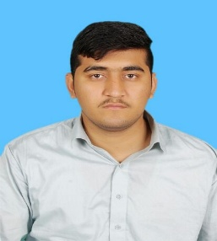**Fawad Ullah**

E-217/B near Sathe Masjid Satellite Town

Rawalpindi Pakistan

Contact: +92 3335793723

Email: abbakheli1997@gmail.com

**CAREER OBJECTIVE**

To acquire a challenging position in a dynamic organization that utilizes my talents to the optimum level, appropriately rewards performance, offers continuous opportunities for career developments and to contribute significantly towards organizational growth.

**PROFILE**

I am a self motivated, patient and diligent worker, believe on quality performance of the work. I have a sound knowledge of,

* CNC Operator
* Welder
* Turner

**EDUCATION**

* DAE (Mechanical Technology)

Punjab Board of Technical Education, Lahore

Year: 2018 Marks 69.10 %

* Secondary School Certification (SSC)

Board of Intermediate and Secondary Education, Bannu

Year: 2013 Marks 71.6 %

**SKILLS AND LANGUAGES**

Strong analytical, communication, problem solving and management skills.

IT Proficiency: MS Word, MS Excel, MS Power Point, Internet

Languages: English, Urdu

**TRAININGS**

* Professional Skills development
* MS office

**GENERAL INTERESTS AND VOLUNTEER WORK**

Books Reading, Internet and Cricket

**REFERENCES**

References will be provided upon request.