**MEHRAN KHAN**

Cell: **+923139899476**

E-mail: engrmehran3696@gmail.com

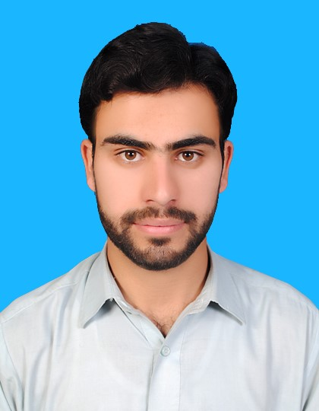

# 

# 

## Objective

To obtain such a position that offers growth, challenge, and career opportunity and enhances my organizational, personal and technical skills through hard working in a dynamic and challenging environment.

## Educational Profile

|  |  |  |  |
| --- | --- | --- | --- |
| **Degree** | **Year/Session** | **University/Board** | **Division/Gpa** |
| **Bsc(Mechanical Engineering)** | 2018 | University Of Engineering And Technology Peshawar, Pakistan | CGPA: 3.41 |
| **HSSC(Pre-Engineering)** | 2014 | BISE PESHAWAR, Kpk, Pakistan | A-1 GRADE  (81%) |
| **SSC (Science)** | 2012 | BISE MALAKAND, Kpk, Pakistan | A-1 GRADE  (82%) |

## Final Year Project

* **DESIGN AND FABRICATION OF SMART SPACE HEATER**

Our FYP was sponsored by Sui Northern Gas Pipelines Limited, SNGPL. The objective of project was to provide the local market with the more fuel efficient and cost-efficient heater with safety design.

## Semester Projects

* Smoke and gas detector apparatus (6th semester)
* Design of Quad copter drone in Pro E software (6th semester)
* Conveyor system using gears (5th semester)
* Micro examination of a specimen for finding Heat treatment process (4th semester)
* Stiffness detector and Modulus finder (3rd semester)
* Design of jet propeller in AutoCAD (3rd semester)

## Major Subjects

* **Powerplants**
* **Fluid mechanics**
* **Machine design**
* **Heat transfer**
* **Thermodynamics**
* **Solid mechanics**

**Engineering softwares**

Familiar with softwares like;

* **Microsoft office, exclusively MS excel**
* **Programming languages, C, C++**
* **Assembly language for Microcontroller**
* **Autocad, Pro E, Solid works**

**Personal Profile**

**Father Name:** Muhammad irshad

|  |  |
| --- | --- |
| **Date of Birth:** | 01/04/1996 |
| **Gender:** | Male |
| **Domicile:** | District: Malakand, KPK |
| **Religion:** | Islam |
| **Permanent Address:** | Mohalla shagai Amandara Tehsil Batkhela District Malakand KPK Pakistan |

**LANGUAGES:**

* + - 1. English
      2. Urdu
      3. Pashto

## Experience

* **2 Months of Internship at 22MW hydroelectric power station jabban dargai**

Worked on Control and maintenance of turbine, Turbine governor system and generator. Also got knowledge about SCADA (Supervisory control and data acquisition) system.

* **1 Month of Internship at Pakistan Locomotive Factory Risalpur**

Worked at drawing and design section and inspection laboratory of the factory. Also observed and analyzed various manufacturing processes that were carrying out in the factory.

## Hobbies

Book reading, traveling and playing cricket

***Other necessary requirements will be provided on demand***