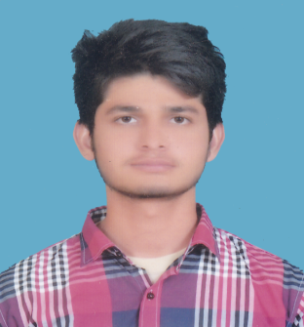 **HARIS MALIK**

**Cell** # 0092-0308-8708377

**Postal Address:** House No # 907/XEX, St. # 1, MOH, Ghaziabad Multan (Pakistan)

**Email:**[malikharis473@gmail.com](mailto:harismalik034@gmail.com)

**Career Objective:**

Seeking challenges to work in a dynamic professional environment with a growing organization and utilize my talent creativity & innovative skills for benefit of the organization. I want to become part of challenging team, where I can get out the best of my potential capabilities with the view to make a prominently significant contribution in the accomplishment of goals and improvement.

**Personal Information:**

Father’s Name Malik Muhammad Hanif Awan

Date of Birth March 28, 1996

C.N.I.C 36302-3477460-1

Marital status Single

**Education:**

**2014 – 2018 B.s Chemical Engg Technology** **CGPA 3.01**

**NFC-IET Multan**

**2011-2014** **DAE (Chemical) 76%**

Multan polyTechnique Institute, Multan PBTE Lahore

**2009-2011** **Matriculation 54%**

Government comprehensive School, Multan

**Internship:**

**Agritech Fertilizer askandrabad, Mianwali** 01 Month internship in Agritech Fertilizer Plant askandarabad, Mianwali.

**Experience:**

01 years experience in coca-cola icecek in supply chain Management.

* Till doing job in **Coca-Cola Icecek** (CCI) Multan as a Quality control officer.
* Working at **water treatment** and **wast water treatment** plant.

**Ability:**

* Control troubleshooting of quality parameters.
* Good communication leadership, making rapid decisions.
* Managing and control troubleshooting at water treatment plant.
* Tracing faults

**Computer Skills:**

* Capable of using Microsoft Office Package (Word, Excel, Power Point)
* Email send & Receive, Internet Surfing etc

**Personal Attributes:**

* Good Interpersonal Communication, Innovative & Presentation Skills
* Ability to work under Pressure & can Handle Multiple Tasks
* Team Player & have good Administrative Skills.

**Interests:**

* Playing Cricket, Reading books & Newspaper

**Languages:**

English, Urdu, Punjabi Good (Written & Spoken)

**Reference will be Furnished on Demand**