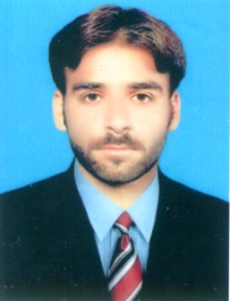**SHAHID LUND**

**CNIC: 45303-6568101-5**

**VILLAGE SARDAR KHAN LUND TEHSIL MORO**

**DISTT: NAUSHAHRO FEROZE**

**Mob: 0308-3827793**

E-mail: balochshahid8@gmail.com

**Career Objective:**

To serve the nation and the organization by my skills and knowledge and to improve my skills by introducing myself in the field.

**Fields of Interest:**

Mechanical Engineering.

**Education:**

|  |  |  |  |  |
| --- | --- | --- | --- | --- |
| **Degree** | **Institute** | **Board/university** | **Year of passing** | **Grade / percentage** |
| **BE (Mechanical Engineering)** | Quaid-e-Awam University of Engineering, Science & technology, Nawabshah | Quaid-e-Awam University of Engineering, Science & technology, Nawabshah | 2017 | **76%(latest result announced)** |
| **HSC (Pre-Engineering)** | Ahlul Bait Public School Moro | B.I.S.E Sukkur | 2012 | **A -72%** |
| **SSC (Science)** | Government Mehran Degree College Moro | B.I.S.E Sukkur | 2010 | **A -77.88%** |

**Key Skills:**

* Good communication skills
* Innovative mind
* Possess positive attitude
* Eligible for teamwork
* Willing to learn and work hard

**Computer Skills:**

* Microsoft Office
* Matlab
* **Strengths:**
* Fast grasping power
* Takes initiative and works independently or as a part of a group.
* Well organized and easily meets deadlines.

**Interests**

* **Reading books**
* **Playing Cricket**
* **Enjoy outdoor activities including Recreational Activities,**
* **Playing Chess.**
* **Badminton**

**Personal Vitae**

* Father’s Name: Saeed Khan
* Date of Birth: 06-11-1995
* CNIC: 45303-6568101-5
* Gender: Male
* Marital Status: Married
* Religion: Islam
* Nationality: Pakistan

**Languages:**

* English
* Urdu
* Sindh

**References**

References will be furnished upon request. Thank you!