|  |  |  |
| --- | --- | --- |
|  | **Curriculum Vitae** |  |

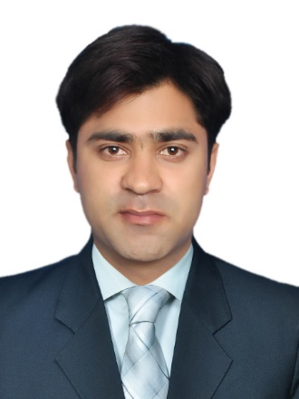

**Zeshan Haydar**

**🕿 +923067999574**

**🖂 Zeshanhaydar@gmail.com**

**Address:** H/n 130 street 10 AA Block ...

Sector D Bahria town Lahore, Pakistan

**DOB:** 10-07-1996

**PEC REGISTERED**

**Personal Summary:**

“A dynamic and energetic individual who is polished and professional in both appearance, personal interaction, and all communications. Possessing superb communication skills & is capable of simplifying and communicating complex concepts to a non-technical audience. Looking for a suitable position with a company that is well established and outperforming the market.”

**Professional Summary:**

I’m Electrical Engineer with experience of working in NTDCL as an Internee Engineer.

I have bachelor's degree in Electrical engineering.

**Academics:**

**BSc Electrical Engineering CGPA 2.76/4**

(The University of Lahore, Pakistan)

2013-2017

**FSc Pre Engineering A+ Grade**

(Faisalabad Board of Intermediate and Secondary Education, Pakistan)

2011-2013 (Faran Model College, Jhang)

**Matriculation A+ Grade**

(Faisalabad Board of Intermediate and Secondary Education, Pakistan)

2009-2011 (Govt High School Ahmed pur sial district Jhang)

**Professional Experience:**

**National Transmission And Despatch Company Limited Lahore, Pakistan**

Period: June, 2017 to August, 2017

Position: Internee Engineer.

**Job Duties and Responsibilities:**

* Designs electrical systems by developing and testing components.
* Evaluates electrical systems, products, components, and applications by designing and conducting research programs; applying knowledge of electricity and materials.
* Confirms system's and components' capabilities by designing testing methods; testing properties.
* Develops electrical products by studying customer requirements; researching and testing manufacturing and assembly methods and materials
* Maintains professional and technical knowledge by attending educational workshops; reviewing professional publications; establishing personal networks; participating in professional societies.
* Contributes to team effort by accomplishing related results as needed.

**Final Project:**

“Three phase bidirectional matrix converter for dc to ac inverter”

**Certificates:**

* Pec supervisory certificate
* Pec registerion card
* Internship letter from NTDCL
* Scholarship from Chief Minister Punjab in Matriculation

**Technical & Computer Skills:**

* Visio
* Matlab
* AutoCAD
* MS Office Word
* MS PowerPoint

**References:**

Available on demand.