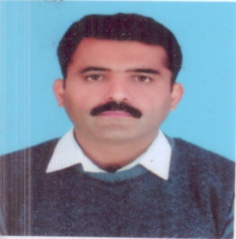 **CURRICULUM VITAE**

**FOR QUALITY/ ADMISTRATION/ SECURITY**

**NAME FIRST MIDDLE LAST : Khurram Nawaz**

**FATHER’ NAME : Rab Nawaz**

**DATE OF BIRTH : 07-03-1977**

**AGE :- 41 Years05 Months**

**RELIGION : Islam**

**NATIONAL ID CARD NO: 37201-6045760-5**

**MARITAL STATUS : Married**

**NATIONALITY : Pakistani**

**QUALIFICATION : DAE Electronics**

**B Tech( *Electronics*)**

**DATA OF PREVIOUS SERVICE**

**ORGANIZATION : Pakistan Air Force**

**RANK : Chief Warrant Officer (*Retired*)**

**TRADE : Radar Fitter**

**DATE OF JOINING PAF : 01-02-1993**

**DATE OF RETIREMENT : 05-07-2018**

**TOTAL SERVICE : 25 Years 05 Months**

**CHARACTER : Good**

**TRADE PROFICIENCY : Superior**

**HOME ADDRESS : Vill & P O Murid Teh & Distt Chakwal**

**EMAIL ADDRESS : tehmanshayan@gmail.com**

**CELL NO : 0333-5925319 & 0321-5593322**

**PROFESSIOAL COURSES DURING SERVICE**

|  |  |  |  |  |
| --- | --- | --- | --- | --- |
| **S No** | **NAME OF COURSE** | **DATE** | | **Duration** |
| **FROM** | **TO** |
| **1** | **DAE Electronics** | **01-02-1993** | **15-02-1995** | **02 Yrs** |
| **2** | **Field Maintance course** | **08-07-1995** | **14-09-1995** | **10 Wks** |
| **3** | ***Quality Control & quality Assurance course*** | **01-03-2004** | **17-04-2004** | **07 Wks** |
| **4** | **Field maintenance course** | **03-03-2008** | **10-05-2008** | **08 Wks** |
| **5** | ***Safe Usage of microwave PME (Precision Measuring Equipment) Course*** | **07-01-2013** | **18-01-2013** | **02 Wks** |
| **6** | ***Military Leadership &Command course*** | **13-01-2014** | **07-01-2014** | **08 Wks** |
| **7** | **(Depot)Level Maintenance course** | **11-12-2017** | **05-01-2018** | **04 Wks** |