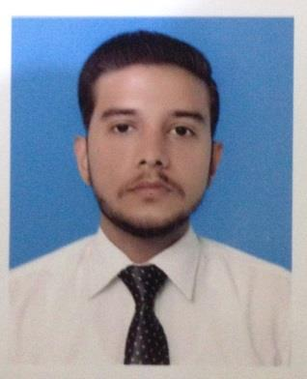**ZARYAB AMAN**

House # 21, Sector4-B, Azim Colony, Khayaban-e-Sirsyed, Rawalpindi.

+923325027823

zaryabaman447@gmail.com

**Career Objective**

I am looking at a path which can lead to my destination where I can excel my knowledge and abilities to gain mutual benefits.

**Qualifications**

* B.com (Result Waiting) 2018 University of The Punjab
* Intermediate 2014 FBISE Islamabad
* Matric 2012 FBISE Islamabad

**Skills & Achievements**

* Excellent command over MS Office
* Good Communication Skills
* Good Speaking and Writing Skills over language (English, Urdu)
* Got certified training of Communication and Presentation Skills.

.

**Experiences**

* As a Customer Service Representative (CSR) at AUGERE QUBEE BROADBAND, Franchise (Pervaiz Telecom) from June 2017

**Personal Information**

**Fathers Name** Mirza Aman Ullah Baig

**CNIC** 35202-6932606-5

**Date of Birth** 03-03-1997

**Place of Birth** Jehlum

**Religion** Islam

**Marital Status** Single

**Domicile** Punjab

**References**

Will be furnished on demand