***IBNAN AHMED cv*** 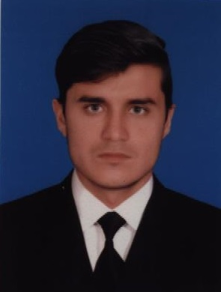

***Village & Post Office Makori Tehsil Banda Daud Shah Distt Karak***

*Cell No. ,+92-3159723468 +92-3028012467 Email:- (ibnanahmed96@gmail.com)*



***OBJECTIVE***

*To get the chance in your esteemed organization to build my career and utilize my professional expertise to fulfill the organizational requirements.To secure a rewarding position in an organization that would fully employ my personal skills as well as my academic training in a carrier that affords professional and personal growth.*

***ACADEMIC QUALIFICATION:***

|  |  |  |  |  |  |
| --- | --- | --- | --- | --- | --- |
| ***QUALIFICATION*** | ***SUBJECT*** | ***YEAR*** | ***MARKS*** | ***%AGE*** | ***BOARD*** |
| ***D.A.E*** | *Chemical* | *2015* | *2669/3400* | *78%* | *BTE Peshawar* |
| ***Matriculation*** | *Science* | *2012* | *684/1050* | *65%* | *BISE Kohat* |

***EXPERIENCE***

* *02 month of experiance on compressors as third party operator working for MOL Pakistan.*
* *02 Years experiance as HSE Supervisor at (Unique Construction) working for MOL Pakistan* *(From 2016 to 2018).*

***PERSONAL INFORMATION***

* *Father’s Name : Adam khan*
* *Date Of Birth : 11- Oct- 1995*
* *N.I.C. No. : 14201-7065346-1*
* *Domicile : Karak (KPK)*
* *Religion : Islam*
* *Nationality : Pakistani*
* *Marital Status : Single*

***COMPUTER SKILLS***

* *MS Office,Excel & Internet*

***PERSONAL ATTITUDE***

* *Disciplined and well organized.*
* *Sincere and devoted.*
* *Eager to achieve target and commitments.*
* *Hardworking and result oriented.*
* *Excellent communication skills*

***EXTRA CURRICULAR ACTIVITIES***

* *Reading Books, Newspaper and Playing Cricket****.***

***LANGUAGES***

* *English, Urdu, Pashto. (Read, Write and Speak).*