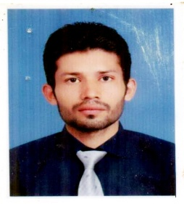

Photo

Mohallah Dhoke Gujjar Pinwal Road, MCB-4/816,

Tehsil & District Chakwal

E-mail: Ateequr632@gmail.com

Per # : 0092-0314 6062412

Home: 0092-0334 8516096

Father’s Name Abdul Rehman

Date of Birth 14-08-1994

Marital Status Single

Domicile Chakwal (Punjab)

Religion Islam

CNIC # 37201-0648448-5.

|  |  |  |  |  |
| --- | --- | --- | --- | --- |
| **Sr. No** | **Examination** | **Board / University** | **Subject** | **Year** |
| 1. | Matric 60% | Board of Intermediate and Secondary Education Rawalpindi | Science | 2010 |
| 2. | D.A.E 68% | Punjab Board Of Technical Education Lahore | Chemical | 2013 |

**Microsoft Computer Applications (MS-Word, MS-Excel, Internet & Excellent Typing Speed)**

**Project Citizen Of Pakistan in high school no 2 chakwal**

1. **02** years professional experience in multinational company ici soda ash khewra.
2. **Ro plant**
3. **Killen**
4. **Brine Plant**
5. **Boilers**
6. **01** x years Professional experience in water treatment company blue lake techionolges.
7. Ro Plant
8. Softener
9. **06** months experience in asian technical Collage .

1. Strong Interpersonal Skills
2. Excellent communication skill
3. Problem solving skill