**CURRICULUM VITAE**

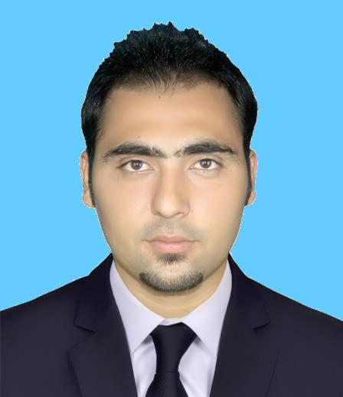

**Muhammad Assnan Khan**

**Mobile No : 03315620399**

**Email:** [**engr.assnan@gmail.com**](mailto:engr.assnan@gmail.com)

**Career Objective**

A resourceful result oriented professional with demonstrated ability in identifying potential strategic opportunities and implementing comprehensive section plans to achieve objective. Strong work ethics as well as excellent and organization skill.

**Personal Strengths**

* Leadership
* Good in interpersonal relationship
* Adaptability and flexibility
* Ability to deal with people diplomatically

**Education Profile**

* Bachelors of Electronics Engineering.
* Fire Prevention and Safety for Industries.
* Intermediate.

**Area of Interest**

* **Maintenance E&I**

**Proficiency in Application Software**

* **Software:** Programmable Logic Controller, Micro Controller, Multisim , Proteus, C, C++, Visual BASIC, Assembly Language , Microsoft Word, Excel, PowerPoint & Outlook .

**Nature of work**

**Instrumentation**

* Continuity of Instrument cable, calibration of electronic and pneumatic instruments PT, FT, TT, LT, PSH, PSL, LSH, LSL, Level Troll, Control Valve, I/P & P/I converter.
* Loop checking, Commissioning and start up check.
* Calibration of Instruments.
* Trouble shooting of Instruments, Booster, Actuator, Positioner .
* Calibration all type of instrument (Pneumatic & Electronic)
* Loop Checking of open and close loops.
* Preparation of loop packages as built of instrument loop drawings.
* Stroke check of control valve.
* Calibration of instruments as per filed parameters using Field communicator, Hart & Field bus.
* Calibration and repair of control valves, ON/OFF valves including Pneumatic and Electro-pneumatic positioner.
* Familiar to all leading instruments manufacturer’s products and their technical specifications such as flow, pressure, level, temperature, vibration monitoring systems and transmitters, ultrasonic and radar type level transmitters and various type switches made by **ABB, Yokagawa, Siemens, Khrone, Endress Hauser, Honeywell, Rosemount, Fisher, Bentley Nevada .**
* Have ability to read P& I Diagram , Functional logic Diagram , Gate Logic , Relay Logic ,Loop Diagram ,Ladder diagram & Loop Schematic.
* Calibration of Pneumatic, Electronic and SMART Transmitters of different makes (Rosemount, Fuji, MTL, Honeywell, Foxboro, Baily Fisher, Yokogawa etc.) for the measurement of Pressure, Differential Pressure, Flow, Temperature, Level, Interface Level and Density.
* Calibration and Configuration using different SMART Transmitter’s Communicators and Configurators HART & HHT, HHC and SFC.
* Calibration, servicing and overhauling of Control Valves of different types and makes (Fisher, ABB, Masoneilan, IL, MIL, Neles Jamesbury, Valtek, El-o-matic etc…). Installation, Calibration and Configuration of SMART Positioners (Fisher, Siemens).
* Calibration and servicing of Damper actuator Valves, ESD Valves, Self-Operated Valves, and Solenoid Operated Valves.
* Configuration and Servicing of Motorized Operated Valves (Rotork, Limitorque).
* Calibration and repairing of Pressure, Temperature, Flow and Level Switches and Gauges, I/P and P/I Converters.
* Calibration and repairing of Electronic and Pneumatic Controllers.
* Calibration and Maintenance activities of Following Analyzers:  
  O, CO,CO, pH and Conductivity, Dissolved Oxygen , Analyzers , Silica Analyzers ,Steam and Water Analyzers.
* Calibration and Programming of Speed Monitors/Transmitters (Bently Nevada and Dymac) and Vibration/Speed Probes.
* Work exposure on Oil & Gas Well Heads, Burner Management Systems, Hydraulic skids and Relay Logic Panels.
* Knowledge about Instrumentation Drawings.
* Faultfinding and Fault analysis of various Instrumentation Systems.
* Work Exposure on Process Safe Guarding Systems.

**Safety**

* Safe work practices and safety awareness.
* Ability to use relevant tools and equipment.
* Having knowledge of safety in Petrochemical. Industrial And Steel plant.
* Beside for this job I have also a knowledge and experience of industrial Safety and how to implement the unsafe activity and condition, also in hot work, working at height, confined space etc.
* Having maintain a good housekeeping before and after the work while doing the job on the site.
* Having knowledge to follow all the standard safety and follow the all safety precaution related to work before starting or while starting the job until finished.
* To do the job under the responsibility till the completion with following the job procedure and safety rules by the standards.
* Having knowledge of Work permit system and knowledge of Logout & Tag out.

**Project Coordinator**

* Self-motivated and confident in making sound business decisions.
* Successful with outlining, managing and performing in multi-tasking environment.
* Work creatively with limited resources.
* Experience with tight deadlines for managing projects.
* Creative problem solving.
* Team-oriented with positive attitude.
* Excellent verbal and written skills.
* Ability to build strong relationships with outside partners and possess strong negotiating skills.
* Demonstrated sound organizational and coordination skills.
* Ability and willingness to travel and work weekends.
* Proven job reliability, diligence, dedication and attention to detail.
* Proficiency with Microsoft Word, Excel, PowerPoint.

***Job Experience in Abroad***

**Sponsor : Mohd Ali Al-Hadabani General Contracting (K.S.A)**

**Company : Sinopec**

Project : Sadara

Designation : Maintenance Engineer

Period : 05 Dec 2016 TO 04 Dec 2017

**Company : Saudi European Petrochemical Co**

Project : Ibn Zahr

Designation : Instrument Technician

Period : 1 Nov 2015 TO 26 Sep 2016

**Company : POSCO E&C**

Project : Wasit Gas Plant Saudi Aramco.

Designation : Project Coordinator.

Period : 25 Dec 2017 TO 18 Jun 2018

***Job Experience in Pakistan***

**Company : Century Paper and Board Mills Lackson Grp Lahore**

Designation : Trainee Engineer

Period : 20 Jun 2014 To 20 Sep 2014

**Driving License**

* LTV valid Driving License for Saudi Arabia.

**Personal Profile**

Name : **MUHAMMAD ASSNAN KHAN**

Father’s Name : **NAUMAN KHAN**

Gender : Male

Marital Status : Unmarried

Religion : Islam

Nationality : Pakistani

Languages Known : English, Urdu, Arabic (Fluently), &Hindi

Hobbies : Playing Cricket ,Football , Swimming & Internet Surfing

**Passport Details**

Passport No. : **BA4135961**

Date of Issue : 03 APRIL 2014

Date of Expiry : 03 APRIL 2019

Place of Issue : Kohat , Pakistan

**Declaration**

I hereby declare that all the information given above is true and correct to the best of my knowledge and belief

Thanking you