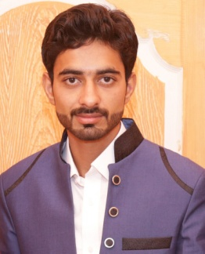

|  |  |  |
| --- | --- | --- |
| SHAHZAIB IQBAL | | |
| Cell Number: +92-304-8592294  Address: House No. 3, Street No. 2, Warind Colony,  Sadiqabad, District Rahim Yar Khan.  Email: shahzaib.iqbal1996@gmail.com | |  |
|  | | |
| Objectives | **“To be an integral part in the success of a growth oriented organization, and render peak performance through commitment and integrity”** | |
|  |  | |
| Post Applied For | Mechanical Technician | | |

|  |  |  |  |  |  |
| --- | --- | --- | --- | --- | --- |
| Education | **Certificates** | **Subjects** | **Marks** | **Year** | **Institute** |
| **DAE** | **Mechanical Technology** | **2446/3450** | **2017** | **P.B.T.E Lahore** |
| **Matriculation** | **Science** | **578/1100** | **2014** | **B.I.S.E Bahawalpur** |
|  |  | | | | |
| Short Courses | **Auto CAD Mechanical**   * **2 Months short course of Auto CAD Mechanical from Pakistan Industrial Technical Assistance Centre under Ministry of Industries & Production Govt. of Pakistan.**   **Diploma In Computer Application**   * **3 Months Diploma in following Computer Application** * **MS WIN 2007** * **MS WORD** * **MS EXCEL** * **MS POWER POINT 2007** * **INTERNET** * **INPAGE**   **From Sadiqabad Poly Technic Institute.** | | | | |

|  |  |  |
| --- | --- | --- |
| Personal Information | **Father's Name**  **Date of Birth**  **CNIC #**  **Domicile**  **Marital Status**  **Religion**  **Nationality** | **Iqbal Mehmood**  **15-Jun-1996**  **31304-7024063-3**  **Rahim Yar Khan (Punjab)**  **Single**  **Islam**  **Pakistani** |
|  |  | |
| Languages | * **English** * **Urdu** * **Punjabi** | |
|  |  | |
| References | **References are available upon request.** | |