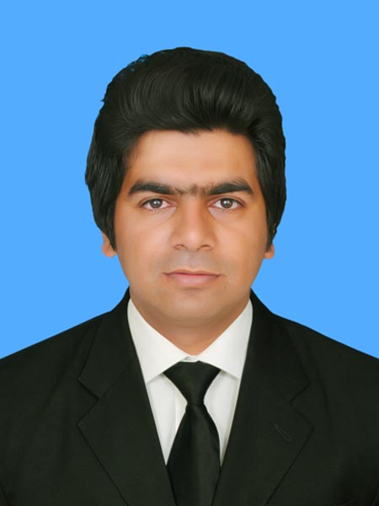**GUL HASSAN**

**MECHANICAL ENGINEER (UET LHR)**

**E-MAIL:**[**gul7475@gmail.com**](mailto:gul7475@gmail.com)

**MOBIL:**03458031559

**Address:** PCSIR LAB COMPLEX FEROZPUR ROAD LAHORE

**PROFILE: -**

Seeking a platform to work with maximum potential in a challenging and dynamic environment, with an opportunity of working with diverse group of people and enhancing my professional skills with learning and experience for career growth.

**CAREER SUMMARY: -**

* **PLANNING & EXECUTION ENGINEER WITH DESCON ENGINERING LAHORE**
* **PLANNING ENGINEER WITH ENGINEERING KINETICS (PVT.) LTD**
* **MECHANICAL ENGINEER AT CARACAL INTERNATIONAL UAE**

**TECHNICAL SKILLS: -**

* **PROJECT MANAGEMENT, EQUIPMENT MAINTENANCE, DESIGNING, EQUIPMENT INSTALLATION,**
* **MICROSOFT OFFICE (WORD, EXCEL, POWER POINT), AUTOCAD 2D & 3D**

**PROFESSIONAL EXPERIENCE: -**

**PLANNING& EXCECUTION ENGINEER AT DESCON ENGINERING LAHORE (OGDCL UCH GAS FIELD)**

**Responsibilities: -**

* Regular progress monitoring using Primavera P-6(16.1), Ensuring execution schedule compliance covering all engineering activities
* Study scope of work, performs field verification and incorporates the additions/deletions and corrections in execution plan accordingly
* Producing daily, weekly and monthly progress reports based on the actual achievements and identifying risks and constraints involved.
* Monitoring the project health by critically analyzing project reports on weekly and monthly basis and raise flags in case of slippages from schedule and low productivity.
* Monitoring the productivity of manpower and equipment on weekly basis, to keep an eye on actual productivity against planned and taking necessary action.
* Attend project meetings and handle project communication with the client.
* Estimate manpower, equipment, tools, materials and consumables in consultation with construction managers.
* Monitoring and analyzing of major shutdown activities status on a daily basis and emphasizing to schedule/execute critical work on priority which could have impact on timely completion of shutdown
* Ensure that all site operations were carried out in safe productive manner.
* Planning of daily progress report for turnaround and examining the effect of progress against the base line schedule
* Preparation of completed area wise schedule along with the resources like equipment and manpower to expedite the job
* Monitor progress to ensure that the project progressing as planned and the targets would be completed within time
* Assist Project Manager, Maintenance Team leader and supervisor on different critical issues as per requirement

**PLANNING ENGINEER AT ENGINEERING KINETICS (PVT.) LTD**

**(GENERAL ELECTRIC, MANGLA POWER STATION MIRPUR)**

**Responsibilities: -**

* Leads the Projects Planning & Control team in plan, schedule preparation, maintenance, updating & monitoring requirements.
* Development of project specific procedures including Work Breakdown Structure and progress measurement methods in accordance with Client's requirements.
* Maintain the earned value system consisting of, progress / productivity reports, and resource forecasts, to assist the Site and Project Manager with cost reporting and personnel requirements.
* Establish, maintain and follow up plans/networks and resources for new and established projects in accordance with Planning procedures and produce the project control procedures.
* Responsible for the leadership of the Risk Management program implemented during project execution.
* Development and maintenance of the Baseline schedule for Client's approval including agreed S-curves and reporting formats.
* Maintain cost and schedule budgets throughout the project life and report actual against standard/budget variances, cash flow and project expenditures.
* Liaise with Quantity Surveyor in respect of monitoring cash flow and preparation and updating of cash flow forecasts.
* Assure that any changes related to the scope of the contract get implemented into relevant plans.
* Ensure any deviation from the plans are promptly spotted and analyses, final time impact is estimated and the effect of corrective actions taken is monitored.
* Ensure that Area and Corporate targets and reporting are complied.
* Actively work together with other Project Controls disciplines to ensure quality in deliverable.
* Support bidding process with execution strategies, schedules and related requirements.

**MECHANICAL ENGINEER AT CARACAL INTERNATIONAL UAE**

**Responsibilities:**

* Working as CNC programmer at CARACAL INTERNATIONAL (UAE)
* CNC Operating 3-Axis and 5-Axis by using CAM programs such as Uni- graphics, and master cam
* Working with the following CNC machine's control (Heidenhain, Fanuc, Siemens),
* Manually programming the CNC machines to make a small part programs for completing any machining operation,
* Set up all the required offsets for the big milling, boring, turning machines such as spindle attachments, tools and all axes,
* Experience in creating tooling, jigs, and sharpening tools,
* Dealing with and understanding of the engineering drawings which made by using Geometrical, Dimensioning and Tolerances GD&T according to ASME 14.5 2009,
* Evaluate production process and make changes to make it more convenient in favor of both productivity and quality improvement,

**MECHANICAL TECHNICIAN** (**FAUJI FERTILIZER COMPANY)**

**Responsibilities:**

* Routine Maintenance and Overhauling of Valve, Pumps, Compressor and Boiler
* Assists to carry out mechanical maintenance activities in time and cost-effective manner
* Preparation of Daily, Monthly and Outage Reports
* Preventive and predictive maintenance of plant
* Trouble shooting, Installation and Alignment of stationary& rotating machinery
* Working with engineers and designers for execution of piping / mechanical work.
* Fabrication and modification of pipelines
* Generate work methods on parts list, procedures, specifications and inspection reports

**INTERNSHIP: -**

* **OIL &GAS DEVELPOMENT COMPANY LIMITED (OGDCL)**

**UCH GAS FIELD**

### INSTALLATION OF MACHINES WITH CHINESE TEAM

* Marking of layout and maintain the foundation of Machines equipment
* Alignment and balancing of machines
* Assembling of part and accessories

**EDUCATION: -**

|  |  |  |  |
| --- | --- | --- | --- |
| **2011-2015** | **(B.Sc. MECHANICAL ENGINEERING)** | **(GPA)** |  |
| University of Engineering and Technology, Lahore | **3.04/4.00** |  |
|  |  |
| **2007-2010** | **(DAE MECHANICAL)** |  |  |
| **(82.31%)** |  |
|  | Precision System Training Centre (PCSIR)Lahore |  |
| **2005-2007** | **(MATRICULATION)** | **(76.47%)** |  |
|  | Govt. Higher Secondary School Feroza, Rahim Yar Khan |  |  |

**LANGUAGES: -**

* **ENGLISH, URDU, PUNJABI, SARAIKI**

**ACHIEVEMENTS: -**

* Gold Medalist in DAE Mechanical Punjab Technical Board Lahore in 2010.
* Award of Scholarship from Pakistan Council of Scientific and Industrial Research laboratory, Ministry of Science and Technology Islamabad

**PROFESSIONAL AFFILIATION: -**

* Pakistan Engineer Council (P.E.C.) Membership